RAPPORT DE HROC DE BASE AU LYCEE MUNICIPAL DE MUSAGA DU 26 AU 27 /1/2022
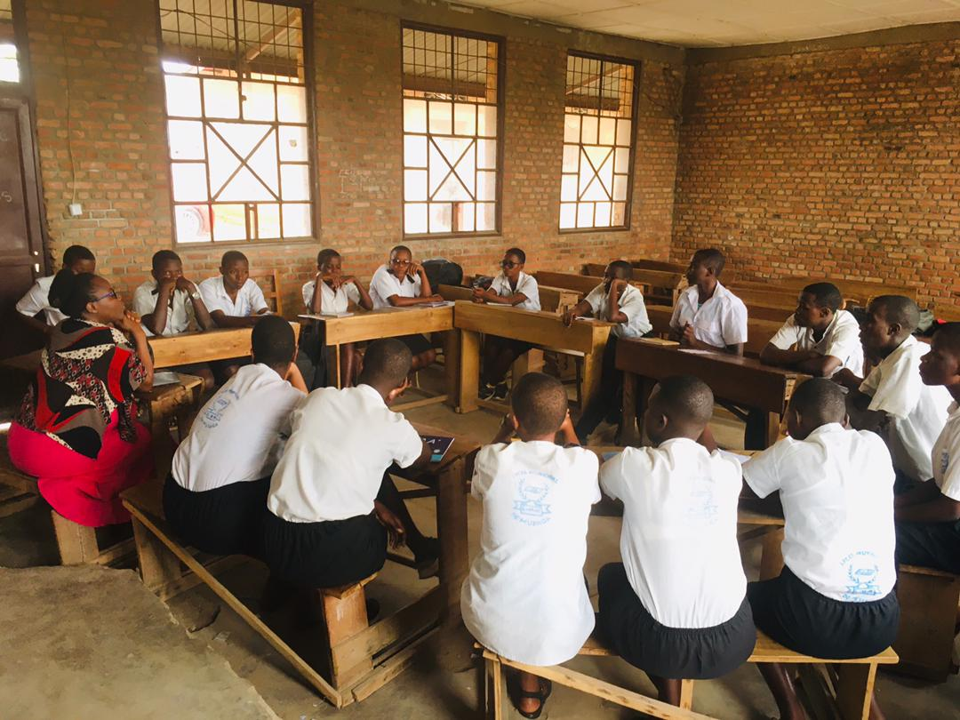
Effectif total: 20
Garcons:4
Filles:16
Les temoignages
IRAKOZE Divine
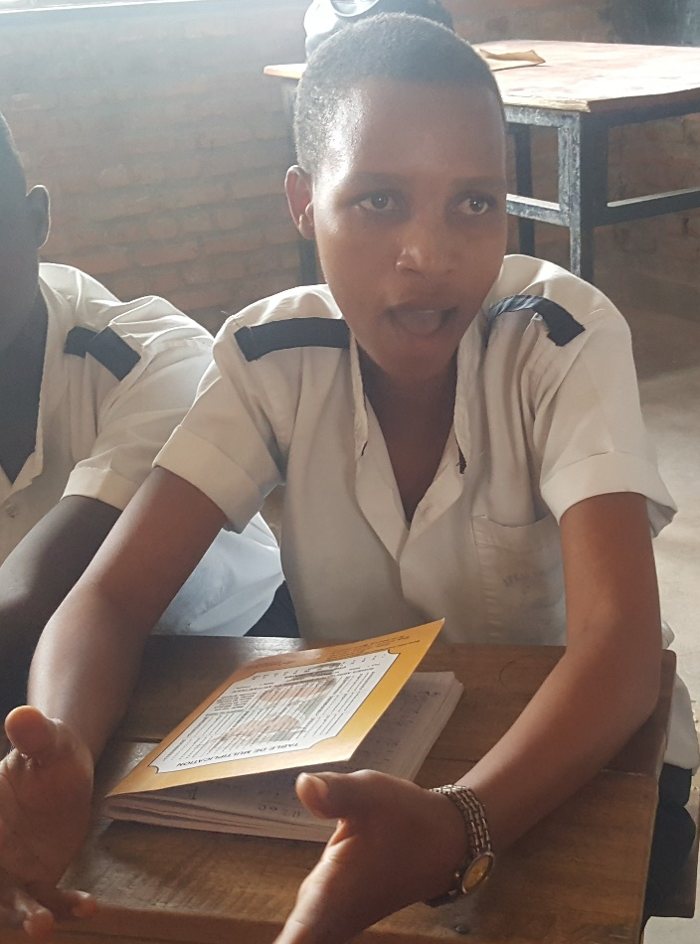
Jewe ikintu cambabaje cane nuko nabuze papa. Nukuvuga akihari ntakintu nakimwe nakenera ngo ndakibure ariko kuva apfuye imyaka itatu iraheze twaciye dutangura kubaho mubuzima bubi. Kwiga tukiga nabi nabi cane kuko hari nigihe twabura ivyo dufungura .
Nubu sinovuga ngo mbayeho neza kuko kenshi ndatangura nishure ntagira uniforme canke ibikoresho vy' ishure kandi bigaca bituma nibuka papa wanje kuko akiriho ivyo ntivyamabakao
Ariko ndashima cane izi nyigisho twahawe kuko zatumye numva niyakiriye naho bimeze uko . numvise nduhutse ku mutima wanje cane. Ndakengurukiye IPB bivuye ku mutima ku nyigisho baduhaye.

NIYONSABA albin
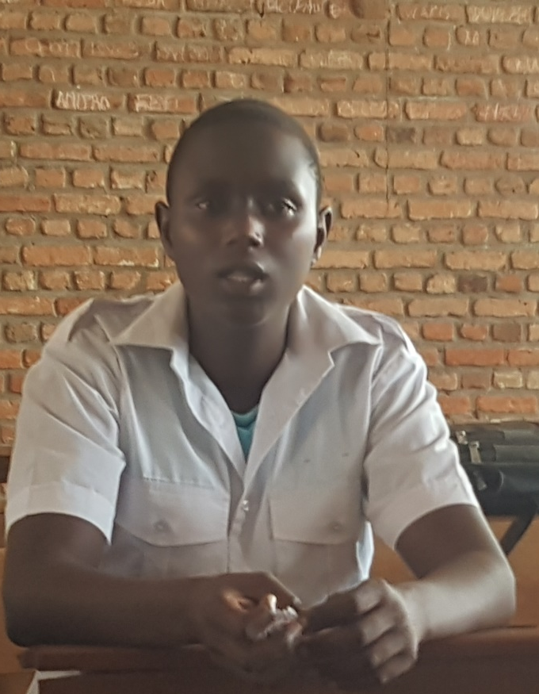
Jewe ikintu cambabaje cane nukuntu nabuze senge wanje nakunda cane yamfashije vyinshi mugihe jewe atakintu nakimwe narinzi gukora. Maman yaravunitse acaja mubitaro nanje nije nitwako nkuze ariko ntakintu nakimwe narinzi gukora. Uwo senge wanje niwe yateka akavoma akahirira inka , eka udukorwa twose niwe yadukora.
Hama ico gihe maman ari mubitaro niho senge yaciye atangura kunyigisha udukorwa two muhira kuko jewe ntanakimwe narinzi gukora. Hama maman ahava aratora mitende aragaruka muhira. Haciye iminsi senge nawe acaragwara afatwa avyimba amaguru. Arivuza ruguru biranka ahava amanuka ibujumbura. Ico gihe maman yari yavuye mubitaro ariko yariko isima ntivyakundako akora ikintu na kimwe.
Ni jewe nateka , nkavoma , nkahirira inka hama nkaja no kw'ishure rero ntivyanyrohera kuko sinari ndabimenyere ivyo bikorwa. Icambabaje nuko senge amaze kuja kugwarira ibujumbura naguma nizeyeko azokira kaza akamfasha ibikorwa ariko haciye igihe gito naciye numvako senge bamuvuye biranka ko akira ahubwo yapfuye. Narababaye cane kuko yarankunda ikindi nibutse ukuntu ariwe yanyigishe ibikorwa vyo muhira bituma numva mbabaye kuko naramaukunda cane.
Ariko numva ndemurutse kumutima ko nshoboye kubivuga kuko vyari vyarambabje cane

KIGEME Ange Claudia
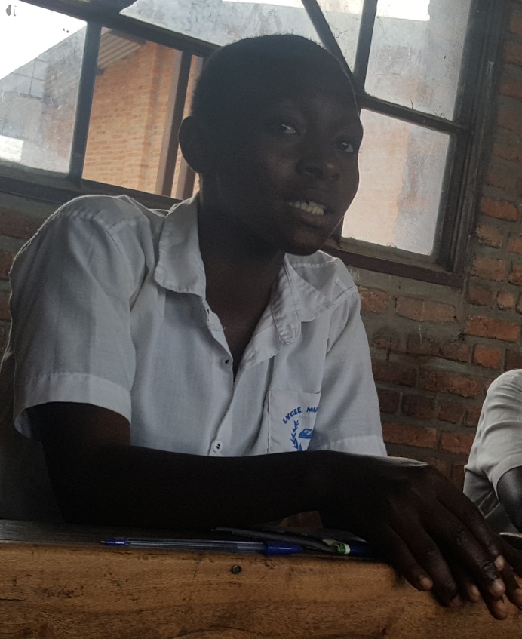
Nanje narabuze papa wanje yankunda cane kandi nanje naramukunda cane. Kuko igihe cose yaba yanyoye inzoga nije yahamagaye vyanse kwataha nkaca nja kumuraba ahari nkamwandaza gushika muhira.
Hama yaragwaye ama poumon araja mubitaro aramara igihe agwaye hama arataha .haraca imyaka ibiri adasubiye kugwara ariko muri 2018 niho yasubiye kugwara acasubira mubitaro aramara igihe kitari gito agwaye .icco gihe rero maman yarafise umwana mutoya acaramudusigarana kuko niwe yagwaza papa. Icambabaje nuko twabana na nyokuru avyara papa naho uwo mwana yarira ntiyegera anatubaza ngo bimeze gute ahubwo yaca yiryamira. Nanje nabo tuvukana tugumaho vyose twifasha kuko mama yaba agwaje papa. Hama ikindi cambaza nuko papa yarfise batoyi biwe kandi yafashije ariko atanumwe yaza kuturaba canke aje nogusuhuza papa. Hama papa atararwara ngwasubire mubitaro hariho umuhererezi wabo yiga muri kaminuza umuryango wari wabwiye papa kwariwe azomurihira amhera azokoresha mugusoma igitabo kandi yari yavyemeye.
Papa rero acaragwara araremba umwe bavukana ataraheza ngwazomurihire ayo mahera . mbere ahava arapfa. Papa apfuye ntakintu nakimwe bigeze badufasha mumuryango vyose mama yarimenye. Mbere atanukwezi kurahera umuryango ucuraza ubwira maman go duhe yamahera umugabo wawe yari yemeye kwazorihira mutoyi wacu asoma igitabo harageze.
Mama yarifashe arayabaha gusa jewe vyarambabje kukuntu baza kumusaba amahera kandi baziko atakintu nakimwe badufashashije igihe papa yapfa. Duca dutangura kubaho ubuzima bugoye cane kuko umuryango wa papa ntanumwe yasubiye kutwitaho bigera naho mama bamwagiriza ko umukozi yadukorera ngwariwe agira amubere umugabo baca bamutegeka ko amwirukana.
Rero vyarambabaje kurugero numva ntobabarira abo bavukana na papa ariko maze kwumva izi nyigisho numvise nobabarira

IRAKOZE Sandine
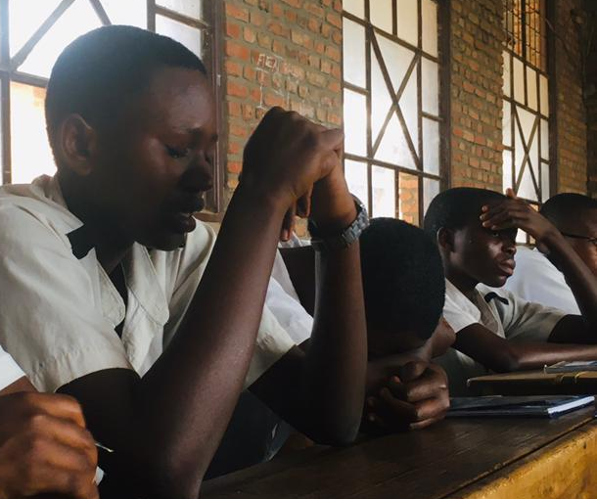

Mva mu muryango wabana 10 ariko abo 9 ntidusangiye papa kuko jewe mama yamvye igitwarira papa acaranyihakana. Hama mama yandereye mubuzima bugoye cane kuko mama wiwe yaciye amwirukana. Mama acaja kuba mw'ishamba agera naho yumva yonta muriryo shamba kubera ukuntu ubuzima yabona bwanse ariko yagera imbere gato bakanka agaca agaruka akantora . hari rero umutamakazi yamusanze muriryo shamba acaja kumuha indaro barabana ariko ubuzima nyene butoroshe niho yahuriye numugabo barikumwe ubu aramutwara duca tuja kuba ibujumbura ariko ubuzima ntibwari bworoshe kuko uwo mu papa ntakazi gashemeye afise . kuko twaragiye gupanga inzu ya 7mille haragera igihe iratunanira kuriha kugezaho naronse umuntu nganirira ikibazo mfise acampa 50.000fr ncandariha ayo twari duheranye ariko duhava turava aho hantu tuja gupanga iyindi nayone haragera igihe tubura ayo kuriha. jewe ndonse amahera uko aba angana kwose ncandayatanga mumuryango kugira dushobore kubaho.
Rero kubera ubuzima bugoye nagumye nsenga Imana ndayisaba ico nokora kuko nabona ubuzima tubayemwo bugoye ihava impa kudandaza ubuyi. Natanguye kubiro nkacumi kandi ako kanyungu naca ndakazana mumuryango kuko gushika nubu kenshi nije ndiha inzu canke ngatanga ration kuko uwo mu papa mbako ntakazi gashemeye afise hari nigihe ambaza ngo sandine ntamahera ufise dusume ? ngaca nkora muritumwe tubuyi kugira ntiturare ubusa.
Twarabayeho duturatua ndetse na sentare ikaza ikadusohora munzu yabandi twabuze ayo kuriha ari ndashima Imana ko ikituzigamye naho ubuzima butoroshe . ndahura nabangerageza bakabwira gute sandrine yobura ikambambiri canke amavuta yo kwisiga.ingo tukwereke uko woyaronka ariko ndashimira Imana ko impa kwihangana nkaba narazigamye ubwigeme bwanje gushika uyu musi kandi nico nama nsaba Imana ngo imfashe sinzote ibanga no nikubera tubayeho mubuzima bugoye. Kuko nubu jewe nije menya uko umuryango ubaho. Ndashimye izi nyigisho kuko zingejeje ahandi hantu numva ndemye mumutima wanje ko ibi bihe harigihe bizorangira .
Photo de famille
Autre

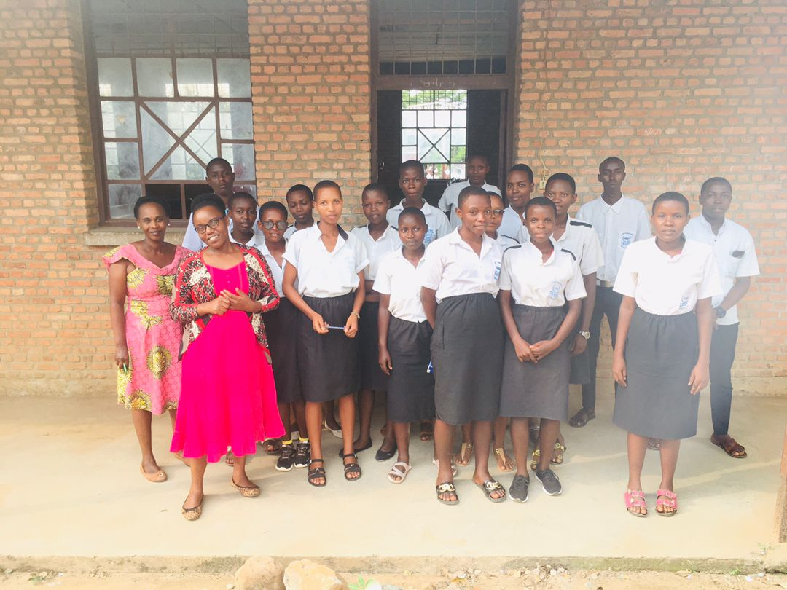

Autre photos
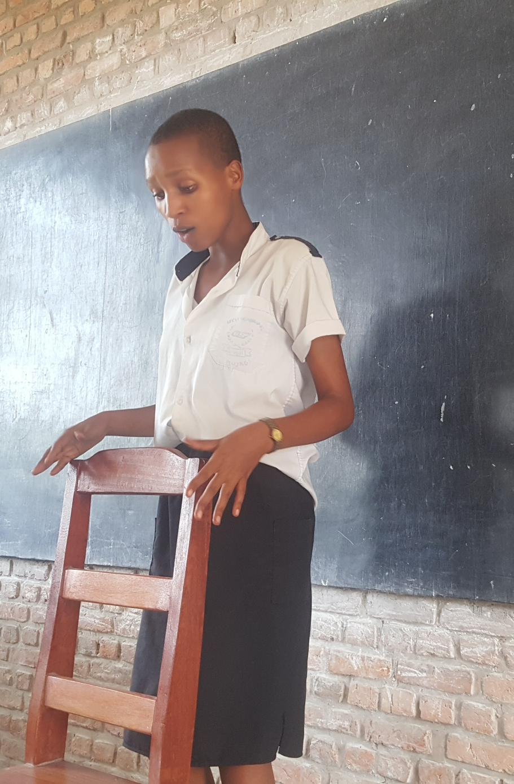

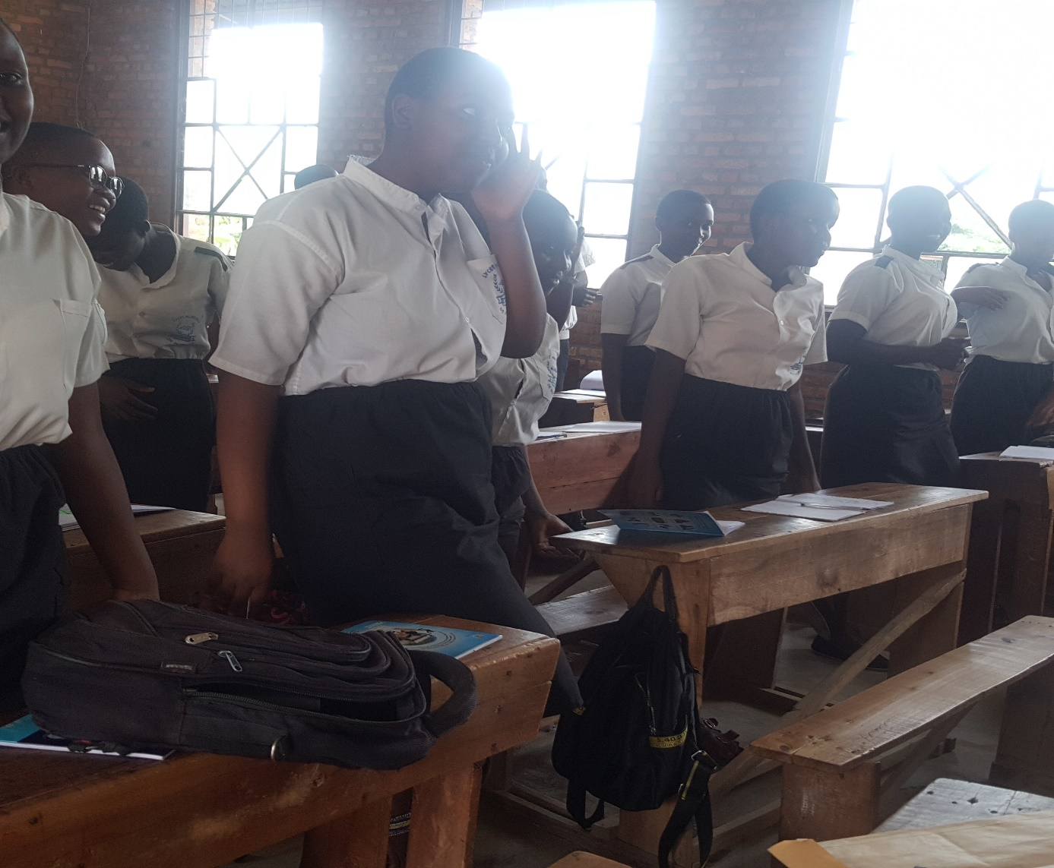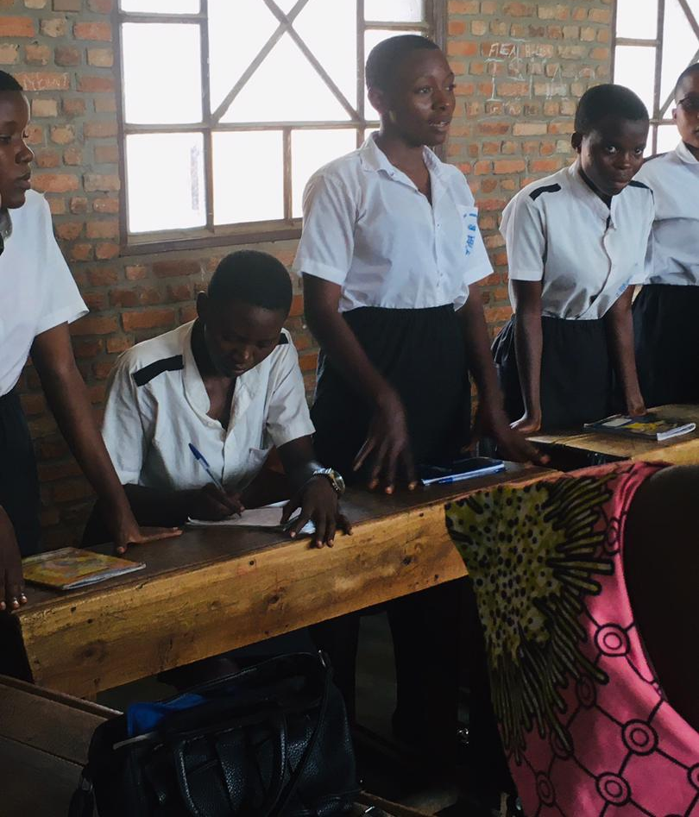

Pour ce dernier image, cette fille nous temoignait comme ca ate interessee par les enseignements recues en nous disant que apres la fin du premier jour de HROC de base. Elle a ressamble sa famille en les temoignant ce qui a touche son cœur durant l'atelier et meme sa famille a dit que cet ateleir était tres interessant car ce sont des choses qui touchent sur la vie quotidienne

