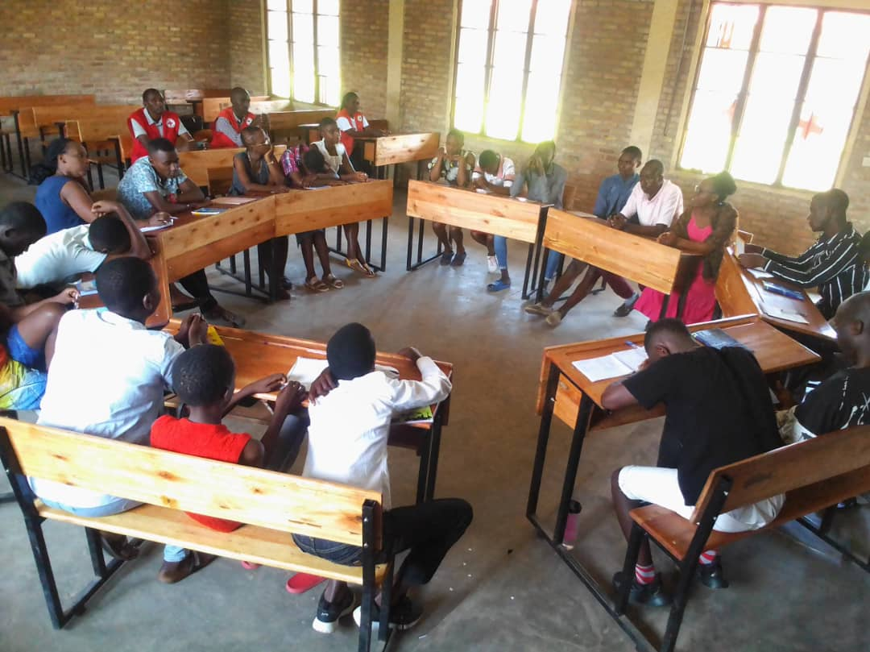
Personal journey of healing: Photo by N.Elie

