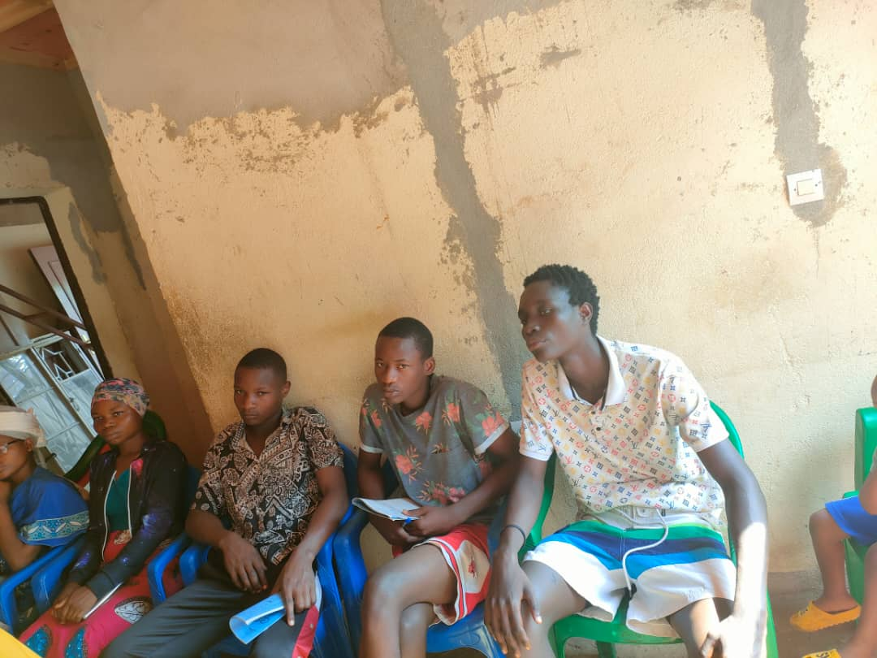Men paying attention during the presentation on the trauma causes, symptoms, consequences and the way to overcome from it