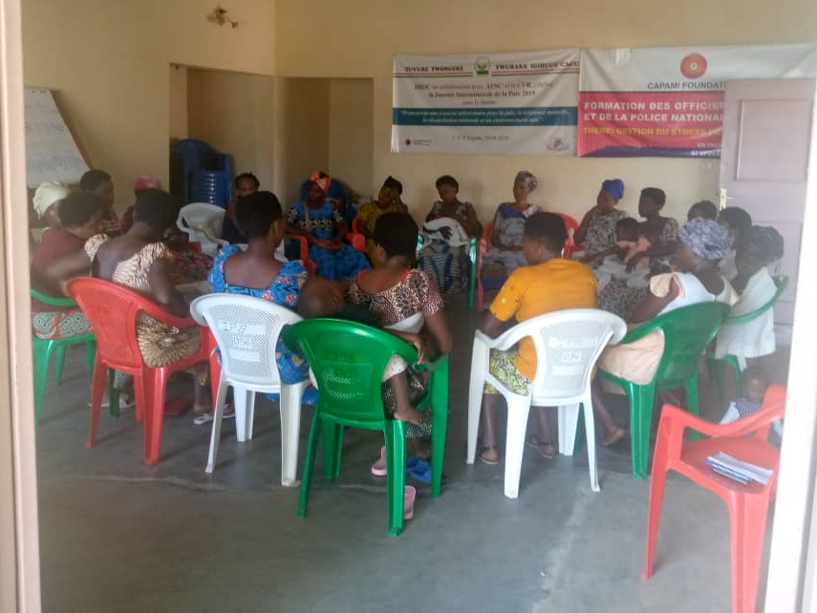
Personal journey of healing: photo by N.Elie

