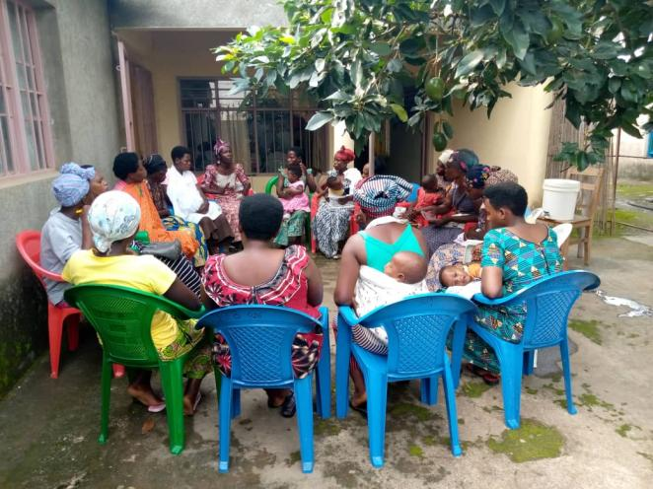
Trauma experiences sharing: Photo by N.Elie

