Report

On November 4, we signed a memorandum of understanding with the Kosovo Olympic Committee for the joint implementation of the campaign “Let’s Add Colors to Our Country”. This event was public through the presence of the main media of the country. On this occasion, we revealed only some of the main details of the campaign, to intrigue the attention of the citizens, to then give the other details at the launch ceremony of the campaign, which was organized on November 24.
On November 24, we organized the campaign launch ceremony in the open air, inviting potential actors and collaborators of the campaign. There were present the ministers of the main relevant ministries of the campaign, deputy ministers, representatives of international organizations in the country which are actively involved in promoting the preservation and protection of the environment (among them, in Kosovo is UNDP which promotes SDGs, and our campaign supports the achievement of these objectives), representatives of local environmental NGOs, Olympic judo champion Majlinda Kelmendi and other athletes, environmental activists, etc. (The ceremony was organized in the open air and all protection measures against COVID-19 were observed! ). The event caught the attention of the entire public and was talked about in the main news of the most followed media in the country.
On the day of the launch of the campaign, on November 24, we also carried out the first action of planting the campaign "Let's Give the Country Color". We planted 18 trees - the number "18" symbolizes "1.8 million". The trees were planted by the guests themselves and each tree holds the names of institutions, NGOs, athletes, environmental activists by whom were planted.
Note: On the following three pages of the document, find attached some photos from the above described events.

Photos during November 4, 2020 - Signing of the memorandum of understanding with the Kosovo Olympic Committee:
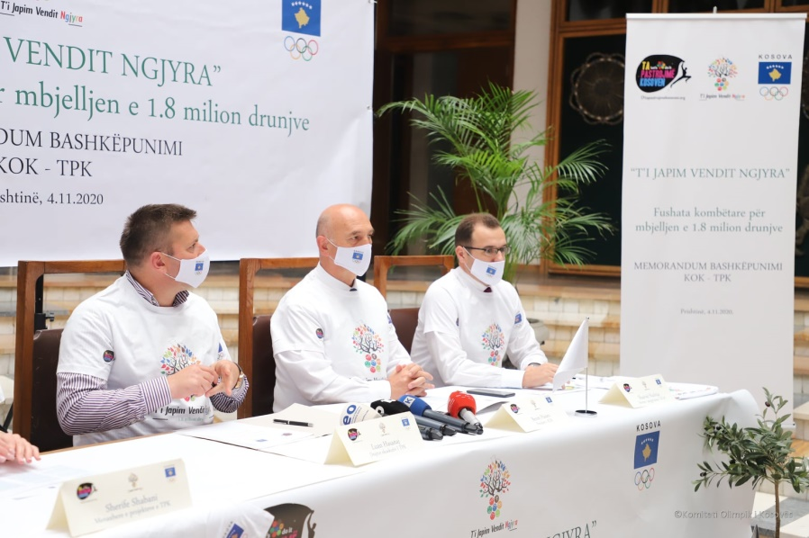
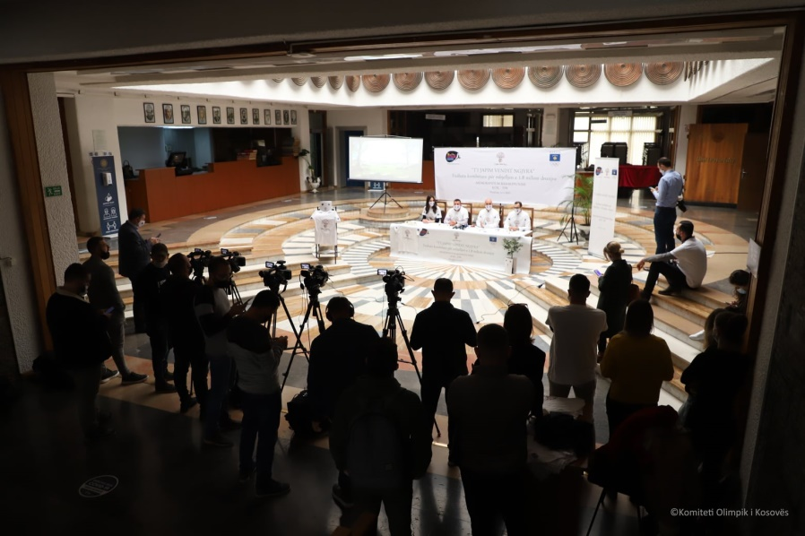

Photos during November 24, 2020 - Campaign launch ceremony and first planting of “Let’s Add Colors to Our Country”:
