THE STREET EDUCATION AND PROTECTION (STEP) PROGRAM:
Addressing the needs of street children through holistic and integrated strategies in Mobile Education, Health and Social Welfare

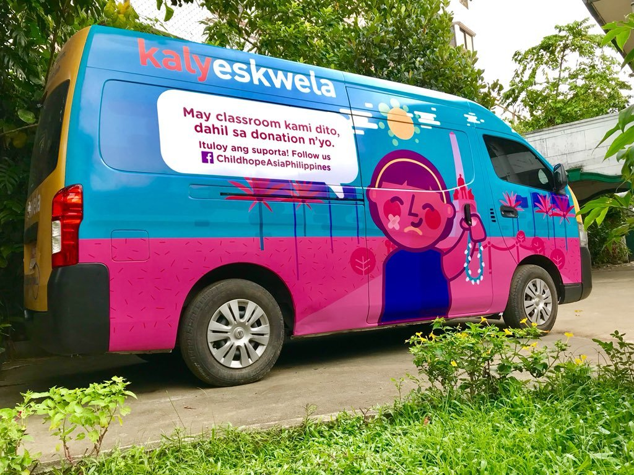
Childhope Philippines Foundation, Inc.
http://childhope.org.ph
igivehope@childhope.org.ph / childhopeasia@yahoo.com

PROJECT PROPOSAL

- GENERAL PROJECT INFORMATION

Project Title: THE STREET EDUCATION AND PROTECTION PROGRAM: addressing the needs of street children through holistic and integrated strategies in Mobile Education, Health and Social Welfare.

Type of Project: Education and Child rights protection
Direct service
Street-based/Community-based

Project Proponent/s: Childhope Philippines Foundation, Inc.
(Formerly Childhope Asia Philippines, Inc.)
1210 Peñafrancia Ext., Paco,
Manila, Philippines 1007
Tel Nos.: (+632) 8563-4647 / 8561-7118
Fax No.: (+632) 8563-2242
E-mail: igivehope@childhope.org.ph
childhopeasia@yahoo.com

Number of Beneficiaries: 100 street children

Project Beneficiaries: Street children and youth

Location of Beneficiaries: Metro Manila

Date of Implementation/Duration: Twelve months (1 year)

Area of Project Implementation: Metro Manila

Total Budget: Php2,712,355.50

- BACKGROUND/SITUATION ANALYSIS

In a 2014 study conducted by UNICEF and the Philippine Institute for Development Studies (PIDS), 44% or about 12.8 million Filipino children under the age of 15 are impoverished. The study presents that these children suffer from multiple dimensions of poverty, particularly deprivations in health and education, food and shelter, to name a few. In the said study, about 550,000 children in Metro Manila live in poverty, forcing them to help earn for their families or fend for themselves on the streets, exposing them to different hazards, making them prone to abuse and vulnerable to illnesses. What makes matters worse is that public assistance for street children is limited and inadequate.

In the 2013 Functional Literacy, Education and Mass Media Survey (FLEMMS) conducted by the Philippine Statistics Authority, one in every ten or about 4 million Filipino children and youth were out-of-school. In the National Capital Region alone, out-of-school children and youth are at about 10.3 percent. This study also showed that 19.2 percent cited insufficient family income to send a child to school as the reason for not attending school. Street children come from among these populations of children who are out-of-school.

This already dire situation of street children in urban areas is exacerbated by the effects on education brought about by this Covid19 pandemic. Although the national Department of Education (DepEd) along with the Department of Social Welfare and Development (DSWD) has been trying to make ways for education to continue despite the odds, the disparities in access to the different learning platforms are more glaring. While those in the upper margins of society have access to technologies that aid in better learning—internet, mobile gadgets, laptop/desktop computers—there are these children in the outskirts of society that have limited to no access to these at all. With the new normal in education gearing towards online learning, the right to education of these vulnerable groups of children should be upheld now more than ever.

Moreover, as we shift towards new learning platforms and new education practices, they are bound to encounter greater challenges, not only intellectually but also in emotional and mental aspects. That is why it is very important to provide psychosocial support for them through constant motivation and counselling. In addition, health is of primary importance and good health is one of the keys to be able to pursue learning, especially amidst the health crisis we are all experiencing.

The challenges are great—investing time, energy, and resources necessary for these children to achieve their full potential. However, the long-term benefits which ultimately aims social reintegration through giving them opportunities to change their lives and break the cycle of poverty via greater access to opportunities for education, basic social welfare services and counselling, health and medical services and skills development activities, far outweigh the costs incurred to implement this project. From a broader perspective, the realization of these children’s human potential should be viewed both as an investment in the nation’s future and a vision that future generations of Filipino children will never have to suffer the hardships of life on the street.
- PROGRAM GOALS, OBJECTIVES AND STRATEGIES
(with the corresponding UN Sustainable Development Goals, and Philippine Development Plan 2017 – 2022)

UN Sustainable Development Goals | Philippine Development Plan  2017 - 2022 | STEP Program  GOALS | STEP Program  OBJECTIVES | STEP Program  STRATEGIES
Goal 2: End hunger, achieve food security and improved nutrition and promote sustainable agriculture  Goal 3: Ensure healthy lives and promote well-being for all at all ages  Goal 4. Ensure inclusive and quality education for all and promote life-long learning  Goal 8: Promote sustained, inclusive and sustainable economic growth, full and productive employment and decent work for all | Pillar 3. Inequality-reducing Transformation (“Pagbabago”)  - Target Outcome: Accelerating human capital development  - Objective: To achieve quality accessible, relevant, and liberating basic education for all  - Objective: To guarantee care at all life stages  - Objective: To improve the quality of higher and technical education and research for equity and global competitiveness  - Objective: To improve employability | Social integration through restoration of social function | - To enable better access to different education opportunities  - To facilitate better access to primary health care initiatives  - To address the needs for psychosocial interventions  - To develop positive behavior through skills development opportunities | - Provision for free access to learning technologies like the internet, mobile tablets, laptop computers  - Provision of assistance in learning through tutorials and guided learning  - Alternative education sessions including child rights, health, gender and values formation  - Basic Literacy and Numeracy (BLAN) classes for younger children  - Non-formal education through Alternative Learning System  - Psychosocial intervention services including case management, counselling, referrals and assistance to clients and their families  - Provision for educational assistance for formal and non-formal education among beneficiaries of the program  - Skills development activities in sports, music and the arts  - Primary health care services through a mobile health clinic, including health status monitoring, diagnosis and treatment, as well as provision of medicines and referral services  - Vocational-Technical Skills Training Project for older children and out-of-school youth
UN Sustainable Development Goals | Philippine Development Plan  2017 - 2022 | STEP Program  GOALS | STEP Program  OBJECTIVES | STEP Program  STRATEGIES
Goal 1: End poverty in all its forms everywhere  Goal 10: Reduce inequality within and among countries | Pillar 3. Inequality-reducing Transformation (“Pagbabago”)  - Target Outcome: Reducing vulnerability of individuals and families  - Objective: To mitigate risks faced by vulnerable groups | Promotion and protection of children’s rights | - To promote the advancement of children’s rights to different stakeholders  - To foster leadership and empowerment among street children | - Advocacy and networking activities, coordination meetings and stakeholder orientation on children’s rights as well as awareness-raising for children’s programs and services  - Organization and leadership development projects for beneficiaries with potential like the Junior Health Workers and Junior Child Rights Advocates Projects

- DESIRED OUTCOME AND IMPACT OF THE PROJECT

The main objective of this program is to enable the street children to claim their rights, enhance their well-being, provide them opportunities for a better future and to better integrate themselves into society. It particularly focuses on claiming and protecting these children’s rights, protection from the different forms of abuse on and off the street, inclusion in terms of basic social services such as basic education, health and medical services, psychosocial services, paralegal assistance, skills development, sports and recreation, among others, and participation in activities that will ensure their growth and development. To achieve this, Childhope will conduct the following activities:
- KalyEskwela Mobile Learning Hub area visits, which will bring to the community where these children live or stay, equipment that will enable them to access the internet like free wifi, use of mobile tablets and laptop computers. The KalyEskwela van is also equipped with printers for them to print out modules or research materials that will help them to comply with learning tasks given by their schools. In addition, the van will carry school supplies and reference materials for use by the learners to aid their studies.
- Sessions on Alternative Education composed of life skills-based modules which are important but not normally taught in school, particularly those that are important in these most trying times: (1) Primary Health Care, (2) Disaster preparedness and Environmental Health, (3) Values Education, (4) Life Skills and Life Goal Planning, (5) Online safety against abuse, and (6) Basic Literacy and Numeracy sessions.
- Psychosocial interventions which include counselling, case management, and referral to appropriate agencies for rehabilitation and continuing assistance, among others. These sessions aim to help the children reflect on their current situation, realize the risks of staying/living on the street and eventually motivate them to leave the streets and be referred to a recovery center or be reunited with their families/relatives when feasible, and develop their life goals.
- Health and medical services facilitated by the Mobile Health Clinic (MHC)/MHC doctor or by referring them to public health centers/hospitals, which include medical/dental consultation and check-ups, assistance for hospitalization, laboratory tests, and provision of medicines, which aim to improve the health and medical condition of the street children participants, especially since they have been exposed to different harmful elements on the street aside from the threat of Covid19.
- Facilitation of skills development and recreation (such as singing, dancing, playing musical instruments, acting, sports, etc.) to be facilitated by volunteers or partner institutions which will help them to further improve their talents and/or enable them to learn new skills necessary to help them relate more effectively with others. These activities will also enable them to develop their self-confidence and self-esteem and engage in more productive activities instead of engaging themselves in illegal/negative habitual behaviour.
- Advocacy and networking among the different sectors of the society about the plight and rights of the street children and the roles that they play to ensure the protection of these rights. This will enable them to understand the situation of the street children and hopefully will encourage them to show positive attitudes towards the street children.

COMPONENT | DESIRED OUTCOME
KalyEskwela Mobile Learning Hub area visits | - Street children gain access to technologies that will aid them in achieving assigned school tasks towards learning  - Street children are able to access different education opportunities and pursue learning and finishing their studies
Alternative Education Sessions | - Street children gain awareness and understanding on their rights and responsibilities  - Street children are able to develop life goals and are motivated to pursue lives away from the streets  - Street children are able to access different education opportunities and pursue learning and finishing their studies
Psychosocial interventions / counseling and referrals | - Street children are able to express themselves and are able to deal with problems they face with a more positive outlook  - Street children are able to deal with specific issues of behavior and abuse in violation of child rights
Medical / Health Services | - Street children gain access to basic medical needs, develop health habits and practice proper hygiene, and improve their health status
Skills Development Activities | - Street children actively participate in training / activities to develop their skills and boost their self-esteem and self-worth.
Advocacy and Networking | - Different stakeholders understand the situation of the street children and are encouraged to show positive attitudes towards the street children

- RISK MANAGEMENT PLAN

Risks | Mitigating Factors | Outcome
Inclement weather | - Identification of alternative venues for conducting classes/sessions in case of heavy rains and floods  - Building partnerships with different establishments in the areas of operation like barangay, church, schools, food establishments | - Sessions/classes can still push through despite bad weather conditions (unless this will put the children and the staff at risk)
High mobility of street children participants and their families | - Mapping of areas where the children and their families usually stay or conduct their everyday activities | - Street educators will locate children and encourage them to attend the sessions regularly
Discontinuation of participation in learning sessions | - Continuous counselling and motivation by social workers for the children participants as well as for their parents/guardians | - Adherence to scheduled classes and commitment of participants and their guardians/parents to let them participate in the sessions as these are deemed important for their future welfare and survival
Rescue/Round-up Operations by the local and national government | - Proper and timely coordination of street educators with residential care facilities where rescued street children are placed  - Advocacy and coordination meetings with local government units with jurisdiction in the project’s areas of operation | - Immediate release of participants/ beneficiaries to their guardians to be able to continue attending learning sessions  - Recognition and protection of children’s rights to education by local government units
Disasters (such as earthquakes, floods, armed conflict) | - Training of street children on disaster risk reduction and management, and specifically to know where to access social welfare services in times of disasters | - Street children can access services from other sources during times of disaster, especially when street educators cannot reach them
 | - Proper and timely coordination of street educators with camps (evacuation centers) where street children may possibly be sheltered | - Continuation of learning sessions while within the camp

- ORGANIZATION AND STAFFING

Office/Staff Designated | Responsibilities | Quantity | Contact Person and Details
Street educator-Alternative Education Teacher  (SE-Alt Ed Teacher) | - Conduct learning sessions among children beneficiaries  - Track progress and maintain records of participants related to education | 1 SE-Alt Ed teacher per area
Street educator-Social Worker  (SE-Social worker) | - Provide counselling, motivation and assistance to children participants  - Case management for children needing intensive interventions | 1 SE-Social worker per area
Program Supervisor | - Over-all in charge of providing direction and task instructions to street educators/social workers  - Keeps records and provide reports for project/program evaluation by management and donors  - Develops operating plan and budget for the program/project, in consultation with other team members | 1 supervisor for 4 teams

- PROJECT WORK PLAN
(see Appendix: Gantt Chart)

PHASES | ACTIVITIES | INDICATORS | OUTPUT / TARGET | PERSON/S IN CHARGE | RESOURCES NEEDED
Phase 1. Planning
- Annual and logistics preparations | - Program Planning |  | - Annual Work and Financial Plan  - Annual Schedule of Activities | - Program supervisor  - Program staff | - Manpower  - Budget  - Venue  - Supplies
Phase 2. Implementation
- Throughout the entire year  - Tuesdays to Saturdays as scheduled | - KalyEskwela van area visits  - Alternative education sessions  - Psychosocial intervention services (monitoring visits, counselling, referrals, assistance, etc.)  - Health and medical services (monitoring, diagnosis, treatment, referrals)  - Skills development activities (sports, music, arts, outreach)  - Advocacy and network meetings | See Appendix: Program Key Performance Indicators | See Appendix: Program Key Performance Indicators | - Program supervisor  - Program staff | - Manpower  - Budget  - Venue  - Supplies  - Partners/ stakeholders
Phase 3. Monitoring and Evaluation
- Quarterly  - Annual | - Reportorial Requirements  - Program Monitoring and Evaluation | - Quarterly and Annual reports (as agreed)  - Annual evaluation with project staff | - Submission of all pertinent reports  - Annual targets accomplished | - Executive Director  - Assistant Executive Director  - Program Supervisor  - Program staff | - Manpower  - Budget  - Venue  - Supplies

- PARTNERSHIP BENEFITS

Upon approval of the proposal, a Memorandum of Agreement will be signed by both parties (Childhope and partner/grant donor). Among the stipulations of the agreement are the following partnership benefits:

  - Childhope Philippines offer various engagement and volunteering opportunities for employees of the partner organization These activities boost the children’s self-esteem and motivate them to build self-confidence in interacting with different people, while these activities with our beneficiaries also provide meaningful engagement to volunteers.
  - Childhope Philippines is registered, licensed and accredited by the Department of Social Welfare and Development (DSWD), the government agency in-charge of monitoring social welfare programs and services conducted by non-government organizations. This means that grant donations given to Childhope Philippines are ensured of reaching the intended beneficiaries, and that our programs and services are at par with the standards set by the department.
  - Childhope Philippines is accredited by the Philippine Council for NGO Certification (PCNC) and is recognized by the Bureau of Internal Revenue as a Donee Institution. All donations to Childhope are tax-exempt.
  - Partners will be acknowledged in social media releases, in the website news and updates and in the e-newsletter which goes out to more than 1,000 individual and corporate followers and contacts, both local and international.

- DETAILED BUDGET REQUIREMENTS
(see Appendix: Budgetary Requirements)

APPENDIX 1. GANTT CHART

Activities | Sep | Oct | Nov | Jan | Feb | Mar | Apr | May | Jun | Jul | Aug | Sep
Phase 1. Project Planning
Annual
Phase 2. Project Implementation
KalyEskwela Mobile Learning Hub area visits
Alternative education sessions
Psychosocial interventions: monitoring visits, counselling, assistance, referrals, etc.
Health and medical services: monitoring, diagnostics, treatment, referrals
Skills development activities
Advocacy and networking activities
Phase 3. Project Monitoring and Evaluation
Quarterly Monitoring
Annual Evaluation

APPENDIX 2. PROGRAM KEY PERFORMANCE INDICATORS

EDUCATION
      - Street children are able to gain access and participate in different education opportunities
        - Number of children who are able to access technology that aids in learning
        - Number of children who participated in alternative education sessions
      - Street children participants have improved literacy level
        - Number of learners assisted who are able to move up the next level of education

PSYCHOSOCIAL INTERVENTIONS
            - Street children have realized the importance of continued learning even while connected to the streets
              - Number of street children given regular counselling and motivation sessions
            - Street children have developed positive behavior among their peers and others
              - Number of children who demonstrated positive behavior in learning and social interaction
            - Street children have improved access to social welfare services
              - Number of children who were given relief and material assistance

HEALTH AND MEDICAL SERVICES
- Street children have better access to primary health care services and improved health status
  - Number of beneficiaries provided with health services
  - Number of consultations and health services provided

SKILLS DEVELOPMENT
- Street children participants assisted to develop a sense of self-confidence and self-esteem
  - Number of street children who have participated in skills development sessions

ADVOCACY AND NETWORKING
- Number of volunteers protecting children’s rights has increased.
  - Number of volunteers from among the stakeholders and other sectors promoting children’s rights
- Stakeholders in the community are promoting and protecting children’s rights.
  - Number of advocacy meetings with different stakeholders to promote cooperation for children’s rights

APPENDIX 3. BUDGETARY REQUIREMENTS

STEP Program Budget for One (1) Year for 100 street children beneficiaries

ITEM/S | DESCRIPTION | AMOUNT
PART I. DIRECT PROJECT COSTS
1. Equipment
1.1. Laptop computers | 2 units x Php40,000/unit | 80,000.00
1.2. Printer/scanner with refillable ink system | 2 units x Php15,000/unit | 30,000.00
1.3. Mobile tablets | 20 units x Php10,000/unit | 200,000.00
1.4. Extension cord | 1 unit x Php1,500/unit | 1,500.00
1.5. Voltage regulator | 2 units x Php2,000/unit | 4,000.00
1.6. LAN cable for laptops | 2 units x Php500/unit | 1,000.00
2. Materials and supplies
2.1. School supplies | Php10,000/month x 12 months | 120,000.00
2.2. Printer ink | Php3,000/month x 12 months | 36,000.00
3. Furnitures and fixtures
3.1. Folding tables | 2 units x Php3,000/pc | 6,000.00
3.2. Storage boxes | 4 boxes x Php650/box | 2,600.00
3.3. Folding chairs | 20 pcs x Php400/pc | 8,000.00
3.4. Folding tents | 2 units x Php6,000/unit | 12,000.00
4. Internet connection
4.1. LTE wifi with 2-year subscription | 1 unit x Php3,500/month x 24 months | 84,000.00
5. Alternative Education sessions
5.1. Materials and supplies | Php200/child x 100 children | 20,000.00
5.2. Mobile Load credits for online sessions | Php60/session per child x 25 sessions x 100 children | 150,000.00
6. Psychosocial Interventions
6.1. Counselling and motivation sessions, including home visits and school coordination | Php1,000/child x 100 children | 100,000.00
6.2. Relief and material assistance | Php1,000/child x 100 children | 100,000.00
7. Health and Medical services
7.1. Provision of medicines, hygiene kits, multivitamins supplements, laboratory tests, doctor's fees | Php3,500/child per year x 100 children | 350,000.00
8. Van expenses
8.1. Fuel | Php12,000/month x 12 months | 144,000.00
8.2. Maintenance and repairs | Php25,000/year | 25,000.00
8.3. Insurance and registration fees | Php25,000/year | 25,000.00
9. Human Resources/Manpower
9.1. Street educator | Basic Salary of Php21,000/mo.
9.1.1. Salaries and benefits | Php309,180/year | 309,180.00
9.1.2. Health insurance | Php12,000/year | 12,000.00
9.2. Social worker | Basic Salary of Php21,000/mo.
9.2.1. Salaries and benefits | Php309,180/year | 309,180.00
9.2.2. Health insurance | Php12,000/year | 12,000.00
9.3. Driver | Basic Salary of Php13,500/mo.
9.3.1. Salaries and benefits | Php205,110/year | 205,110.00
9.3.2. Health insurance | Php12,000/year | 12,000.00
Subtotal for Direct Project Costs |  | 2,358,570.00
PART II. SHARED SERVICE COSTS
1. Administrative and Operating expenses | 15% of total project costs | 353,785.50
Subtotal for Shared Service Costs |  | 353,785.50
GRAND TOTAL | Direct Project + Shared Service Costs | 2,712,355.50

