About Us
Bearfoot Ranch is a comprehensive equestrian center dedicated to providing riding activities for everyone in a safe, effective and compassionate environment. The center furthers our students’ knowledge of horses and horsemanship; offers riding lessons to children; provides therapeutic riding sessions to adults and children with special needs regardless of ability; and challenges them to reach their potential through the love of horses.
Bearfoot Ranch also acts as a rescue facility for horses that have been abused or neglected. After rehabilitation, we place the horses in forever homes, giving these animals a second chance at a new life.

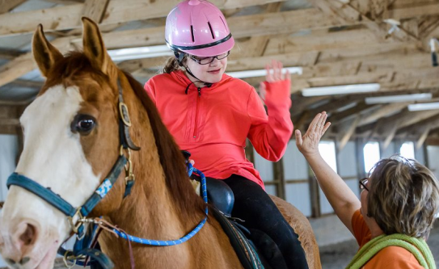

We’re Growing
We have recently moved our facilities and with this additional space, we will be able to provide more therapy sessions and aid in the rescue of more horses in need. Volunteers are needed to continue to make our new location a success at 12976 Cumming Hwy. Canton, GA 30115

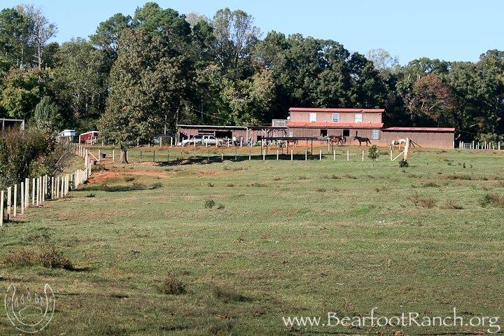

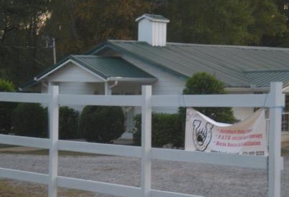

Our History
Bearfoot Ranch was established in 1997 by Darrith Russell, Melanie Vaughan, and Edie Ahola with a combination of over 75 years of experience.

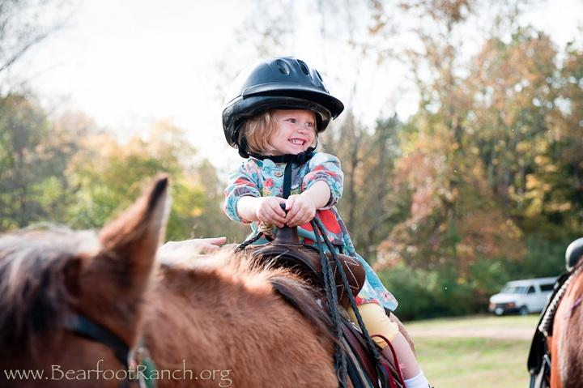

After serving as a host farm to a therapy group, we were inspired to work on our own certification. Edie Ahola became a PATH (Professional Association of Therapeutic Horsemanship) certified instructor. PATH promotes equine assisted activities and therapies for people with special needs. Bearfoot Ranch services are available to children and all people with special needs, regardless of ability.

As a horse rescue facility, Bearfoot Ranch has worked closely with local authorities to help rehabilitate horses that have been abused or neglected.

Benefits to Volunteering
We will never turn down volunteers. Volunteering can be hard work and big fun! We offer free or low cost training (groundwork and riding) to volunteers who serve on a consistent basis! The goal though, is not to just have folks come out solely to ride. We are still looking for individuals with spirit & a desire to learn true horsemanship thru the care of the animals. We are looking for volunteers who have empathy for the horses.

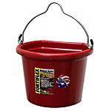

Other Ways You Can Help
If you are not interested in grooming/feeding, cleaning stalls, building & repairing fences, or helping with therapy sessions, then a tax deductible monetary donation is welcome. Your donation can sponsor a rescue or therapy horse, give a riding lesson to a child in need, or just buy a roll of hay. Any help, no matter how big or small, is greatly appreciated.

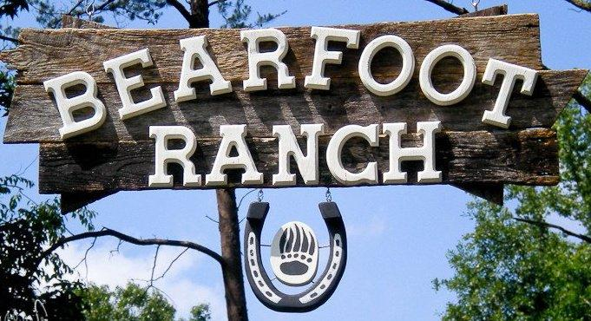

For more information about our services, sessions, or rescue program, see our

website at:
(Donations can also be made via PayPal on our website.)
(678) 805-7433

Bearfoot Ranch

Bearfoot Ranch
12976 Cumming Hwy
Canton, GA 30115

678-805-RIDE

Our Mission
- Therapeutic Riding for Special Needs Children/Adults
- Horse Rescue
- Riding/Horsemanship Education to Everyone
“...helping people meet their potential through the love of horses...”

