**Strengthening Authorities for accountable responding to**

**the needs of Vulnerable Children**

In some remote areas in Cambodia, many children still miss the opportunity for schooling and other development. One of the main reasons behind this is that they don't have a birth certificate to identify their identity. Without this essential official document, there would be a disaster for their whole life living without true identities, could not access any necessary available services according to their right, and were not protected.

So that, helping Orphan and Vulnerable children to have a birth certificate is an essential support in our case management process for getting them away from the possible risks and having their best interest regarding their rights.

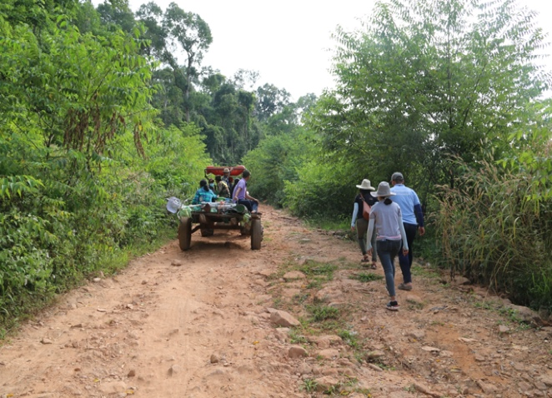

**Road to the village**

Indeed, in Rom Lech village, 2 Crocodile commune, Pusat province, approximately 90 percent of children from 0 to 16 years of age remain without birth certificates. According to the child protection policy, they are already at high risk for their situation without birth certificates. That means they are already losing important services and protection. Our staff has been visiting the area intended to access the reason behind this and witnessed the information given by the local authority that most families are impoverished and located far from the commune center.

After gathering information, we have been working with the Department of childwelfair by gathering relevant authorities in a meeting to identify any possible and practical intervention activities for helping those vulnerable children to get birth certificates.

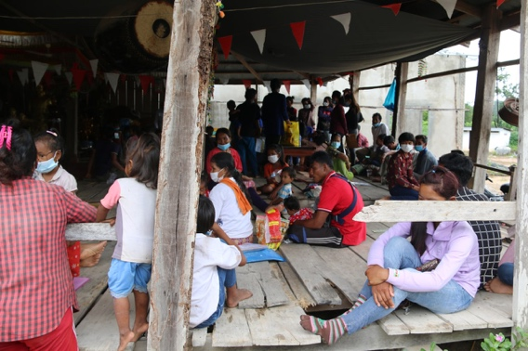

Parents and children are waiting for birth certificate

Many ways have been raised to sort the problem out, but it seems challenging to carry them out with the difficult road and the safety for the children. Finally, the authorities have decided to bring all the relevant materials such as computers, printers, and other stuff to the closest areas to the children's house. It was the surprising and tear of joy to see this going to happen, for it seemed impossible and rarely happened, seeing the commitment of commune officers willing to do such a thing.

As a result, the plan worked very well, and 105 vulnerable children have received their birth certificates within two days from the strong will and commitment of the authorities. During the event, the vulnerable children who are at high risk are also identified and noted for intervention by local authorities. And More than this, the families who brought their kids for birth certificate also were educated from the local authorities about the important of having birth certificate for their children.

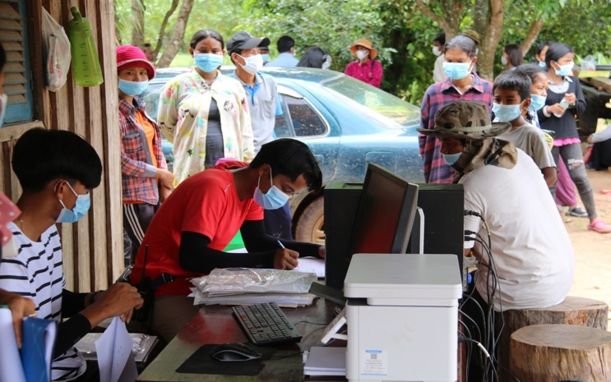

Commune officers are processing birth certificate in mobile office.

As a local NGO who are working for the life changes and better life of Orphan and Vulnerable children, we are so happy to see the changes of behavior and attitude of duty bearers who commit and put themselves in the effective accountability in their job for the protecting the children and their best interest.

**Photos of children received birth certificate:**

