
Patronato, ISMEP
Pina, Recife, Brazil

Funding needed: £5,000 – 30,000 per annum www.abctrust.org.uk
Children of the Bode favela in Pina often suffer from social exclusion and have a low quality of life, with few prospects for the future.

ISMEP’s Praiar programme allows children from all ethnicities to join educational and creative activities.

Funding can help impoverished and socially excluded children find more options in life by choosing education instead of informal labour or crime.

The ABC Trust believes ISMEP can help children learn new skills, gain hope and transform their community.

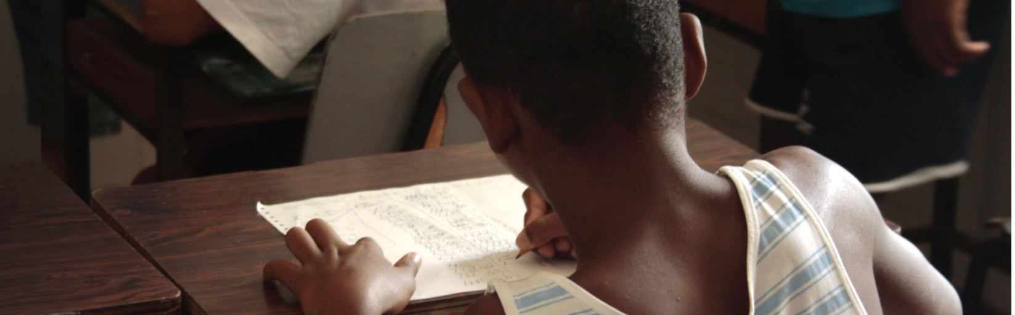

Issue:
Children of the Bode favela in Pina often suffer from social exclusion and have a low quality of life, with few prospects for the future.

The favela, or shanty town, of Bode is located in the Pina region of Recife. With around 72,000 inhabitants, poverty in this region has led to a failing education system and a fractured community life. Levels of domestic violence are high and the elderly are often excluded in community activities.

Due to the poor quality of education, supplementary schooling is needed to keep children engaged. Without access to good quality education, these children have very little chance of developing a sustainable and prosperous future. If young people do not feel engaged, they are more likely to drop out of school at an early age and become involved in crime and/or child labour.

Research has shown that arts and cultural activities together with education are effective in engaging children before they reject wider society. Social and cultural activities such as capoeira dance and percussion are part of the Afro-Brazilian culture, and offer a way to communicate and interact with children who are disillusioned. Also, it allows young people to enjoy their childhood and develop a vision for a positive future, something not felt by those living in the Bode favela.

Response:
ISMEP’s Praiar programme allows children from all ethnicities to join educational and creative activities.

Instituto Social das Medianeiras da Paz (ISMEP) was founded in 1989 and is now an established NGO which contributes to the social integration of children and adolescents of low-income families from the Bode favela in Recife. Their work focuses on supplementing the education system, as well as developing family and community cohesion. ISMEP does this through its three programmes: Projeto Praiar, the Mae Mare Project, and the Convivencia Project.

Projeto Praiar is an educational project for children aged 7-16. The project consists of school workshops with supplementary education, focusing on Portuguese, Maths, History, Capoeira, Arts-education, IT, Sport/Leisure, and Creative arts. These activities promote self-esteem, a love of learning and an awareness of citizenship.

The Mae Mare Project provides professional training courses for 75 young people aged 16-24, many of whom are ex-students of the Projeto Praiar. This project strengthens the work of families who partake in seasonal fishing (for income), cookery and computer science.
The Convivencia Project works with 95 elders, many of whom are grandparents of the children attending Projeto Praiar. This project’s weekly group and recreational activities help increase self-esteem, family involvement and participation in local affairs.

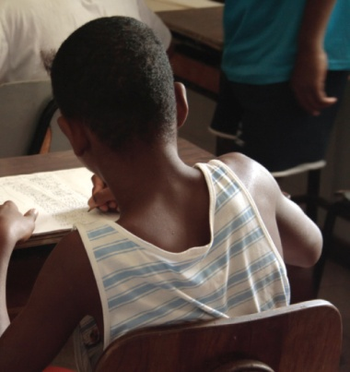
Patronato, ISMEP
Pina, Recife, Brazil

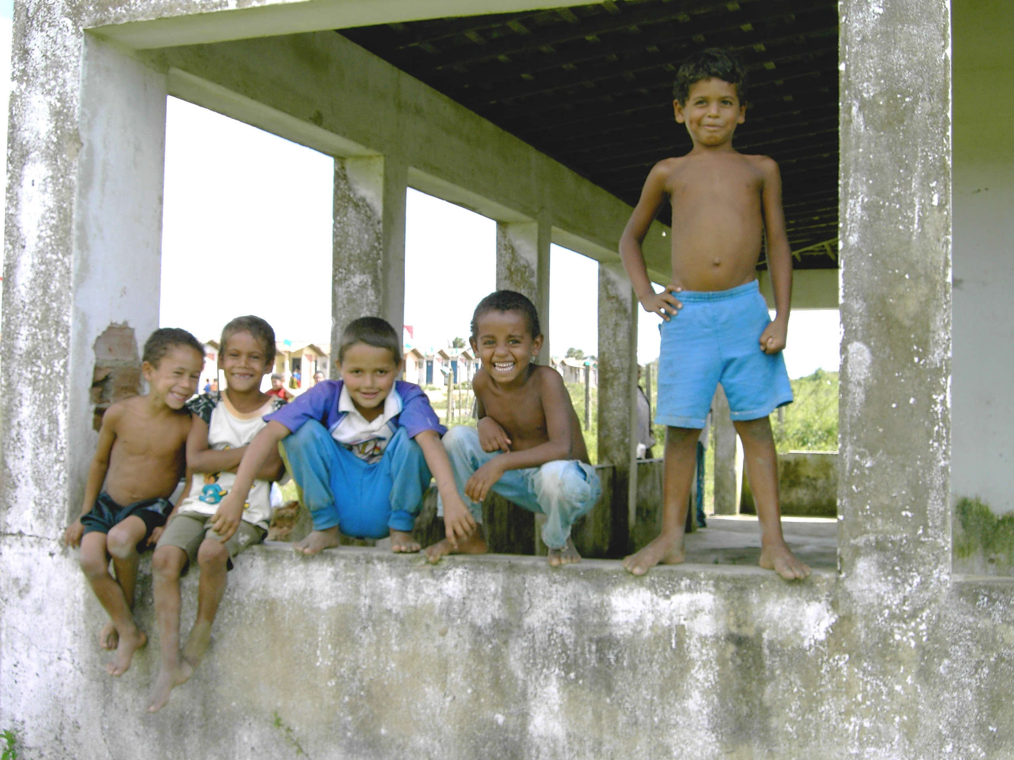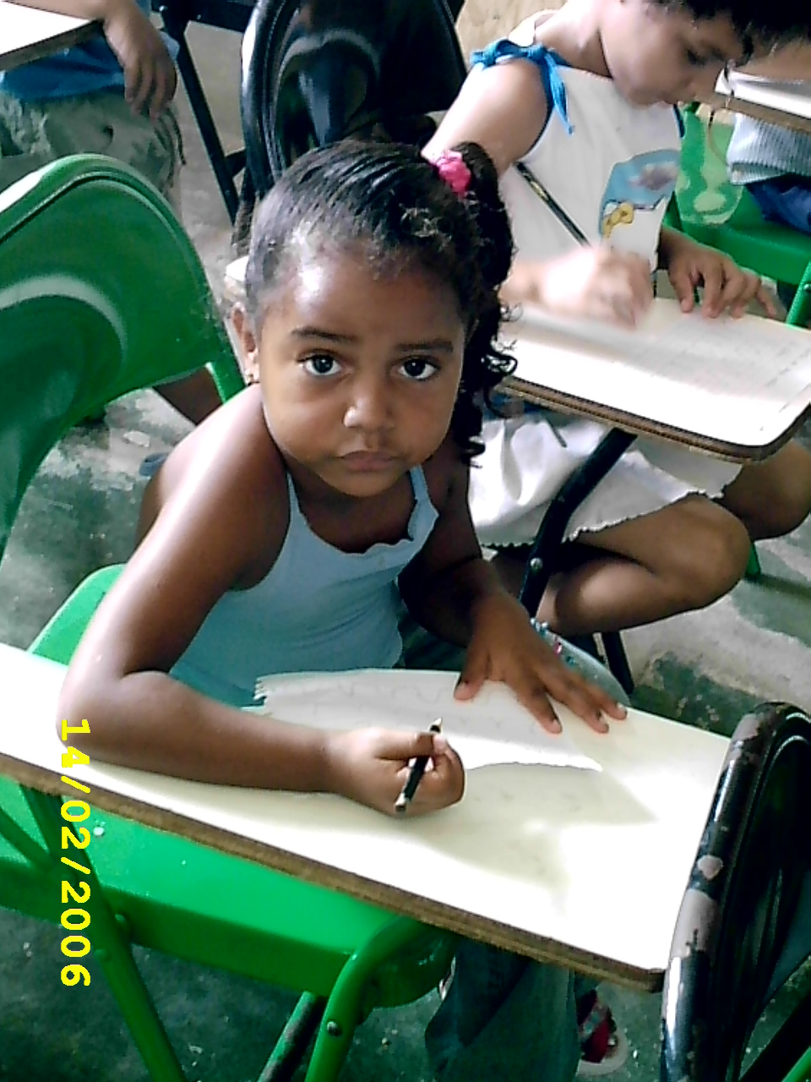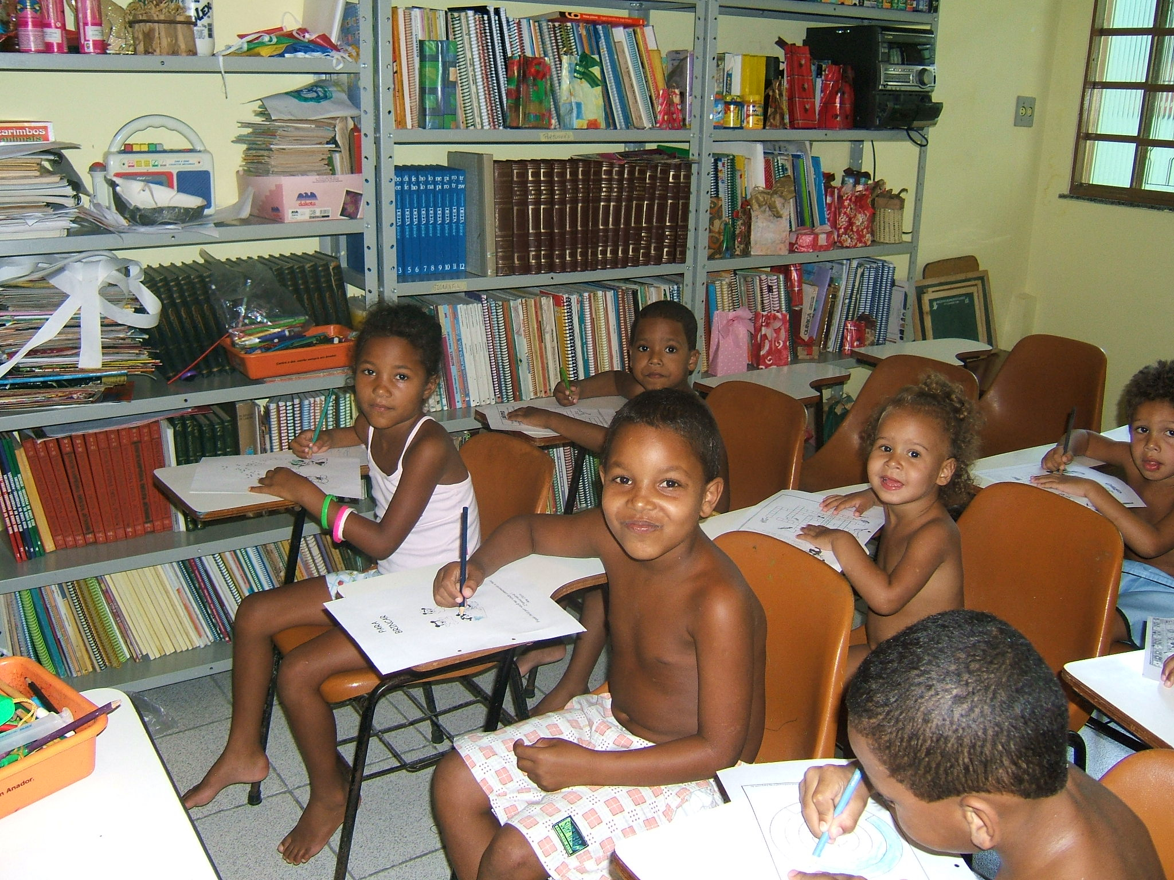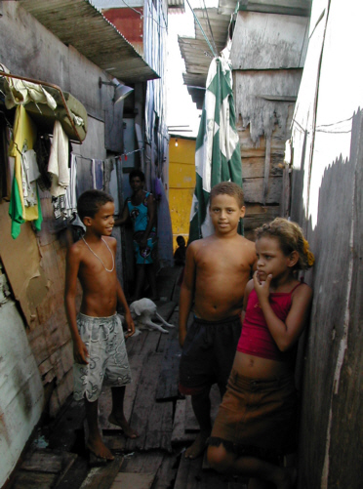
Results:
Funding can give socially excluded and disadvantaged children more options in life by helping them to choose education instead of informal labour or crime.

ISMEP engages children and young people in education and helps them to build positive futures for themselves and their local community.

Through Projeto Praiar, children have developed stronger academic skills, and their confidence and self esteem have grown. 208 children currently attend either the morning or afternoon session of Projeto Praiar and the project organises a monthly meeting for their parents too. Great improvements have already been noted in the children’s general behaviour, as well as in their school results.

The Mae Mare Project enables families to support children in their ambition to learn rather than enter employment as minors. Through the project, parents have also found more regular work in the hospitality industry. The project directly benefits 100 mothers and their 400 children living in the Bode favela and indirectly improves the lives of another 400 families living in extreme poverty. In 2006, 370 adults took courses that led to employment in hospitality and tourism.

Through the Convivencia Project, the elderly generation has become more integrated within the community. ISMEP strengthens social relationships within the community on all levels.

Feedback from the project’s participants has been very positive with reports of a large decrease in domestic violence, a more balanced nutrition for young children and skills training for adults to enter the job market better prepared. With quality education and a safe place to play, fewer children remain vulnerable to the appeal of crime and the drug trade. ISMEP’s holistic approach has had a significant and positive effect on the people from the Bode favela.

Recommendation:
The ABC Trust believes ISMEP can help children learn new skills, gain hope and transform their community.

ISMEP uses a holistic approach to improve the lives of the people who live in the Bode community through education and cultural awareness. Over the past 30 years, it has continued to produce impressive results. A deep commitment from the staff, volunteers and local community has ensured that activities remain ongoing and that this project integrates the community on all levels. ISMEP was awarded the UNICEF regional prize for work with children and has proven itself in developing a strong strategic response to symptoms of life in the favela.

ISMEP aims to expand its work to reach more children and families. In 2007, a percentage of its funding came from the local government programme for the eradication of child labour (PETI). The staff at ISMEP are continually seeking funding from a variety of donors each year. However, because they pay their educators fair wages and pay their taxes, the project overall requires a large amount of funding.

There is a waiting list for children and without this project, they will drop out of school and start to find other ways to work and raise money. Therefore, to reach the lives of a wider range of children, ISMEP must expand to encourage children to complete their education.

By employing qualified teachers, skilled academic staff and volunteers, ISMEP is able to maintain the high quality of this project, without which the impact of their work would not be long term.

The ABC Trust finds it essential that ISMEP continues to create long lasting change and encourage children, adolescents and their families to transform their lives.

