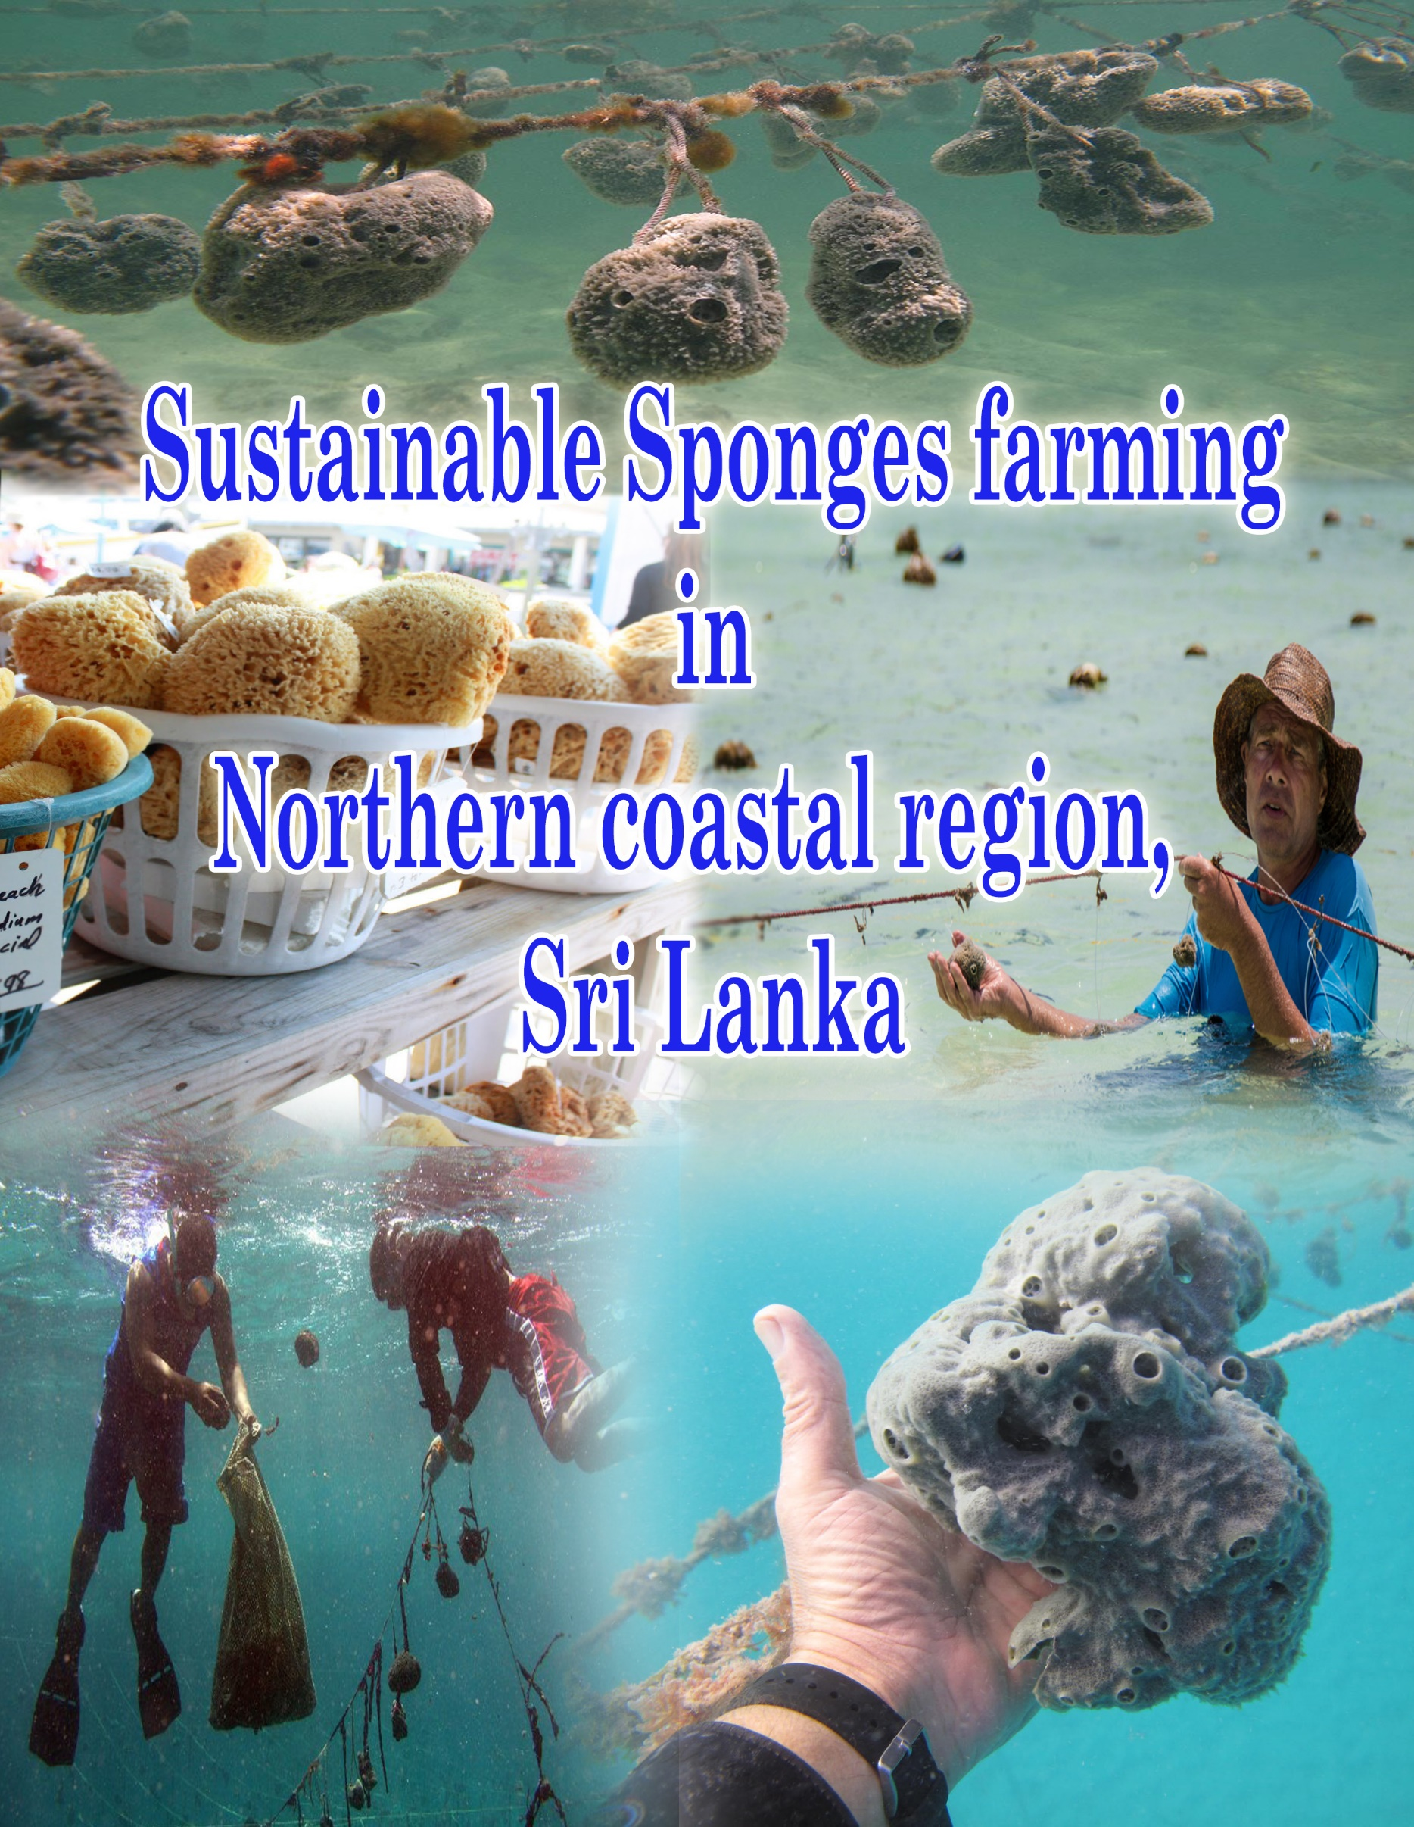
Contents
01. Introduction 1
02. Objectives 2
03. Site selection 3
04. Methodology 5
4.1 Collection 5
4.2 Transportation 5
4.3 Setting up the farm 6
4.4 Cutting, Stringing and Planting 7
4.5 Harvesting 7
4.6 Processing and Packaging 8
4.6.1 Drying 8
4.6.2 Wash in the ocean 8
4.6.3 Drying & Cleaning 8
4.6.4 Washing out 9
05. Conclusion 10
5.1 Benefits of growing sponges 10
5.1.1 It easy to culture 10
5.1.2 Profitable and Sustainable farm 10

Sponges farming in Northern coastal region in Sri Lanka

Introduction
Natural sponges are harvested from many different locations in the world.Due to overharvest and disease, wild sponge stocks worldwide are in decline. Farming sponges is a solution to overcome the market demand. Sponges have been commercially cultivated in many countries worldwide. But Sponge farming is a very new field to Sri Lanka. So we are go into initiate a pilot project at Northern coastal region in Sri Lanka.
Sponges are living animals whose cells are loosely arranged about a soft fibrous and glass skeleton.Sponges provide homes for many other animals, plants, and microorganisms. Most sponges are sedentary, and live attached to coral heads, rocks, logs, or shells.Sponge species differ from each other in overall size, shape, and colour. Some of sponge species products used for bath and beauty; painting; medical; and industrial applications.
Sri Lanka is a biodiversity hotspot, because of that reason so many different sponge species can be observed around the Sri Lankan coastal water.

Objectives

To initiate the sustainable ocean sponges farming in Sri Lanka.
To promote marine aquaculture in the Northern coastal area.
To increase the income of the rural people
To create more employment opportunities
To decrease the fishery activities

Site selection

Northern coast is selected to this project and the reason for this selection is mainly due to high diversity of the natural sponges. Specially in Allaipiddy coastal site, different abundant sponge’s species were observed. Allaipiddy coastal site is a shallow water area with high amount of sea grass patches which could be used as a natural attachment for the growth of sponges. Calm tides and 15 feet of maximum depth are good to achieve optimum growth in sponge and these requirements easily fulfill in the Allaipiddy area.
As the Allaipiddy area are not disturbed frequently by the anthropogenic activities for any purposes it could be used as one of the best site for the sponge farming.
In addition, the other necessary factors that could help in the un interrupted farming activities of sponges such as electricity, transportation are easy to access from the selected location which helps us to further adhere the site to achieve a best result.

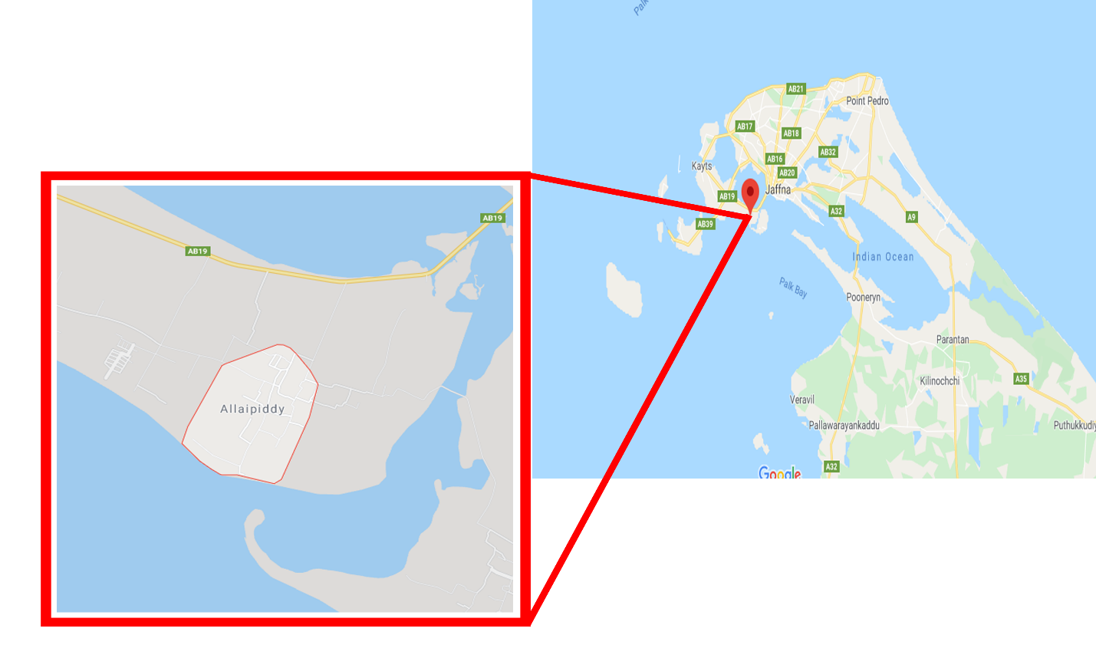
Figure 1 Allaipiddy Area
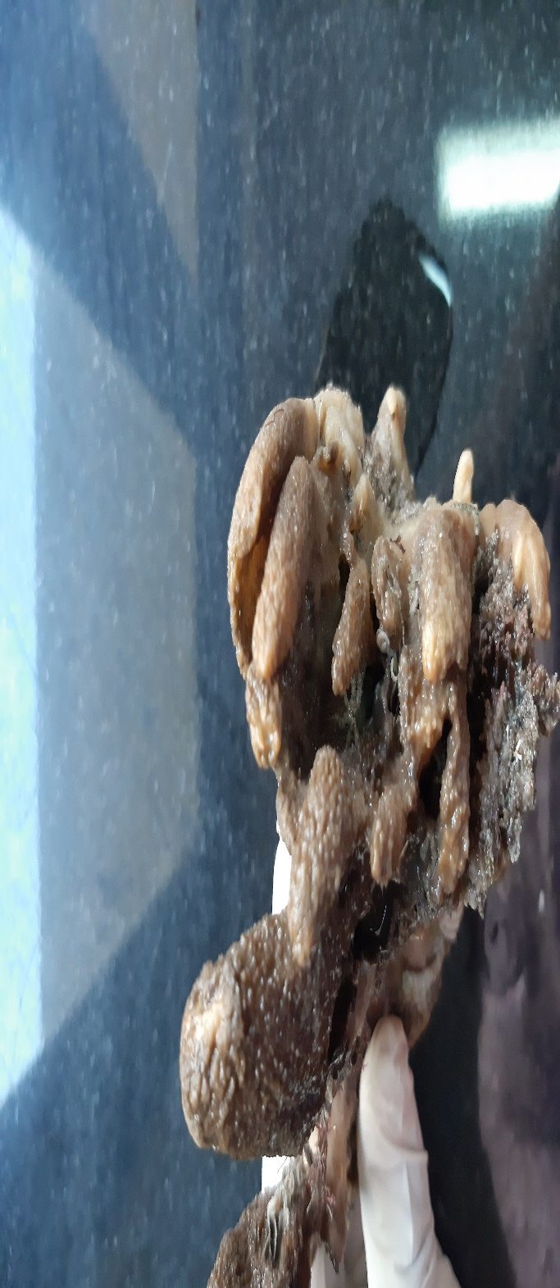
Unidentified sponges species collected from Allaipiddy area

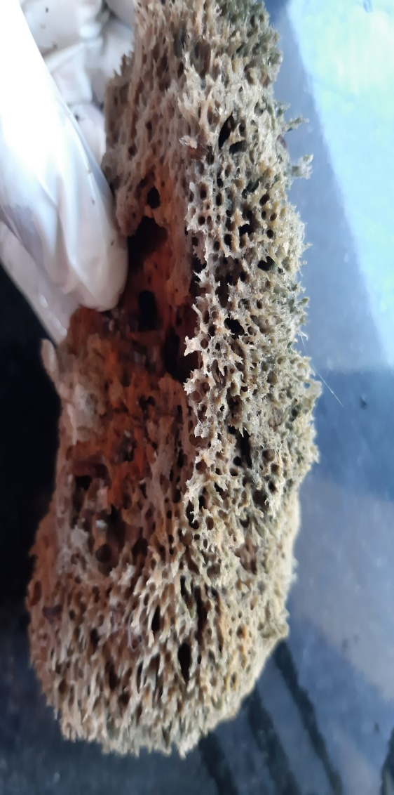

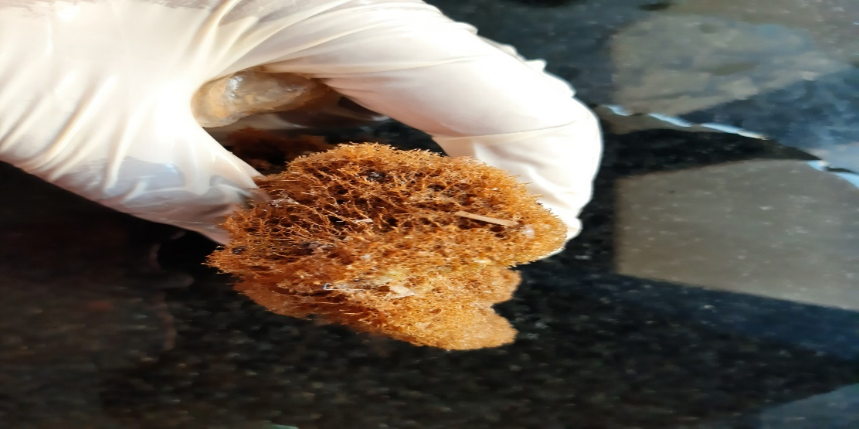

Methodology

Collection
The sponges needed for the farming had been planned to collect in wild of the Allaipidy region as it is abundant with those species.The species needed for the purpose will be collected by hand picking with the help of professional divers using knife and sharpening stones to avoid damages during collection.
The 1/3 part of the sponges will be cut off for the farming to ensure that remaining part will lead to the re growth of parent plant. And always use a sharp knife
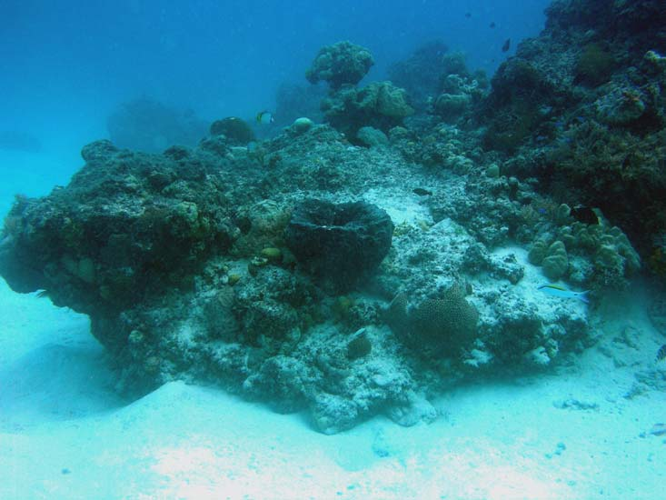
Figure 2 Wild collection

Transportation
Collected sponges from wild will be transported to the selected site for the plantation.Sponges are very simple animals and cannot stop pumping water through their bodies when they are collected. For this reason, it is important that all the sponge must be covered with the water or else they will take in air and die.Therefore,sponges should be moved as quickly as possible between the collection and farm site. And also collected different sponge species shouldn’t store in one container because they may kill each other.

Setting up the farm
In the selected region as there are very less amount of coral were observed it is not possible to tie up them in the coral heads. So it had been planned to construct a floating farm on the water. For construct the farm we need to use cement blocks as an anchors, buoys and ropes.
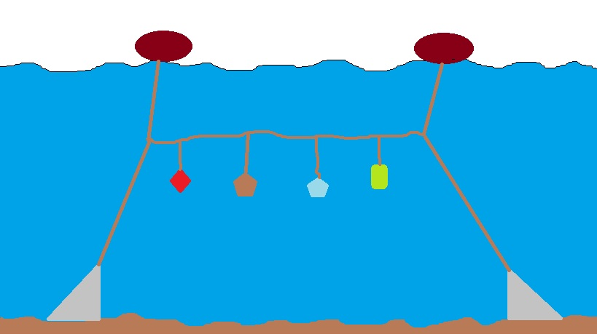
sponge
rope
Cement block
Buoys
Figure 3 Side view of the farm

Cutting, Stringing and Planting
The collected sponges will be cut inside the water by the divers then held together by stinging and then it will be hanged in the constructed frame.fishing lines are used to attached the sponge to the main line,because the fishing line is stiff enough to make a hole in sponges and sediments don’t attach.
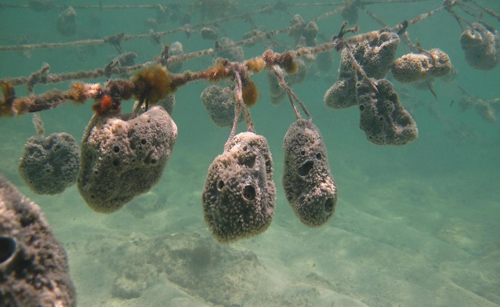

Figure 4 Sponges planting

Harvesting
According to the reference sponges may take 1 ½ years to reach harvest size. Some time it will more than expect but also some time it may show rapid growth. Because in Sri Lanka we don’t have expert previous studies on sponge’s growth.
Sponges should be harvested when they reach commercial size (800 grams). Sponges are removed from the growing line by cutting the tarred twine. Sponges are collected in a bag for removal to the processing site. About 25% of sponges harvested should be set aside on growing lines for use as future brood stock for the farm. That’s leads to sustainable farming.
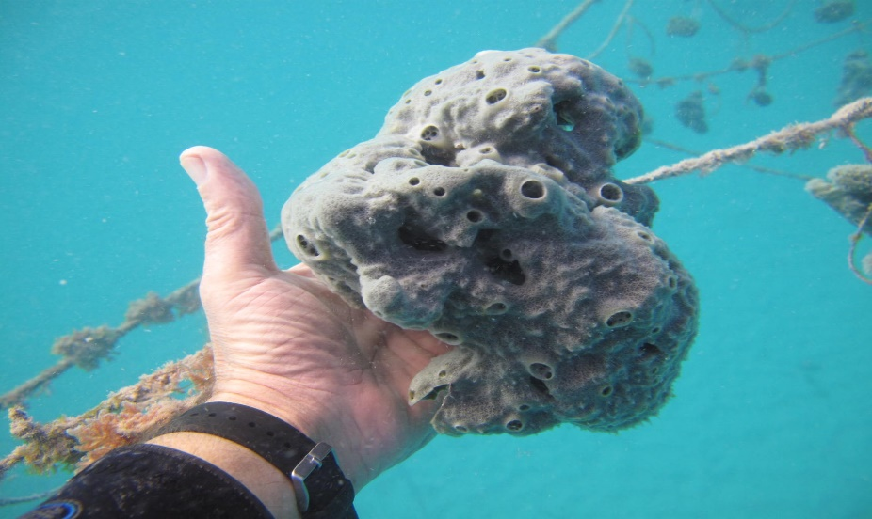
Figure 5 Well grown sponge

Processing and Packaging
After harvest the sponge must be rotted to remove the skin and any other living material from the skeleton. The sponges are left out of the water for one day so that they die. Processing procedure take several steps.

Drying
After they die the sponges are placed in the shade for 1-2 days to dry. Without squeezing or wring out the sponges.

Wash in the ocean
The sponges are placed in nets that must be attached to the Ocean farm. There they are washed out for 3-7 days but according to the sponge species it may take more days and must be kneaded regularly.

Drying & Cleaning
The sponges are dried completely for 2-3 days, as shown in Figure 1. Then they have to be rolledover with a rolling pin until they are soft. To remove small items, the sponge is shaken out and the holes are cleaned with a needle.

Washing out
The final step in the cleaning process for the sponges is to put them through a household washing machine. The sponges go through 2-3 wash cycles. During the first cycle, household laundry detergent is used to wash the sponges. In subsequent cycles no washing powder is used. The sponges are then laid out on a flat, well ventilated surface to dry. Properly rotted and washed sponges should be light in weight and resume their original shape immediately after squeezing.
Rather than the washing machine farmer can use citric acid and baking powder to washing.
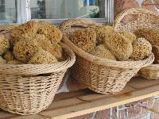

Figure 6Sponges after processing

Conclusion

Benefits of growing sponges

It easy to culture
Growing sponges requires very little special knowledge, and anyone in the family, fromgrandparents to young children, can participate in planting, maintenance, and harvesting of thesponge crop.

Profitable and Sustainable farm
farmer can gain a continuous income year-round, and improve his overall standard of living.By the introducing the sponges farming to rural people can increase their income level and also increase the employability.

The development of sustainable and economically viable fishery production alternatives, such as sponge culture, constitutes an additional contribution to environment sustainability. It is a working alternative for fishermen to create new community employment sources and generate income of foreign currency and also sponge farming is a relatively new business opportunity that does not harm the marine environment.
About us - www.earthlanka.net

EarthLanka is an online media network started in 2009 with a group of passionate journalists from 15 different countries Our Headquarter is located in Colombo, Sri Lanka and the regional office for middle east is established in Doha, Qatar. The web site was basically running on news about sustainable development, scientific research, environment topics, health and disaster management topics. Today EarthLanka web site function as a news portal on science and environment in Sri Lanka and the web site is register under News Web Media Act introduced by Ministry of Media & Information in Sri Lanka. It is also the only news casting website on science and environment in Sri Lanka today the news team is comprised of 20 journalist’s news correspondents around the world. The website provides information and engages with Environments and other key stakeholders on a range of pressing news which includes the following

▪ Impact of Global Warming
▪ Natural Disasters
▪ Extinction of Species
▪ Deforestation
▪ Human Elephant conflict
▪ Pollutions world wide
▪ Threats faced by eco systems globally
▪ Smuggling of fauna and flora globally
▪ Issues on marine eco systems globally

Recognition of the website has improved with good audience with a good popularity through media, Facebook, Twitter & Through Google. EarthLanka Sri Lanka operates as the headquarters for all the other countries and also operates as the regional office for the Asia- Pacific Region. Redefining news reporting on climate change and sustainable development in region with authentic and Real-time news in the region and State of Sri Lanka. Especially about the dialogues take place in UNFCCC for the past 8 years from COP15 to COP23 relating to the Climate Change.

Goals/Objectives
• Producing a young voice for environment journalism in the world.
• To create a community to reuse, reduce, and recycle our resources exists today.
• Taking Conservation efforts for threatened species.
• To reduce carbon footprint and human ecological footprint.
• Awareness among public, youth and children on conservation efforts.
• Recognizing youth and their initiatives towards sustainable future.
• Creating a group of journalists to report on environment related news locally and internationally.

Major Millstones
• Recognized as an official online news portal in Sri Lanka for climate change, by the Ministry of Media and Information Sri Lanka in 2012.
• Online Media Partner for Scientific Seminars and Climate Change seminars since 2010 at school levels.
• Media Partner for South Asia Youth Summit on Climate Change held in Sri Lanka 2010.
• Partner to facilitate the first’s ever National side event for 20th conference of parties for United Nations Convention on Climate Change held in Lima Peru.
• Publishing news on various events done by ICIMOD Nepal, CSE India and Many other worldwide recognized organizations.
• Our Journalist Article publish on the “CoolerPlanet” serious of Articles Initiated by the Restless Development During the COP 21.
• Nine years consecutive reporting of UNFCCC COP15 – COP23 Session held from 2009 to 2017

EarthLanka Youth Network

Just a year into its operations EarthLanka is slowly yet steadily beginning to expanding its outreach and form strategic partnerships with likeminded organizations and individuals through the youth online community which was registered under Central Environment Authority, Ministry of Environment Sri Lanka in 2010. The online youth network which became an organization is working heavily with young people in recognizing them in the society and to bring up their Initiatives for the development in Sri-Lanka

Impact and Achievement
• As a leading organization contributed for the National Voluntary People’s Review for the Agenda 2030 that was held in High-level Political Forum July 2018.
• Global Goals Youth Campaign” YouthPower” for 2030 where we will be the official representatives for the youth campaign in Sri Lanka.
• Leading Organization that contributed to the establish the Sri Lanka SDG Stakeholder Platform.
• Empowered school children in the coastal belt on environment protection.
• Created the first ever side event for Sri Lanka in UNFCCC and created a digital media campaign n Human Ecological footprint.
• One of the global partners for Action 2015 and Local Focal point for Sri Lanka and our key activities of SL campaign was featured every part of the world through social media.
• Partnered for the firsts ever regional youth climate summit for climate action
• Local Focal point for Global power shift Sri Lankan chapter.
• Country focal point Asia Pacific Regional CSO Engagement Mechanism UN ESCAP.
• As a leading organization contributed for the youth draft for Rio+20 national statement held in Rio 2012.
• Country Focal Point for Global Youth Biodiversity Network under the UNCBD.

Vision

Towards building a generation of young people committed to positive social change protecting the Ecology, the fauna, the flora and exploring and promoting active global awareness for safeguarding the earth’s natural resources.

Mission

To create and sustain and protect the environment creating spaces for young people to express themselves and take action on Environment issues, which they feel strongly for safeguarding the earth’s natural resources.

