CHEP Stories
Wahome is a 10-year-old boy who has suffered a lot. He was born with a deformity that makes it difficult for him to pass urine and causes him a lot of pain. His parents, who are casual laborers, work hard to provide for the family, which is often not easy. Wahome needed an operation that they could not afford.
Thanks to the CHEP Program, he has received the surgery he needed and is now happy
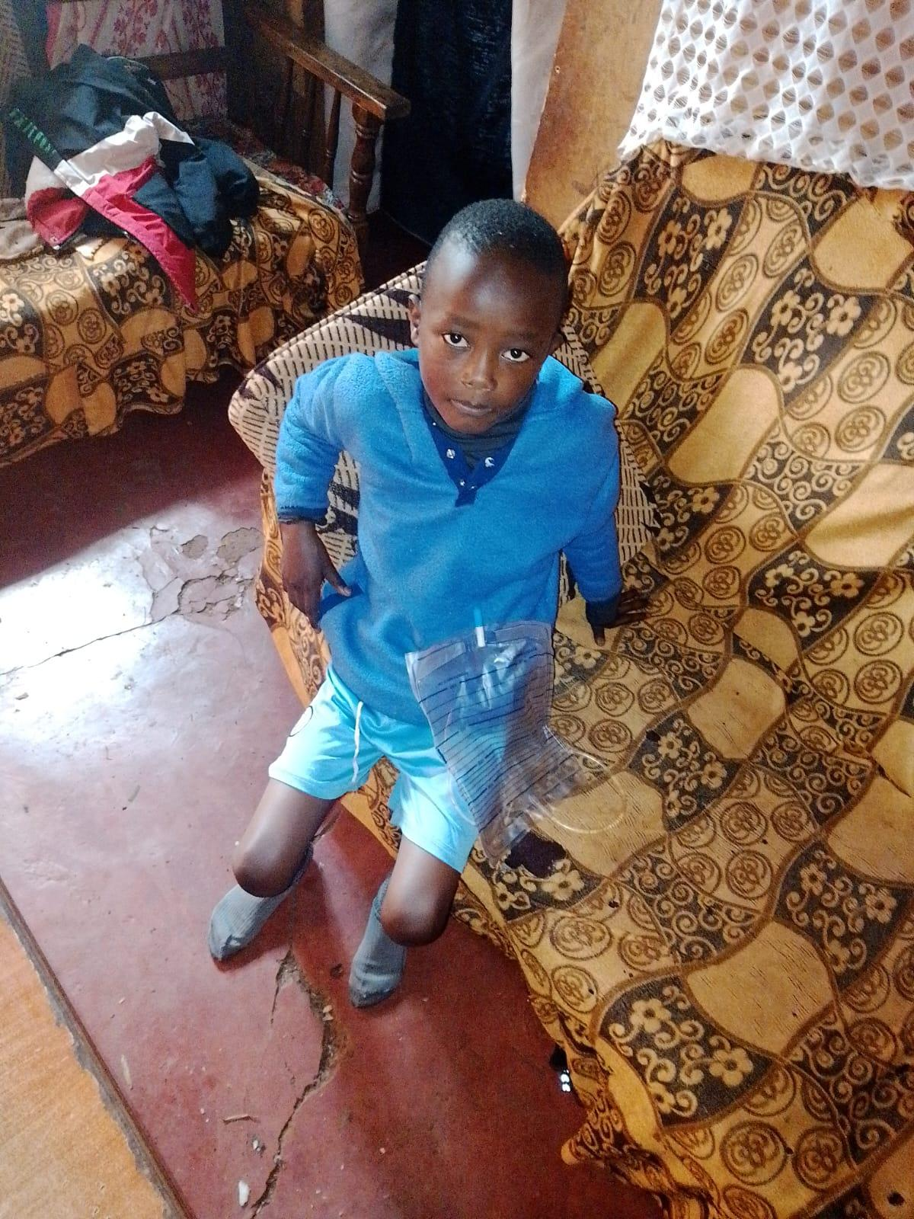
After the operation, already at home, but still with the drainage.

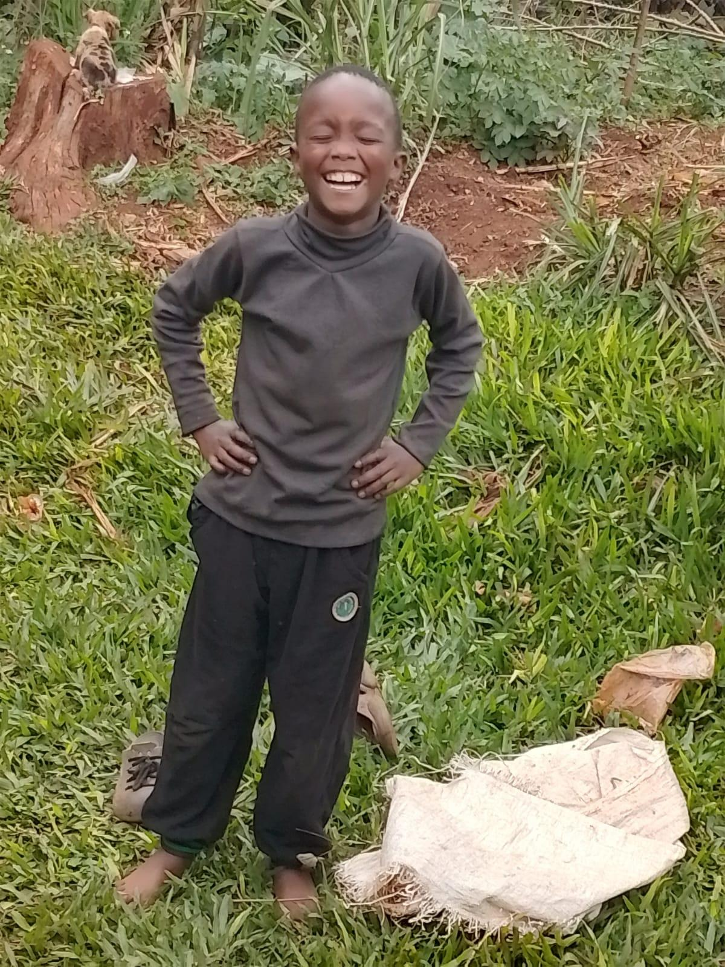
Now fully recovered
Eye check-up
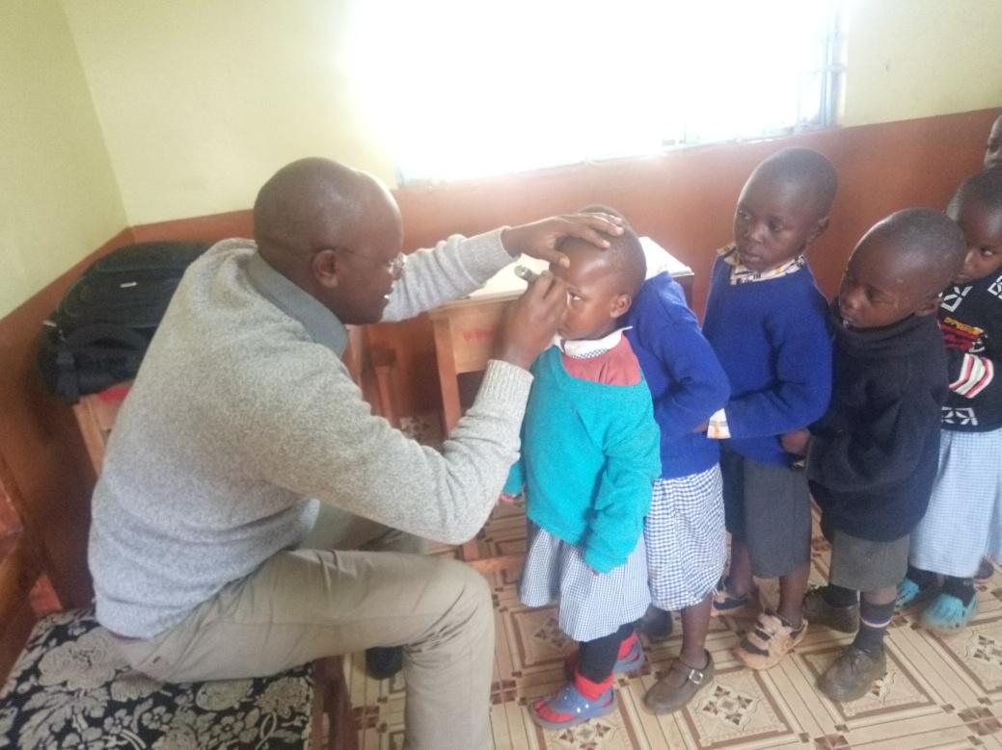

All the children in the program have had an eye check-up. More than 50 needed treatment for infections and allergies.
Some students were given different eye drops to correct certain problems, others were given reading glasses, others required special lenses, while those who needed minor or major corrective surgeries were given a yellow card indicating the diagnosis and the possible corrective procedure that we are following up on
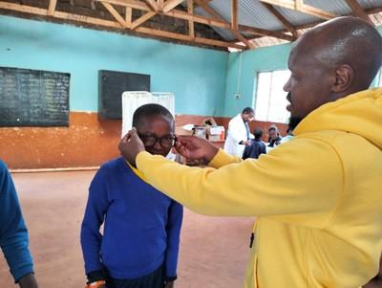

Njeri is a 7-year-old orphan who lives with sympathizers. She was sexually abused by her uncle and cousin and was also a victim of violence, to the point of being hit on the head with a rungu (a traditional club).
We contacted the police to have her taken to the children's department. She now lives in a children's home, and her guardian is in custody. When we visited her, she seemed very happy and had made new friends.
Kamau is an 11-year-old boy from a very poor family. At school, he used to cover his arms so no one would notice what was happening to his skin, but the problem was discovered during a checkup. His parents didn't give it much importance because even if they took him to a doctor for a consultation, they knew they wouldn't be able to pay for the medication.
He was taken to a skin specialist, and the boy can now smile and show his arm without being ashamed of what the other children might say.

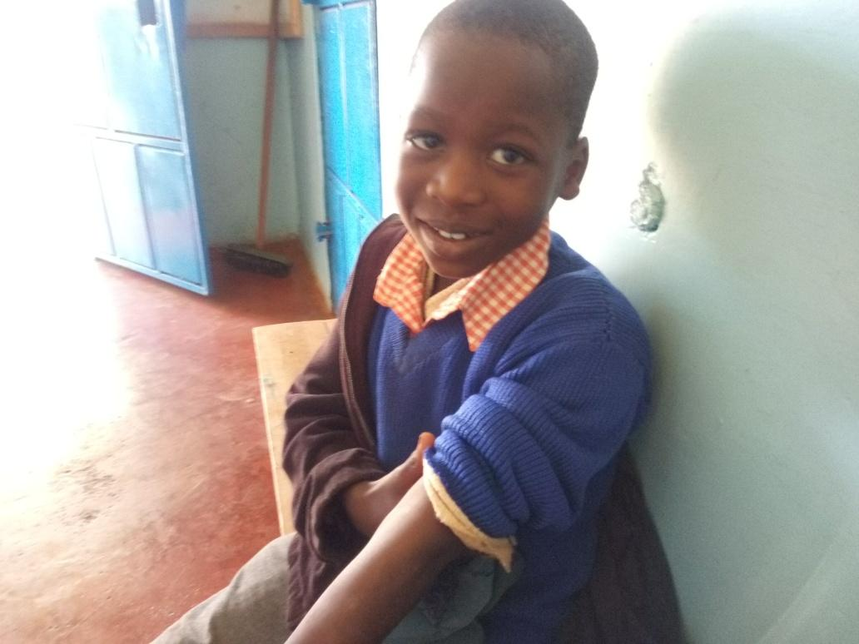
Wairimu was raped by a friend of her mother while her mother was away. Her hands and legs were tied, but she was rescued by the landlord. Her mother did not believe her, and she didn't tell the father because he is very abusive, even towards the mother. The girl seems dazed and traumatized, but her mother attributes it to the dysfunctional nature of the home. She has seen her mother beaten and kicked, and many times they have gone without food. Both the mother and daughter have received counseling, and the mother is now better equipped to take care of the family.

Omondi is a boy who appears to have been neglected by his mother. He had ringworm on his scalp, has been treated, and is now doing well. He has also received counseling sessions.

