**Kulika Uganda Project Progress Report:**

**October–December 2024**

This report covers the period October – December 2024 and it’s the thirteenth progress report since obtaining funds in October 2020.

During this period, the project continued to carry out training, production and marketing of briquettes to promote safe, cheaper and clean energy, income generation and contribute to reduction of three cutting for fuel, thus contributing towards environmental protection.

**Progress Towards Adaptation**

***Briquette Training*:** During the quarter, 7 members of ICON Female Youth Group were trained with essential skills such as carbonation process, mixing, understanding correct ratios, and knowledge to produce and market carbonized briquettes.

***Domestic Cooking***: Kulika Training Centre registered 5 new female headed household clients during this quarter who adopted briquettes for domestic cooking. This resulted in a cumulative total of 260 household clients from the 255 clients reported in the previous quarter indicating 16% increase in the number of clients. Additionally, the Centre onboarded two new institutional clients, bringing the total number of institutional clients to seven.

***Brooding Chicks*:** During this quarter, one member of the trained ICON Female Youth Group adopted the use of briquettes for brooding day-old chicks. Additionally, the seven clients reported in the previous quarter have maintained their use of briquettes for brooding purposes. Kulika Training Centre also continues to utilize briquettes in its own brooding activities, demonstrating the effectiveness and sustainability of this energy solution.

***Production and Marketing***: Briquette production and sales continued to grow steadily during this quarter. The Centre produced and sold 8,189 kilograms of briquettes, generating UGX 8,189,000. This reflects a significant increase of approximately 60.5% in production volume compared to the 5,100.5 kilograms produced and sold in the previous quarter.

***Community Extension Work*:** The Centre continued to follow up the trained women groups for monitoring and technical support. Sensitization on the benefits of briquette making and usage as a way of mitigating climate change, generating income, and providing a clean energy source for cooking in the communities and schools has also continued.

**Way Forward for the Next Quarter**

* Continue training learners from various institutions.
* Sensitize at least 20 additional women on briquette usage.
* Conduct awareness sessions on briquette usage in at least 10 schools.

**Appreciation and Request**

Kulika Uganda extends its heartfelt gratitude to Global Giving for its generous support. The funding has been instrumental in training communities on fuel-saving technologies through briquette production and usage. We look forward to continued collaboration to enhance the impact of this initiative.

*Prepared by Kulika Uganda*

**PICTURES OF ICON FEMALE YOUTH GROUP TRAINING ON MAKING BRIQUETTES USING A HAND PRESS AND MAKING BRIQUETTE BALLS**

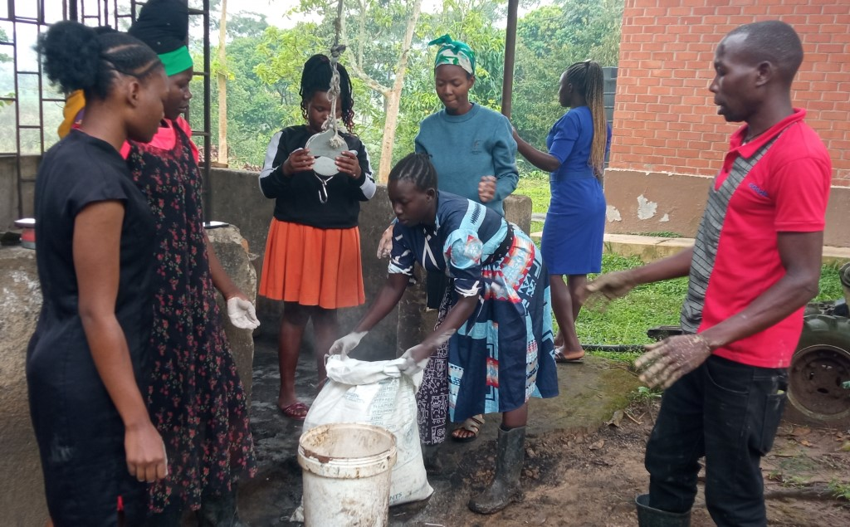

Measuring cassava flour

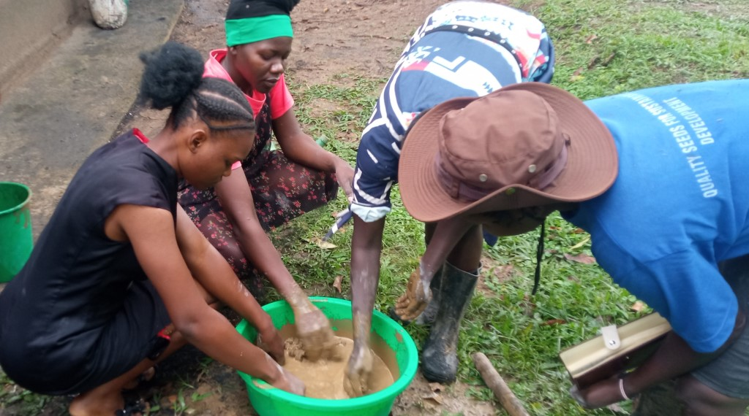

Mixing clay

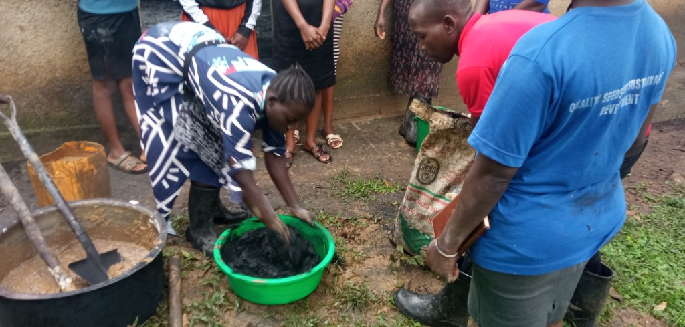

Mixing clay , cassava porridge with carbonized bio mass

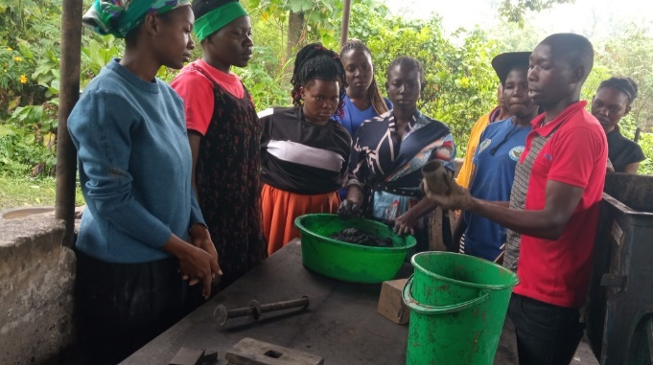 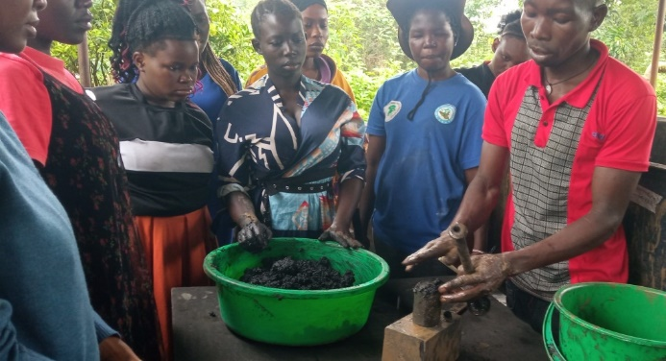

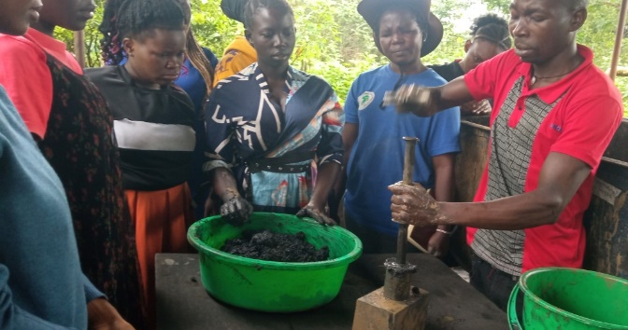 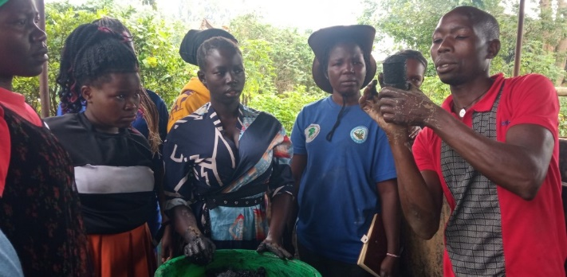

Demonstration on using a simple hand press

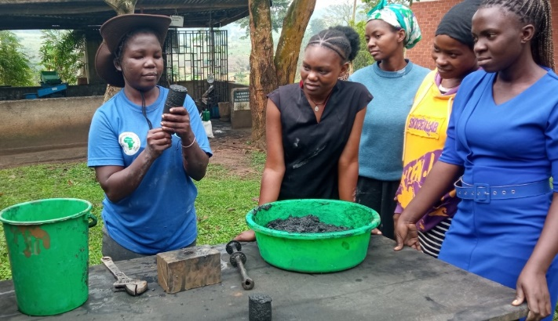 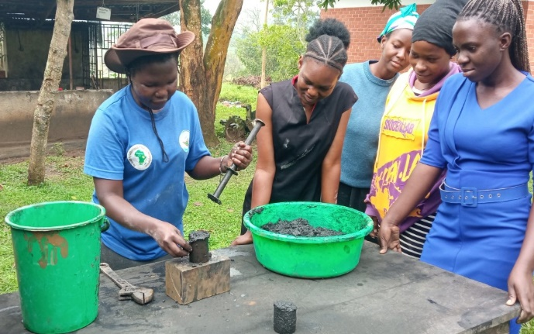

Practice on how to use a simple hand press

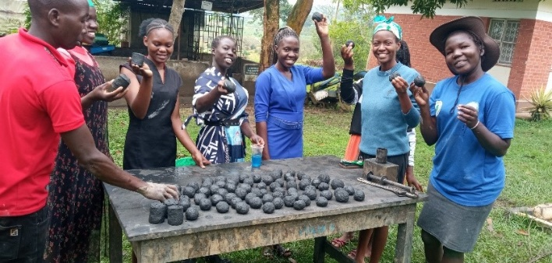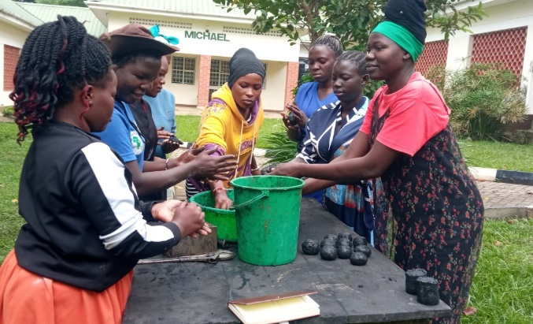

Making ball briquette