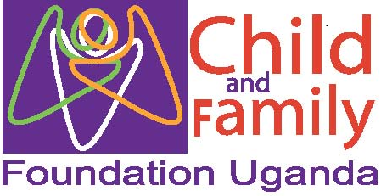

Improving early detection and treatment of children with malnutrition and access to nutritional services together with their mothers/caretakers using a community-based approach in Kawempe Division in Uganda

COMPILED BY:
Ronald Mugaga
Reviewed by Dr. Harriet Babikako
May 10, 2021

List of acronyms
CFU Child and Family Foundation Uganda
OPD Out Patient Department
IPD Inpatient Department
LAB Laboratory
RDTs Rapid diagnostic tests
SAM/E Severe acute malnutrition and edematous
SAM/NE Severe acute malnutrition and non-edematous
MAM Moderate Acute Malnutrition
SAM/D Severe Acute Malnutrition with Dermatosis
RUTF Ready to Use Therapeutic Food

1.0 Background and Introduction
Child and Family Foundation Uganda is registered as an independent and indigenous Christian-based NGO which was registered in February 2012. The organization is dedicated to improving lives of the: poor, vulnerable and disabled groups in rural and urban informal settlements and focuses on children, youths, women and persons with disability. CFU works with government and private sectors, local and international partners – donors and implementing parties, individuals, families and communities as beneficiaries to reduce disease, disability, illiteracy, poverty and social injustice and to promote human development through service delivery, capacity building, community interventions, research, policy development, and advocacy
Kawempe Division is the largest division in Kampala capital city, with an estimated population in excess of 338 665 according to the Uganda National Population and Housing census 2014. Kawempe Division has a high mortality and morbidity burden compared to the other four divisions in the city. Despite having over 50 private Clinics and health centers and various government health centers and hospitals, the state of health among the inhabitants of the Kawempe division is still low and malnutrition is a major burden of illness.

2.1 Preparations before the outreaches
The community outreaches are organized by a skilled team with experience and dedication. This team includes; the medical department of the organization headed by Dr. Nickaf Godfrey, the research and data systems department headed by Mr. Musasizi Ezekiel along with the other CFU staff members.
Before the outreach, through the village health teams (VHTs) we visit the proposed site for community entry and engagement. The VHTs introduces us to the local council authorities who together with the VHTs help us identify a pitch camp.
CFU funds most of the activities including drugs and medical supplies, and facilitation of health care workers. The program also receives donations from the global giving community. The outreaches are publicized at the local community radios. A stakeholders’ meeting with the VHTs was conducted on February 12, 2020 at CFU to officially introduce the program to the VHTs and peer mothers and train them on how to do nutritional assessment.

2.1.1 Proceedings during the outreaches
The team travels from office to the village at 9.00 am. On arrival at the camp site, we meet the VHTs for briefing and introduction. Part of the team stays at the camp site to receive the serve the clients while the other team members traverse the village to carry out the planned activities.

3.1 Objectives and structure of CFU community programming
- To Improve screening and identification of children with malnutrition and link nutrition care services and other nutrition service packages to community for improved livelihood
- To enhance capacity of the mothers/caretakers, CFU staff and local leaders in screening of children for malnutrition using mid-upper-arm circumference (MUAC) and referral of these children to care
- To improve access to and utilization of quality nutrition services in management of acute malnutrition for children in Kawempe division
- To assess the community knowledge of mother/caretakers on child malnutrition

3.1.1 Structure of CFU community programming
CFU offers an integrated community program. At the center of the program activities is the research and data center that coordinates all the other department of CFU to ensure early community screening, detection and screening for acute malnutrition.
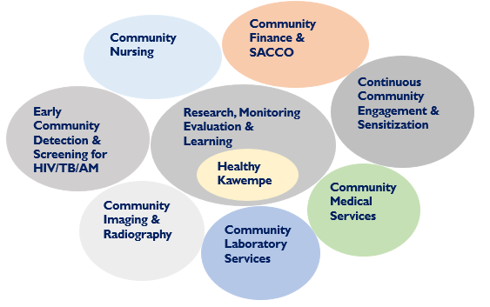

3.1.2 Who is involved?
Community entry and engagement is made possible through collective efforts of CFU, VHTs and peer mothers and local leaders.

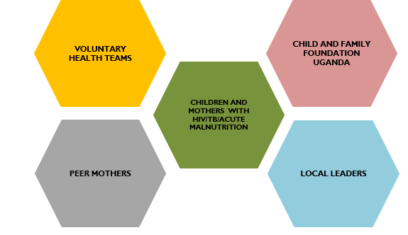

Child and Family Foundation Uganda (CFU) and together with the entire staff as a team are delighted to share the second report of SAVING LIVES OF MALNOURISHED CHILDREN IN UGANDA at https://goto.gg/48930 and below are the Results/ What we have done so far

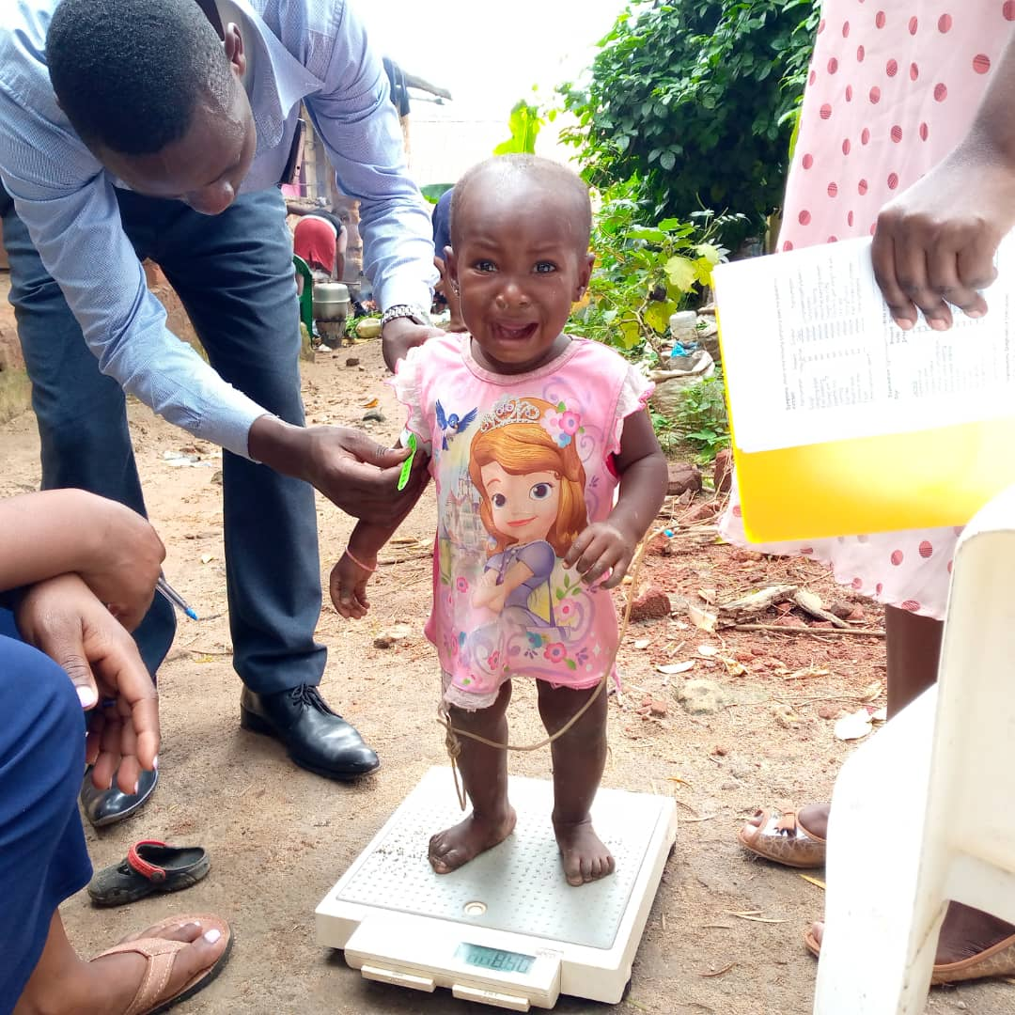
Assessment of child nutrition in Kiganda zone by CFU teams

 | Number of children screened/assessed for malnutrition in the community | Number of Moderate Acute Malnutrition | Number of Severe Acute Malnutrition | Total
January 2021 | 201 | 57 | 28 | 85
February 2021 | 88 | 22 | 11 | 33
March2021 | 295 | 19 | 13 | 32
April 2021 | 136 | 14 | 9 | 23
Total | 720 | 112 | 61 | 173

Of all the 173 children identified from the community with malnutrition, 82 children were treated and they recovered however, 38 children have defaulted and need to be traced by the village health teams to ensure the children do not regress into a deathly state.

We conducted a stakeholders’ meeting in which we demonstrated to the VHTs and peer mothers how to screen and assess for malnutrition. It was a hands- on session through which the participants were able to do the assessments by demonstrating to the others
During the same meeting we toured the kitchen garden that was set up at CFU and the participants were able to ask the nutritionist questions about how to set up and maintain the garden.
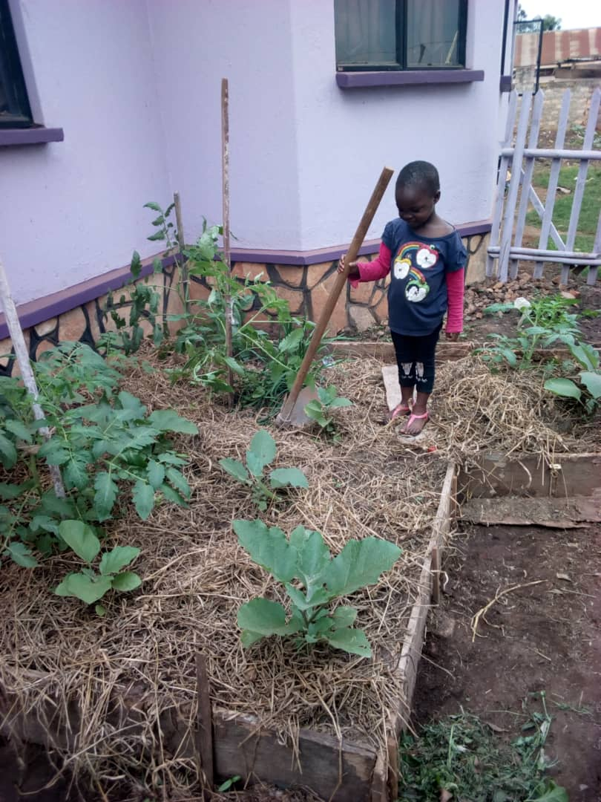
A demonstration kitchen garden set up at CFU for mothers with malnourished children to learn and replicate in their homes so that they can have vegetables added to their usually monotonous diet.
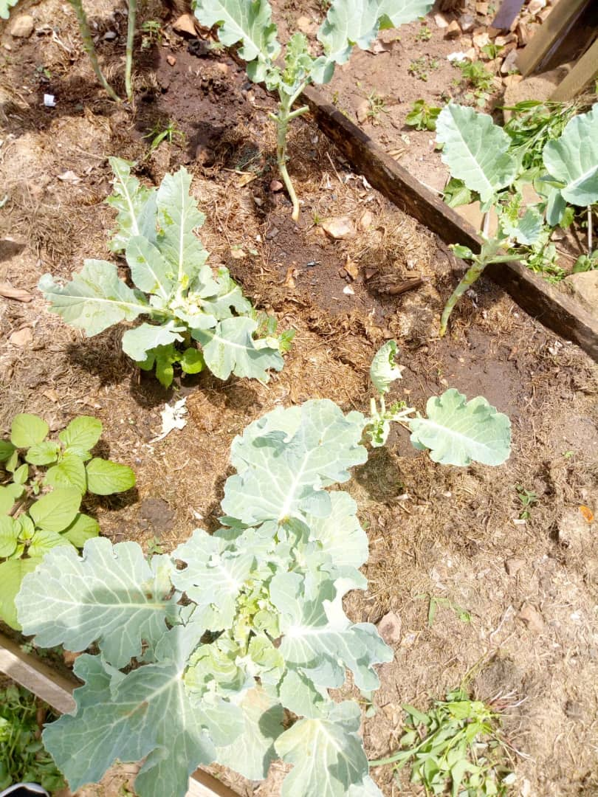-

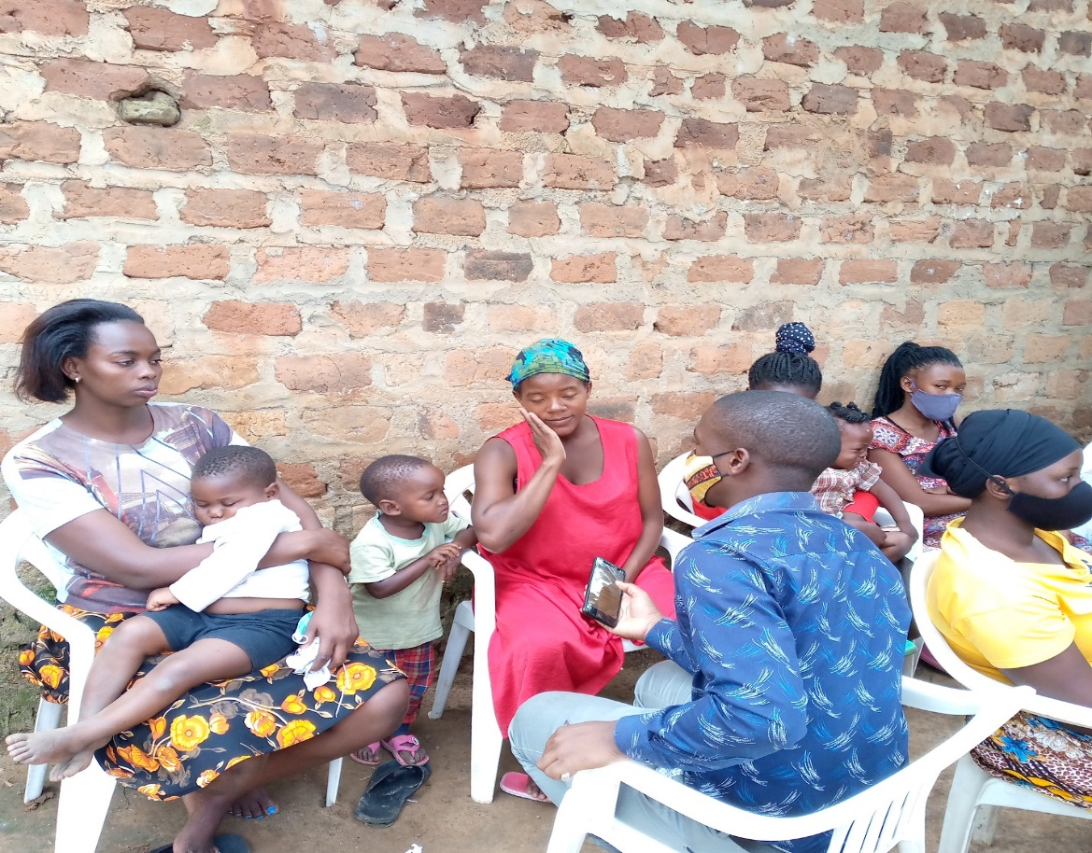
Health education session in Kilokole zone by CFU teams
There was a gain in knowledge about child nutrition of mothers from 17 (30%) before the health education to 32 (68%) after health education as shown in the figure below
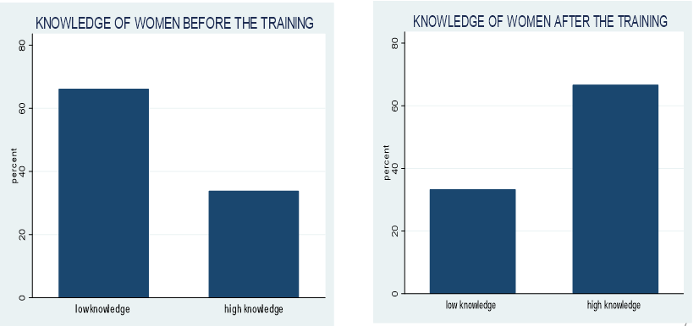

The story of the beneficiaries of the community program
A mother with a child named Authority Jonah (name disguised) is up to now still wondering what we gave to her child that made him walk and gain weight after a period of 2 years of no walk
We assessed the child and was found to be with severe acute malnutrition with complications which we treated/managed and started the boy on Ready to use feeds (RUTF) after the management of complications. We kept monitoring and reviewing the boy every two weeks for six weeks and the boy was responded well by presenting normal, well nourished, and we later educated her on how to maintain the child’s diet as it has been using local foods and then the child was discharged. A month later, the mother requested to work as our agent and we trained her to be among our village health team (VHT)

One of the village health team members who goes out to screen children in the community every week was thankful “ever since CFU aka Child and Family Foundation Uganda came to our community, people are now taking nutrition seriously. Before CFU came into our community, it was difficult to convince the community members on our own as VHTs. I know some family members who have benefitted from CFU nutrition services and they are very grateful”.
In the same vein, CFU thanks everyone donating towards this project. All the 173 malnourished children received ready-to-use therapeutic foods (RUTF) and medical treatments. Eighty- two children have completely recovered and caught up with their milestones.

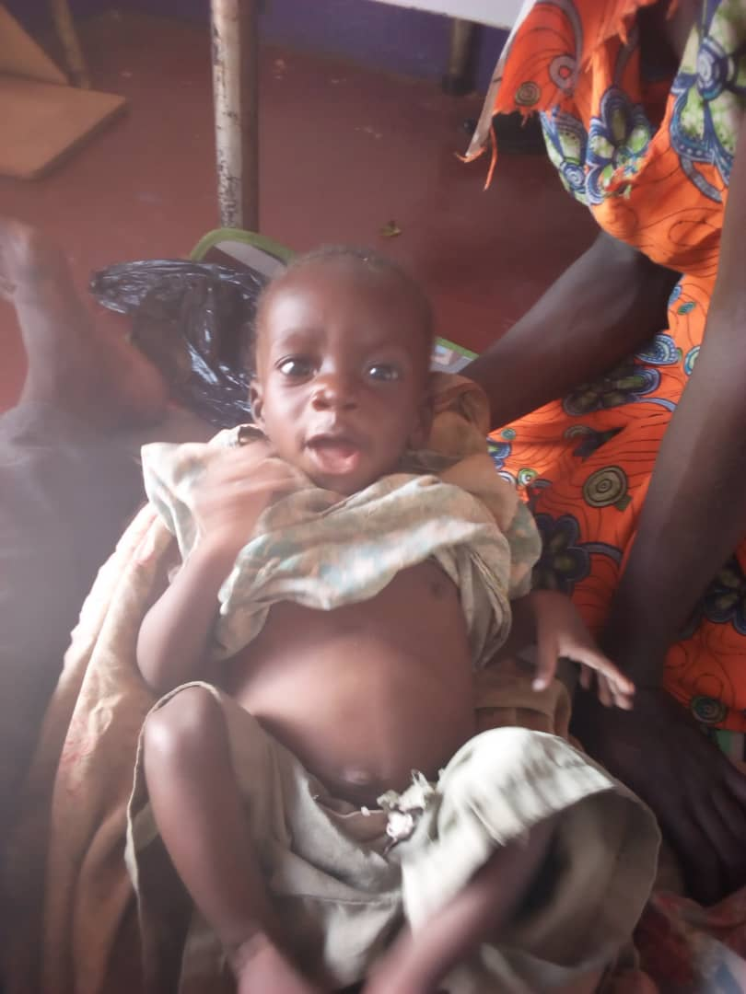
A picture of a child screened with malnutrition, Nawansaso.
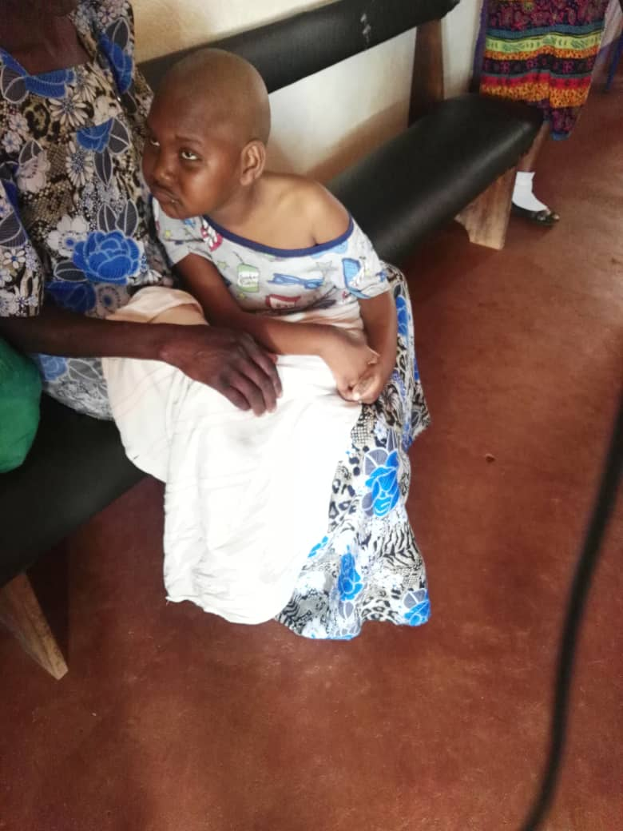
A child attending the outpatient nutrition clinic at CFU, Ttula

To identify more children with malnutrition like Jonah, is through the support and donations from the Global Giving platform. Support our project interventions at https://goto.gg/48930 to enable us scale-up the project interventions to reach more children and parents who are not aware that malnutrition is bad for their children if not managed in good time.

