Child and Family Foundation Uganda (CFU) Launches Saving Lives of Malnourished Children in Uganda

Child and Family Foundation Uganda (CFU) and together with the entire staff as a team are delighted to share this first report of SAVING LIVES OF MALNOURISHED CHILDREN IN UGANDA at https://goto.gg/48930 with support from GlobalGiving donors and supporters. The donations from GlobalGiving has enabled the CFU Team launch the screening of 52 children from poor families and identified 17 malnourished children in slum settlements of Kawempe North in Kampala city and in rural Nawansaso parish in Kamuli district in Eastern Uganda where children with malnutrition is high.

In preparation for the launch and later scale-up of the project activities, CFU has together trained 18 technical staff and 20 community health workers referred to as village health teams (VHTs) and sensitized community leaders in Kawempe North in Kampala city and in rural Nawansaso parish in Kamuli district. During the training and launch, VHTs were trained in screening and identification of children with malnutrition using the standard and recommended mid-upper-arm circumference (MUAC) tape and assessment of swelling for both feet as shown in this photograph.

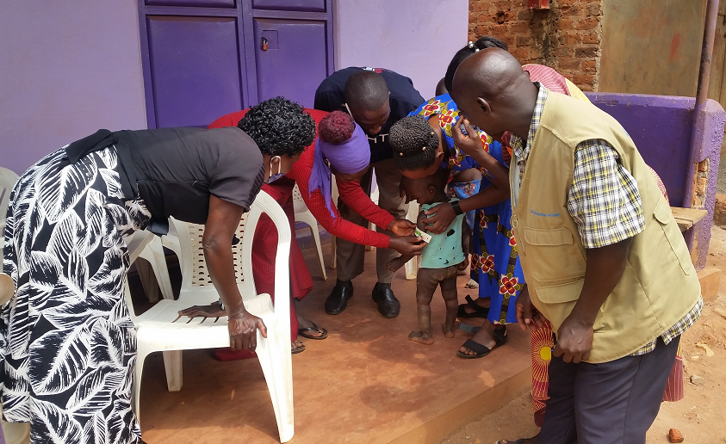  Trained VHTs using MUAC | Trained VHTs assess for swelling of both feet

We thank everyone donating towards this project as in this little time, we have established the foundation to scale-up the project activities. All the 17 malnourished children received ready-to-use therapeutic foods (RUTF) and medical treatments. All the 52 screened children received supplementary foods through our trained technical and VHT staff. The caretakers or mothers received knowledge on nutrition and disease prevention.

Preparing mothers to receive RUTF and how to use it at home | Teaching mothers on preparation of nutritious food for a child at home

We are motivated with the GlobalGiving donations and support. Support our project interventions at https://goto.gg/48930 to enable us scale-up the project interventions to reach the desired targets, follow-up the identified malnourished children till recovery and empower affected families or caretakers with income generating skills and activities to prevent recurrences of malnutrition and other disease conditions.

Registration of new clients at the clinic | 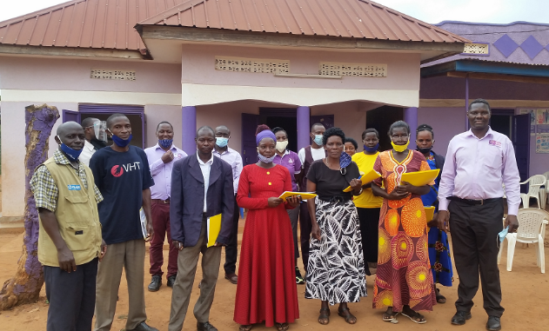  A team of trained VHTs and CFU facilitators

