Table 1: Showing children screened for malnutrition & linked to care at CFU, Jul-Sept, 2021
Characteristics | 0-23 months |  | 24-59 months |  | Total
 | M | F | M | F
Children screened | 133 | 158 | 105 | 98 | 494
Moderate Malnutrition | 6 | 6 | 7 | 4 | 23
Severe Malnutrition | 15 | 6 | 0 | 9 | 30
Enrolled in program | 21 | 12 | 7 | 13 | 53
Total discharged | 12 | 3 | 5 | 7 | 27

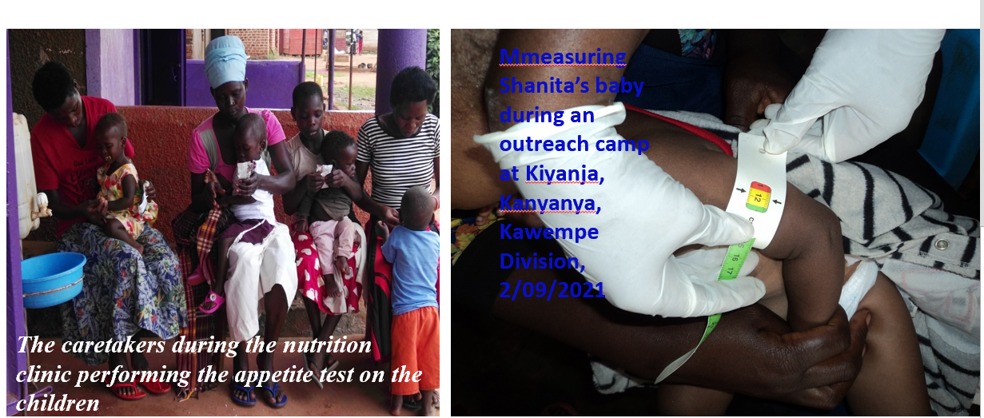

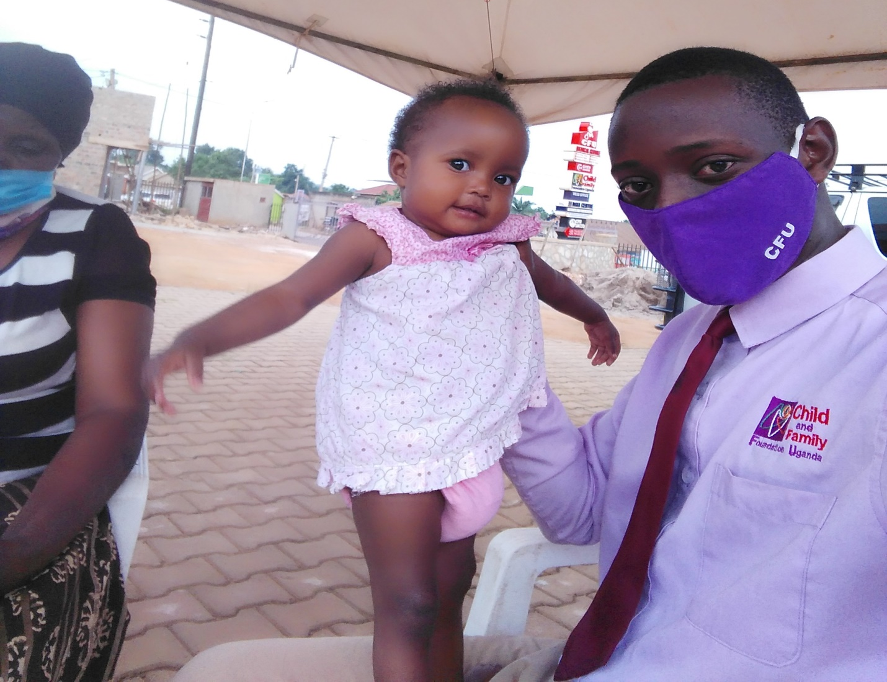
Our lovely baby that has been on the Malnutrition program, now cured and discharged in the month of June 2021

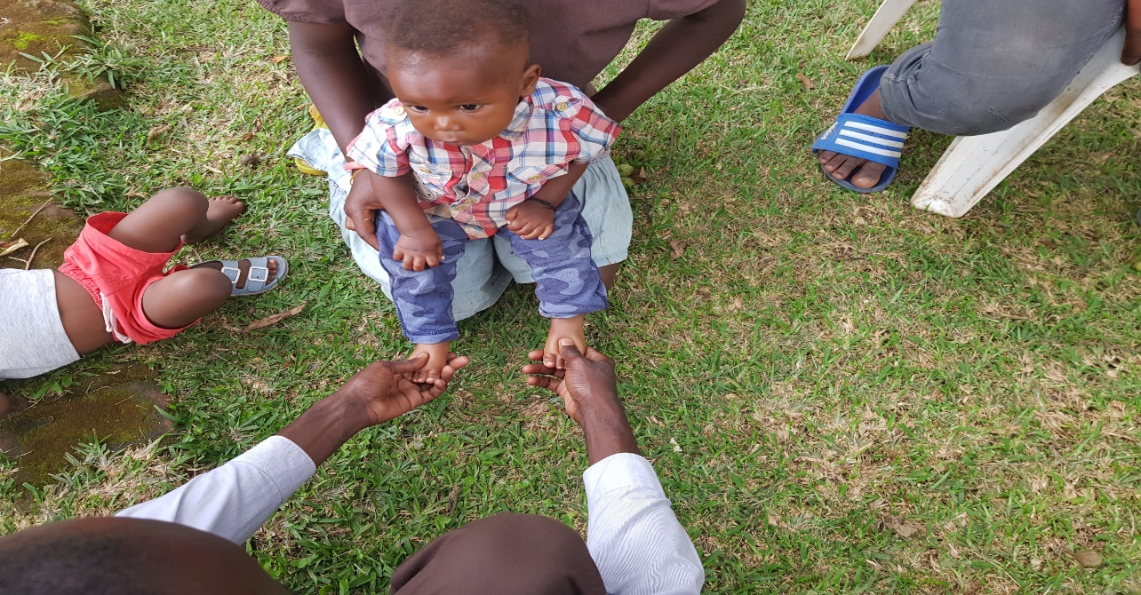
Baby Joel, not real name, identified from the community by the village health teams, sekayonyi, kawempe, sept 2nd 2021 linked to care at CFU.
