**Foreword**

Pakistan is facing a serious health threat unlike any other in our lifetimes due to Covid-19. The virus spread on alarming rate and on March 18, 2020 COVID-19 cases had been registered in all provinces and by June 17, each districts in Pakistan had recorded at least one COVID-19 case. On 15 June, daily new confirmed case numbers reached their peak, with [6,825 new cases recorded](https://en.wikipedia.org/wiki/COVID-19_pandemic_in_Pakistan#Statistics) [[1]]. Moreover, the up surge of the virus hit hard the stressed out health systems, economies and day-to-day lives of the common man. The social and economic fallout from the combination of the pandemic affected mostly the poorest of the poor. The province of [Sindh](https://en.wikipedia.org/wiki/Sindh) had recorded the most cases at about 134,000, and registered the most deaths due to COVID-19, about 2,500 to date. The country was further devastated due to flash floods. The low laying areas of Pakistan were worst-hit by torrential rains in August 2020 that lashed several cities and, remote areas; triggering flash floods, causing deaths, injuries and loss of property, more specifically in Sindh and Baluchistan Provinces. 1 million people are estimated to be affected in nine districts and National Disaster Management Authority (NDMA) warned of potential new flooding across the country, which could further increase the number of people in immediate need of assistance [[2]].

Heavy rainfall started in Sindh and Baluchistan from 6–7 August 2020 with intermissions. District Dadu and District Sanghar were hardly hit by the flood and more than 150 villages of both the districts were declared calamity zones. PMS Disaster Response Team immediately established liaison with Dadu Disaster Management Consortium (DDMC) a government led network. The other consortium members included Pak Army, Johi Development Organization and PMS, leading the relief operations on Core Humanitarian Standards to reach the most affected households. These rural households are landless peasants living below poverty line, face scarcity of resources, poor sanitation, non-existent health facilities, and lack of livelihood options make these poor communities vulnerable and left behind in the wake of natural disasters.

PMS flood relief response reduced starving and ensured food intake of 300 disadvantaged families of District Dadu by the provision of Food Items, health and hygiene kits and tarpaulin sheet. Through the relief work, the coordination of PMS has strengthened with local Government and local civil society organizations. The targeted communities have expressed their gratitude to the Global Giving for raising much needed support for the remote and far off human fraternity. Some of the case stories are attached for your records. PMS is pleased to account for the initial funds of **US$ 5000** through this report and will be sharing another report for **US$ 15000** in due course of time.

**Background**

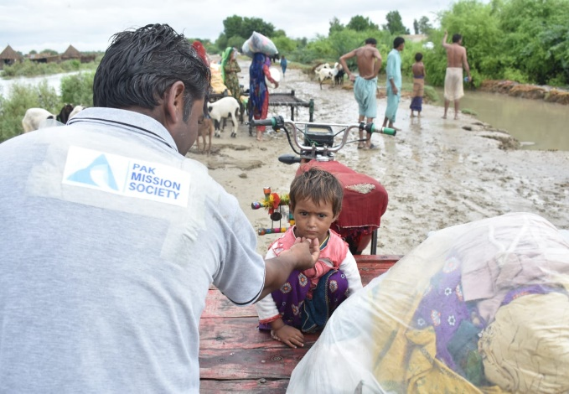The Climate Change is impacting countries like Pakistan at dangerous pace. Pakistan is worst-hit by torrential rains in August 2020 that lashed several cities and remote areas, triggering flash floods, causing deaths, injuries and loss of property in Province Sindh and Baluchistan. Heavy rainfall started in Sindh and Baluchistan from 6–7 August 2020 with intermissions. According to Pakistan’s National Disaster Management Authority (NDMA), 19 people died in rain-related incidents in northwestern Khyber Pakhtunkhwa province, 12 in southern Sindh province, eight in Punjab Province and 10 in the country’s scenic northern Gilgit-Baltistan region till August 10, 2020 [[3]].

This Monsoon rains created floods situation in Karachi, Hyderabad, Shaheed Benazir Abad and Dadu. However, Tehsil Johi of District Dadu is the area which is greatly affected by flash floods. It has been reported that floods not only damaged the houses but also destroyed crops in Johi Tehsil. Government of Sindh, already declared 80 villages of District Dadu as “Calamity Affected Areas’’. The floods also hit different parts of Baluchistan including Kacchi, Sibbi, Harnai, Naseerabad and Jhal Magsi [[4]]. Many villages of Dadu district badly affected due to hill torrent and breach of bund. Army troops Including Army Engineer motor boats and Army medical teams reached affected areas for rescue and relief efforts for stranded people in distress in Dadu.

**FLOOD RESPONSE 2020**

PMS has a history to respond to disaster immediately; as soon as the information reached, the Disaster response team immediately reached to District DADU and District SANGHAR for the Rapid Need Assessment. The details of the need assessments are as under:

**Rapid Need Assessment in Tehsil Johi, District DADU**

This rapid assessment study illustrates the situation of flood-affected 3 UCs in Johi District Dadu – within these 3 UCs. The average household size in the 3 affected UCs was found to be 7 persons per house. The detail is given below:

|  |  |  |
| --- | --- | --- |
| Union Council | Villages | Number of KII |
| 1. Kamal Khan | 1. Faiz Muhammad Lund | 9 |
| Mohammad Panah Rodnani | 8 |
| 1. Khair Muhammad Jamali | 5 |
| 1. Sawro | 1. Nando Khan | 8 |
| 1. Haji Amad Jamili | 8 |
| 1. Bajhi Khan Mastoi | 12 |
| 1. Drigh Bhala | 1. Haji Khan | 7 |
| 1. Nangar Daryo | 5 |

* According to the report from the key informants, livestock and agriculture are reported as the main source of income of communities; standing crops of Onion, Jawar and fodder are completely damaged in all of these villages.
* Casual labor was shared as the main source of income of communities, but these casual laborers are out of work, because of submerged agriculture lands, as their main occupation was agriculture related labor work this unexpected hill torrent flood has badly affected both of these income sources.
* Communities have got stuck into their villages as routes have been blocked by water and there is no other source of communication people have reported they don’t have food stocks and fodder for their animals as they are cut off from the markets.
* The Tehsil health facilities have been in inaccessible due to damaged roads. Furthermore, as many are cut off from main towns, communities are unable to access health services when needed.
* Pregnant women in particular are facing problems in accessing health services.
* Flash floods have caused severe damages to housing infrastructure. In several cases, whole villages are flooded with water and standing water level is 4 to 5 feet.
* 35% of the people houses living in the above villages are fully damaged and 25 % houses living in the above villages are partially damaged
* People are drinking contaminated / stagnant water due to the damages of water facilities.
* Livestock died at large level and 100% Agriculture standing crops have been damaged

**Dadu Disaster Management Consortium (DDMC)**

The District Government has established Dadu Disaster Management Consortium (DDMC) for coordination and networking. The Objective of this consortium is to work in close coordination with the Government and to avoid duplication of provisions. The Name of DDMC organizations are given below:

1. Pak Mission Society
2. REEDS Pakistan
3. Nari Development Organization
4. Child Development Organization
5. Development Empowerment Society
6. Ali Daduwala Foundation

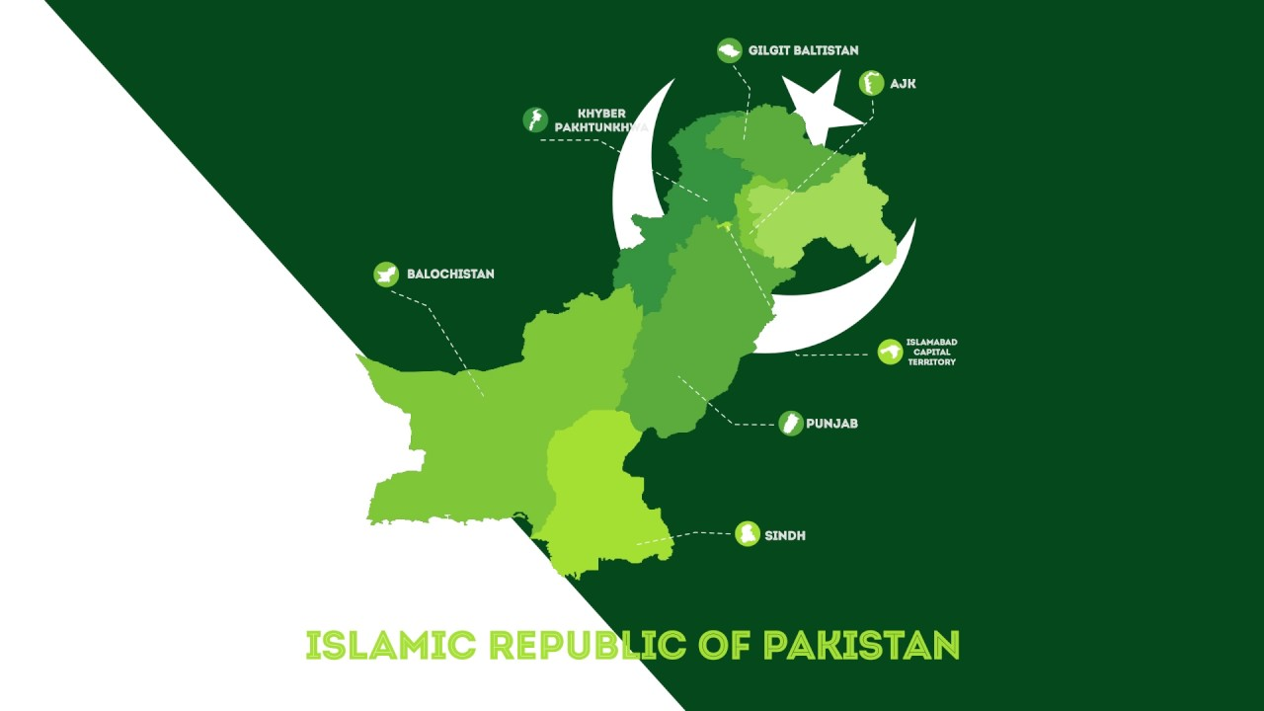**GEOGRAPHIC AREA COVERED BY RESPONSE**

Pak Mission Society responded immediately in 3 Union Councils in Taluka Johi of District Dadu, Sindh. Dadu is 52nd largest city in Pakistan. The city is located on the western bank of River Indus and is administratively subdivided into three Union councils. The total population is estimated to be 171,191 and covers the area of 300 Kms. Most of the people are associated with labor work.

Dadu

The geographical presence of PMS in Flood affected areas can be viewed on the map. Most of these households depend on casual labour, and their coping capacities have already been exhausted by COVID-19.

**RESULTS ACHIEVED AS PER THE STATED OBJECTIVE**

1. 300 flood affected disadvantaged families of District Dadu received Food Items, health and hygiene kits and tarpaulin sheet.
2. Strengthened Networking with the local organizations and Civil society
3. PMS become the part of the District Disaster Management consortium formed by the Local Government
4. Collected nearly 1 million from local fundraising and digital fundraising

**IMPLEMENTATION STAGES**

**ELIGIBILITY CRITERIA FOLLOWED FOR BENEFICIARY SELECTION**

* Family whose house has been fully/partially damaged.
* Household who lost their livestock.
* Household whose standing crops has been washed away
* Family having persons with disabilities.
* Widow responsible for household livelihood/Women headed household.
* Household who do not received any assistance.
* Household who need urgent food assistance.

**RELIEF DISTRIBUTION**

The distribution took place from 9-11 September 2020 in Dadu. Local Government, local civil society actors and few politicians participated in the relief distribution. Adequate spaces were selected for distribution of relief packages. It was ensured, that distribution points were easy to access for the selected beneficiaries. In order to adopt COVID-19 precautionary measures, distribution points were setup with appropriate markings to ensure social distancing. Village

Development Committee (VDC) members and PMS volunteers were engaged for facilitation of beneficiaries. The selected beneficiaries were guided to ensure the use of entrance and exit point.

In both the areas, following distribution mechanism were followed:

**Information/Guidance Desk**

PMS team set up an information desk at distribution point. The purpose of this desk was to provide facilitation to selected beneficiaries and orientate them about distribution mechanism.

**Waiting Area/Sitting arrangement**

At distribution point, an appropriatesitting arrangement was arranged for selected beneficiaries.

After proper verification only selected beneficiaries were allowed to enter through selected entrance. The selected beneficiaries were asked to ensure their identity through token and Computerized National Identity Card (CNIC), after proper validation and receiving, relief packages were handed over to relevant beneficiaries. Two staff members were assigned at exit point who were responsible to facilitate the beneficiary to collect relief package peacefully and maintain distance at least two meters between each other. The relief recipients were also advised, to move out from distribution point on receiving of relief package.

**DETAILS OF THE BENEFICIARIES SERVED**

|  |  |  |  |
| --- | --- | --- | --- |
| Sr.# | AREA | # of Beneficiaries Served | Intervention Type |
| 1 | Dadu, Sindh | 300 Families | Distributed:  1.Food items & Health Care |

**GENDER SEGREGATION**

|  |  |  |  |  |
| --- | --- | --- | --- | --- |
| Sr.# | AREA | # of Beneficiaries Served | Gender Segregation | |
| **Male** | **Female** |
| 1 | Dadu, Sindh | 300 | 75 % | 25 % |

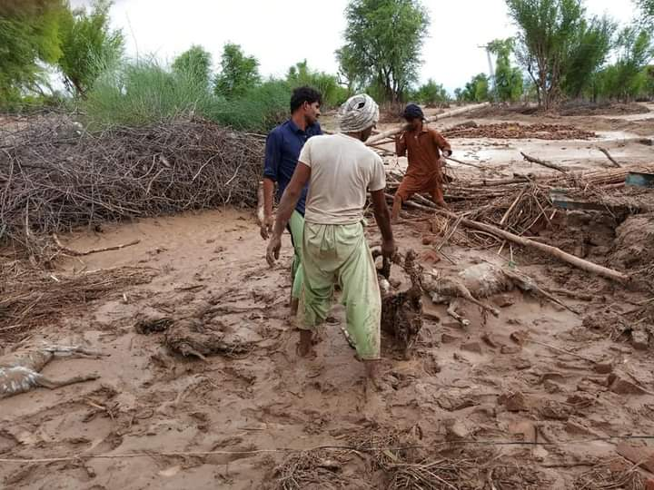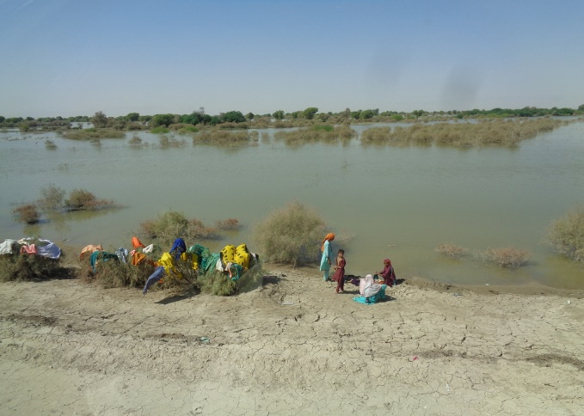

**FOOD PACKAGE DETAILS**

|  |  |  |
| --- | --- | --- |
| Sr.# | FOOD PACKAGE ITEMS | UNIT |
| 1 | Wheat flour  supreme | 20 Kg/Bag |
| 2 | cooking oil 5 liter dalda | 5 Ltrs. Pack |
| 3 | rice 86 no | 10 Kg |
| 4 | pulses monge | 2 Kg |
| 5 | pulses channa | 2 Kg |
| 6 | pulses Masoor | 2 Kg |
| 7 | wheat porridge | 3 Kg |
| 8 | salt iodine national/shan | 800 Grams |
| 9 | sugar | 5 Kg |
| 10 | black pepper national/shan | 50 gms. |
| 11 | Red chili national/shan | 250 gms |
| 12 | Turmeric powder national/shan | 50 gms |
| 13 | Supreme tea | 500 gms |
| 14 | biscuits | 6 Rolls |
| 15 | Matchbox | 1 box |

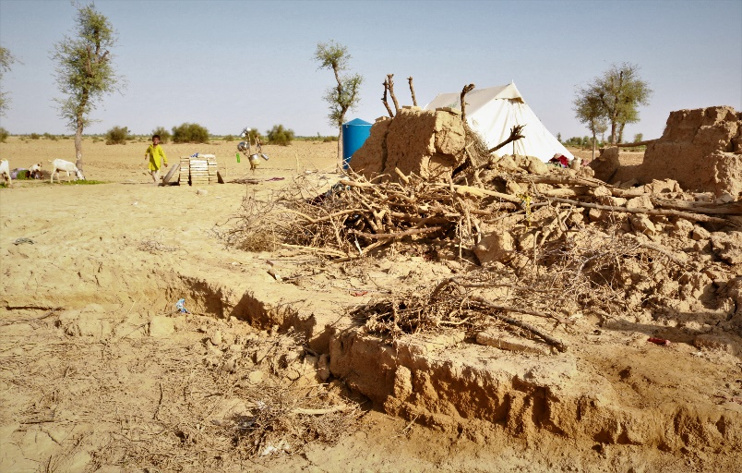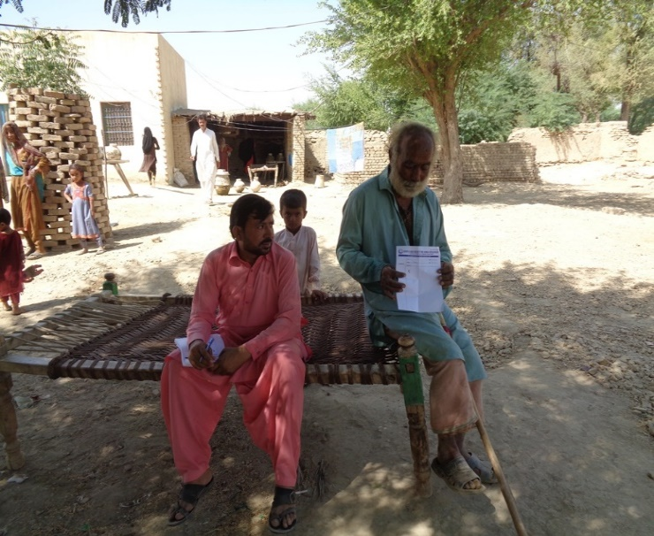

**Key Challenges**

* It was difficult to reach in many areas because of high level of flood water.
* Need of the flood survivors was high and PMS had limited resources.
* It was extreme hot weather and muddy roads due to which posed great commodity delivery challenges, thus encouraged PMS Disaster Relief Teams to go for extra mile to reach the unreached.
* The local influential people tried to influence PMS teams in beneficiaries’ selection, however, this challenge was mutually settled among the local influential by raising the vulnerability of the poor who were in great need.

**Beneficiaries Expression**

**Case Stories**

Hopes are being washed away

*Flood affected in Sindh are once again in need of food, shelter, and medical support.*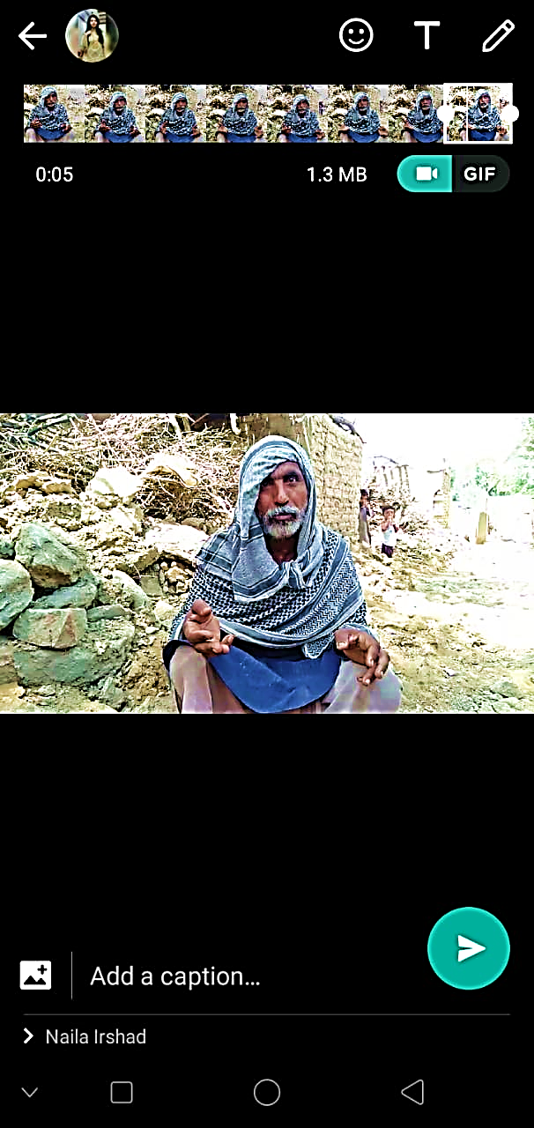

*“I have lost my house, my goats, and even my national identity card,”* says Allah Bachayo, a 45-year-old man badly affected by floods in Sindh. Bachayo was identified as a beneficiary of our flood response relief pack during the initial assessment in Tehsil Johi, District Dadu, Sindh.

Allah Bachayo is a landless farmer and has been facing life challenges, even before the floods. With seven children and not very well-to-do, Bachayo has been supported by PMS for the flood relief pack but still, his need for rebuilding his life is much more than ever. His children are currently living under a temporary shelter provided by PMS with the support of Global Giving.

When our Disaster Relief Team representative, told Allah Bachayo how this assistance has been possible and these funds have been raised through an autonomous, generous and impartial world portal i.e. Global Giving which supports world’s poor in their time of need. Allah Bachayo could not believe that if it was real, and his expression was Wow, may God Bless everyone who contributed to their needs in the time of misery and dismay. Sure, there are many who would like to convey their sincere thanks. Please acknowledge earnest and genuine word of thanks to our fellow supports in the Global Giving, from PMS in Pakistan.

**Beneficiaries Expression**

**Case Stories**

**LIVING ON THE EDGE**

*Flood affected in Sindh are once again in need of food, shelter, and medical support.*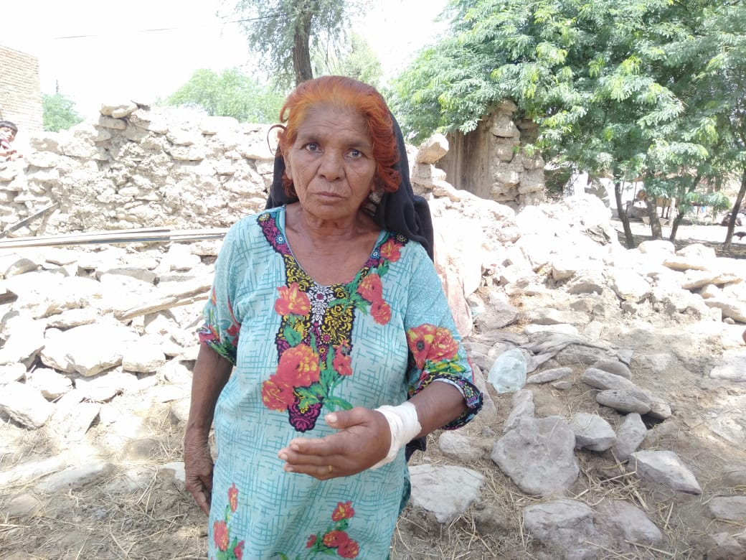

“I beg for a living,” says Masmat Rahima, a 70-year-old widow from Tehsil Johi, District Dadu, Sindh. PMS Disaster Response Team representative met her during the initial assessment of flood victims in the area.

Masmat Rahima had fractured her hand due to the roof falling on her while she was asleep. she was not just in physical pain but emotionally distressed too. Although Masmat Rahima does not have a big family to support but at this age losing your house to the flood raised extreme challenges for day to day living.

Masmat Rahima was catered as senior beneficiary with utmost respect and dignity and not only provided with flood relief pack, including food, and non-food items along with shelter. But she was given due medical care for her fractured hand. We pray for her and wish to support her more if we can!

It was amazing to see her respond; when PMS Disaster Response Team, representative informed her that who PMS raised funds for the flood survivors. Of course listening to the fast forward world and virtual and online systems, she was totally ignorant about the latest advancements and how world is moving these days. As she realized that worldwide there are individuals and groups who support the poor, she thanked PMS with tearful eyes and appreciated Disaster Relief Teams for reaching to the most vulnerable households in the time of disaster.

PMS would like to extend its heartfelt gratitude to all the generous givers who contributed to the cause, enabling PMS to stand next to the human family and express love of neighbored, without cast, creed or faith affiliations. Thank you so much to Global Giving help us channel the Giving to the most in need.

1. https://en.wikipedia.org/wiki/COVID-19_pandemic_in_Pakistan
2. https://reliefweb.int/report/pakistan/wfp-pakistan-sindh-flood-response-situation-report-1-10-september-2020
3. <https://www.aljazeera.com/news/2020/08/50-killed-days-monsoon-rain-pakistan-200809081427731.html>
4. <https://reliefweb.int/report/pakistan/pakistan-monsoon-floods-information-bulletin-15-august-2020#:~:text=Attachments&text=Heavy%20rainfall%20started%20in%20Sindh,greatly%20affected%20by%20flash%20floods.>