BUDGET BREAKDOWN
% OF THE PROJECT | NAIRA₦ | USD $ | APPLICANT’S CONTRIBUTION N | USD $
Human Resources | 50,000.00 | 128.86600 | 300,000.00 | 773.19600
Transportation cost | 256,000.00 | 659.79392
Logistics /Administrative cost | 60,000.00 | 154.63920
Equipment for training | 30,000.00 | 77.31960
Training Inputs | 30,000.00 | 77.31960
Communications | 25,000.00 | 64.43300
Miscellaneous | 49,000.00 | 126.28868
Total N | 500,000.00 | 1,288.6600 | 300,000.00
Grand Total of % of the Project + Applicant’s Contribution | 800,000.00 | 2,061.85600
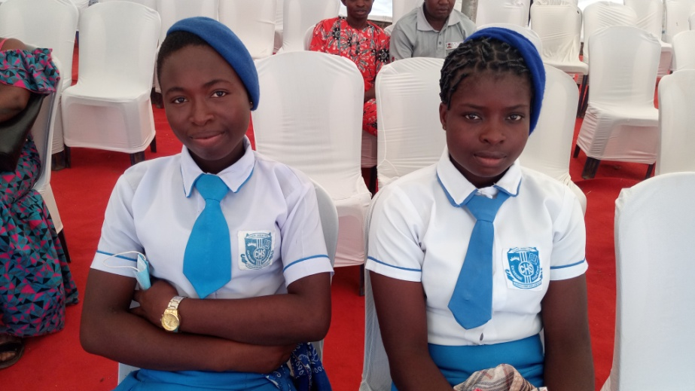
Students that won the quiz competition 1st to 3rd position

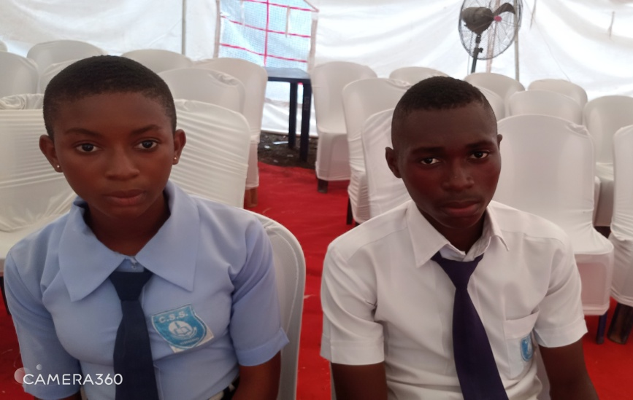
Rita & Asogwa 3rd position Scholarship beneficiaries
Clara & Joy 2nd position Scholarship beneficiaries
Dinwoke & Nnadiogo 1st position Scholarship beneficiaries

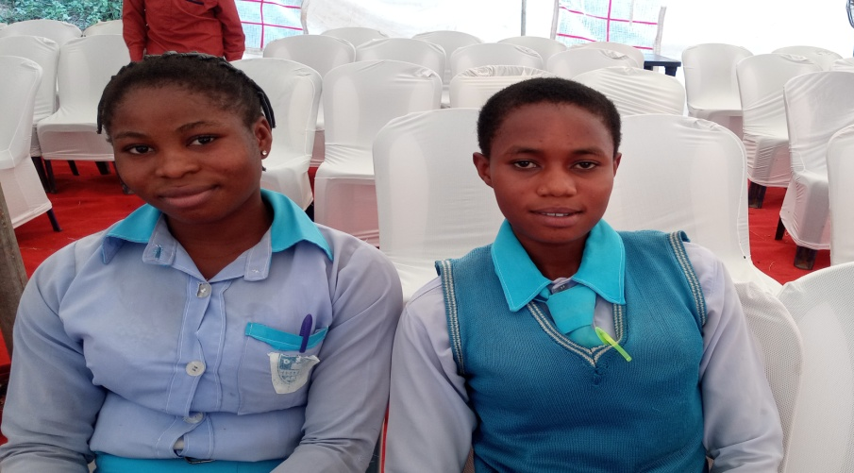

Clara & Joy 2nd position Scholarship beneficiaries

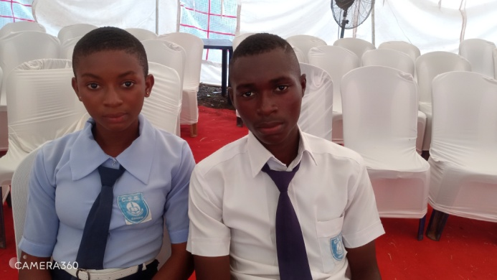

Rita & Asogwa 3rd position Scholarship beneficiaries

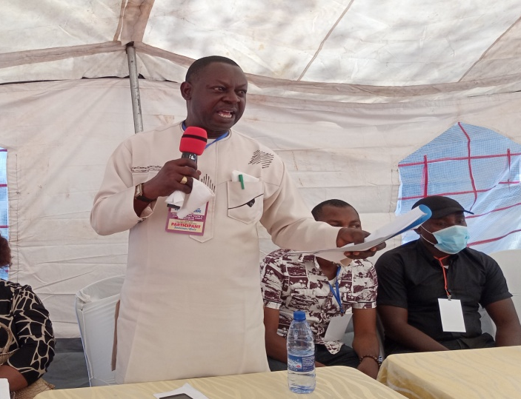
The facilitators were;

Dr. Okon
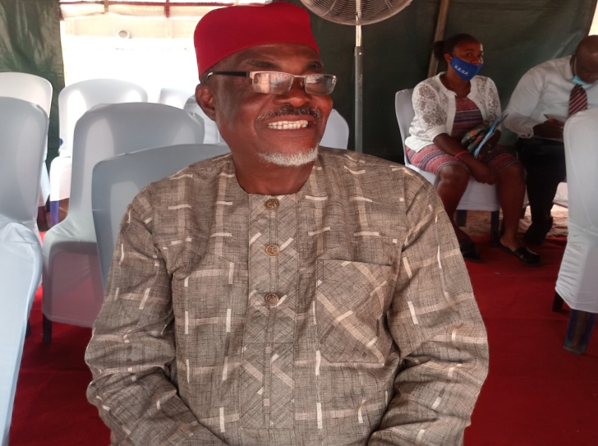

Prof Pat Ngwu
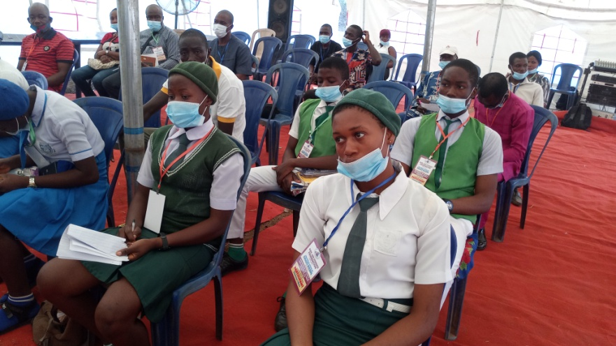
Beneficiaries and participants

