- BACKGROUND

MISSION: Home Roots Foundation is a grassroots community organization dedicated to improving the educational, economic, social, and civic development of communities we serve in Haiti.

HISTORY: Home Roots Foundation (HRF) was founded in 2003 and had been historically involved in affordable housing advocacy, education, youth tutoring/mentorship, and supporting policies intended to improve low- and moderate-income communities in the District of Columbia. As a result of the financial crises of 2008, HRF became inactive. After a trip to Haiti in 2018, members of HRF concluded they had to help and decided to use HRF as a vessel to alleviate the misery of the people. So, in 2018, we agreed to turn the focus of HRF to Haiti. In Haiti, we support existing schools monetarily and run programs for youth. Working in Haiti initially was challenging since knowledge of processes in Haiti was lacking. Thus, we decided to partner with local organizations in Haiti to let them teach us and work to improve existing programs.

JUSTIFICATION OF WHAT WE DO
Many people outside of Haiti have become discouraged about change and the impact of funding. We at Home Roots Foundation are ever more encouraged and emboldened! This is because we have witnessed the difference we have made, in a short amount of time, with the very little we had. Students who could not afford to go to school are now attending; schools that were shuttered because they couldn’t pay the professors are now gearing to open back up; once street kids are now back in school and part of a club; entrepreneurial women unable to get loans now are able to start a business. On Thursdays and Saturdays, we hold the Speak English Together Club (SET-Club), which is an informal school that teaches youth English free of charge and this alone will give them an advantage in getting a job when they are older. Now, economists forecast increase poverty and the threat of famine to over four million Haitians experiencing food insecurity. What we are doing to benefit children, women and men in vulnerable situations is as vital as ever.

- PROGRAM ACTIVITIES AND ACCOMPLISHMENTS
SCHOOL SUPPORT PROGRAM: Our largest program by far is supporting existing schools providing primary and secondary classical education. We support these schools by providing school materials, helping pay teachers and tuition, providing school scholarships, tutoring and fostering nurturing environments. Currently, we support two schools and have five to eight more that will be added in the next few years. We are planning to add a school lunch program.

School: Collège Les Sophos d’Haiti
Opened in 2016 and located in the city of Delmas, about 6.6 km from the capital city Port-au-Prince, Collège Les Sophos in 2018 had enrolled 70 students and struggled to retain teachers. In 2018, grades range from 1st to 8th. Les Sophos began experiencing financial difficulties and was in the process of closing before HRF intervened. RESULTS: Due to our support, in 2019, 150 students had registered to enroll at Les Sophos, our partner school located in Delmas. Kindergarten and the 9th grade were added to accommodate the growing student body. The number of teachers and staff members were due to increase also, but the protest of the 2019 precluded a normal school year. Besides the students, between 250 and 300 parents are benefiting from the availability of the school in their neighborhood.
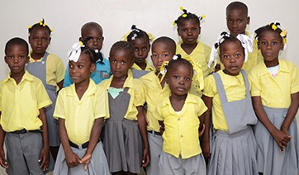
More than 90% of primary schools are non-public, enrolling more than 80% of all primary school children. Many cannot afford to pay and must stay home.

Students of College Les Sophos d’Haiti in 2018. This picture was taken during a field visit to distribute school supplies.

School: Institution Mixte Source Divine
Opened in 2018 and is in the commune of Cabaret, locality Titanyen, 23 km from Port-au-Prince. Source Divine opened originally with 25 students, 6 teachers and a Principal. Grades range from kindergarten to 6th grade. Almost all the students live in the area, but some come from the city of Cabaret. The school is located very close to the memorial for the victims of the 2010 earthquake. RESULTS: During the two years of collaboration, in addition to receiving school materials (schoolbags, books, notebooks, pens, pencils, full school scholarships), HRF was able to contribute to the construction of a roof for the school to open. In 2019, 72 students had registered to attend Institution Mixte Source Divine and the number of teachers had increased. About 100 parents are benefiting from the availability of the school in their neighborhood and the scholarships provided.
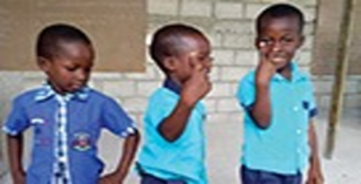
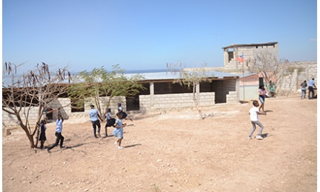
Kindergarteners at Institution Source Divine Strike a Pose Students Play at Institution Mixte Source Divine

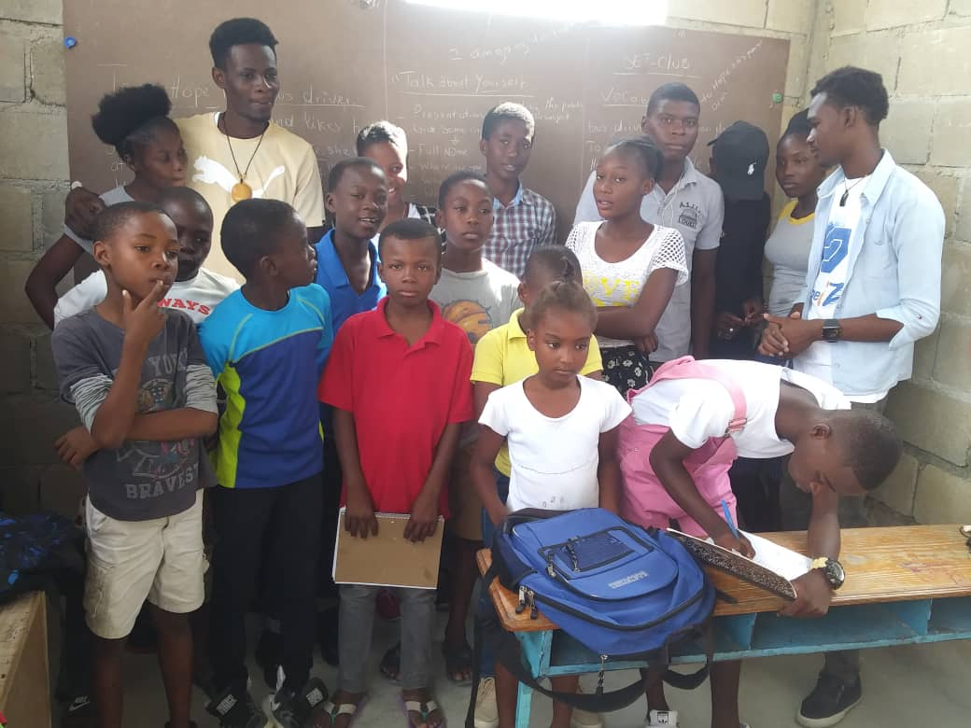
SPEAK ENGLISH TOGETHER CLUB (SET-Club): On Thursdays and Saturdays, we hold the SET-Club, which was founded in 2016. SET-Club is an informal school that teaches youth English free of charge and exposes them to American culture. It consists of a staff of 5 teachers who volunteer their time and expertise to teach children and youth ages 8 to 17. RESULTS: Home Roots helped SET-Club grow from 20 to 80 participants. However, it went down to about 25 as a result of ongoing protests in 2019. Current learning methods are limited to lectures, listening, speaking and writing English in chalk on the writing, and tests. We will expand the number of young people to 150 and enhance the learning process through audio, video, internet, watching American DVDs, and reading some children’s and young reader books from the US.

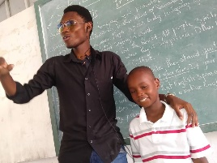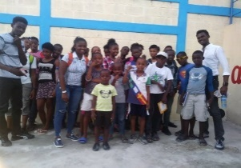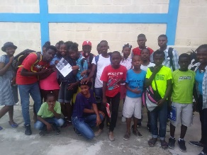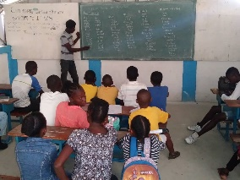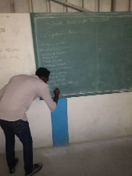
SET-Club 2018

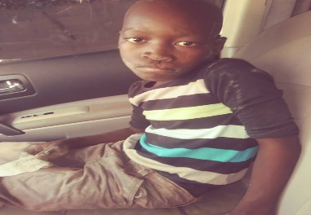
YOUTH ENGAGMENT CIVIC EDUCATION PROGRAM (YECE): This is a project that was inspired by a 12-year-old boy one of our members in Haiti saw licking the dirt off rocks because he was so hungry! Started in early 2020, YECE is aimed at wayward children who are often on the streets during school hours and have little or no home structure. YECE has several components that include mentorship, tutoring, encouraging kids to be in school, teaching civics through lectures and field trips, volunteering in the community, and child protection and safeguarding.

Jervens is an 11-year-old kid found by Herold, a member HRF on the side of the road eating dirt because he was so hungry, on December 22, 2019. He is the sixth child in a single parent family. His childhood was deteriorating day by day. Thus, a member of the HRF team being struck by this situation had integrated this child into the youth empowerment and community engagement (YECE) program. Today, Jervens Cadet benefits from moral and some economic support from HRF. We are working to do more.

Jardens lives in the town of Croix des Bouquets, near the bridge in the town of

SUMMER CAMP 2018 AT INSTITUTION MIXTE SOURCE DIVINE:

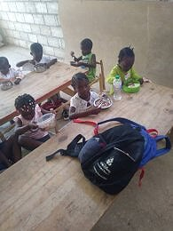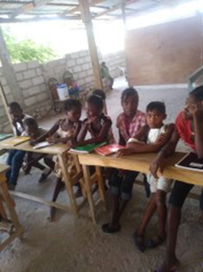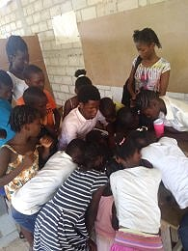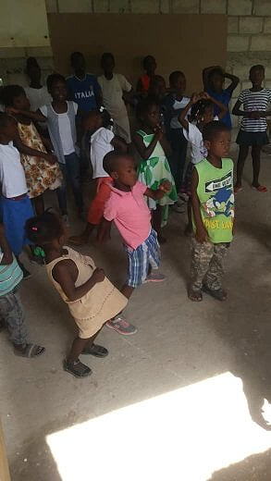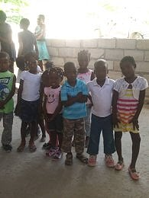
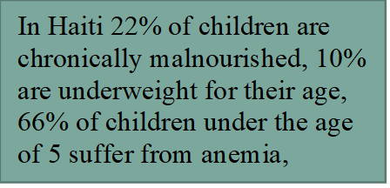
Students were able to play, eat, and learn at summer camp held at Institution Mixte Source Divine

COVID-19 WORK
We financed a video for COVID-19 that started playing in July 2020 on YouTube. We are planning to visit schools upon opening to recruit for the SET-Club and speak to the students, accompanied by health experts, about the pandemic. ( https://www.youtube.com/watch?v=wyI-_leZ2z8&t=1s).

- OUR APPROACH AND EXPERIENCES
Community participation is the key element of our success. It is present and active in all projects. People in the community have been so appreciative of our efforts, yet don’t realize they are instrumental in successful outcomes of any project. Thus, our approach differs from the classic one which consists in undertaking activities for populations guided by nonprofits. In our approach, success is attained through community guidance. Therefore, we choose to work with existing projects (e.g. SET-Club) and help improve them.

CONSTRAINTS
Our financial means were insufficient considering the extreme level of poverty, malnourishment, and other ills that plague Haiti. So, our approach was to work with the community very closely and use volunteers. Yet, communities have different needs. In Belle Fontaine it was roads, so the kids don’t have to walk three hours to get to school. In Jean-Rabel, in the northwest of the country, it was new school buildings and food. The one thing that was consistent is the harsh poverty. We heard from these communities that organizations come and go but Home Roots Foundation is in Haiti to stay. To do so we seek funding, which has been our biggest constraint.

FUTURE PLANS
Our immediate plan is to help more students enrolled in our schools. However, the high rate of malnutrition leaves us compelled to feed the children during school hours. School directors often make the school day short for fear that students (especially younger ones) may pass out in class from lack of eating. Most parents cannot afford to send their kids to school with a lunch. We want to start a school feeding program, extend the school day, and most importantly, help to make the children healthy. A school feeding program will be our next project!

