1. 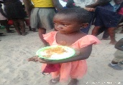Feed the Children in need 2. Blanket Provision to keep children warm during this winter

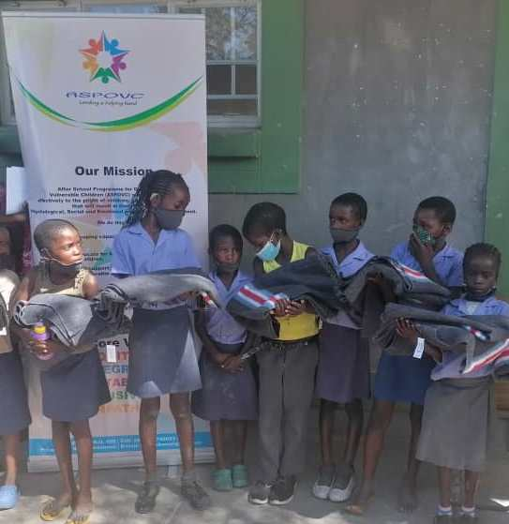

3. Under Tree couching at the project site. 4. Outreach/Home visit to gauge the root causes.

