Widows and Orphans Empowerment Organization (WEWE)

Who We Are
We are Widows and Orphans Empowerment Organization (WEWE) a 100% women led, not for profit, non-governmental, non-political, non-partisan, charitable, social welfare, faith-based organization (FBO) which follows the teachings and guidance of Jesus Christ, Our Lord and Savior, duly registered under the Corporate Affairs Commission (CAC), with her registered office situate at No. 25 Idanre Hills Street AMSSCO Platinum Estate, Galadimawa Abuja.

WEWE was founded in 2004 as a small Community Based Organization (CBO) registered with Okigwe Local Government (LG) welfare unit in Imo State in January 28, 2005. WEWE’s LG registration Number is OKLG/ARC 184. In 2009 WEWE was officially registered with the CAC and its registration number is CAC/IT/NO 33132.

WEWE is also registered with the National Budget and Planning Commission, Federal State Ministry of Women Affairs and Social Development, Anambra State Ministry of Social Welfare, Children and Women Affairs (MSWCWA), Imo State Ministry of Women Affairs and Social Development, Rivers State Ministry of Social Welfare and Rehabilitation, Civil Society on Malaria Immunization and Nutrition (ACOMIN) and Network of Civil Society organization against Child trafficking, abuse and labour (NACTAL) and Society for Water and Sanitation (NEWSAN) – Imo State Chapter.

WEWE, with the help of grants from Donor Organizations currently functions in the following technical areas: Democracy and Governance, WASH, Education, Health, Psychosocial care, Protection, Shelter, Nutrition, Food security and Household Economic Strengthening in line with the National Standards for Improving the Quality of Life of Vulnerable Children in Nigeria. WEWE also has technical capacity in Gender particularly in addressing Gender Based Violence (GBV) and preventing negative gender norms. WEWE is also very strong in resource mobilization and has helped build the capacity of 100s of local NGOs to raise millions of dollars to support their work. WEWE has built the capacity of 17 local NGOs in the area of financial, procurement, organizational and fundraising capacity to be able to access funds from International donors such as USAID directly.

WEWE has its Head Office in Abuja, Rivers and Imo States.

- WEWE Office Abuja No. 25 Idanre Hills Street AMSSCO Platinum Estate,
Galadimawa Abuja.

- WEWE Office Rivers State No. 1 Ike Crescent off Rukpokwu, New Road, Eliozu,
Port Harcourt

- WEWE office Imo State Plot 101, Housing Area C, New Owerri Layout,
Owerri, Imo State,

WEWE’s financials and Auditor

Audited financial statements:
WEWE has for the last three years had the following audited income (January – December)
FY19 - N 471,843,004 (approx. $ 1.3 million)
FY18 - N 1,045,244,069 (approx. $ 2.9 million)
FY17 - N 701,184,063 (approx. $ 2.0 million)
FY16 - N 385,521,851 (approx. $ 1.2 million)
FY15 - N 344,429,360 (approx. $ 1.5 million)

Annual income and accounting practices
WEWE practices Generally Acceptable Accounting Practices (GAAP)
WEWE is currently using QuickBooks Pro 2015 accounting Software

Auditors
WEWE’s statutory auditors are: Price Water House Coopers International Chartered Accountants (PWC)

2. Our Organizational Ideologies

At WEWE, we believe that;
- We can be used by God to significantly contribute to improving the lives of millions of widows, orphans, vulnerable children and other vulnerable population in Nigeria & Africa.
- The change the world wants to see may be hidden in the life and destiny of a widow and/or OVC.
- We need to be the best in what we do and we continually strive to beat our yesterday’s performance.
- In this Nation, we have highly skilled Nigerian professionals that can come together to show forth our spirit of excellence and ingenuity.
- We can be the most financially compliant local NGO in Nigeria and Africa.
- We can be an example of a credible NGO in Nigeria and Africa.

WEWE’s Vision
A society where vulnerable people achieve their full potential and actively contribute to national growth and development.

WEWE’s Mission
To implement effective advocacy and high-impact empowerment programs and services that continually improve the quality of life of orphans, vulnerable children and vulnerable women, working in collaboration with strategic partners.

WEWE’s Core Values
- Accountability and transparency: Being accountable to both internal and external stakeholders, upholding transparency and honesty in our operations and taking responsibility and ownership of our actions and decisions.
- Excellence: Upholding good work ethics and striving for the best in everything we do.
- Integrity: Committed to doing the right thing at all times.
- Partnership: Valuing working with relevant stakeholders, recognizing their potentials and values, and harvesting and deploying these resources appropriately for mutual benefits.
- Humility: Operating at the level of simplicity that the vulnerable people can feel free to approach and confide in us.
- Selfless service: Deriving joy and fulfilment in rendering service to the vulnerable without expectation of reward from them, but from God.
- Teamwork: Working together with one mind, for a common purpose, believing that together we can achieve more.

Our Incorporated Board of Trustees

WEWE is a women led, faith based NGO that supports and promotes the rights of women and also promotes gender equality particularly for women. WEWE Board of Trustees is women dominated and women led. Find below the members of our incorporated Board of Trustees:

Mrs Funmilayo Oyefusi, BSc. MSc. MCIPM
Trustee/Chairperson of the Incorporate Board of Trustees of WEWE
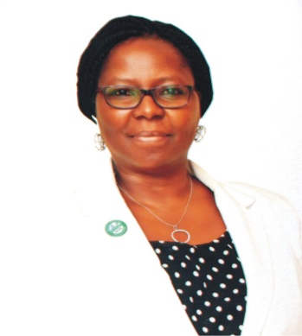
Mrs Funmilayo Oyefusi is a trustee and the current chairperson of the incorporate board of trustees of Widows and Orphans Empowerment Organization (WEWE).

She is a Human Resource and Organizational Development Practitioner with 25 years’ work experience. She is also currently the Director of Organizational Effectiveness in ActionAid Nigeria.

Funmi is a Member, Chartered Institute of Personnel Management (MCIPM) is a graduate of Agriculture from Obafemi Awolowo University Ile-Ife, Nigeria.

She also holds a Master’s degree in Global Human Resources from the University of Liverpool, United Kingdom. She is currently working on her PhD in Organizational and Human Development from the Atlantic International University, Hawaii USA.

Funmi is a member of the Institute of Personnel Management Nigeria and Society for Human Resource Management, USA. She serves as the Secretary to the Board committees of ActionAid Nigeria and has served as the secretary to Board Committees of ActionAid International Kenya, and as the Chair of Human Resource Policy Review Committees. Funmi has passion for organisational development, building the systems and structures of organisation, and building the capacity of the governance structure.

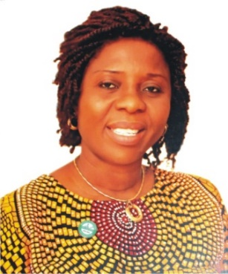
Ms. Gloria Njiowhor, B Art, PGD, is a trustee and secretary of the Incorporated Board of Trustee of Widows and Orphans Empowerment Organization (WEWE).

Gloria is a Trustee, Member and Secretary of the Incorporated Board of Trustee of WEWE. Gloria is a Nigerian public servant and she has worked for 13 years as a Chief Admin Officer in the Independent National Electoral Commission (INEC), Abuja office and her electoral duties covers the North Central, Niger zone

Gloria is a Senior Chartered Public Manager from the Chartered Institute of Public Management of Nigeria. Gloria has a Bachelor of Arts degree (B.Art) in English from the University of Port Harcourt, and a Post graduate Degree (PGD) in Public Administration from the University of Abuja. Gloria is currently carrying out a Master of Science (MSc) in Peace and Conflict Resolution from the National Nigerian Open University of Nigeria (NOUN).
Gloria is from Obio-Akpor Local Government Area of Rivers State.
Gloria is a natural women leader with a passion for improving the lives of vulnerable children and widows. She brings to the board her leadership, administrative, operational skills gained in coordinating elections and her passion for vulnerable children and widows.

SAM OMOKHOJE JEGEDE FCA, ACTI, MILRM, MBA
Member, WEWE Incorporated Board of Trustees/
Chairman, Audit Committee

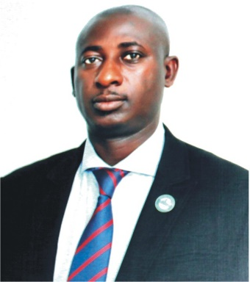
Mr. Sam Jegede is a trustee, member and head of the Audit Committee of the Incorporated Board Of Trustees of WEWE.
Sam is a Chartered Accountant by training (Fellow of ICAN), a member of several professional institutes such as 1. Associate of Chartered Institute of Taxation, Nigeria (CITN); 2. Associate of Institute of Loan & Risk Management (MILRM) and 3. Certified Institute of Cost Management of Nigeria. He is also a certified Management Professional Trainer by the Centre for Management Development (CMD) - Nigerians Training Accreditations Agency.
Sam has professional experience and certifications in Forensic Audit, Accounting, Financial Advisory, Revenue Assurance, and Tax Arrears Driver.
Sam has over 25 years cognate experience in Banking, Internal Control, Multinationals, NGO, Audits, Performance Management, Consultancy, and FGN Resource, Public Income Assurance Reviewer.
Mr. Sam Jegede has two Masters in Business Administration (MBA) in Finance from the University of Lagos; Executive MBA in Operations Research and Project Management from Obafemi Awolowo University, Ile Ife. He is an experienced Audit professional, a Fellow of Institute of Chartered Accountants of Nigeria (ICAN);
Sam has over two decades cumulative and cognate experiences were garnered from various sectors of the economy (the Nigeria Financial Institutions), namely EKO International Bank of Nigeria, SKYE Bank, First Bank of Nigeria, Bank PHB and KEYSTONE Bank (Polaris), In 1988, He worked with DHL International, where he distinguished himself resulting to being rewarded the first debagging Operations Team Leader.
A servant and minister of the most-high, committed to faith based purposeful living, believing in the undiluted word of the God. Sam is happily married with adorable kids.
Mr. Sam Jegede is from Owan East Local Government Area of Edo State.

Our Executive Management Team

WEWE has a 100% Female Management Team which comprises of the Executive Director, Project Director, Director of Finance and the Strategic Information Director who are all women in accordance with the vision of WEWE as a women led organization that supports and promotes the right of women.

Josephine OGAZI – EGWUONWU, PhD, BSc, MSc, IoD,
Founder/Executive Director and Chairperson of the Senior Management Team in Widows and orphans Empowerment Organization (WEWE).

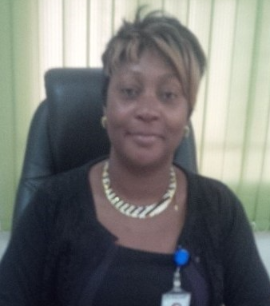
Josephine is the Founder/Executive Director and Chairperson of the Senior Management Team for WEWE.

She is a Nigerian development professional with over 30 years of working experience. Twenty (20) years of her work experience has been in domestic and international resource mobilization and organizational development (OD) of the civil society in Nigeria. She is also a Gender expert and has provided leadership to gender mainstreaming in all her intervention in WEWE.

Josephine has a PhD and M.Sc. in Agronomy and a B.Sc. in Chemistry, all from the University of Ibadan, Oyo State, Nigeria and she is a certified management consultant with Institute of Directors (IoD) Nigeria

Josephine is a born leader and her leadership skills were gained from over 20 years in senior management positions. Josephine leadership skills was gained while working as a Nigeria Country Director/Country representative for three International organizations and Chief of Party (COP) for three USAID funded projects where she successfully identified and accessed millions of US dollars in domestic/local resources for these organizations in Nigeria. The three international organizations are:
- Winrock International (WI), www.winrock.org 2000 - 2010 (10 years)
- University Research Company (URC) – https://www.urc-chs.com 2012 - 2014 (2 years)
- European Cooperation for Rural Development EUCORD https://eucord.org 2007 - 2009 ( 2 years)

Josephine has mobilized resources of over $40 million US dollars from domestic/local and international funding sources to treat, prevent, mitigate and provide support for thousands of adults and children living with HIV/AIDs and their families.

She has in-depth hands-on experience in resource mobilization and new business development with particularly strong expertise in competitive proposal writing which she has used to help local organizations and her own organization access funding for a direct grant from USAID Nigeria mission and this accounts for how she was able to lead WEWE to receive their first direct grant of $11,049,990 for a 5-year cooperative agreement with USAID Nigeria mission.

From 2014 to 2020 Josephine used her resource mobilization skills to provide leadership to WEWE management and staff to win and access five major projects listed below:
- A. US$11,049,990 for a Cooperative Agreement (CA) for a 5 years USAID funded Local Partners Initiative for Orphans and Vulnerable Children (LOPIN) project for Region 2 from 2014 to 2019. Region 2 covered Akwa Ibom, Anambra, Imo and Rivers State in Nigeria.
- B. US$113,283.084 (US$ 314,675) was a sub-contract from Chemonics International Inc. to implement an Organizational Capacity Development intervention for seventeen (17) of their local CSOs sub-grantees under their USAID funded Strengthening Advocacy and Civic Engagement (SACE) project. Josephine coordinated this subcontract and provided leadership and coordination to strengthen the institutional capacity gap of these 17 CSOs who were SACE sub-grantees in 10 states. The ten (10) states include Abuja, Rivers, Kano, Ondo, Edo, Delta, Lagos, Bayelsa, Akwa Ibom and Imo. The project focused on four areas of specialization which include (i) Institutional capacity, (ii) financial Management, (iii) procurement, (iv) Fund Raising and Report Writing. The duration of this OD intervention was from August 1, 2017 to October 12, 2018. Josephine led an 8-man team of management consultants with expertise in the above mentioned four (4) areas of specialization and she used the methodology of developing training manual and tools and conducting trainings in the form of onsite one on one skill development and workshop trainings one in Imo State and one in the Abuja.
- C. US$1,640,000 was a sub agreement from the Institute of Human Virology Nigeria (IHVN) under an award from Centre for Disease Control (CDC). The technical focus of the project was to implement the Orphans and Vulnerable Children component of Rivers State OVC Surge Project.

- This project is implemented in 17 local Government Area (LGAs) out of the 23 LGAs in Rivers State in over 200 health facilities from 2019 to 2020.
- D. N7,161,000 million (Naira) was received through a Letter of Agreement (LOA) from the Institute of Human Virology Nigeria (IHVN) under an award from Centre for Disease Control (CDC). This project is implemented in 23 local Government Area (LGAs). Its objective is to prevent and respond to gender-based violence, engage men and boys to address norms and behaviors around masculinity and sexuality, increase gender-related policies and laws that increase legal protection and Increase gender equitable access to income and productive resources, including education.
- E. N30,331,480 million (Naira) a sub-contract from Research Triangle Internatinal (RTI) to implement USAID Effective Water, grant Sanitation and Hygiene Program (E-WASH); from 2019-2022 in Imo State, Nigeria and provide COVID19 prevention project in Abuja.

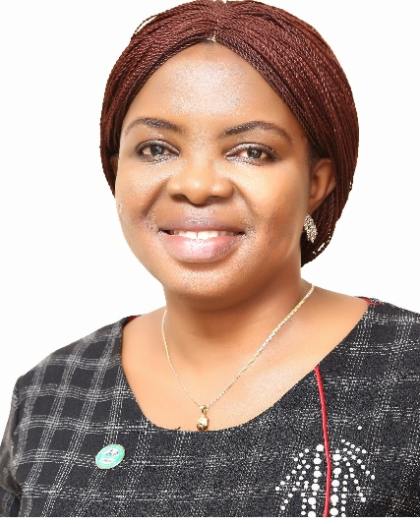
Mrs. Ngozi Orame - Okeke, HND, M.Sc. is the Director Programs and a member of the Senior Management Team (SMT) in Widows and Orphans Empowerment Organization (WEWE).
Ngozi is a Nigerian development professional with over 16 years’ experience in Orphans and Vulnerable Children (OVC), HIV/AID Programming, and Monitoring and Evaluation (M&E).
Ngozi has a Masters in Cooperative Economics and Management and a Higher National Diploma (HND) in Agricultural Engineering.
Ngozi is currently the Director Programs for WEWE. She has worked with WEWE for over 8 years. Before taking up the position of Director Programs in WEWE, she was the Deputy Chief of Party (DCOP)/Program Director for WEWE, for a project called ’Local Partners Initiative for Orphans and Vulnerable Children (LOPIN)’ from 2018 - 2019. She also worked as a Quality Improvement Director for the same LOPIN 2 project from 2014 to 2018. She spent two (2) years as M&E and Knowledge Management Advisor for a USAID funded project being implemented by a US International NGO called University Research Company from 2012 - 2014. She worked for two (2) years as the M&E Specialist for Children of Hope OVC project which was implemented by WEWE from 2011 to 2012.

She worked as M&E officer on a USAID funded OVC project called Care and Support for Orphans and Vulnerable Children SUCCOUR from 2010 to 2011 implemented by Catholic Secretariat.
Ngozi also worked as an M&E officer in USAID funded YCARE HIV prevention project which was implemented by Young Women Christian Association (YWCA) from 2008 to 2009. Prior to this position she work for five (5) years as Program Officer on a USAID funded Community Care in Nigeria (CCN) project implemented by Christian Aid from 2005-2008. Before then she worked on a USAID funded Global HIV/AIDs initiative (GHAIN) projects from 2003 - 2005 in a Community based Organization (CBO) called Care for the Child organization.

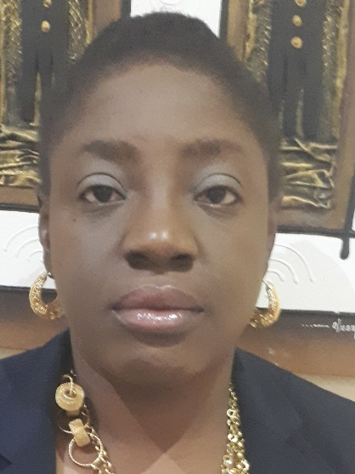
Funmi Adegbesan, FCA, MBA, B.Sc., ACIB, IoD
Director, Finance in Widows and Orphans Empowerment Organization (WEWE)
Member of the Senior Management Team (SMT)
Funmi Adegbesan is the Director of Finance in WEWE and she is talented in finance management of projects funded from International donors and especially in managing large budgets and ensuring compliance to statutory government requires and donor rules and regulations in Nigeria.

Funmi is a chartered accounting, a fellow of the Institute of Chartered Accountants of Nigeria (ICAN). Funmi has 15 years working experience in finance management for NGOs, which she gained from working as a Finance Manager and Director of Finance and subcontract with:
- Columbia University - International Center for HIV /AIDS Care and Treatment Program (CU-ICAP), 2006-2011.
- Center for Integrated Health Program (CIHP) 2011-2017,
Before joining WEWE, Funmi worked with Center for Integrated health Program (CIHP) for seven years and rose to the position of Director, Finance and Subcontract. In CIHP funmi managed a budgets of US$ 25 million dollars per annum. She started her career in NGO sector by working with for five years and rose to the position of Finance Manager. She started her working career as an Audit trainee with an Audit firm named Z.O Ososanya & Co, Lagos office and moved to Wema Bank Plc. where she rose to the position of an Assistant Manager.

Funmi is a Fellow of the Institute of Chartered Accountant of Nigeria (ICAN) and Associate member of Chartered Institute of Bankers, Nigeria (CIBN) respectively. She had a BSc. degree in Accounting and Management from Obafemi Awolowo University, Ife and Certification in Basics of Health Economic from World Bank Institute. She has MBA degree in Health Management from Paris Graduate School of Management, France.

Director Strategic Information (SI)
Mrs. Chidimma Okoye, B.Sc. (Hons), MPH,
Member of the Senior Management Team (SMT) of Widows and Orphans Empowerment Organization (WEWE).
Chidimma Okoye is currently WEWE’s Strategic Information (SI) Director. She has over 12 years of professional experience in Monitoring, Evaluation, Learning and Adaptation. She has an MPH, (Major Health Promotion) from the Federal University of Technology Owerri, Nigeria, 2018 and a B.Sc., (Hons.) Biochemistry, from Anambra State University, 2005. Prior to this position Chidimma was the Director, Quality Improvement on WEWE Local Partners Initiative for Orphans and Vulnerable Children (LOPIN) project from 2018-2019 and the Senior Monitoring and Evaluation Specialist/Advisor on WEWE LOPIN-2 project from 2014 - 2018.
Chidimma has 11 years’ experience of providing management of strategic information for Human Immunodeficiency Virus (HIV) and Orphans and Vulnerable Children (OVC) programming particularly in the area of Monitoring and Evaluation (M&E).

Chidimma is a member of the National OVC M&E Technical Working Group (TWG), and has trained the Federal and State Ministry on National OVC Management Information Systems (NOMIS). Chidimma is outstanding in OVC M&E and as a result of her expertise, WEWE has received commendations from USAID SI M&E Manager - Mr. Akinyemi O. Atobatele on our high performance in M&E reporting.

Chidimma was the Senior M&E Specialist on Management Science for Health (MSH) and Community‐Based Support (CUBS) OVC project from 2013 – 2014.

Chidimma worked for four (4) years as M&E Specialist on MSH CUBS project (2010 - 2013). Prior to this position she worked for two (2) years as M&E Officer on Christian Aid funded Community Care in Nigeria (CCN) project from 2008 – 2010. She worked for one (1) year as a M&E Officer as a volunteer on FHI360 - Global HIV/AIDS Initiative Nigeria (GHAIN) project from 2007 - 2008.

Chidimma is skilled in developing USAID M&E plans, facilitating USAID Site Improvement through Monitoring Systems (SIMS) Plans. She has conducting quantitative and qualitative data analysis using excel and Statistical Package for the Social Sciences (SPSS) to inform documentation of progress impact, decision making by stakeholders and lessons learned from projects/programs.

Chidimma has successfully built the capacity of Government and CSOs on M&E fundamentals and M&E management information systems in Nigeria for over 12 years. She has conducted training on M&E for over 20 CSOs and implementing partners M&E staff, desk officers of state Ministries of Women Affairs and Social Development, M&E focal person of the Federal Ministry of Women Affairs and Social Development and over 9 LGA Desk officers on data collection tools and reporting and also built their capacities on the use of the relevant National M&E tools and Management Information Systems such as NOMIS, and data demand, information and use.

- Current Projects

- N30,331,480 million (Naira), USAID Effective Water, Sanitation and Hygiene Program (E-WASH); 2019-2022 | Imo State, Nigeria | Total value:; AID-OAA-l-15-00033 – 0215989; Sub-grant from Research Triangle Internatinal (RTI)

WEWE is currently implementing the E-WASH Project in Imo State and Abuja through a sub-grant from Research Triangle Institute (RTI). The objectives of this sub-grant are:

- Promote sector-wide reform for improved public accountability
- Facilitate key utility (SWB) reforms for service improvement and social accountability
- Sanitation and Hygiene Promotion in urban communities

- COVID 19 Prevention (This was awarded in July 22, 2020)

Results as at March 2020: (i) WEWE has conducted advocacy for the provision of waste bins in schools; Conducted commemoration of Global Hand washing Day by the State Government: (ii) Review of Imo State WASH Policy On October 19, 2019; (iii) CSOs Interface/Meeting with the General Manager Imo state Water and Sewerage Cooperation and (iv). Mapping of urban WASH structures. WEWE in collaboration with Imo State Water Supply and Sewerage Corporation (ISWSC). Society for Water Supply and Sanitation (NEWSAN) and other relevant stakeholders organized for a training on open Defecation in Comprehensive Development. This involved Six (6) participants, which include School WASH Clubs, One Women Group, One Youth Group, Zonal WASH Customer Forum Meetings and quarterly Coalition Meeting. A total of 218 (100M, 118F) persons were reached with WASH interventions (water, sanitation and hygiene) with special emphasis on household water treatment and safe storage.

Among this number; 123 (60M, 63F) are students while 23 are women and the remaining 72 (40M, 32F) are Zonal WASH Customer Forum members, Coalition Meetings and youths.

- Rivers State Surge Project: 2019-2020 | River State, Nigeria | Total value: US$1,640,000 million (NGN);

WEWE received a letter of agreement (LOA) from the Institute of Human Virology Nigeria (IHVN) under an award from Centre for Disease Control (CDC). This project is implemented in 17 local Government Area (LGAs) out of the 23 LGAs in Rivers State in over 200 health facilities. The goal of this project is to improve the lives of 196,406 beneficiaries of Orphans and Vulnerable Children (OVC) households living with HIV/AIDs. Results: WEWE has successfully enrolled 957 HIV positive children and 2695 Adults.

- Gender Based Violence Prevention: 2019-2020 | River State, Nigeria | Total value: N7,161,000 million (NGN); 23 local government

WEWE received a letter of agreement (LOA) from the Institute of Human Virology Nigeria (IHVN) under an award from Centre for Disease Control (CDC). This project is implemented in 23 local Government Area (LGAs). Its objective is to Prevent and respond to gender-based violence, engage men and boys to address norms and behaviors around masculinity and sexuality, Increase gender-related policies and laws that increase legal protection and Increase gender equitable access to income and productive resources, including education. Results : Gender Based Violence Prevention for 2387 using the following strategies provision of minimum package of care for survivors of GBV, establishing a GBV response team make up of key stakeholder such as government, law enforcement, FIDA and Nigeria police.

- WEWE Past Projects
WEWE worked on the following projects in the past:
N113, 283,084. (US$ 314,675). Strengthening Advocacy for Civil Education (SACE): This project was implanted in 10 states Akwa Ibom, Bayelsa, Delta, Kano, Imo, Rivers, Edo, Ondo, Lagos States and Abuja FCT and it was to ensure that no less than six of SACE’s grantee partners fully developed the administrative capacity to implement a direct grant from USAID. The duration of the project was August 21st 2017 – August 20th 2018, and it had a budget of N113, 283,084.00. WEWE implemented an Organizational Development project which had a goal to build the capacity of for 17 local CSOs sub-grantees of a sub-contract from USAID funded Strengthening Advocacy and Civic Engagement (SACE) implemented SAII associates limited by guarantee (an associate of Chemonics International Inc.); The project’s goal was to strengthen the institutional capacity gap in 17 CSOs who were SACE sub-grantees in 10 states which include Abuja, Rivers, Kano, Ondo, Edo, Delta, Lagos, Bayelsa, Akwa Ibom and Imo. The project focused on four areas of specialization which include (i) Institutional capacity, (ii) financial Management, (iii) procurement, (iv) fund raising and Report Writing, from August 1, 2017 to October 12, 2018 and the project’s budget was N113, 283,084. (US$ 314,675).

The strategy and tools used was training manual and tools and conducting trainings in the form of onsite one on one skill development and workshop trainings one in the south (Imo State) and one in the north. (Abuja). The major results were:
Eight (8) of the CSOs who are SACE sub-grantees had adequate systems (organizational, financial, internal control, procurement and fundraising) to directly access USAID grants in Nigeria – CENSOJ, YAF, HDI, ANEEJ, LITE Africa, HERFON, WARDC and CISLAC
- All 17 CSOs SACE sub-grantees had improved organizational vision, mission/core ideologies.
- Ten (10) CSOs SACE sub-grantees had their policies (Human Resource, Financial and Procurement) revised to meet the minimum global standards
- All the 17 CSOs SACE sub-grantees significantly improved in their Organizational Capacity Assessment (OCA), Non-US Pre-Award Survey (NUPAS), Pre-ward Preparedness Self-assessment tool & Capacity Development Plans (CDP) as compared
to baseline assessment.
- There was a significant increase in resource mobilization and proposal writing skills of all the CSOs and 9 of them within 12 months were able to raise over $1 million dollars in grants from donors.

- $11,090,990 million US dollars - Local Partners for Orphans and Vulnerable Children (LOPIN) – Region 2 Project, with a budget of $11,090,990 million US dollars for 5 years 2014 – 2019.
The LOPIN 2 Project was a Direct Cooperative Agreement from USAID Nigeria to improve
the lives of over 85,000 orphans and vulnerable children in Anambra, Imo, Akwa Ibom and
Rivers States from 0-18 and 21,000 adult care givers who received evidence based quality
interventions as at March 30, 2018 and 17,000 of these targets are adolescent girls
between 10 -18.

These services cuts across the four domains “healthy”, “schooled”, “stable” and “safe”,
through direct service provision to the child, caregiver, community with emphasis on
building household economic resilience.

- US$ 2,047,000 - Children of Hope (CH) Project, Orphans and Vulnerable Children (OVC): This project was implemented in Imo, Enugu, Ebonyi, Oyo, Edo, FCT and Benue States. The nature of the project was to conduct a grant management program and provide sub-grants of $100,000 to $150,000 per annum to 10 local CBO/FBOs caregivers in 7 states valued at $1,764,996.48 for 2 years. The sub - grants were provided to 10 CBOs & FBOs to reach 11,055 OVC (5,466 males 5,589 female) and 2500 and 11,626 individuals (4974 males, 6652 female) – provided Household Economic Strengthening for over 4000 vulnerable households.

- N 34,010,831 (Naira). WEWE Positive Action Fund Project (PACF): This was implemented in Imo and Abia States, with the aim of providing Prevention of Mother to Children Transmission (PMTCT), providing education and referrals to 750 women of child bearing age in 20 communities. The project spanned from Oct 2012-Jan 2017 and it had a budget of N 34,010,831.

- FHI 360 Malaria Action Program for States (MAPS): This project was implemented in Oyo State to provide supportive malaria treatment and reduce the incidence of malaria among 1000 vulnerable pregnant women and children under 5 years old by 80% in 20 wards across 5 LGAs in Oyo State. A total of 2,405 Households were reached on malaria prevention. The project was for the period covering Aug 2014- Jan 2015.

(1) Civil Society Legislative Advocacy Centre ((CISLAC), (2) Centre for Social Justice (CENSOJ), (3) NECA's Network of Entrepreneurial Women ((NNEW), (4) Human Development Initiative (HDI), (5) Joint Organization of Persons Living with Disabilities ((JONAPWD), (6) Centre for International Technology and Development ((CITAD), (7) Health Reform Foundation of Nigeria (HERFON), (8) Ugboroke Progressive Fish Farmers Association (UPFFA), (9) Women Advocates and Research Development Council (WARDC), (10) Life and Peace Development Organization (LAPDO), (11) Africa Network For Environment and Economic Justice (ANEEJ), (12) Leadership Initiative For Transformation & Empowerment (LITE-Africa), (13) Nede Cooperative Development Fund (NCDF), (14) Youth Alive Foundation (YAF), (15) Citizens Centre for Integrated Development and Social Rights (CCIDESOR), (16) Edo State Cooperative Farmers Association (ESCAFAL) and (17) Health Reform Foundation of Nigeria (HERFON)

