ACTIVITY REPORT 2017-2019 (2 years) PRESENTED BY PEOPLE TO PEOPLE INTERNATIONAL-TOGO
CONTEXT
The goal of People to People International-Togo is to promote sustainable human development in fraternity on an international scale.
The objectives of the organization are to:
- Promote education;
- Fight against the degradation of natural and environmental resources;
- Support social cases and the sick;
- Promote the exchange of national and international cultures;
- Promote brotherhood between the peoples of different countries;
- Establish harmony and understanding between the peoples of different countries;
- Assist the poor and deprived children;
- Sponsor underprivileged children;
- Construction and renovation of schools
- Construction of a Water Reservoir
To achieve its objectives, People to People International-Togo (PTPI-TOGO) intends to intervene in the following areas:
Education ;
- Culture and international exchange;
- Humanitarian action and sustainable development;
- Environment.
Following this observation of serious deterioration of the educational system leading to a drop in school level.
The situation is so worrying that it requires a judicious diagnosis with a view to finding adequate and concerted remedies with the organizations concerned.
People to People International -Togo are called, given their socio-educational vocation, to take into account all categories of education in difficulty, among which are the schools: Public Primary School (EPP) of Amadenta Attieme, Prefecture of Agoe Nyive, EPP of Ando Adekpui, Prefecture of Ave, EPP of Ahepe Kpowla 1, Prefecture of Yoto, College of General Education (CEG) of Ahepe Kpowla 2, CEG of Tokoin Wuiti. Prefecture du Golfe, Private Secular School ETEBA, Prefecture of Golfe and EPP de Tokoin Dodome, Prefecture of Golfe.
OBJECTIVES
Main objective
Contribute to improving the education and working conditions of teachers and students.
Specific objectives
• Strengthen educational capacity.
• Promote education of excellence.
• Contribute to the improvement of teaching conditions and the environment of the education system.

ACTIVITIES REALISED
I : 2017-2018 :
1. Organization of Global Youth Service Day with awareness raising on excellence in education and the environment.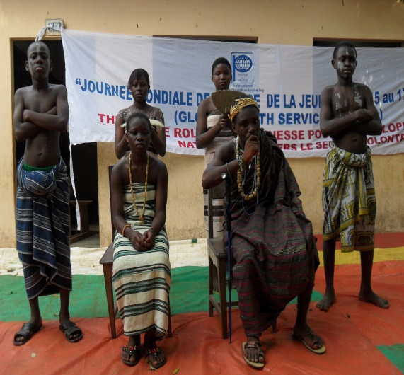 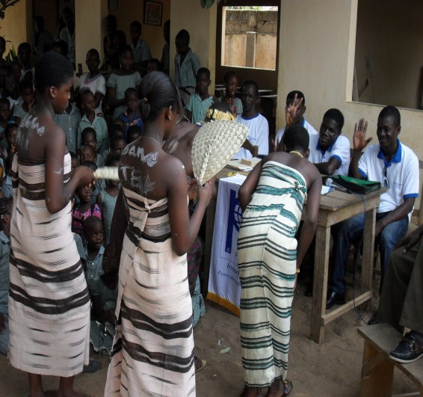 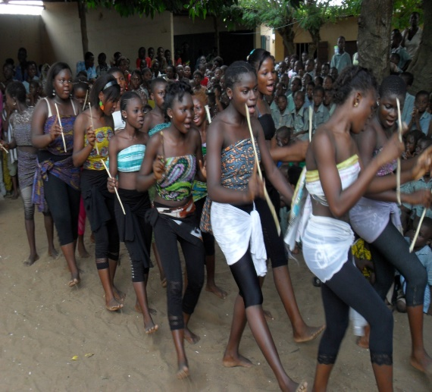 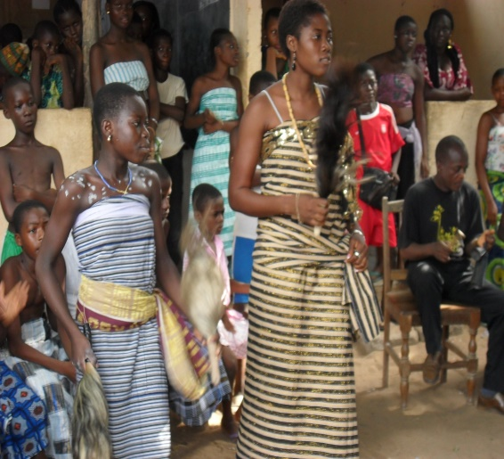

2 : Distribution of school kits and awareness at Tokoin Dodome Public Primary School.
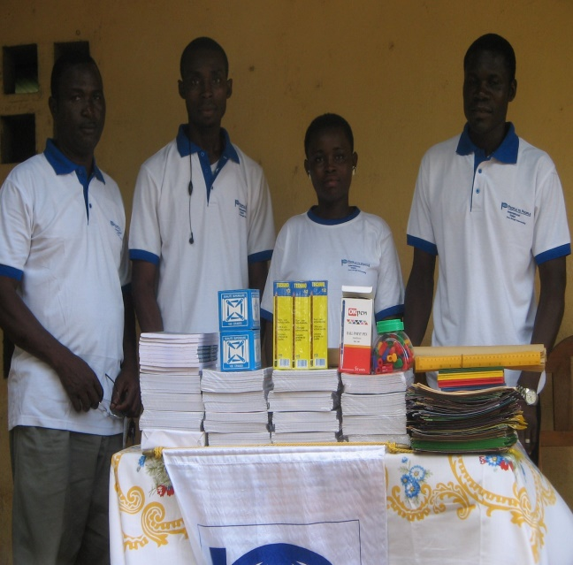
3 : Distribution of school kits, awareness raising and donation of 25 table benches to the Amadenta Attieme Public Primary School.
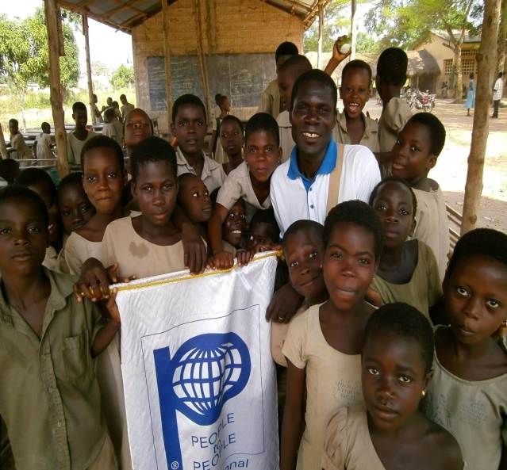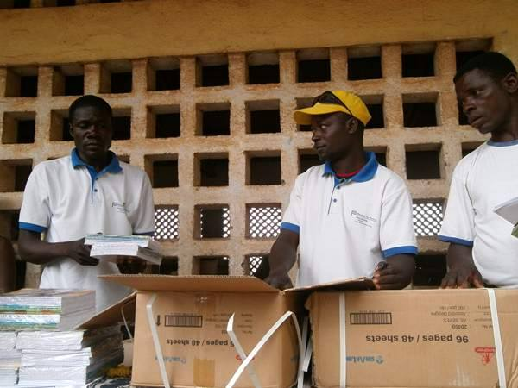
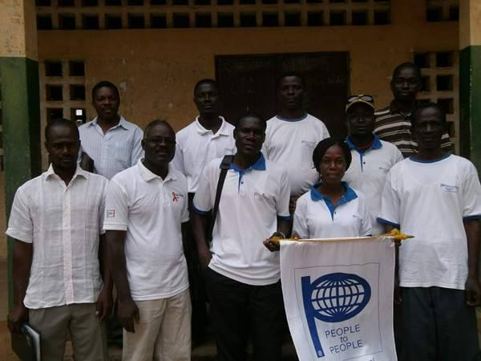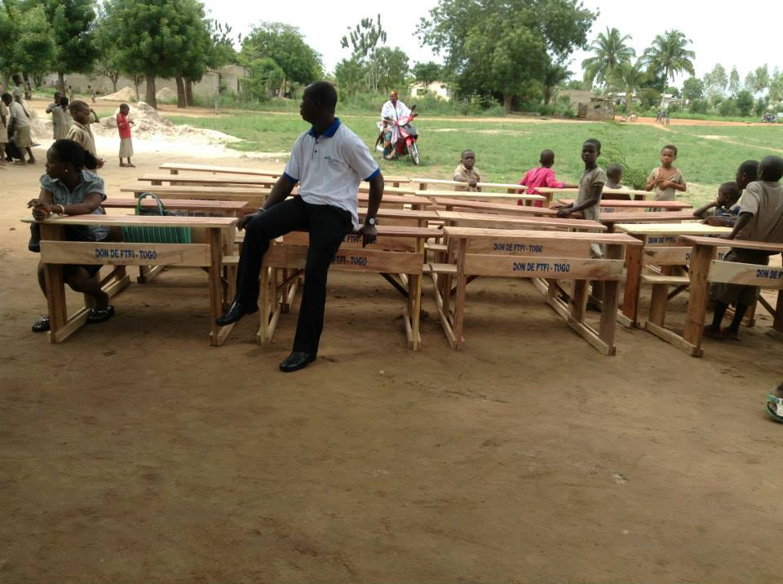
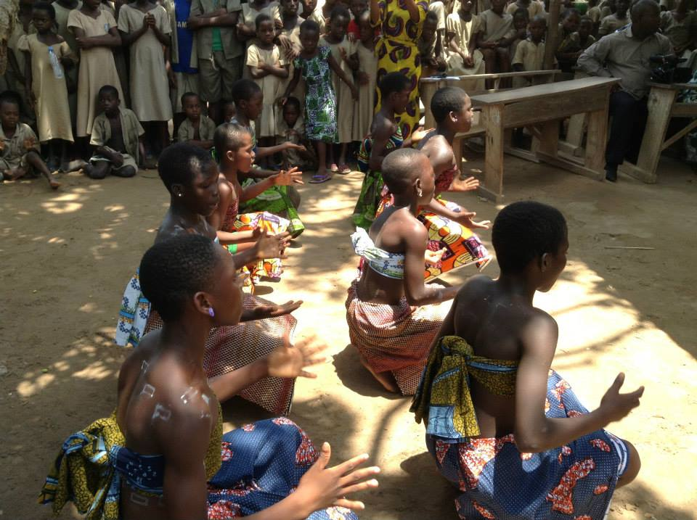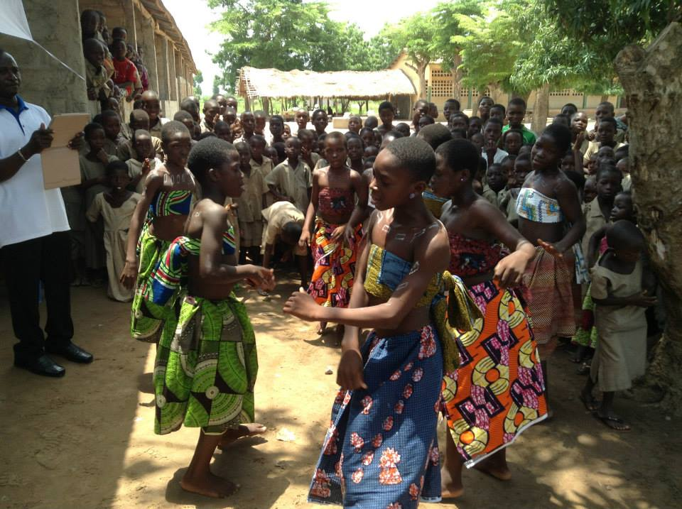
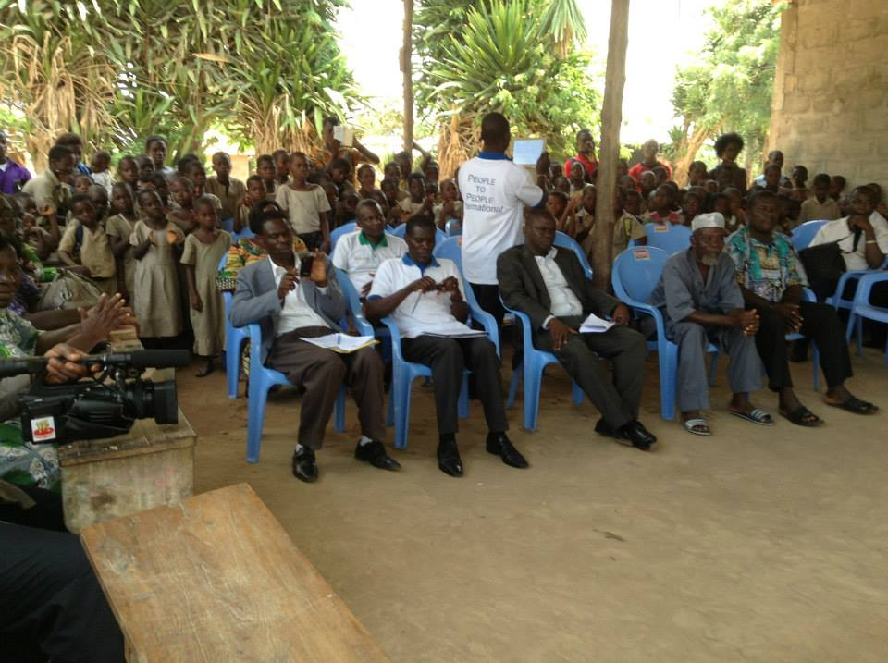
3 : Donation of scholarships for 25 students, school kits and awareness raising Tokoin Wuiti Junior High School on the importance of education and environmental protection.
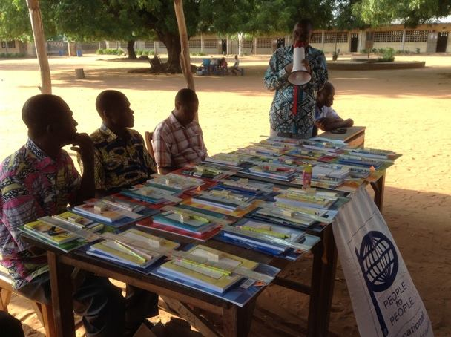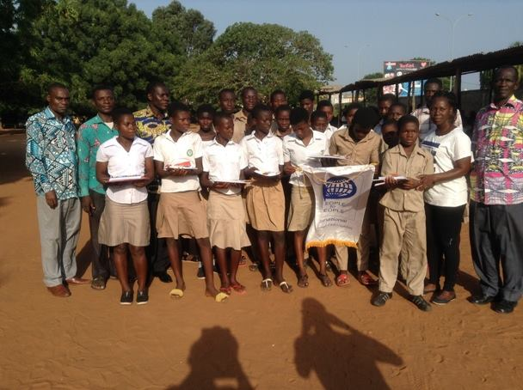
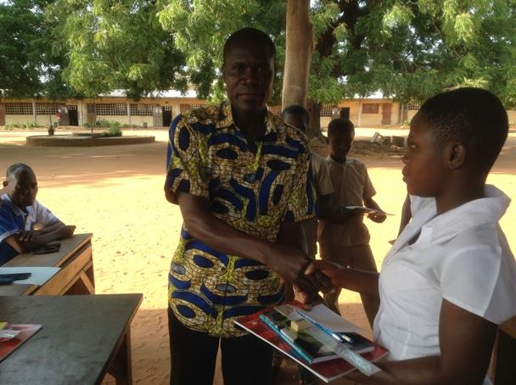
II : 2018-2019
1 : Construction of a classroom, a water reservoir, distribution of school kits, donation of table benches and awareness raising on citizenship at the Public Primary School of Ando Adekpui, Prefecture of Ave.
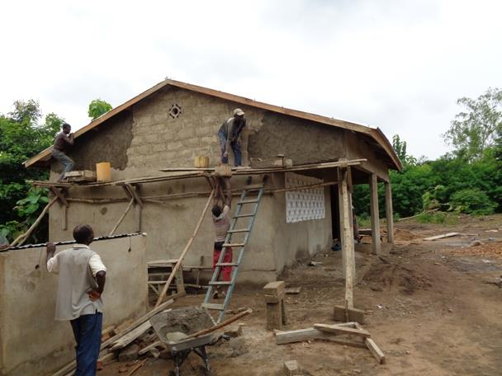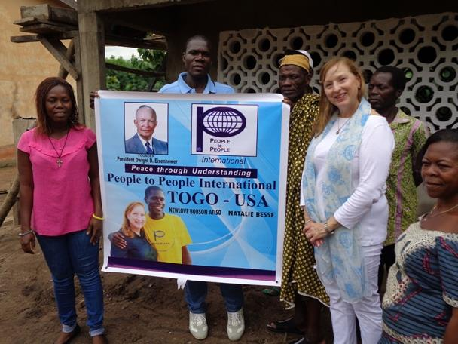
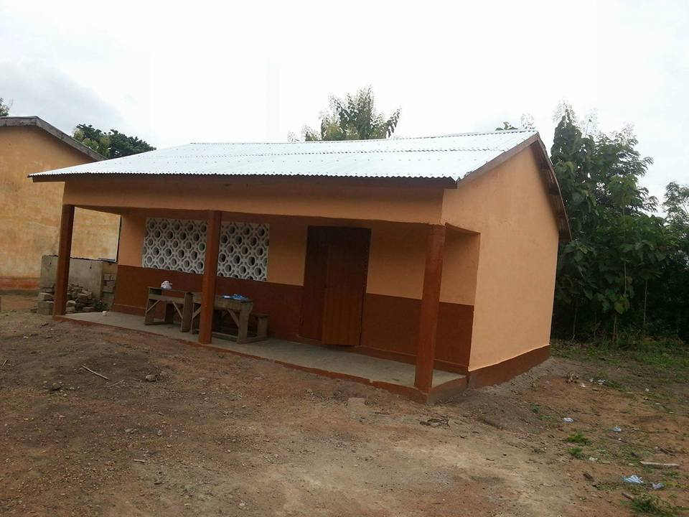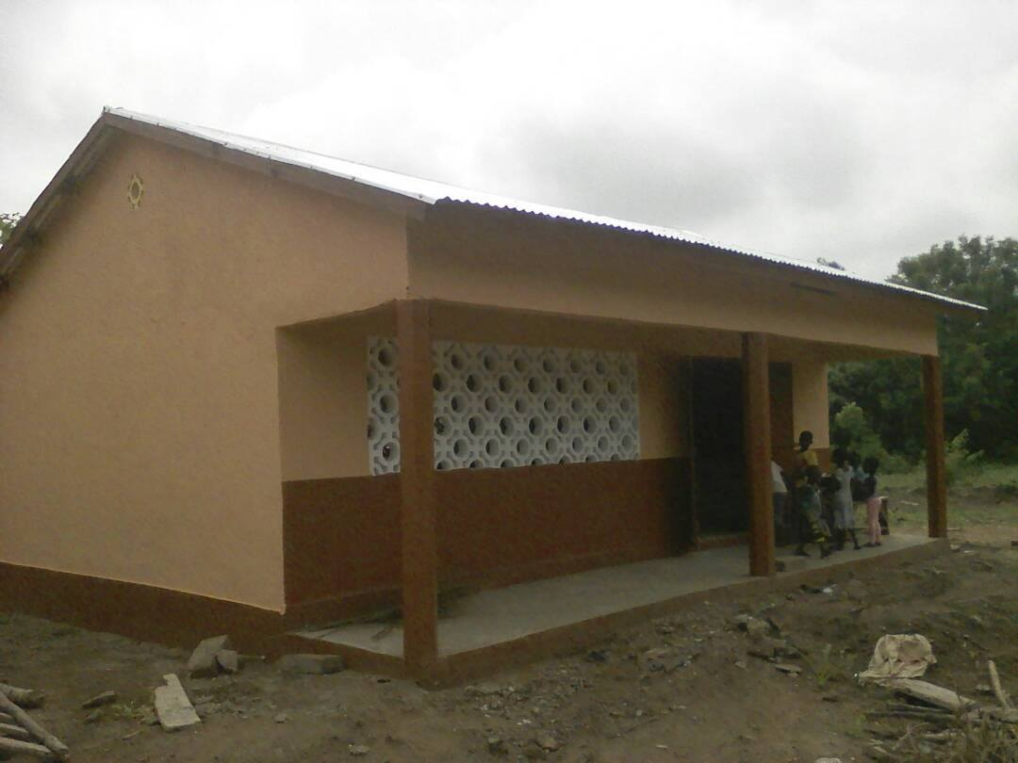
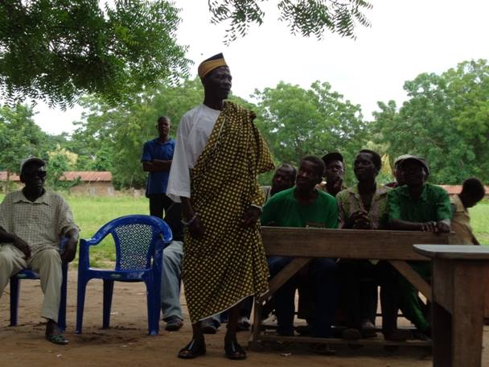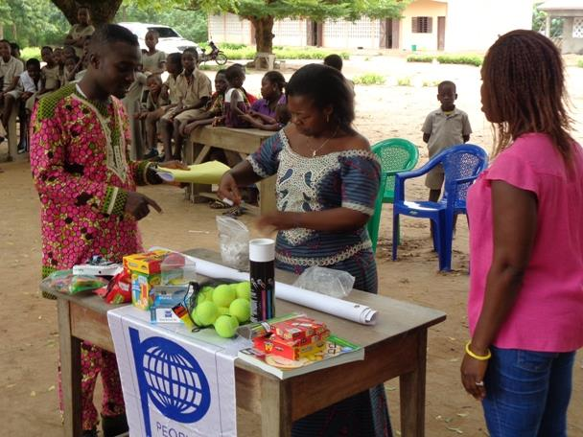
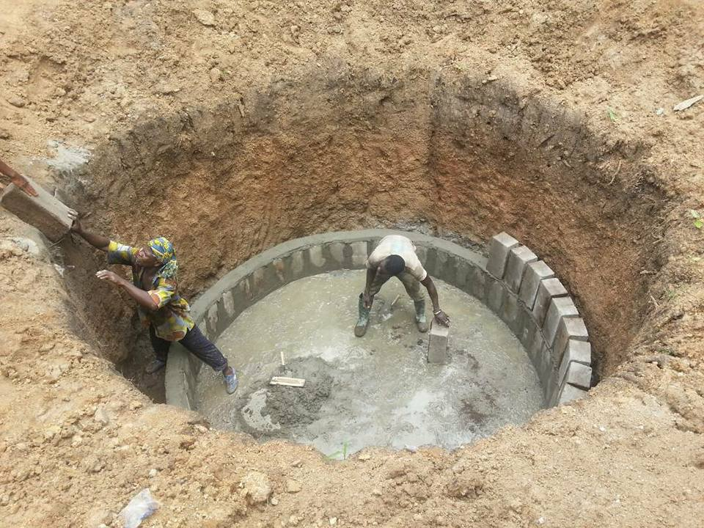
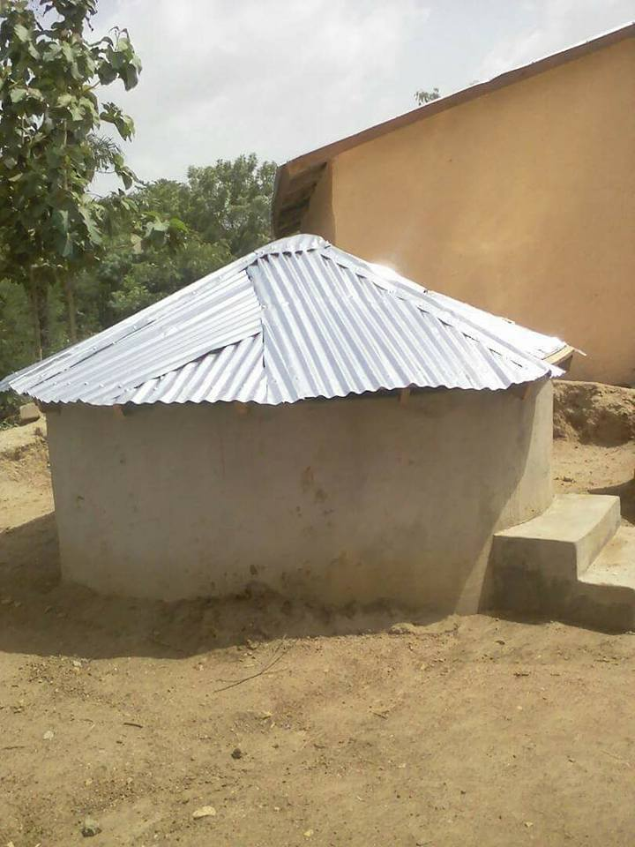

4 : Donation of scholarships for 15 students at Ahepe Kpowla 2 Junior High School, supplies of school kits and awareness at the Ahepe Kpowla 1 Public primary School.
5: Donation of scholarships for 25 students, school kits and awareness raising at Tokoin Wuiti Junior High School
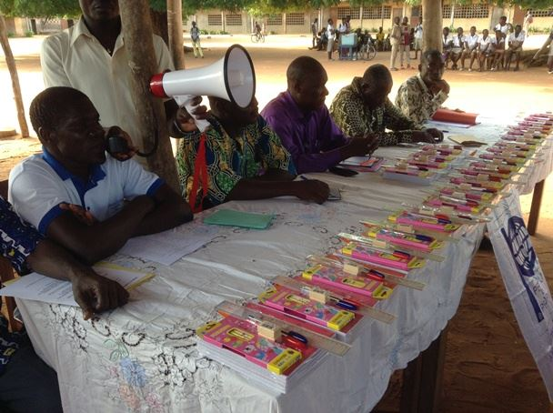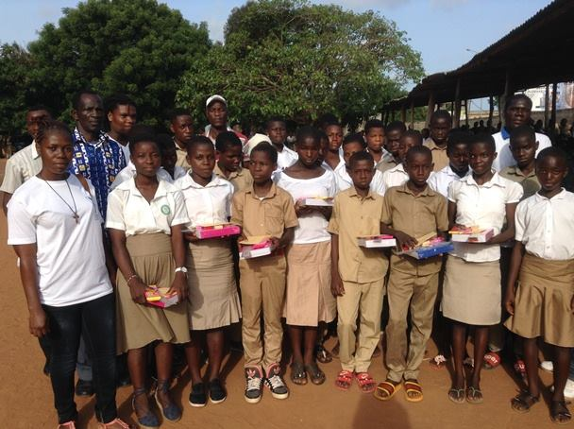
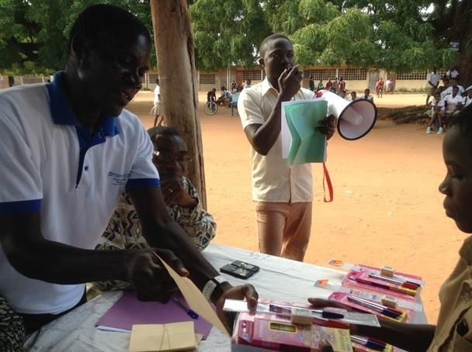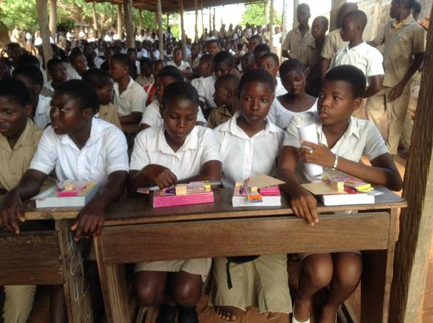
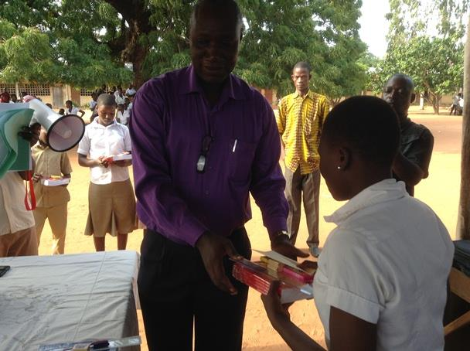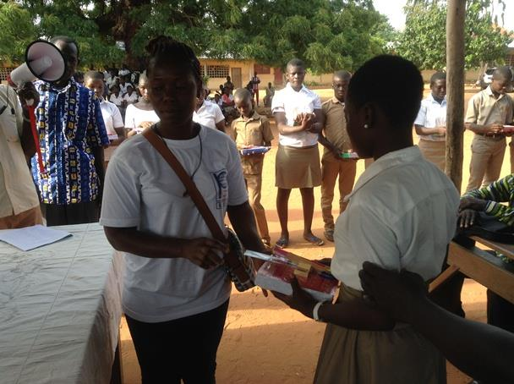
Apart from its activities in education, People to People International-Togo brought other actions last
2017-2019 such as:
- The donation of living assistance at the Cador Orphanage Center;
- Material support for the Adakpame Hospital Center;
- Organization of Forum on CULTURE FOR PEACE IN West AFRICA;
- Organization of the World Youth Service Day;
- Live and material support for people waiting for HIV / AIDS;
- Training in agriculture, animal husbandry and financial support for the 5 women's group in Ahepe etc.
PTPI-Togo to also participate in various training seminars, workshops organized by the States and other organizations.
Done in Lomé on 11/30/2019
ATISO Newlove Bobson
Founder / President

