KONKOURONA ALLIANCE FOUNDATION (KAFO), INC
FIRST MILE COMMUNITY DEVELOPMENT PROGRAM IN RURAL BURKINA FASO
Empowering the community of Konkourona to create a better future
August 2020
Konkourona Alliance Foundation (KAFO), Inc

101 Fairway Lane, Norristown, PA 19403, USA
1. Background 2
2. Situation analysis 3
2.1. Primary school education 3
2.2. Primary health care services 4
2.3. Water and basic sanitation 6
3. Recent developments 7
3.1. Association of Mami Siara Na 7
3.2. Projects completed 7
3.3. Regional authorities 8
4. First Mile Community Development Program (FMCDP) 9
4.1. Vision 9
4.2. Objectives 9
4.3. Strategic Approach 10
5. Sustainability plan 10
5.1. Administrative sustainability 10
5.2. Financial sustainability 11
6. Corporate capabilities 11
7. Primary stakeholder roles and responsibilities 13
8. FMCDP strategic framework 14

Background
According to the World Health Organization, in 2017 Burkina Faso ranked 183rd out of 188 countries on the poverty scale. This situation of poverty is characterized by poor access to basic social services and the lack of universal health coverage. As a result, health indicators such as a 61 year-life expectancy at birth, maternal mortality rate at 330 per 100,000 Live Births in 2015 and under 5 mortality rates at 76 per 1000 live births are among the worst in the world.
Burkina Faso is a typical “Sahelian” country, characterized by strong climatic variations, rapidly progressing deforestation and irregular rainfall. As a result, food supply shortages and poverty are permanent features, recently exacerbated by insecurity due to the rise of terrorist activities in the region.
Despite significant progress in improving primary health care access over the last few decades, the epidemiological profile is characterized by persistent periodic outbreaks of vaccine preventable diseases such as acute respiratory infections, measles, meningitis, diarrheal diseases and endemic communicable diseases such as malaria. The country is also experiencing a gradual increase in the burden of non-communicable diseases.
The issue of poverty is exacerbated in landlocked rural villages such as Konkourona, where the absence of basic infrastructure, lack of access to health, education and social services put the roughly 4000 subsistence farming inhabitants at risk of extreme poverty.
Migration of families from less hospitable areas of Burkina Faso has doubled the population of Konkourona in less than 2 decades. The pace of land degradation has accelerated. Erratic rainfall and the lack of coherent, sustained support from the government have contributed to transform Konkourona from a relatively green area into a more barren land with deteriorating soil and water resources.
Konkourona Alliance Foundation (KAFO), Inc. was created in 2019 to help break the cycle of poverty in this village as a proof of concept that, if successful, could be used to expand the experience to other villages in the sub-region. KAFO founders believe in empowering local communities to take action to create a better future.

Situation analysis
Like many villages in Burkina Faso, Konkourona faces many complex and interconnected challenges. Some of these challenges are amenable to solutions with relatively modest support from the government and non-governmental organizations (NGOs):
- Ineffective primary school education
- Lack of access to primary health care, including maternal and childcare
- Lack of access to clean water and basic sanitation
Recent developments in community awareness and mobilization provide an opportunity to address these challenges.

Primary school education
The school infrastructure is inadequate in Konkourona. Two grades are taught simultaneously in each classroom with up to 90 children in each. The existing classrooms were built by the government 2 decades ago and are poorly maintained, with crumbling walls, broken desks and a leaking roof.
- There is no library. There are no reading materials beyond textbooks and the few textbooks available are collected at the end of the day and unavailable for students to read at home.
- There is no lodging for teachers. Seven to 8 young teachers are appointed to the village each year. However, due to the lack of lodging, most of these teachers do not report to work. When they do, they must share makeshift lodging facilities in disrepair.
- Teachers lack basic classroom materials. The few textbooks provided by the government must be shared among 3 or 4 students. There are few rulers, compasses, maps, pens and other basic materials needed for education.
Given this situation, the quality of elementary education is abysmally low: only 1 or 2 children pass the mandatory end-of primary school exam. Those who pass this exam must travel to neighbouring villages to attend middle school, where they predictably fail, given the challenges such as the need to travel approximately 2 hours each way by bike along a dirt road, overcrowded classrooms, unavailability of textbooks and basic teaching materials, etc. As a result of this lack of academic success, the foregone conclusion for the children of Konkourona is to drop out school and join their parents’ subsistence farming activities, with no prospect of breaking the cycle of poverty. The future is particularly bleak for girls, who are subjected to early marriage, premature childbearing and a high risk of maternal mortality.
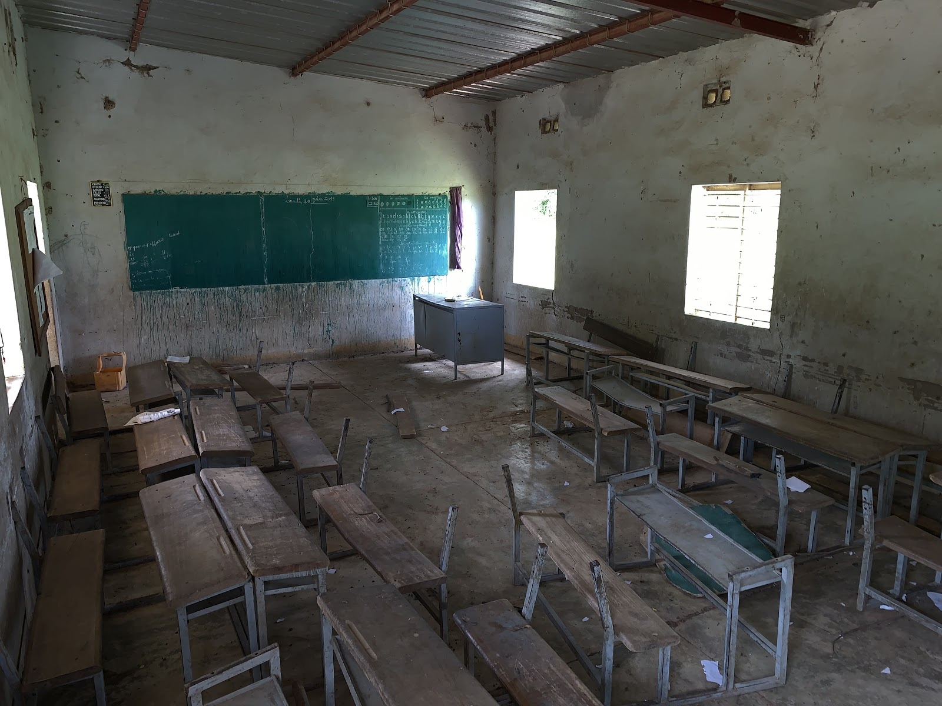
Existing, sub-standard primary school classroom

Primary health care services
Empirical evidence suggests that the high maternal and child mortality rates are in the vast majority cases due to causes that could averted through basic healthcare services, including the prevention and treatment of malaria, access to childhood vaccines, diarrheal disease prevention measures, antenatal and post-natal care. However, access to these basic services is limited to Konkourona population due to several factors:
- There is no health post. The nearest hospital is 50 miles away, in Bobo Dioulasso, the second largest city in Burkina Faso. The need to travel so far for health care presents an impractical and intimidating environment for subsistence farmers who do not have the necessary social network to support a hospitalization, nor the means to afford the cost of a physician consultation, hospitalization, or medication.
- There is no trained health worker. In the absence of a health facility, there is no government trained health worker living in Konkourona. The nearest government facilities tasked to organize outreach visits to Konkourona to provide immunizations and family planning education do so infrequently according to their availability and road accessibility.
- There is no pharmacy. Because the village does not have a pharmacy, access to essential medicines, vaccines and other health products is limited. As a result, inhabitants from Konkourona rely heavily on “traditional medicine and therapies” provided by non-trained healers.

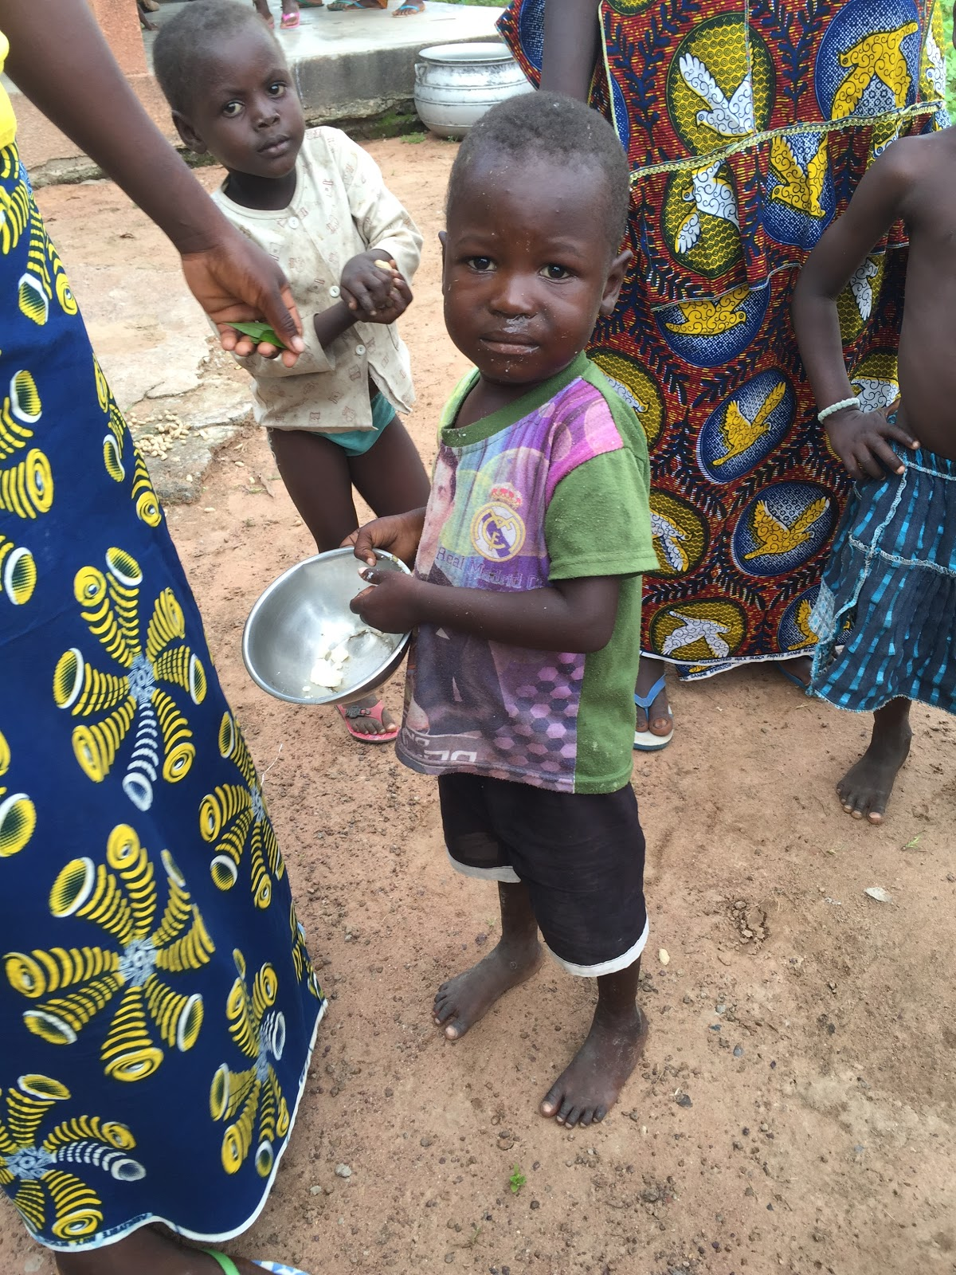
Young children in Konkourona

Water and basic sanitation
Burkina Faso is in the Sahel region where rains are scarce and limited to four to five months per year. As a result, water is in short supply. Konkourona, as in the vast majority of the 9000 villages of Burkina Faso, has no running water, and basic sanitation is lacking.
- The water supply is insufficient. Villagers supply their water needs from 3 wells equipped with manual pumps and other makeshift wells polluted by dust, farm animal faeces, insects and reptiles. Only a couple of these wells reliably have water yearlong; the others have intermittent yields. As a result, supplying water for the basic needs of the family is a major time-consuming activity for women
- The village lacks latrines. There are only few non-functional latrines near the school, which badly need renovation. As a result, open-air defecation is the norm in Konkourona. Practices that greatly increase the risk of contamination of food and water by deadly pathogens.
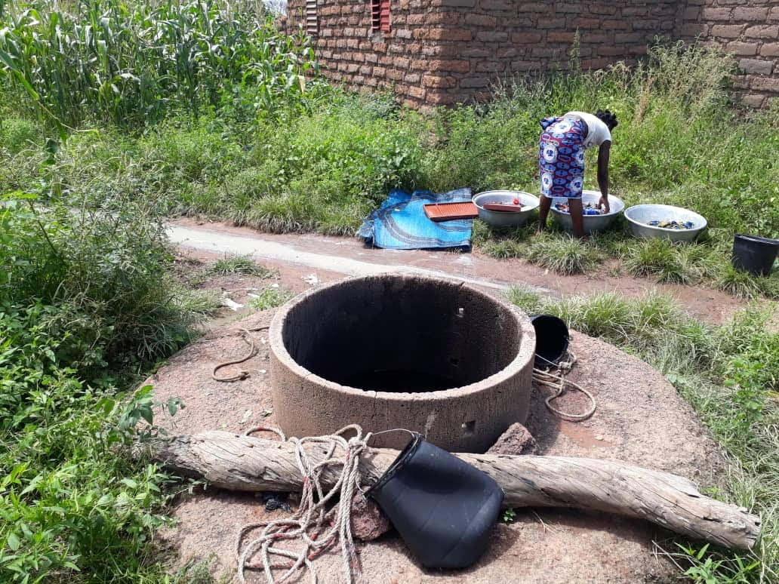
Makeshift well

Recent developments
In 2019, KAFO began efforts to empower the people of Konkourona through the Association of Mami Siara Na.

Association of Mami Siara Na
Several hundred men and women of all ages from Konkourona decided to join the Association “Mami Siara Na,” which means “We want Peace and Prosperity,” in the local dialect. Mami Siara Na (MSN) was registered as a non-profit organization with tax-exempt status for operation in Burkina Faso in 2019. The members of the association are highly motivated to promote and contribute to development efforts in their village. They demonstrated the strength of their commitment by providing the manpower necessary for KAFO funded construction to improve the school infrastructure. MSN is a very functional organization, with members contributing through dues and participating in regular meetings to make decisions about the future of the village.
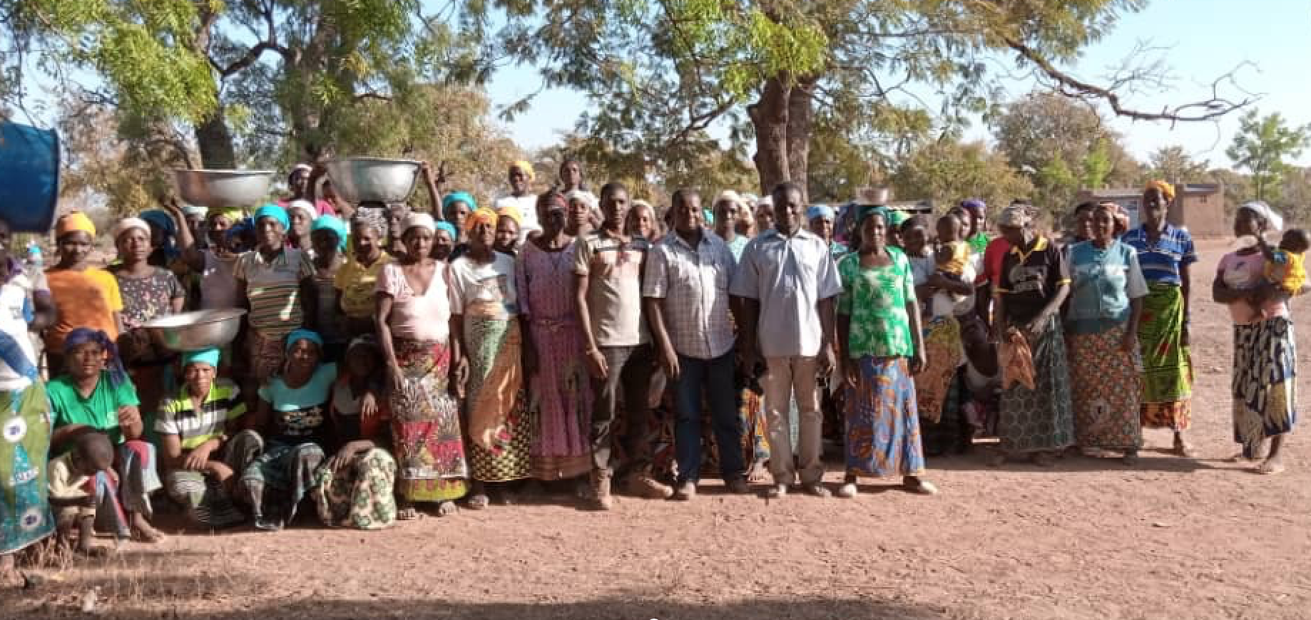
Members of Association of Mami Siara Na

Projects completed
Less than a year after its creation, KAFO/MSN managed to build 3 new classrooms and a school office, and is finalizing the construction of 4 new houses for teachers. In addition, 2 existing houses for teachers are being renovated. As a result of these activities, adults in the village, school children and teachers are very energized. For the first time in Konkourona education history, the success rate for passing the 6th grade exam jumped 10-fold; 20 children successfully passed the national exam this year. Teachers have vowed to enhance their commitment, offering to start school 2 weeks before the official beginning of the school year in an effort to further improve the number of students who move on to middle school. MSN also provides modest stipends for teachers to tutor students after school.
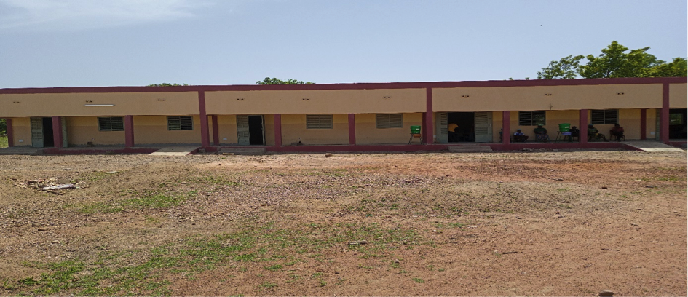
New school built by MSN (2020)

Regional authorities
Recent visits from regional health, education and administrative authorities provided strong encouragement and confirmed support for appointment of teachers and health personnel to Konkourona. Education administrators confirmed that Konkourona will serve as a center for national exam testing. This is a significant advantage for next generation of 6th grade children who will no longer have to travel several miles along dirt roads to take the exam, after which they are often exhausted and unprepared.
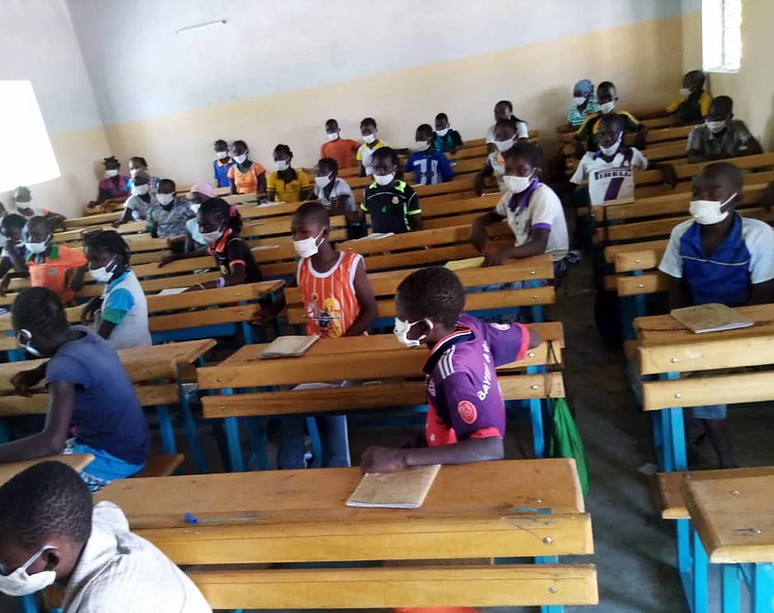
New classroom built by MSN (2020)

First Mile Community Development Program (FMCDP)

Vision
Remote villages in Burkina Faso are often considered to be “the last mile” for development, since most development efforts focus on national or regional needs and rarely make it to the villages. KAFO sees empowerment of villages as “the first mile” contending that overall development in the country can be enhanced through investment in rural communities, beginning with education of the children and improving basic care of all citizens.
Given the challenges in Konkourona, and the successes of empowering the people that are immediately apparent, KAFO intends to continue implementation of the “First Mile Community Development Program” in the village of Konkourona in partnership with MSN as a proof of concept, which can then be replicated in other villages in Burkina Faso.

Objectives
FMCDP objectives for Konkourona are to:
    - Strengthen educational opportunities for children
    - Provide access to primary health care
    - Improve access to clean water and basic sanitation

Strategic Approach
Core to the overall development strategy is partnership with the Association of Mami Siara Na in Konkourona on all projects. While KAFO will provide recommendations to focus efforts around education, healthcare, water and sanitation, KAFO will look to the Association for decisions about what is most important to them and about how any new infrastructure is maintained. It is Mami Siara Na who will lead discussions with government officials to obtain approvals for work planned and commissioning of staff to work in classrooms and healthcare facilities. Further, the Association will work with the School Director, parents and teachers to build the community support for education needed for students to be successful. It is the Association that will help generate revenue for sustainability of projects.

Sustainability plan
KAFO is acutely aware that while initially successful, many well-meaning development projects become ineffective over time without ongoing international support for maintenance activities. Schools, healthcare and other facilities are built but then quickly fall into disrepair. Aware of these pitfalls, KAFO has established a system that is designed to be self-sustaining beyond initial infrastructure investment. A plan to ensure administrative and financial sustainability has been developed to prevent that from happening.

Administrative sustainability
KAFO is ensuring that the following elements are in place for administrative sustainability:
- Leadership by an Association of citizens of Konkourona (Mami Siara Na)
- Partnership with regional administrative authorities during planning, execution and implementation of the projects
- Staffing and basic support are provided by the government and not replaced by KAFO’s efforts
- Ownership of the infrastructure by the community and regional administrative authorities
- KAFO complements existing government and community support, being careful not to create a new and parallel system

Financial sustainability
KAFO is ensuring that the following elements are in place for financial sustainability:
- MSN membership fees to support maintenance activities
- Rental fees for teacher lodging payable to MSN
- Support for initiating MSN revenue generating activities
- MSN user fee recovery for health services in the primary health center
- Fees to MSN for purchase of essential medicines from the pharmacy
- Continuing subsidies from government that exist for education, health, water and sanitation
- Active ongoing pursuit of collaborations with regional education, health, water and sanitation initiatives (e.g. Friends of African Village Libraries, Merck for Mothers, Georgie Badiel Foundation, Water Aid, Rotary International, etc.).

Corporate capabilities
Konkourona Alliance Foundation (KAFO), Inc. is a charitable NGO, incorporated in the United States of America with 501(c)(3) status. Less than a year after its creation in May of 2019, KAFO, in partnership with MSN, established a strong track record of delivering on its commitment to support the development of Konkourona.
Village schools built by the government typically lack electricity to save costs. Three new classrooms furnished with student desks and equipped with solar powered electricity, and an office for schoolteachers were built in the village, dramatically increasing school capacity. Electric lights and ceiling fans in village classrooms are groundbreaking by the standards in Burkina Faso. MSN also provided hand washing equipment and facemasks for those working on MSN projects and the school children to reduce the risk of spreading COVID-19. Construction of 4 new houses and the rehabilitation of 2 old ones to serve as lodging for the teachers will be completed in September 2020. The new houses will be equipped with exterior latrines and solar powered electricity.
KAFO is the first NGO in the history of the sub-region to make this level of contribution to the development of a village, an example that has the potential to encourage other villages to seek similar partnerships. Community leaders from neighboring villages have visited Konkourona to inquire about how this experience can be extended to them. Government political, health and education authorities have visited to provide encouragement and support for KAFO initiatives. Following the success in Konkourona, KAFO may expand its reach to other villages within Burkina Faso.
KAFO’s leadership in the US consists of volunteers who are employed in the healthcare industry. The KAFO Co-founder and President has a 30-year track record of success in public health leadership positions at sub-national, national and international levels. The Co-founder, Secretary and Treasurer has worked with national and international governments in support of public health for over 25 years. The other KAFO Board of Directors representative has provided primary healthcare for almost 40 years and worked in a nonprofit organization for much of that time (see APPENDIX 1).
Efforts in Konkourona are led by MSN, in partnership with KAFO. MSN is led by Father Siméon, a religious leader responsible for support of 13 villages in Burkina Faso, and by Victorien Millogo, a self-taught subsistence farmer and recognized leader in Konkourona. Both Father Siméon and Victorien have experience supporting other development efforts. All villagers are invited to join MSN with no discrimination based on race, color, religion (creed), gender, gender expression, age, national origin (ancestry), disability, marital status, sexual orientation, or military status, in any of its activities or operations. The Association currently consists of several hundred members.
KAFO’s and MSN’s technical partner, SCMS is a nationally renowned construction management company with an excellent track record of delivering high quality buildings, bridges and other major construction projects in Burkina Faso.

Primary stakeholder roles and responsibilities
Stakeholder | Role | Responsibilities
KAFO | Strategic leadership and funding | - Provide strategic guidance to MSN on development of Konkourona  - Build strategic partnerships to create synergies in support of projects  - Serve as advocates for development  - Ensure compliance with US laws governing 501(c)(3) corporations  - Provide managerial support for MSN to ensure continual progress and accountability to project timelines and budget  - Mobilize donors for funding of projects  - Promote and provide support for education beyond elementary school
MSN | Implementation and oversight | - Work with parents, the School Director and teachers to identify the priorities to support education  - Engage with government authorities to gain approval and support for projects  - Ensure compliance with national nonprofit laws  - Partner with SCMS to support infrastructure development by  - Mobilizing Association to provide labor  - Approving distribution of funds  - Overseeing the work to ensure it meets expected  - Develop community led sustainability plans for ongoing support of projects  - Lead community adoption of new behaviors to support education, healthcare and water
School Director | Quality of education | - Provide recommendations to MSN regarding priorities for improvement of education in Konkourona Primary School  - Distribute tutoring fees and materials to teachers  - Work with MSN to ensure maintenance of buildings and procedures needed to support education  - Participate in plans for sensitization of students for education, health, water and sanitation
Regional Administrative Authorities | Approval, implementation and oversight | - Approve infrastructure development plans  - Appoint and provide salaries for teachers and health workers for Konkourona  - Ensure continuing education of staff  - Ensure continuous provision of school and health equipment and supplies to current government standards  - Provide supervision and monitoring of education and healthcare activities  - Ensure appropriate maintenance of infrastructure  - Organize community sensitization on education, healthcare, water and sanitation  - Establish linkages with other organizations working in the region to create synergies and avoid redundancies for development projects
SCMS | Infrastructure development | - Develop architectural plans in alignment with government standards  - Execute construction projects  - Perform quality and financial oversight of projects  - Serve as a liaison between KAFO/MSN and government authorities  - Advise KAFO/MSN on good maintenance practices  - Provide detailed execution implementation reports on status of projects

FMCDP strategic framework
Objective | Major activities | Output | Timeline | Estimated Budget
Empower community members to lead village development | Support Mami Siara Na (MSN) activities for development of Konkourona | MSN regular meetings, documented decisions | Ongoing | As needed
 | Contribute to training and capacity building for community in management of programs and budget | Training to support projects | Ongoing | As needed
 | Encourage community contribution to funding for essential activities (maintenance of school, PHC, and water and sanitation systems) | Funding is available for essential activities | Ongoing | TBD
 | Promote Peer-to-Peer Learning between MSN and other community organizations | Study visits to other villages | 2021 | TBD
Strengthen education and improve opportunities for children | Build new classrooms and an office for the School Director and teachers and implement single grade instruction | 3 classrooms and 1 office | Complete | $60,000
 | Promote COVID-19 measures | Hand washing equipment, PPE | Ongoing | $345/year
 | Improve access to textbooks, school supplies, and sports equipment for children | Textbooks and school supplies each school year | Ongoing | ~$3000/year
 | Support additional tutoring for school children | Students passing 6th grade exam | Ongoing | $130/month
 | Ensure government support for Konkourona primary school | Teachers | Ongoing | Government funded
 | Provide housing for teachers | 6 houses | 2020 | $91,000
 | Provide support for children who progress to middle school, high school, technical school and university, as needed | Funds for logistics for students to attend advanced schooling outside of Konkourona | Ongoing | ~$10,000/year
 | Build a library | Library and books | 2022 | TBD
Improve access to Primary Health Care | Build primary health center equipped with running water and electricity, separate facilities for the general population and maternal care, a pharmacy, housing for healthcare personnel, and latrines | Primary health center  Maternity center  Running water  Pharmacy  Housing for healthcare personnel  Equipment and supplies  Konkourona included in MCH  Healthcare personnel  Essential medicines | 2021 | $240,000
 | Provide equipment and supplies for the health center
 | Provide transportation for patients and supplies
 | Include Konkourona in maternal and child health (MCH) support programs
 | Ensure the availability of staff, essential medicines and sanitary products for girls
Improve access to clean water and sanitation | Build additional wells in Konkourona to improve access to clean water | Wells | TBD | ~$12,000/well
 | Build latrines to improve sanitation | Latrines | TBD | TBD
 | Promote hygiene and sanitation practices | At least 2 training sessions/ year | TBD | TBD

APPENDIX 1 – BACKGROUND INFORMATION

Jules Millogo, MD, MSc

Co-founder and President

Konkourona Alliance Foundation (KAFO), Inc.

Norristown, PA – United States of America

Dr. Jules Millogo has been empowering citizens from Konkourona Burkina Faso to escape poverty for over 30 years through support of education, healthcare and business development. In 2019, Dr. Millogo co-founded the Konkourona Alliance Foundation (KAFO), Inc. to expand his empowerment efforts to include improvement of primary education for all children in Konkourona, support for more secondary education for those children who progress to middle school, provide access to healthcare, and provide access to clean water and sanitation.

Dr. Millogo is a Public Health physician with more than 30 years of experience working in developing countries at national and international levels. He joined Merck Vaccines as Medical Director, Public Health Partnerships in August 2010. In this position he serves as Merck’s liaison with the World Health Organization (WHO) and supports Merck’s engagements with other global immunization stakeholders. Within Merck, Dr. Millogo informs the company’s vaccine implementation programs, WHO Prequalification of vaccines, as well as the clinical and manufacturing divisions on vaccine packaging and formulations suitable for low- and middle-income countries.

Prior to joining Merck and co-founding KAFO, Dr. Millogo served for several years in John Snow, Inc, (JSI) a Non-Government Organization as Project Director of a 150 million-dollar US Government funded global initiative to reduce the risk of medical transmission of HIV/AIDS. In this position Dr. Millogo led the development, managed country and international staff in 12 African and Caribbean countries, and oversaw the development of national policies, the supply and distribution of injection and healthcare waste management materials and the training of health workers.

Prior to joining JSI, Dr Millogo worked at the World Health Organization (WHO) in Geneva/Switzerland supporting immunization programs in numerous African and Asian countries. Before joining WHO, Jules had worked in the Ministry of Health of Burkina Faso in various positions from District Medical Officer to Director of the National Immunization Program, developing the national immunization policies and guidelines and implementing outbreak response to public health emergencies.

Dr. Millogo holds a Medical Degree from the University of Ouagadougou, and a Master of Science (MSc) in Epidemiology of Communicable Diseases from the London School of Hygiene & Tropical Medicine, United Kingdom. He also received numerous technical and management trainings through various organizations including the World Health Organization and the Japanese International Cooperation Agency.

Catherine Hoath, B.S.

Co-founder, Secretary and Treasurer

Konkourona Alliance Foundation (KAFO), Inc.

Norristown, PA – United States of America

Catherine Hoath has supported many international efforts to make progress on the United Nations Sustainable Development Goals to end extreme poverty, reduce inequality, and protect the planet by 2030, but was unsure what impact that support was having. In 2019, Catherine co-founded the Konkourona Alliance Foundation (KAFO), Inc. to ensure greater traceability between the support she provides and the measurable results. She is eager to empower the citizens of Konkourona to make improvements in education, health care and access to water and sanitation as a proof of concept, and expand to other villages, once successful. Catherine holds a B.S. in Biology from Ursinus College, Pennsylvania, United States of America, and is currently on the Board of Directors for the Keystone Opportunity Center in Souderton, Pennsylvania. She is also a member of the Souderton-Telford Rotary Club.
Catherine is the Director of Regulatory Affairs International for Vaccines with more than 30 years of experience in the pharmaceutical industry, 25 of which have been in regulatory positions. In her current role, she leads a team responsible for global vaccine registration activities to prevent many infectious diseases. Within Merck, she leads development of innovative regulatory strategies for registration and encourages collaboration widely across departments. Encouragement for collaboration extends externally to include working with the World Health Organization as well as regional groups and trade associations to lead and support collaborative registration and policy development among countries to promote broad access to vaccines regardless of income levels.
Catherine partners with the President of KAFO to set the strategic vision for the organization and has led many of the non-profit start-up activities, serving as Secretary and Treasurer. As Secretary, she is currently responsible for scheduling and preparing for Board of Directors and team meetings, issuing official communications, agendas and minutes, ensuring adherence to Bylaws, and translation of all documentation from KAFO’s sister organization in Burkina Faso, Association of Mami Siara Na. As Treasurer, Catherine prepares the budget, tracks expenses, initiates bank transfers, completes all organization documentation required by state and federal governments (e.g. Articles of Incorporation, Bylaws, Solicitation, 501(c)(3), taxes, W-9), and coordinates audit of operations. As a co-founder, Catherine leads fundraising efforts by developing a website, sending routine updates to donors, maintaining platforms on LinkedIn, Facebook and Twitter, and identifying opportunities for partnership with other organizations (e.g. GlobalGiving, Rotary International, WaterAid, etc.).

Prior to joining Merck, Catherine conducted pharmaceutical research on potential treatments for ALS, oncology, cardiovascular, gastrointestinal and neurodegenerative diseases at Cephalon, Inc. in West Chester, PA and at R. W. Johnson Pharmaceutical Research Institute in Spring House, PA, both in the United States of America. Prior to those positions, Catherine held a position performing quality control testing for Gentrak, in Plymouth Meeting, PA, United States of America.

Gail P. Houseman, RN, CNS-BC
Board of Directors
Konkourona Alliance Foundation (KAFO), Inc.
Norristown, PA – United States of America

Gail Houseman, RN, CNS-BC has led and supported many professional and volunteer efforts to improve health care and education in the United States throughout her life, and has had a lifelong desire to support development in Africa. Gail has two adopted daughters, one from China, and one from Guatemala, and views the world without boundaries between people. She is committed to helping others live their best lives possible. Gail is a founding member of the Konkourona Alliance Foundation (KAFO), Inc. Board of Directors and helps provide strategic and financial oversight of empowerment projects in Konkourona. She holds a nursing degree from ?.
Gail is a registered nurse with almost 40 years of experience in direct patient care and education of prospective nurses. For the past 20 years, she has been working as a Regional Nurse Coordinator in a non-profit organization dedicated to helping patients with ALS. Within the ALS Association, Gail provides direct care, case management, mental health care and education to patients diagnosed with ALS, as well as their caregivers. Gail also coordinates the ALS Association Greater Philadelphia Chapter’s Visiting Volunteer Program, Care Connection Program, Shimer Loaner Program and Equipment Program. In addition, Gail works for Montgomery County Community College, instructing and supervising student nurses in the psychiatric setting.
In a prior role, Gail served as an Adjunct Faculty Clinical Instructor for Holy Family University, where she instructed and supervised student nurses in the psychiatric setting. Gail’s experience in caring for clients with psychiatric diagnoses came from her work at Friends Hospital, where she was a Senior Nurse leading psychoeducational groups, treatment planning and care coordination and was responsible for supervision and evaluation of employees.

Previous to working with psychiatric clients and nursing students, Gail worked as a Staff Nurse at the Roxborough Memorial Hospital, a Home Health Nurse at Community Home Health, a Nursing Supervisor at Saint John Newman’s Nursing Home and a Volunteer Clinic Nurse at Ten Communities Health Center, all in the United States of America.

