REPORT 8: OVERVIEW OF COMMUNITIES REACHED AND STORIES FROM THE GROUND

Our heartfelt gratitude goes out to Global Giving and our supporters for the generosity you have shown to those in need.

- INTRODUCTION

Nutrition, stimulation, and attachment are three essential components crucial for the optimal development and growth of children. The DO MORE FOUNDATION’s National Programmes place great emphasis on these aspects. Our comprehensive nutrition support encompasses Do More Porridge and Nutrition Education initiatives.
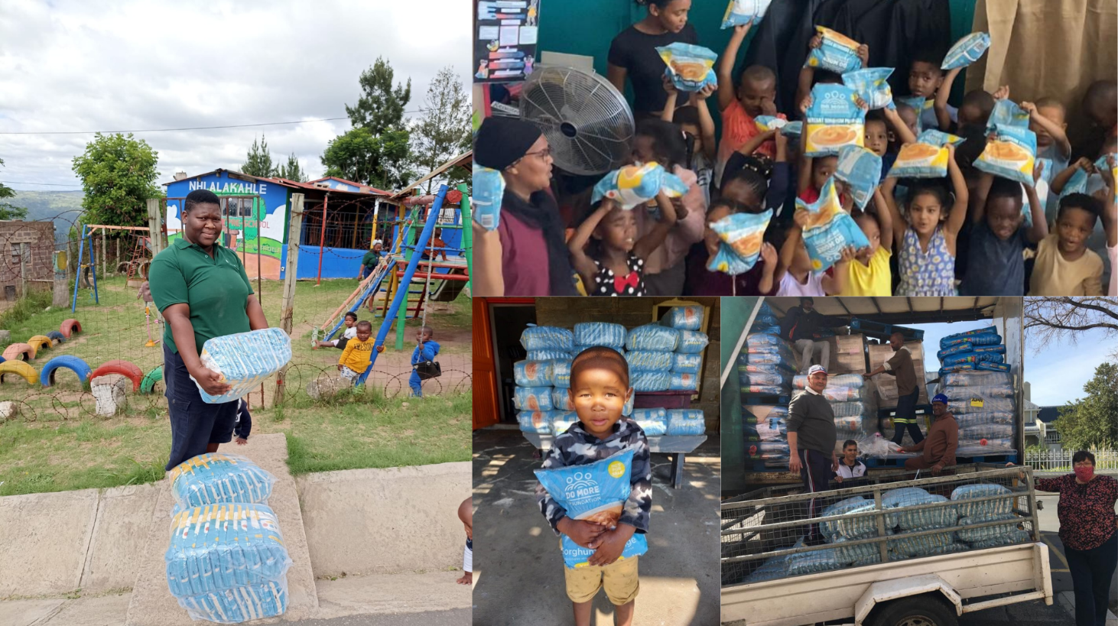
We firmly believe that Early Childhood Development (ECD) Centres have immense potential to serve as nutrition HUBs within communities. Recognising the Foundation's primary focus on young children, our interventions prioritise early childhood development. We understand that, in under-resourced communities, the porridge we provide sometimes becomes the sole nutritious meal of the day for many children. To amplify our impact, we have established a collaborative distribution network that reaches vulnerable households, ensuring multiplied benefits for those in need.
- NUMBER OF MEALS DISTRIBUTED

Your generous contribution has supported our efforts to provide 3,379 meals to young children in South Africa between April 2023 and June 2023.
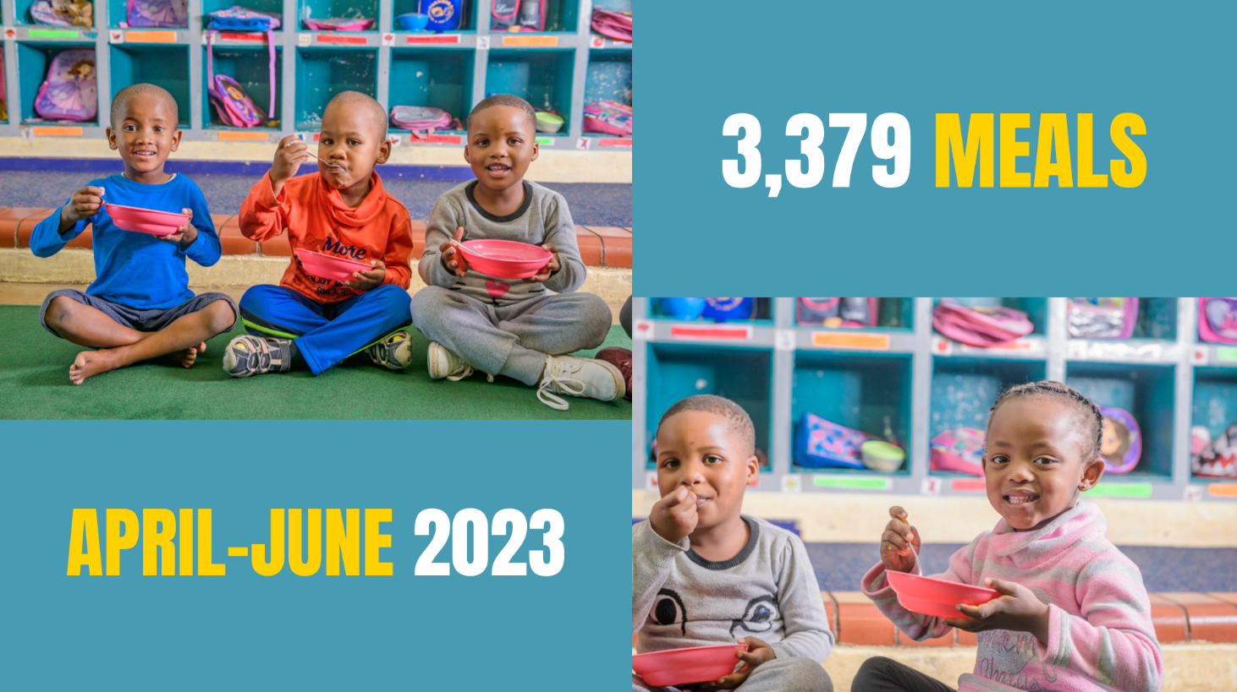

- END NOTE

To disrupt the cycle of inter-generational poverty, it is crucial that we ensure young children are granted a robust and fair foundation in life. By offering nourishment and fostering early learning opportunities for 20,000 of our nation's most vulnerable young minds, we can fortify their growth during the critical stages of human development (as 90% of brain development takes place before the age of five). This initiative will not only bolster their future well-being and economic prospects but also unleash the untapped potential of forthcoming generations. Your invaluable support brings us one step closer to realising this transformative vision.
Please feel free to review our website and social media platforms to view our ongoing work during this pandemic and beyond.

Website: https://domore.org.za/
Facebook page: https://www.facebook.com/domore.org.za/
Instagram Feed: https://www.instagram.com/domorefoundation/
LinkedIn page: https://www.linkedin.com/company/the-do-more-foundation/?viewAsMember=true

Thank you for #DoingMore!

Kind regards,
The DO MORE FOUNDATION team.

