REPORT 6: OVERVIEW OF COMMUNITIES REACHED & STORIES FROM THE GROUND

Our heartfelt gratitude goes out to Global Giving and our supporters for the generosity you have shown to those in need. When KwaZulu-Natal was hit with large-scale flooding in April 2022, leading to hundreds of deaths and thousands of people being displaced, the DO MORE FOUNDATION again responded with emergency relief to meet the needs of affected communities. Through your help and the generocity of corporate and individual donors as well as implementing partners on the ground, the Foundation distributed over 4,2 million meals to families and young children in the floods’ aftermath.

Responding to these disasters, particularly their effect on young children, has provided insights into how partnerships can be set up, both to meet the nutrition needs of young children in times of crisis and to address malnutrition through nutrition-focused caregiver programmes and more sustainable food systems.

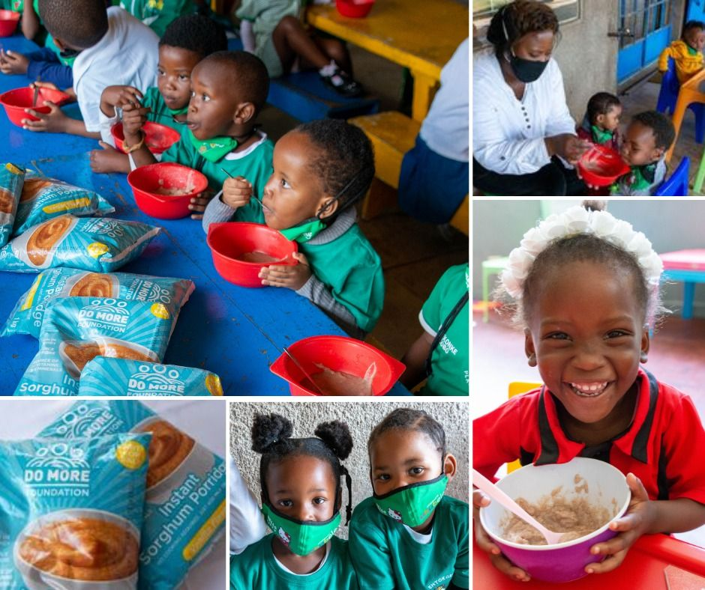

# INTRODUCTION

Nutrition, simulation, and attachment are three critical elements of children's optimal development and growth. As part of the DO MORE Foundations’ National Programmes our nutrition support includes Do More Porridge and Nutrition Education.

We believe that ECD Centres have the potential to function as HUBs of nutrition in communities. Given the Foundation's focus on YOUNG CHILDREN, our interventions support early childhood development, we know that the porridge is sometimes the only meal of the day that children in under-resourced communities receive. We are able to achieve greater impact through a collaborative distribution network to reach the vulnerable household for multiplied impact.

# AREAS OF DISTRIBUTION

Your generous contribution has supported our disater relief efforts to provide 4161 meals to children affected by the #kznfloods.

# END NOTE

To break the cycle of inter-generational poverty, we need to give young children a healthy and equitable start in life. Providing nutrition and an incentive for early learning for 20,000 of our countries most vulnerable young children will strengthen their development during the most fundamental years of human development (90% of brain growth occurs before the age of five); build their future health and economic prospects; and unlock the potential of future generations. Thank you for helping contribute towards this vision.

Please feel free to review our website and social media platforms to view our ongoing work during this pandemic and beyond.

Website: <https://domore.org.za/>

Facebook page: [https://www.facebook.com/domore.org.za/](https://www.facebook.com/domore.org.za/?redirect=false)

Instagram Feed: <https://www.instagram.com/domorefoundation/>

Linkedin page: <https://www.linkedin.com/company/the-do-more-foundation/?viewAsMember=true>

Thank you for #DoingMore!

Kind regards,

The DO MORE FOUNDATION team