
Africa Youth for Peace and Development

Shelter for Africa House- National Stadium
Freetown – Sierra Leon- West Africa
Website: www.aypad.com Email:info@aypad.com
Tel: 00232-33-588641-0023277833462-00232-33-834361

To advocate for civic education and literacy programs for youth

To seek lasting solutions for peace, unity and development among youth in Africa and the world as a whole

To promote the dignity and value of our heritage

To engage in War against Hunger Programs

EMPOWERMENT OF AYPAD WOMEN THROUGH MICRO-CREDIT FACILITIES

Background/Rationale
Objectives
Project stratigy
.Disbursement Schedule and Repayment Plan
Monitoring Mechanism
ATTACHMENTS
Registration form
Payment Forms
Rules and Regulation
Disbursement Form
Target Beneficiaries 50 Women of AYPAD Organization
Sponsoring Body: IOKO Credits
Funding Requested Le: 15,000,000(Fifteen Million Leone Only)
$5,000(Five thousand Dollars

Having seen harsh realities which are being experienced throughout the African continent as a result of violent wars, seven youth founded Africa Youth for Peace and Development (AYPAD) in 1995. AYPAD was registered in 2000, under the Ministry of Youth and Sports in Sierra Leone, as a non-governmental, non-profit youth development organization that aims at organizing, empowering and creating opportunities for youths and youth groups that are in difficult circumstances. AYPAD’s vision of continental unity for youth development and peace is rooted in the organization’s belief that violence achieves no meaningful goal.
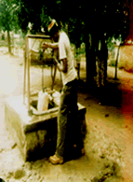

AYPAD Water Project

Background / rationale
The Africa Youth for Peace and Development (AYPAD) is a youth serving, empowerment and advocacy movement with a multi-faced mission and vision of ensuring peace and development among youths and the wider citizenry of Sierra Leone. among the organizations diverse activities, to name but few, are the commemoration of internationally declared events and days, such as the International Day of Peace, International Youth Day, Global Youth Service Day, World Environment Day, World Aids Days, including the International Women’s Day. Also, the organization has embarked on several national and community voluntary services, such as sanitation and beautification drives, teaching and mobilizing the energies of youths to be patriotic and enterprising by introducing team to life saving initiatives like waste collection and Management through tri-cycles and push carts.
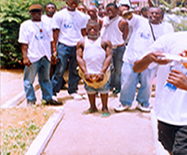
International Slaver Day
Obsessed with the desire to positively transform the lives and living conditions of vulnerable children (boy & girls) and women, AYPAD has been undertaken series of research and documentation of experiences together with suggested recommendations of street children and commercial sex workers, most of whom have subsequently been absorbed into AYPAD’s membership, and gradually acquired coping mechanism skills. AYPAD holds the view that women’s empowerment lies with that economic power and decision making abilities, which would also reflect positively on their children. The rationale of this request is to enhance the economic empowerment of the women members of AYPAD through the provision of revolving Micro-Credit scheme.

Youth on the street Forum

Objectives
- To ensure the economic empowerment of women members of AYPAD through the provision of micro credit
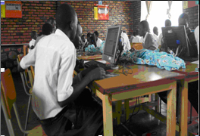
AYPAD Wireless and Communication Project

• To create a revolving loan scheme for women through the formations of Solidarity groups
Project Strategy
The main thrust of the project is to effect a revolving micro-credit scheme for women members of AYPAD as a means of enchaining their economic empowerment. To ensure these, members would be encouraged to form solidarity groups comprising three members. A number of seven to eight groups would be created from among the twenty and five targeted beneficiaries. These members would be given responsibilities as chairperson, secretary and collector per group who would co-monitor each other to ensure timely repayment of loans to ensure the support of other women in subsequent schemes. The strategy would also involve the registration of members, and preparation of membership card to be used as a means of monthly registration. Members would be encouraged to engage in a regular meeting to ensure effective utilization of the funds, overcoming problems and ensuring the timely repayment of loans.
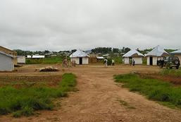
AYPAD Orphanage
Home

Disbursement Schedule
Upon registration and formation of solidarity groups, monies would be disbursed in cash to the groups head / chairperson, who would then be responsible to re-disbursed to the other members. Before disbursement, eligible members must ensure to fill in AYPAD’s financial records form and other important documents. Monies would be disbursed within a two-days time frame after all the necessary registration and documentation work would have be undertaken.
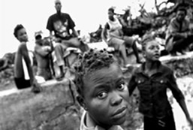
Girl Child Project

Repayment Schedule
The micro-credit scheme is hoped to be a revolving process and clients are expected to fully ensure repayment of loans given to them. Repayment of loan is expected to be done on a weekly basis. At the end of the week, the head of the group through the collector should ensure that all monies are collected and deposited in a recognized bank account of the organization. The loan is subjected to gradual increment based on the level of repayment performances of clients.
Additionally, clients would be encouraged to open savings accounts at a credible banking institution through which deposits would be made. These accounts would be controlled by AYPAD financial officials and supervised by gem officials.

Note: The clients who prove to be very effective efficient and ensure the timely repayment, would be encouraged through the offering of certain privileges such as exemption from re-registration fee, or be given some interest. for those who fail to comply with the timely payment of loans, would be required to re-register and a give would be levied against the group.

Monitoring Mechanism
The micro-credit scheme gold be monitored by a monitoring body comprising officials from IOKO Credits and AYPAD. This body would oversee the process of disbursement and repayment of the micro-credit scheme. Monitoring indicators would include photos, monthly progress reports, as we as, bank and financial statements.

