Marianne Foundation for Youth Development- Ibanda
(MFYDE)

Report – May 2021
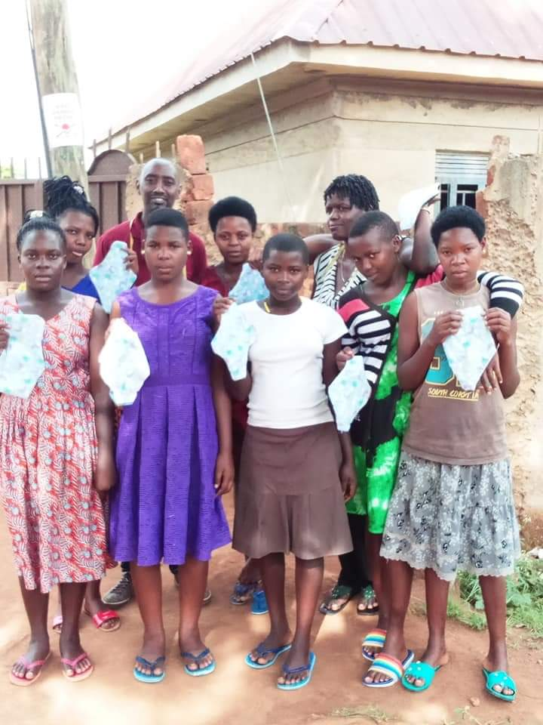
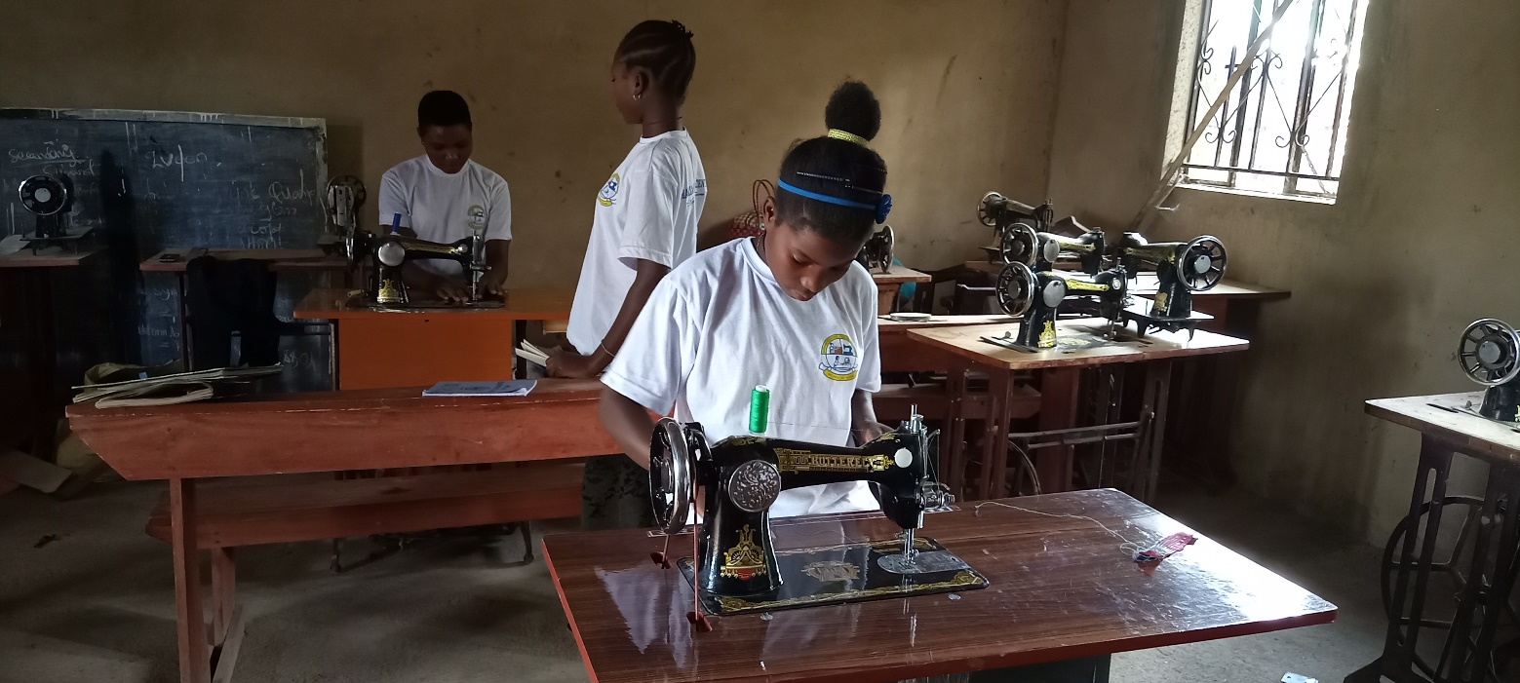

Project Name: Provision of pads to women and young girls in refugee camps

Introduction
Organization (Partner) Name: |  | Marianne Foundation for Youth Development
Partner Local Contact |  | Justus Ahimbisibwe |  | Report Date: | 10th May 2021
Partner International Contact |  | Clare Killian (International Development Director)
Partner Contact Titles: |  | Directors
Country: |  | Uganda
Project / Program Name: |  | Provision of pads to women and girls in refugee camps
Email: | Fyde.org@gmail.com  ahimbisibwejustus@gmail.com |  | Website:  www.mariannefoundation.com | Facebook :Marianne foundation Uganda
Donor: | Global Giving, Light my fire, Marcie Pourteous |  | Project Status: | On Going
Marianne Foundation for Youth Development (MFYDe) is an indigenous community based Not for profit organization working in western Uganda (www.mariannefoundation.com). We use a rights-based approach in our programming, whereby communities identify their own challenges and through rural performance appraisal, we agree with communities about what role they can play in solving their challenges and we work to identify partners who can help us help these communities live better. Rights-based approach also has an emphasis on the fact that every problem should be looked at as a human right and therefore the communities themselves make sure that their right is enjoyed. In our work, we relate the challenges that affect communities and encourage the communities to believe that it’s their right to get access to what they do not have. The communities are always encouraged to take the first step towards solving their challenges. This has created a bottom up planning for all our projects. Our projects are all community driven, focusing on women’s empowerment through health, economic, political and social empowerment.

Our Mission:
To empower rural youth and women to lead their communities in innovating appropriate solutions to their own challenges through mobilization, training, and expedient partnership development.

Our Vision:
Marianne Foundation envisions ‘an economically independent community sustaining itself through utilization and conservation of its own resources.’

Project Back ground:
Since its inception, the project has brought a total of 10 girls into a skilling program at Marianne Skills Center in western Uganda. The project was funded through Global Giving 2020 Accelerator. After the accelerator, Marianne Foundation was approved to be a partner at Global Giving. The project aims at skilling girls and providing 2000 reusable menstrual towels to refugee girls and women in vulnerable situations within the refugee communities of Rwamwanja Refugee settlement in western Uganda.

- ACCOMPLISHMENTS

No. | Village Name | Description | People Impacted
1 | Selection of girls to be trained in making pads | We selected 5 more girls out of the 10 who were most vulnerable.  In addition, the 2 girls were allowed to join under the community sponsorship. 3 girls could not be enrolled because the funding was limited. | 15 girls
2 | Training in making pads | In a bid to improve on our quality but also reach the local girls in rural Uganda, we got the services of Aine Dixon, the Founder of Sustainable Youth Development Foundation.  He trained the girls in making pads using their own hands, trained girls making pads using electric machinery, quality improvement, among others.  Due to COVID19, girls are being trained in two groups. The first girls are almost completing while the new girls are progressing well.  We distributed 600 pads in Easter holiday to the camps. However, these pads were handed over to the Refugee offices since they could not do open distribution. We joined Rotary club under their refugee program to do this. | 15 girls, 600 pads delivered to the Office of Refugees
3 | Procurement of sewing machines | We have so far bought more 5 sewing machines for the girls and more are arriving this January. Training is also going to be shifted to the refugee settlement since transportation and feeding the girls is highly expensive.

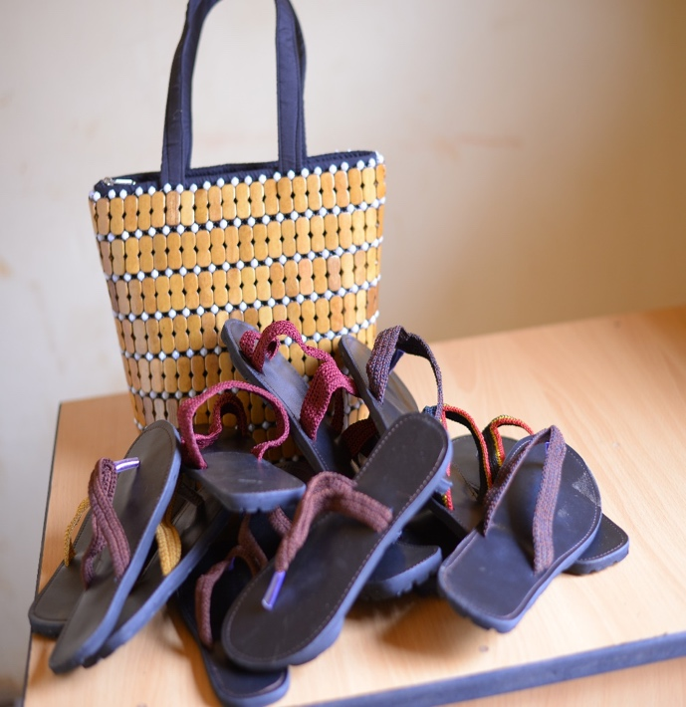
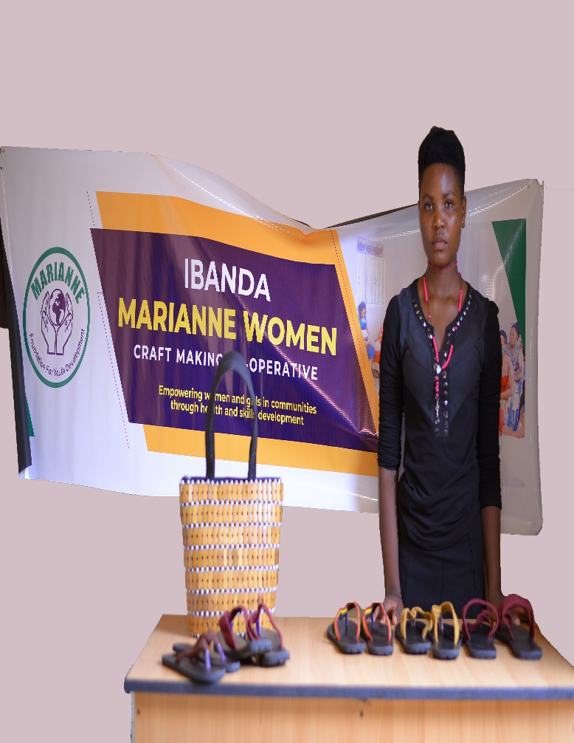
In addition to making pads, girls have been trained in making craft shoes. Such business needs capital to be supported. This will lead to employment of 20 girls in the garment and craft cottage.
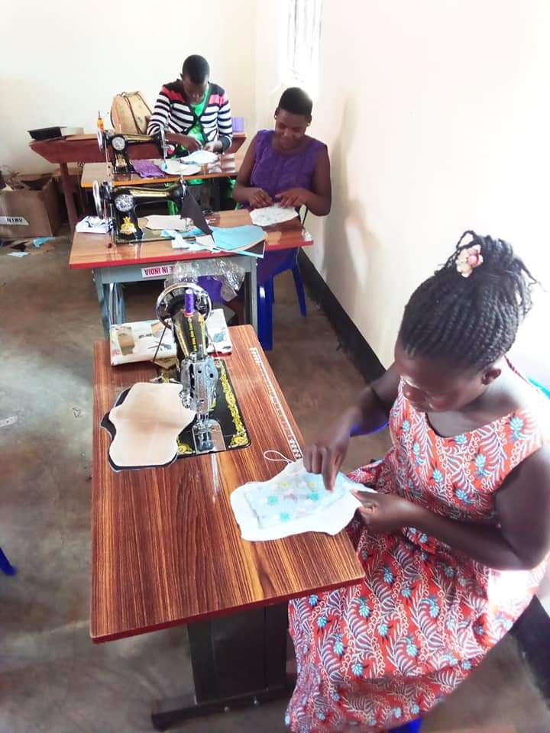
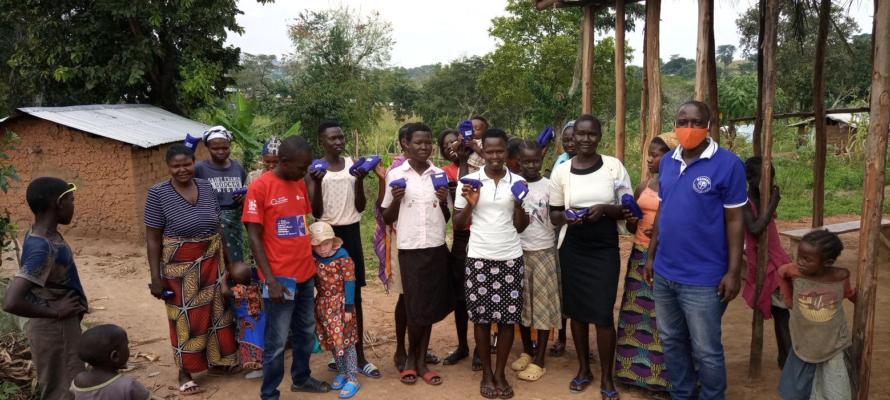
Above: Previously, we would distribute to the last person like in the photo above. However, this time, we delivered to the refugee office
Below: Women making pads with hands

Challenges
- Salary support: There is currently no funding to support a salary for the executive director. We ask well wishers to help and provide a fund for the director, as all of this would not be possible without Justus’ true heart and passion for this work. Please contact Clare Killian at clare.killian2@gmail.com if you are interested in being apart of this fund.
- Transportation: The organization does not have consistent, private transportation. Traveling in public puts every member of our foundation at the risk of the COVID-19. We will keep praying that friends and partners can fundraise for a simple means of transport. We therefore train in shifts which has presented additional challenges.
- Due to COVID19, we are only allowed to have 10 girls on training with strict regulations. This becomes a challenge in implementing of the project and makes every expenditure more expensive than what had been projected.
Future Plans:
- Keep fundraising for the maternal health center project
- Construction of a skills center in Rwamwanja settlement
- Begin women economic, social and health empowerment programs in the refugee settlement
- Continue fundraising at Global Giving to raise 4000 USD to enable us construct a health center in rural Uganda
- Launching of EmpowerPads onto the market

Our Appeals

- To anyone who is in the position to help, kindly partner with us to achieve our 2021 dream of the construction of a health center to reduce maternal death in rural Uganda: https://www.globalgiving.org/projects/mariannehealthcenter/
- Support the retooling of our skills center to enable us do industrial production of crafts and pads with a purpose of creating jobs for 20 young refugees
- We have reached a time of making our biggest recruitment!
    - We need our adolescent program coordinator and our executive director fully employed and paid living wages - we appeal for 12,000 USD to enable us employ both the executive director and adolescent program coordinator for 2 years.

Projected funding for future activities
Activity | Projected funding required in USD
Purchase of electric sewing machines, craft making machines and mixer for detergent manufacture. This will led to an employment of 20 refugee girls and 10 women | 5000
Continue fundraising at global giving to Purchase materials for making pads as a startup boost for the commercial pads to raise income to support the girls | 2000
Construction of health center in rural Uganda | 40,000
Procure vehicle for transportation of staff to conduct field work | 5000
Administrative support to 2 staff members  - Health and Adolescent Coordinator and Executive Director @ $500 per month | 12,000
Total Projected | 64,000

Marianne Foundation.
Financial Update as at 17th April 2021
 |  | Budgeted | Spent To date | Balance | Explanation
Training New Girls |  | 450 | 300 | 150 | Funds to be paid in the remaining months ahead
Learning Materials |  | 3375 | 2000 | 1375 | More materials
Sewing Machines |  | 1000 | 800 | 200 | The Machines were cheaper than projected
Training in making Pads as an income generating activity and Quality improvement |  |  | 400 | -400 | For sustainability and employability of the girls, we trained them in entrepreneurship, costing, profit margin calculation, etcetera
Transporting sewing Machines |  |  | 50 | -50 | We bought machines from nearby city in western Uganda
Feeding Girls |  |  | 400 | -400 | The girls are always accommodated at the skills center. We provide them food 2 meals per day.
Land procurement |  | 1700 | 1700 | -1700 | This land will either be for the health center or the skills center, whichever is funded first and needed first.
Global Giving Admin | 500 |  | 500 | -500 | This is always deducted for organization support at Global Giving
Admin |  | 150 |  | 150 | This was left to cater for an already deducted Global Giving fees
 |  | 6675 | 6150 | 525

Conclusions & Acknowledgements

We thank Wendy of Global Giving, all friends of our development Director – Clare Killian for your role at international scene despite of your hard work at Boston University. We thank Macie Porteous for your timely donation through Global Giving. Please know that the all the girls under the skilling program, the women that received pads, all acknowledge your efforts in solving their menstrual health challenges.
Thank you for trusting Marianne Foundation amidst COVID-19 pandemic around the world. We promise never to take this trust for granted. We will forever treasure this trust and build on it to impact the current generation so that the many generations to come will find our communities in a better place to live in.

The words of Johan Wolfgang are always good to us: “The world is so empty if one thinks of only mountains, rivers and cities; but to know someone who THINKS and FEELS with us, and who though DISTANT, is close to us in spirit, this makes the earth for us an inhabited garden!”

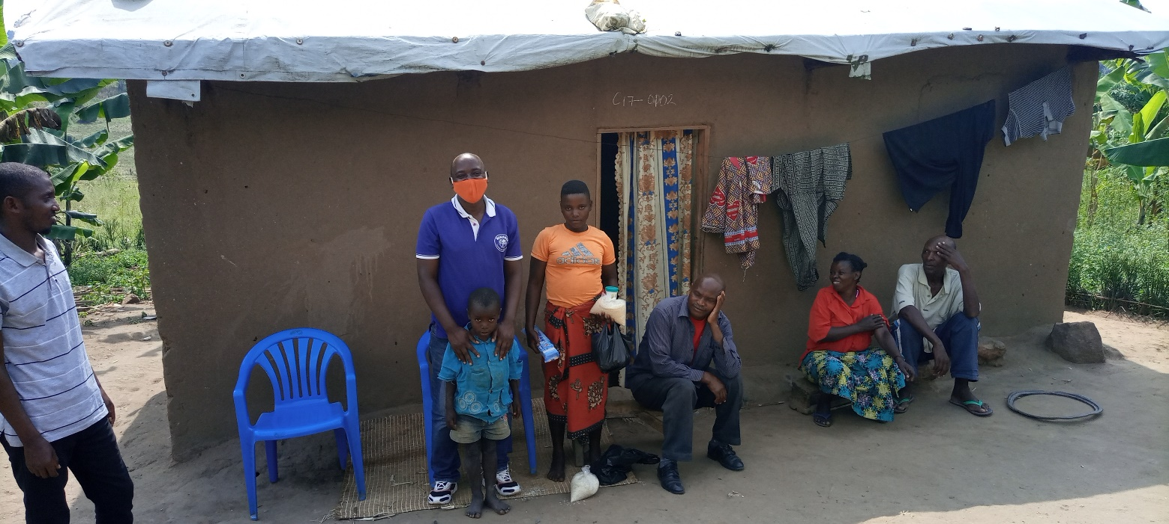
Home Visits during the festive season and distribution of family support and pads

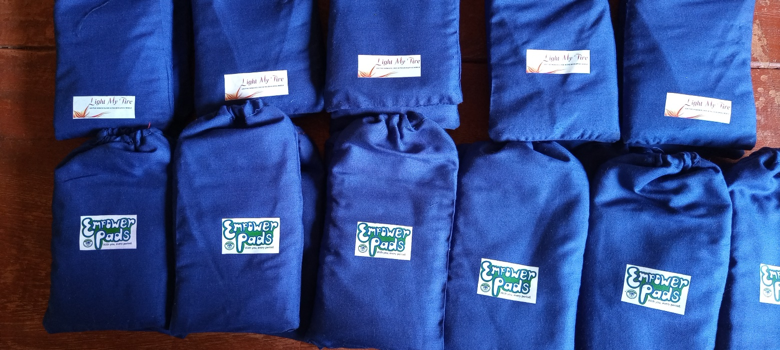
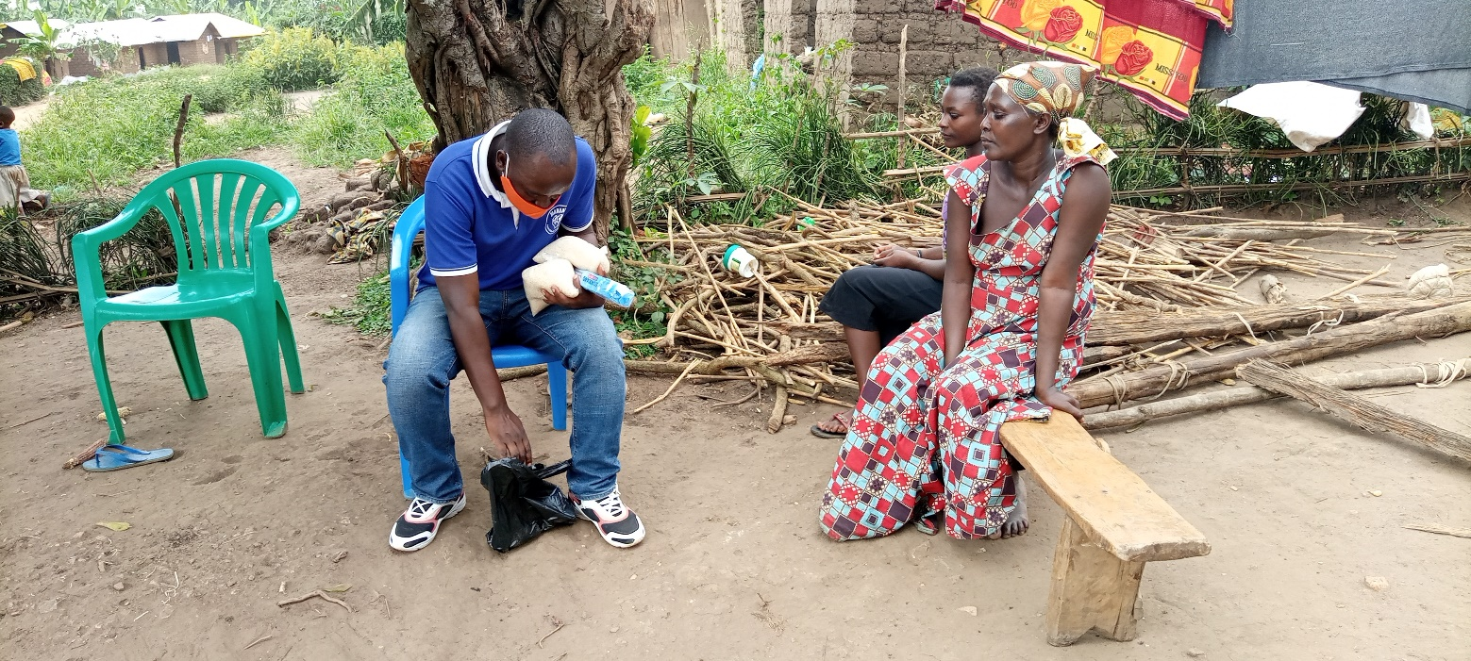
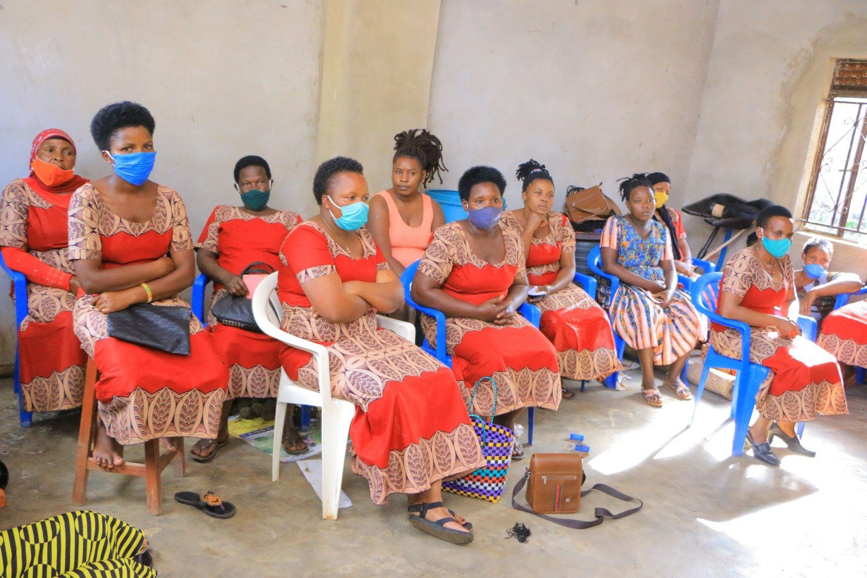
Marianne women groups remain major focus for sustainable family based empowerment. We plan to develop the first women bank in our region.
