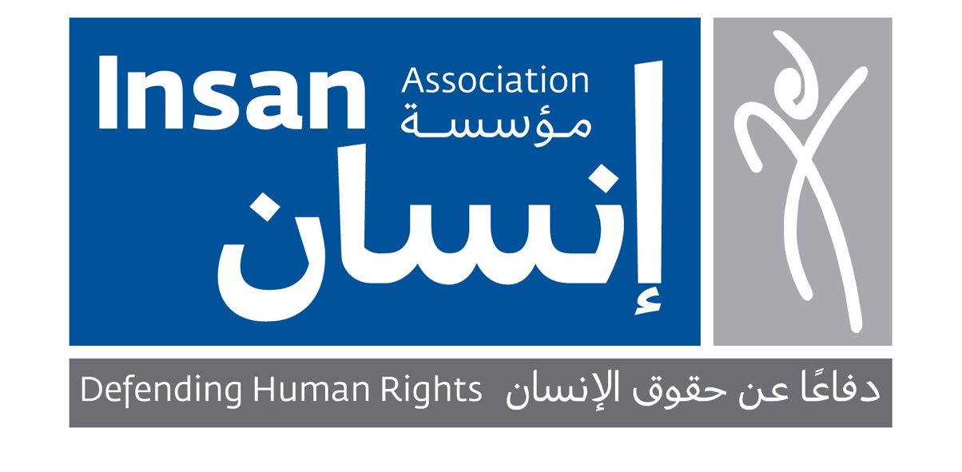
Concept Note

Organization: INSAN Association
Intervention: Basic assistance for the most vulnerable families in Lebanon
Activities: Distributing food boxes, household supplies, medications, hygiene kits, baby supplies etc.
Target Groups: Families who have been the most affected by the economic collapse and numerous crisis in Lebanon
Project Start Date: 06.08.2020
Requested Amount: USD 100,000

Project Name

Assistance to Vulnerable Families All Over Lebanon

INSAN's History

INSAN’s mission is to protect and promote the rights of the most vulnerable and marginalized individuals in the society. Since 1998, INSAN Association has been implementing a range of projects to improve the lives of the most marginalized people and communities. INSAN adopts a holistic service delivery approach to its implementation of activities, which includes rapid response, education, psychosocial, medical, legal, advocacy and research programs.

Current Needs

Lebanon has been struggling with a multitude of economic and political crises since late 2019 that have led to massive unemployment, skyrocketing prices and shrinking salaries, road closures by angry protesters and a government with no clear plan to slow the descent. Additionally, at least 190 people lost their life in the Beirut Port explosion in August 2020. Insan is now receiving more and more requests for help via social media, phone calls and drop-ins every day, unable to help everyone.

Through this project Insan will provide basic assistance in the form of food boxes, baby supplies, hygiene kits etc. to families in Lebanon who have been the most affected by the country’s economic collapse and numerous crisis which have made the middle class disappear and drove 55% of the population into poverty (ESCWA, 2020).

Project Objective

Help families who have been the most affected by the economic collapse and numerous crisis in Lebanon to survive until the Government of Lebanon provides a long-term solution.

Project Activities

1. Food assistance in the form of distributing food boxes

2. Household assistance in the form of distributing household supplies such as mattreses, bed sheets, towels, kitchen and cleaning supplies etc.

3. Medical assistance in the form of distributing medications to people who are not able to afford medications.

4. Hygiene assistance in the form of hygiene supplies such as hand sanitizer, face mask, toothpaste, shampoo, laundry detergent and diapers for babies.

Project Expected Results

The most vulnerable families are able to sustain life thanks to receiving help with food items, household supplies, medications and hygiene articles.

Contact Details

INSAN Association
Address: Adib Ishak Street, Maalouf Bldg. 7th Floor, Ashrafieh, Beirut, Lebanon
Website: http://www.insanassociation.org/en/
Telephone: +961.1.333.091

Resources:

Hubbards, B., & Saad, H. (2021). Lebanon’s Financial Collapse Hits Where It Hurts: The Grocery Store. The New York Times. Retrieved 20 April 2021, from https://www.nytimes.com/2021/03/22/world/middleeast/lebanon-currency-groceries.html.

United Nations Economic and Social Commission for Western Asia. (2020). ESCWA warns: more than half of Lebanon’s population trapped in poverty. Retrieved 20 April 2021, from https://www.unescwa.org/news/Lebanon-poverty-2020.

