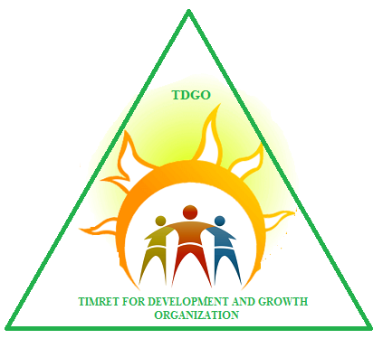

TIMRET FOR DEVELOPMENT AND GROWTH ORGANIZATION (TDGO)

REACHING ADOLESCENT AND YOUTH IN BATI TOWN WITH SEXUAL AND REPRODUCTIVE HEALTH INFORMATION

November 1, 2020 to April 30, 2021

Project Profile

Name of the project | Reaching adolescent and youth in Bati town with sexual and reproductive health information
Location of the project | Bati town,Bati woreda of Amhara Regional State, Ethiopia
Types of beneficiaries | Adolescents and Youth, parents
Number of beneficiaries | 3000 Adolescents and Youth, 1500 parents
Funding Agency (If any) /Source of Fund | Still waiting
Executing Agency | HAPCO and Woreda Health Office, Woreda Education Office, Schools
Implementing Agency | Timret for Development and Growth Organization(TDGO)
Contact person: | Ato Endris Seid Kassa  Position: Executive Director  Telephone: +251920144790  Email: abatuseid8@gmail.com  Bati Town, Head Office

Table of Contents
Acronyms 3
1. Executive Summary 4
2. Project back ground & justification 5
3. Problem analysis 5
4. Policy context & implications 6
5. Goal (Smart) 7
6. Objectives 7
7. Beneficiaries Selection Criteria 8
8. Target group /Beneficiaries 8
8.1. Direct 8
8.2. Indirect 8
9. Project Duration 8
10. Project Activities 8
11. Project Out put 9
12. Project Description 9
12.1. Location Region Zone – Woreda – Site 9
13. Organization & Management 10
14. Monitoring and Evaluation and Reporting Strategy 11
15. Expected outcome 11
15.1. Short term 11
15.2. Long term 11
16. Risks and Assumptions 11
17. Sustainability and phase out strategy 12

Acronyms
AYRH = Adolescent and Youth Reproductive Health
CSA=Central Static Agency
EMDHS=Ethiopian Mini-Demographic and Health Survey
HIV/AIDS= Human Immunio Virus/ Acquire Deficiency Syndrome
HTPs=Harmful Traditional Practices
IEC= Information Education Communication
NGO= Non-governmental Organization
RH= Reproductive Health
SRH= Sexual Reproductive Health
STDs=Sexually Transmitted Diseases
STIs= Sexually Transmitted Infections

Executive Summary
Adolescent and youth sexual reproductive health project shall focus on the goal of sexuality education and parent-child communication to enable adolescents and young people develop the knowledge, autonomy and skills such as communication, decision-making and negotiation to make the transition to adult-hood in good sexual health. The project includes information about sexual reproductive health, which includes pregnancy, drug abuse, STIs, and HIV/AIDS education.
Adolescent behaviors are influenced by a sizeable number of factors operating at the individual, family, school, community, and societal levels. These factors also influence adults, but because adolescents have not fully developed-- socially, psychologically, and physically -- they are perhaps more susceptible to "contextual" or "environmental" influences than are adults. This susceptibility requires that programs address a number of determinants or "antecedents" of adolescent behaviors simultaneously.
However, the extent to which parents are involved and the manner in which they are involved in their children’s lives are critical factors in the prevention of high-risk sexual activity. Children whose parents talk with them about sexual matters or provide sexuality education or contraceptive information at home are more likely than others to postpone sexual activity. And when these adolescents become sexually active, they have fewer sexual partners and are more likely to use contraceptives and condoms than young people who do not discuss sexual matters with their parents, and therefore are at reduced risk for pregnancy, HIV and other Sexually transmitted diseases (STDs).
Therefore, in this project we shall also promote parent-child sexual communication through the parent awareness creation program which will increase parent-child communication about sexuality, teen pregnancy prevention, and related issues.
The aim of the project is to provide information about all aspects of sexual, reproductive health and rights of adolescent and youth so that they are aware of the changes they go through and how they should protect themselves against sexual abuse, drug abuse, STIs and HIV/AIDS.
The Project will be implemented over the period November 1, 2020- April 30, 2021 in Bati Town Oromia Zone of Amhara Regional State. This is 6 months project during which different activities will be carried out. The total cost of this project is $ 5,000.

Project back ground & justification
Projection from the 2007 population and housing census estimates the total population of Ethiopia for the year 2015 to be 90 million (CSA, 2015). According to the Ethiopian Mini-Demographic and Health Survey (EMDHS) (CSA, 2014), the country is characterized by a young population with 33.8% of its population being in the age range of 10-24 years. The age group 10-14, 15-19, and 20-24 account for 15.6%, 10.6%, and 7.6% respectively.
In Ethiopia, the sexual and reproductive health (SRH) needs of adolescents and youth have not been sufficiently met. Research has found that, young people have different SRH needs from the adult population and require programmes tailored to their specific needs and contexts.
Adolescents and young people in Ethiopia face a number of health and development challenges. Several studies have shown that adolescents young people aged 10-24 years have inadequate access to health and education services, and that their rights to information, participation and protection are not being met..
From our rapid assessment we made in Bati town, we observed adolescents and young people in the town are frequently associated with high risk sexual behavior and this is often linked to substance abuse, including excessive khat consumption accompanied by alcohol drinking. Adolescents and youth sexual reproductive health remains culturally and socially untouchable/sensitive issues among the whole community of Bati town. Talking about reproductive health brings someone out of communities social life and let him live alone. It is essential to reach through any appropriate means to community, religious leaders and opinion leaders to influence the community members, parents.

Problem analysis
Adolescent girls and boys face a lot of problems as they transcend to adulthood. Most of these are related to their sexual and reproductive health. Adolescent girls and boys are recognized as one of the underserved categories and their sexual, reproductive health and rights (SRHR) related issues exist without concrete action plan. Young people’s knowledge regarding SRHR is limited.
Inadequate information, lack of privacy, cultural and traditional barriers, and general youth unfriendly environment are some of the barriers that youth face in accessing reproductive health services.
From our rapid assessment we made in Bati town, we observed adolescents and young people in the town are frequently associated with high risk sexual behavior and this is often linked to substance abuse, including excessive khat consumption accompanied by alcohol drinking. Adolescents and youth sexual reproductive health remains culturally and socially untouchable/sensitive issues among the whole community of Bati Town. Talking about reproductive health brings someone out of communities social life and let him live alone. It is essential to reach through any appropriate means to community, religious leaders and opinion leaders to influence the community members, parents. Educating adolescent and young about reproductive health and HIV/AIDS, skill for negotiation, conflict resolution, critical thinking, decision-making, and communication enable to improve their self-confidence and ability to make informed and responsible choices.
Family life education is an especially effective way to teach adolescents and young people critical life skills that can help them to postpone sex until they are mature enough to protect themselves from unintended pregnancy and STIs/HIV. All of this together will help to increase young people’s self-esteem, build their confidence, and elevate their self-efficacy. This is made possible by full engagement of young people as right holders and building the capacity of program implementing stakeholders as duty-bearers to fulfill claims of the most vulnerable.

Policy context & implications
The Government of Ethiopia has adopted policies and strategies to address some of the social, economic, educational and health problems faced by young people. Previously, national programmes are guided by a 10-year plan which is based on the ‘National Adolescent and Youth Reproductive Health Strategy 2006-2015’. The nine year (2007-2015) National AYRH Strategy sought to provide a multi-sectoral support to every young person living in Ethiopia with education and information that will lead to the adoption of a healthy lifestyle physically, psychologically and socially. This was to be achieved through provision of age and sex appropriate information and counseling, comprehensive health services complemented by self-care, livelihood and leadership skills or competencies. Other key documents indicating government commitment include the Young People Policy issued in 2000, the Policy on HIV/AIDS launched in 1998, the Revised Family Laws amended in 2000 to protect young women’s rights, (for example against forced marriages), and the Revised Penal Code, which penalizes sexual violence and many harmful traditional practices.
Accordingly, many gains have been achieved. The rate of new HIV infections among 15-24 year youth has decreased significantly, the proportion of females aged below 20 years who deliver with the assistance of a skilled provider increased to 40 per cent. On the other hand, teenage pregnancy remains high (12%). Health services for adolescents are largely not integrated, are of poor and uneven quality and coverage, with inequity in access and utilization, and are generally limited to SRH, HIV and STIs and do not fully address the broader health and health-related problems faced by adolescents and youth.
Thus, a new Adolescent and Youth Health Strategy for the period 2016-2020 is developed to guide programs to mitigate the dual challenge that the country faces from the emerging health threats as well as those from the unfinished agenda of preventable death and infectious diseases among its large adolescent and youth population. The formulation of the strategy is informed by the findings of the comprehensive and participatory situational analysis on adolescent and youth health in Ethiopia conducted in October and November of 2015.
The strategy goes far and beyond SRH, HIV and STIs to provide broad strategic directions to promote, prevent, and protect the health and wellbeing of Ethiopian adolescents and youth. It incorporates current recommendations on policies and programs that respond to priority health needs of the adolescent and youth, reflects the evidence base for action, captures new interventions and service delivery mechanisms, and guides on building a framework of focus to continually improve the health and development of adolescents and youth through their participation and engagement, and through effective coordination with public, private, NGO, local and international partners.

Goal (Smart)
The overall goal of the project is to provide updated information about all aspects of sexual, reproductive health and rights of adolescent and youth (aged 10-24), for 3000 adolescents and youth (school in and school out ) and 1500 community members/parents in Bati town Oromia Zone of the Amhara Regional State from September 1, 2020 to February 28, 2021 G.C.

Objectives
Objective 1: To enable parents and communities have the capacity to effectively respond to demands of adolescents and youth and to ensure a protective and enabling environment for their development which includes protecting them against gender based violence , HTPs and the violation of their reproductive rights
Objective 2: To enable adolescents and young people to actively participate in programmes concerning them and the development of their communities so that they will be able to claim their rights for information and services.

Beneficiaries Selection Criteria
An independent need-based approach that are appropriate for the target beneficiaries will be used to ensure equitable access, especially for the most vulnerable, within the project areas.
The following guiding rules are used for beneficiary selection and targeting:-
- Independent selection and verification of beneficiaries through Woreda level responsible organisation and project specific needs-based selection criteria
- Prioritisation of the most vulnerable.
- Facilitation of access to assistance for all, especially the most vulnerable
- Taking into consideration pre-existing social, cultural and political system or practices that may marginalise or exploit certain groups is fundamental.

Target group /Beneficiaries
The project will cover adolescents and youth (in school and out-of-school) with a focus on groups requiring special focus such as adolescent girls, orphans, other vulnerable adolescents & young people and parents/communities.

Direct
The project aims to reach 3000 adolescents and youth by creating a sustainable and enabling environment, which will result in the enhancement of young people’s capacity, making it possible for them to claim their rights and access an integrated package of youth-friendly services.

Indirect
1500 Parents/Communities that live in the Bati town who have a child of this age group

Project Duration
The Project is a 6 month project. It will be implemented from November 1, 2020 to April 30, 2021 G.C.

Project Activities
- Strengthening in-school and out-school clubs through IEC materials support
- Organize gender awareness raising discussion among youths aged between 15 to 18 on monthly basis
- Organize a one day training to parents and guardians on RH, communication skills to build open discussion and communication norm among parents and their children
- Organize awareness creation sessions on RH through open market public education once every month
- Organize a two days training on SRH and life skill to adolescence and youth
- Organize dialogue sessions among youth to youth and adolescence to adolescence once every month
- Organize a one day workshops or conferences every quarter for key project stakeholders
- Disseminate relevant information on harmful effects of alcohol, and drug substance use through different means

Project Out put
Output 1: 1500 parents and community member capacity increased to effectively respond to the demands of adolescents and youth and ensure their rights, including on GBV and HTP prevention, are protected, respected and fulfilled
Output 2: 3000 adolescents and youth get updated information on sexual reproductive health and rights that enable them to protect themselves against sexual abuse STIs and HIV/AIDS.

Project Description
Adolescent sexual, reproductive health project shall focus on the goal of sexuality education and parent-child communication to enable young people develop the knowledge, autonomy and skills such as communication, decision-making and negotiation to make the transition to adult-hood in good sexual health. The project includes information about sexual reproductive health, which includes puberty, pregnancy, STIs, and HIV/AIDS education.
The aim of the project is to provide information about all aspects of sexual, reproductive health and rights of adolescent so that they are aware of the changes they go through and how they should protect themselves against sexual abuse, STIs and HIV/AIDS.

Location Region Zone – Woreda – Site
The project is planned to be implemented in Bati town which is the capital of Bati Woreda. Bati is one of Woredas of Amhara National Regional State, administratively located under oromia special zone of the region.
The Bati town is located at a distance of 405 kms from Addis Ababa and 540 kms from regional town Bahir Dar, and the Woreda was bordered by south wello in west and by afar in south, east and north. The Woreda has 26 rural kebele, and six health centers and 26 health posts with physical health service coverage is 100%.
In 2007 national census conducted by the Central Statistical Agency of Ethiopia (CSA), reported that this woreda has a total population of 107,387. The main ethnic groups in the Woreda are Oromo (92%), Amhara (7%), and Afar (1%). The main spoken languages are Oromiffa (88%) and Amharic (11.4%). The main religions in the Woreda are Muslim (97.3%), and Orthodox Christian (2.4%).
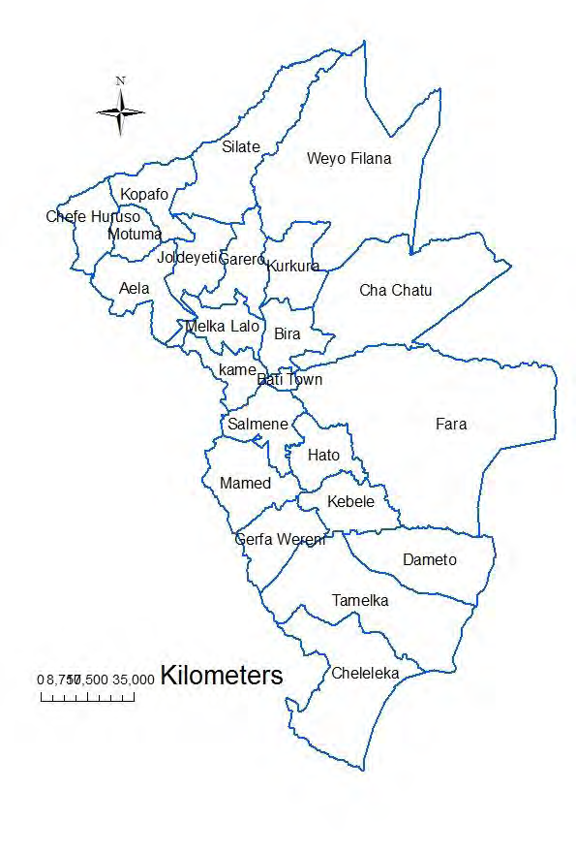
Figure 1: map of Bati Woreda, Amhara region, 2016

Organization & Management
Our organization is still at very early stages and the institutional arrangements for managing and coordinating activities are still in the process of being set up. The governing body of our organization will be the board which is the highest decision making body. The Board, which constitutes five members, is elected from among the founders and other members for a period of four years. The board appoints the Executive Director. Our organization has a volunteer Executive Director. The Executive Director will lead all of technical and administrative staff based in Bati.
Board

Auditor
Executive Director

Financial Manager

Accountant
Others

Casher

Monitoring and Evaluation and Reporting Strategy
There will be a comprehensive monitoring and evaluation system developed as an integral part of the project design of which overall objective is to review progress against planned activities and to assess the achievement of objectives of the project. Project monitoring and evaluation will be carried out in accordance with procedures that are set by our organization. Monitoring and evaluation of project outcomes/results (both intermediate and end-of-project) will be coordinated by our organization and relevant stakeholders.

Expected outcome

Short term
- Increased awareness and knowledge, skill and practice on SRH/HIV issues among adolescents and youth and their parents;

Long term
- Improved safe sexual health-seeking behavior of adolescents and youth;
- Reduced vulnerability and risk of HIV infection and promote SRH behavior;
- Increased SRH service utilization; and
- Reduced incidence of GBV and HTPs

Risks and Assumptions
Project risks can involve both external and internal factors. External risks are those that may occur outside the control of the programme or project, and they represent factors of the project environment including political, economic, environmental, and social conditions. Internal risks are those that may arise from the management of the projects, such as inadequate human resources, and lack of clarity in accountability in partner organization.

Sustainability and phase out strategy
The project will be built on existing governmental and local community structures. The aware parents will work as community volunteers/ facilitators hence the acquired skills and knowledge will remain in the community and live beyond project period. The project will promote community participation and hence building of ownership to enable communities identify and solve own health program through the use of community action cycle approach and this will ensure sustainability of the project. The SRHR and gender pamphlets for peer educators and parents will be developed and published in both English and local language will be copied and distributed in schools.

