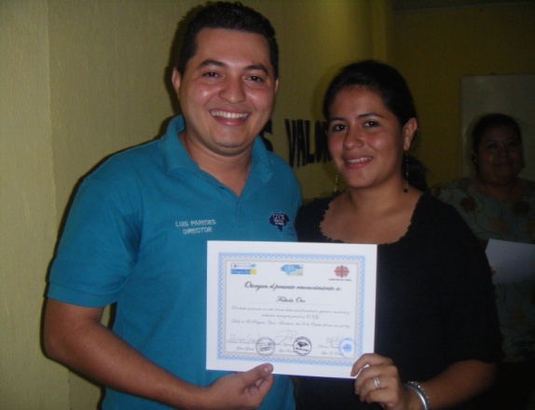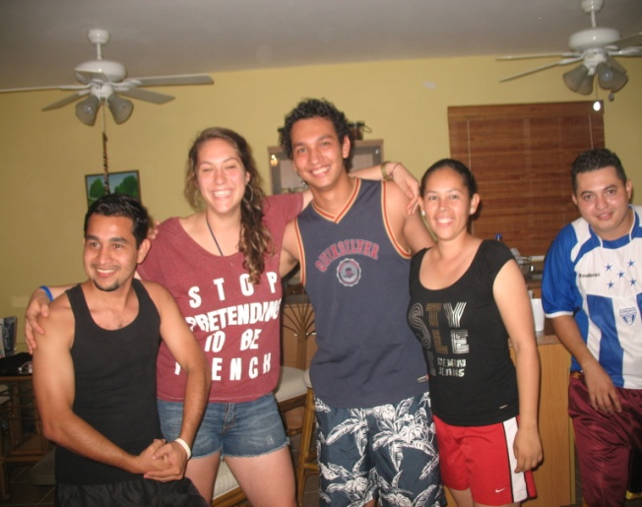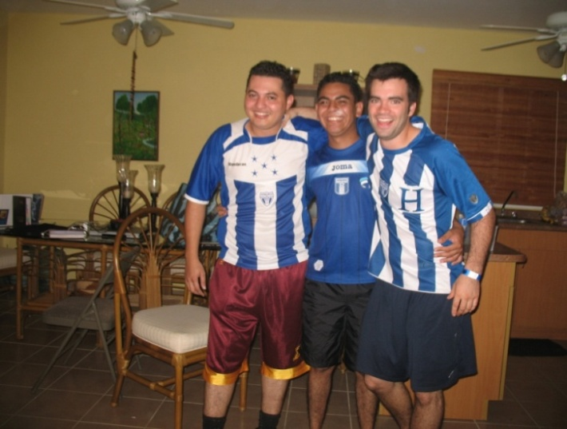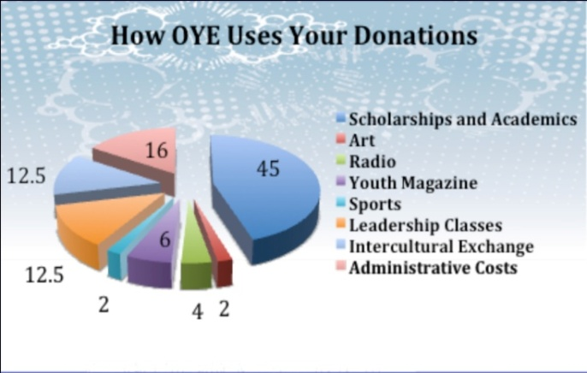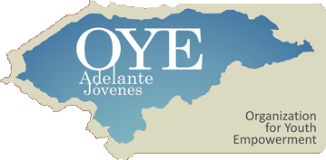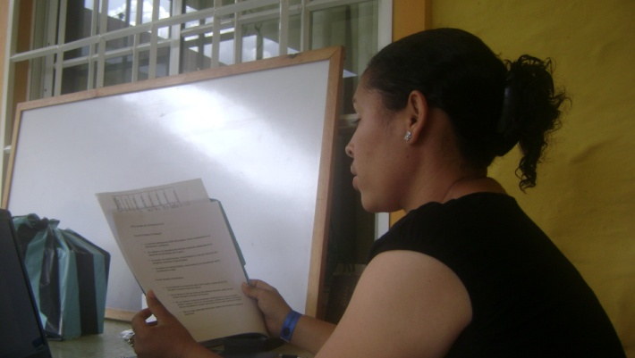

*75 at-risk Honduran youth directly participated in OYEs 2010 projects*

*5,000 at-risk Honduran youth were both directly and indirectly involved in OYEs 2010 program*

*OYE trained 45 youth in the process of planning and managing non-profit projects*

*100% of OYEs students graduating high school will continue on to University*

Fabiola Oro recieves a diploma for completing a youth project management class

OYE Staff and Scholarships students take a break from next years planning to mug for the camera

OYE Boys gearing up for Staff VS Scholarship futbol game

**Dear Donor,**

As 2010 comes to a close OYE cannot thank you enough for your support. This has been another incredible year of growth and evolution for our young organization. After five short years, your support and our hard work has transformed a scholarship program based on bank accounts and debit cards into an integrated development system that foments the development of over 75 socially conscious youth leaders each year.

OYE is proud to announce that your money is being directly invested in the youth of Honduras. With an administrative overhead of just 16%, 84 out of every $100 donated to OYE contribute directly to our projects, and benefit nearly 15,000 at-risk Honduran youth a year.

At OYE, we leverage your money by creating youth-led projects that are sustainable and engage the whole community both inside and outside the offices of OYE. This year we are happy to announce that all of our projects are youth led. That is to say, OYE scholarship students whom have received capacity classes in the creation, management, and reporting of youth projects are the ones in charge of our radio group, youth magazine, scholarship program, study circle, capacity classes, inter-cultural exchange, and sports programs. Realizing this change is an important step in the process of creating youth leaders.

Without your support, OYE would not have reached the level it is at today. We are proud to pass the reins and responsibility of project management to seven capable scholarship students, but the preparation for this step was not an overnight process. Each day of each year OYE works to build these capable and confident youth leaders that not only contribute to the sustainable growth and structure of this organization, but are both the present and future agents of positive change in Honduras.

Thank you for your support,

Samuel Rioux

OYE Honduras

Director of communications

Iloany shares her annual report on OYE's sports program