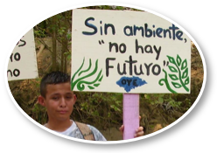
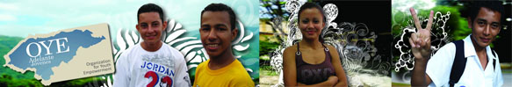
1
Greetings from OYE!
2
OYE Publishes Revista Jóvenes
2
Environmental Activism: OYE teams up with Disney
3
Volunteers Visit OYE
4
More OYE Updates
Organization for Youth Empowerment Newsletter
May 2011
Qué es el Qué at OYE?
Newsletter of the Organization for Youth Empowerment

Contents

Greetings from OYE!
Five months after awarding 91 youth from Honduras with OYE scholarships, OYE has been changing lives through leadership training, capacity-building, and opportunities to participate in OYE's many creative projects and programs. From the production of the bimonthly magazine Revista Jóvenes, to a two-part environmental protection project with Disney Friends for Change, and hosting volunteers from James Madison University and American University, among other successes, OYE has remained committed to empowering all of the youth who come through its doors while having a transformative impact on the greater Honduran community.
Every day OYE is finding new and innovative ways to use education to empower youth to take hold of their futures, become leaders, and contribute positively to society. We invite you to take a look at what our entirely youth-led organization has been up to recently and what events are ahead in the near future.
The first five months of 2011 have been fantastic ones for OYE, and we hope this newsletter will provide you with a glimpse into the changes youth are inspiring here everyday in Honduras.


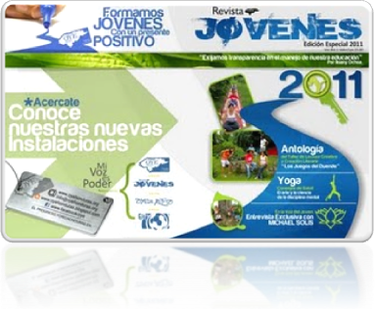
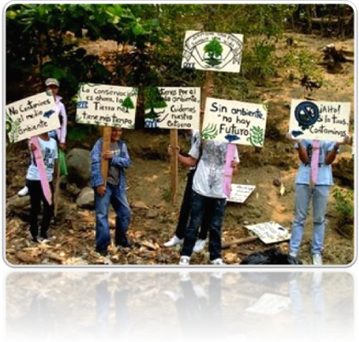

OYE Publishes Revista Jóvenes!
OYE has published 3000 copies of its latest edition of the bimonthly magazine Revista Jóvenes. Revista Jóvenes is written, designed and distributed by OYE students and focuses on informing, educating and entertaining their peers.
The current magazine focuses on pertinent issues such as the reality of Honduran education, which the OYE youth believe to be so highly politicized that it has a negative impact on the quality of education that Honduran students receive. Another article highlight the benefits of yoga for people’s health.
Additionally, the magazine features an anthology of prose and poetry from students in OYE's Reading Circle, one of OYE's newest programs. The Reading Circle, led by two local Honduran writers, took place from February to April and resulted in the creation and crafting of individual works of literature from OYE youth.
The magazine teaches students to think critically about their realities and to articulate their views, concerns and opinions. The first edition was distributed in May of 2009. Revista Jóvenes has since distributed more than 13,000 magazines in their communities, high schools and universities. Currently Revista Jóvenes publishes 6 youth magazines per year, printing 3000 magazines that are distributed throughout the country and abroad, with a version posted online. Magazines cost 15L (less than USD $1), and sponsors such as local businesses and the municipality can purchase advertisements.

VOS
Por Sthefanie Matute
Así como el polvo danza en el azul velo,
bajo el compás del silbido del viento,
y aplaude el bosque sin su reproche,
tu regocijo será hasta el derroche

Así como las amplias y frecuentes olas,
golpean sus límites en las arenas
y retroceden hacia el cauce de las aguas
vos restauras

Jamás detengas tus bondades,
Que fluyen como aquella cascada,
Que brotan como un manantial
Tu gracia, tu amor y tu paz.
Environmental Activism
OYE received a grant from Disney Friends for Change to carry out an environmental impact project in Honduras. More than 80 OYE scholars from each of OYE's programs, led by youth scholar Fabiola Oro, joined forces on Youth Service Day (April 16, 2011) to clean up El Progreso's act...that is, to have a positive and sustainable impact on the environment. OYE scholars split up into teams to clean up the heavily polluted Pelo River in El Progreso. They worked all day under El Progreso's blistering sun in neighborhoods such as Palermo, Bendeck, Suyapa, and Penjamo. The municipality donated garbage bags, and OYE scholars filled more than 100 of them with garbage in and along the river.

OYE scholars posting signs for their river clean-up project sponsored by Disney Friends for Change
Organization for Youth Empowerment Newsletter
May 2011
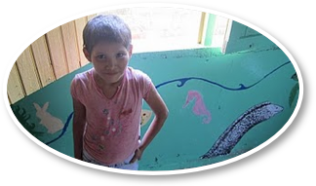
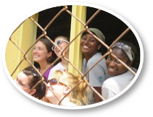
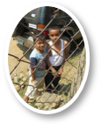

Volunteers Visit OYE!
OYE had the recent pleasure of hosting American University and James Madison University students from March 5-12, 2011. Both groups learned about Honduran education and the problems facing Honduran youth while taking part in community service projects with local youth groups and communities.
The week started out with a trip to Copan Ruinas, where OYE staff, scholars, and American University students traveled to learn more about ancient Mayan culture, to explore the ruins, and to eat local Copan Ruinas cuisine at the central market. Afterwards, American University returned to Progreso where they learned about the reality of education in Honduras. They visited local schools, including Chevez High School, La Perla de Ulua High School, Juan Ramon Morales Elementary School, Notre Dame High School, and the Techological University of Honduras (UTH). The group also sat in on two forums, including one on the Honduran reality with guest speakers that included teachers, students, and UNICEF workers, as well as another with OYE youth scholars who shared their life stories and the impact that OYE has had on them and their families.
Perhaps the most exciting event of the week was the strike that the volunteers attended in the center of El Progreso. Thousands of Honduran students who attend public schools marched through the streets to the municipality to speak out against the government's proposed plan to privatize all public high schools with a new education law that recently passed. Students, teachers, and families banded together throughout the country to protest the law for fear that it would make education inaccessible to most youth who attend public schools.
In addition to visiting Pro-Niño, a local organization that provides a home and space for education to street children, American University volunteers helped begin painting a logo for OYE’s office.
JMU Students took part in an intensive community service project to repair and repaint a school in the neighborhood known as Primero de Marzo. A building in the community that served as a school for many years was in a state of disrepair. The JMU group arrived and helped clean the walls, pick up the garbage in the schoolyard, and repaint the exterior and interior. They also added an artistic touch with murals, an alphabet, a multiplication table, and other paintings. The volunteers worked tirelessly, with some days lasting from 8:30am until 5:00pm. The community's President, David Castillo, was deeply appreciative of JMU's contribution and will be working with community members on repairing the school's floor and roof after JMU's departure.
JMU volunteers also visited Pro-Niño and the Nutrition Center, which treats malnourished children who are up to six months old and whose families cannot afford to feed them. In addition to taking part in the forum on the Honduran reality with American University students, JMU volunteers watched the movie Sin Nombres, which provides a glimpse into the realities of immigration to the United States, a perilous and costly voyage that millions have made and continue to make out of necessity, and youth gangs, which have become an alternative for youth in Central America who have little to turn to with respect to education, leadership, the arts, or other opportunities. The JMU volunteers left understanding how vital OYE’s work is to providing a healthy alternative to OYE
Photos from the site of JMU’s service project in El Progreso.
Organization for Youth Empowerment Newsletter
May 2011
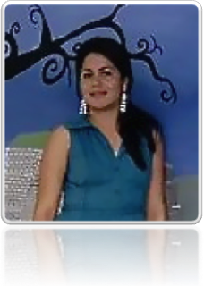

More OYE Updates
Four student interns from Mary Baldwin College completed their internships with OYE. During their time in El Progreso, the students carried out a research diagnostic with a local community, Las Mercedes, which was built for people displaced by Hurricane Mitch in 1998. The interns complemented their research experience organizing a community celebration for Las Mercedes with OYE scholars, as well as a career fair, health fair, and youth mentoring program at OYE.
According to a recent study carried out by American University graduate student Deneysis Labrada, there is a statistically significant, positive association between OYE youth scholars' participation in OYE and their decision to continue their secondary and post-secondary education. Factors that enable OYE youth to continue with their education are the monthly stipends to pay for expenses such as books and transportation, the social network OYE provides, and support from family and friends that cannot be found in schools.
Former OYE volunteer Eduardo Martín Hermana made a generous donation to help sponsor COPA OYE, OYE's annual soccer and volleyball tournament, which will take place in June. Thank you Eduardo!
OYE's Upcoming Events
Beach Clean-Up in Cayos Cochinos: The Disney environmental project will continue into late-May, when a team of seven OYE scholars will travel to Cayos Cochinos to carry out a beach cleanup and community outreach with an environmental tourism organization run by local youth from the Garifuna community.
COPA OYE: In June OYE will host a month-long soccer and volleyball tournament, engaging students from ten different schools who have their eyes set on the gold!
San Pedro Sula Marathon: Cheer on OYE family members Ana Luisa Ahern, Demetri Lopez, Michael Solis, and youth scholars who will be running in the San Pedro Sula Marathon in June.
OYE's Anniversary: On June 7, 2011, OYE turns 6! In the past 6 years OYE scholarships have changed the lives of 339 youth, with 80% of OYE high school graduates going to college when only 12% of Honduran youth do so nationally. Now that's something to celebrate!

OYE Scholar Fabiola Oro
“Leading the Disney Friends for Change environmental project was a unique experience that helped me discover my strengths as a leader as well as areas of improvement in my professional life. I worked with a team of talented young people to carry out an environmental campaign in El Progreso, where we cleaned up the Pelo River while teaching community members the importance of respecting the environment.
“My favorite part was that we were all young people working for a shared cause. We had a lot of fun while we were doing something important for our community.
“The most difficult part was trying to work with the local community. Honduran culture doesn’t place much emphasis on taking care of our surroundings, which made it challenging to engage others. Still, we were able to work with about 100 youth from 10 different neighborhoods along the river.
“Our work in protecting the environment does not end here. We will work hard to continue creating environmentally-focused projects with and for OYE youth that will benefit our communities, country, and world.”
Organization for Youth Empowerment Newsletter
May 2011
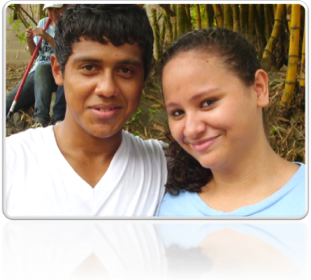

Spring 2012
Thank you for reading OYE’s Newsletter!
Your support has carried us through times of political turmoil to allowing us to grow our scholarship program. When we started, we only had the resources to provide 5 scholarships a year. But thanks to people who believed in the untapped potential of the youth of El Progreso, we’ve grown into a multi-faceted youth development organization that now supports 91 scholars per year.
By making a gift to OYE in 2011, you can have a tremendous impact on our ability to offer more scholarships and enhance our leadership development programs for Honduran youth.
Remember that your scholarship support is just the beginning. Each scholarship liberates OYE youth from the destructive path of gang involvement, violence, and drugs and allows them to focus on their education and development. The challenges that Honduran youth face today are not new, nor are they easily solved. However, OYE is helping develop a generation of leaders who are equipped with the tools and education necessary for making a difference.

