**Report on the project to provide educational services to displaced children in Yemen**

**June 2025**

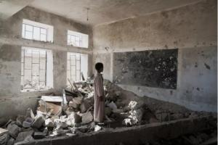

**Project name :** Providing educational services to displaced children in Yemen

**Location :** [ Aden, Lahj, Hadhramaut, Al Bayda, Ibb , Taiz, Hodeidah, Marib, Sana'a.

**Applicable Organization :** [ Sand Organization for Relief and Development ( SORD )

**Report duration :** [ Quarterly

**Start date** 01-03-2025

**Expiry date** 01-06-2025   
**Report prepared by** :

**Contact information :**

* **Report author's name :** [ Shaif Ezz El-Din
* **Current position :** Project Manager
* **Email:** [ Programs.officer@sanid.org
* **Mobile phone number :** 967778515109+
* **The organization's website** **: http:/sanid.org**

**Project summary :**

Increasing access to safe and healthy basic education services for displaced children in displacement hosting sites in ) Aden, Lahj, Hadramaut, Al Bayda, Ibb , Taiz, Hodeidah, Marib, Sana'a. ( In Yemen, who have been deprived of education due to the conflict. By creating child-friendly learning spaces and providing curricula and educational resources, we seek to get these children back on the path to learning and protect their future.

**Project data :**

**1. Context and Need :** *   
The project aims to achieve several key outcomes, including increasing access to education. The project seeks to ensure that 3,000 displaced students annually, over a period of three years, receive basic school supplies and nutritional supplies during school hours. This will contribute to improving school enrollment rates and access to education among displaced children in Yemen.   
  
As the conflict in Yemen enters its tenth year, the education crisis has emerged as one of the most pressing and devastating challenges facing future generations. The current situation can be summarized as follows :

**1. Destruction of educational infrastructure :**

* Thousands of schools have been completely or partially damaged or destroyed as a result of shelling and clashes . This leads to a severe shortage of safe and suitable classrooms for learning .
* Many schools have been converted into shelters for displaced persons or military sites, depriving children of their usual educational spaces .

**2. Millions of children are deprived of education :**

* Millions of children are at risk of dropping out of education or being deprived of it completely .
* Displaced children face additional challenges, including difficulty accessing schools, lack of documentation, and psychological trauma that impacts their ability to learn .
* An increasing number of children are forced to work to support their families, which keeps them out of school .

**3. Lack of educational cadres and their support :**

* Teachers suffer from irregular or non-existent salary payments in some areas, which affects their motivation and ability to continue teaching .
* There is a severe shortage of continuous training and qualifications for teachers to meet the new challenges in the conflict-affected education environment .

**4. Poor quality of education :**

* Even in schools that are still operating, the quality of education is affected by overcrowded classrooms, lack of learning materials, and curricula that may not be tailored to the needs of children affected by conflict .
* Focusing on education in emergencies does not necessarily meet comprehensive education needs .

**5. Exacerbation of other humanitarian crises :**

* The education problem is exacerbated by overlapping humanitarian crises such as malnutrition, disease, and mental health, which affect children's ability to learn and attend school .
* The priority for displaced families is often to provide food and shelter, making education a secondary priority in some cases .

**6. The need for urgent intervention :**

* Reports confirm that there is an urgent need for sustainable and flexible interventions to provide safe and stimulating educational opportunities for displaced and conflict-affected children .
* It requires the combined efforts of humanitarian organizations, government agencies, and donors to ensure children's right to education and protect Yemen's future .

Overall, the educational situation in Yemen reflects a catastrophe that threatens an entire generation and requires a comprehensive and long-term international response.

.

**2. Project objectives :**\* **General objective :**

Contributing to the realization of the most important rights of displaced male and female students in Yemen, particularly with regard to education and nutrition. By providing safe and healthy basic education services, the project aims to open new horizons and hope for the future for these vulnerable children. Additionally, the project seeks to address the humanitarian crisis in Yemen by bridging the education gap and providing job opportunities for mothers and sisters of displaced children. Through these efforts, the project aims to empower local communities, enhance educational capacities, and improve the overall well-being of displaced people in the region.

* **SMART Objectives :** *

* Increasing enrollment rates: By identifying and reaching out to displaced school-age children who are not currently enrolled in formal education programs, the project aims to increase school enrollment rates by providing them with safe and healthy basic education services.
* Strengthening the capacity of teacher and parent councils: The project invests in training and supporting teachers and parent councils in host locations. By strengthening their capacities, these key stakeholders become better equipped to provide support and guidance to displaced children and more effectively meet their educational needs.
* Empowering volunteer teachers: By providing cash incentives, the project motivates the participation of volunteer teachers, enhancing their commitment and dedication to facilitating the educational process in temporary schools. Empowering teachers directly contributes to the effectiveness and sustainability of educational initiatives within host sites.
* Strengthening the capacity of partners, service providers, civil society, and authorities on education issues, including children's learning, school dropout prevention, and education.

**Activities carried out during the reporting period (mention detailed activities with quantities and locations** ) :

* 400 male and female students benefiting from educational services for displaced children were followed up and began taking exams at schools.
* 200 students were targeted with morning meals at their schools daily.
* Conducting 20 counseling sessions with 50 male and female students, with the help of a social worker, to discuss the students' problems, identify their causes, address them, and follow up with them according to their needs and psychological and social circumstances.
* 22 male and female students received medical care immediately after contracting severe diarrhea (cholera) and other diseases, with 12 of them being referred to isolation centers designated by the competent authorities.
* 42 male and female students were referred to medical service providers for the necessary medical examinations.
* 36 students were referred to service providers to receive the medication prescribed by the doctor.
* Two sessions were held during the period with the Education Office and relevant authorities to discuss the situation of the targeted children, review their educational, social, psychological and living reports, and follow up on the implementation of the plan agreed upon with the educational authorities.
* Three meetings were held with the Parents ' Council in the targeted areas to discuss the needs of the targeted children and find solutions to their problems.
* Continuing awareness campaigns in the targeted areas to highlight the importance of education and the benefits of the project. (Target audience: parents, caregivers, community leaders) from during SORD team .

**Challenges and lessons learned :**

* Challenges : [ The large number of students who are eligible for assistance and who should be included in this project.
* Lack of support, donations, and resources to ensure that this project targets the largest possible number of those eligible for educational services.
* Recommendations: The need to intensify efforts and provide sufficient support to cover the largest possible number of children included in the project.
* As the 2024/2025 academic year is coming to an end , the organization has prepared a plan to implement summer activities for the targeted children, whether recreational, educational, or awareness-raising. This is to ensure their continued interest in education, to be in educational incubators, to prevent them from getting lost during the summer vacation, and to protect them from falling into the traps of some terrorist groups, gangs, and moral deviations. These activities are no less important than education in schools, and they require increasing the level of donations and support to implement them due to their extreme and utmost importance. However, this plan has faltered in its implementation due to the lack of sufficient funding for these activities, which requires concerted and intensified efforts and providing the support that enables the organization to implement these activities.

**Future plans (for the coming period) :**

* Explore innovative mechanisms to reach children in remote or hard-to-reach areas, such as using distance learning or mobile classrooms, if security and technical conditions permit .
* Developing educational curricula to be more flexible and appropriate to the needs of displaced children, incorporating the concepts of psychosocial support and protection .
* Providing ongoing and advanced training for teachers on interactive teaching methods, managing large classrooms, and how to deal with psychological trauma that children may experience .
* Providing additional and diverse educational materials and learning resources (such as books, stationery, educational games, digital resources) to support the learning process .
* Integrate intensive psychosocial support programs into educational activities to help children cope with trauma and improve their mental health .
* Strengthening referral mechanisms for protection cases, and cooperating with specialized agencies to ensure the safety of children and protect them from violence, exploitation, and dropout .
* Providing special training for employees on child protection principles and the best course of action in the event of suspected cases of violence or abuse .
* Strengthening partnerships with local communities, especially parents, to ensure their active participation in the educational process and support their children’s attendance .
* Building the capacity of community committees to enable them to contribute to managing and monitoring the educational process and identifying needs .
* Effective coordination with local and national education authorities, and other humanitarian organizations working in the education sector, to ensure complementarity and avoid duplication .
* Searching for sustainable and diverse sources of funding to ensure the project's long-term continuity .
* Develop strategies for gradual exit or handover of the project to local authorities when circumstances permit, to ensure the sustainability of educational services .
* Prepare transparent and detailed periodic reports for donors and partners to demonstrate the impact and effectiveness of resource use .
* Develop a robust monitoring and evaluation framework to measure progress and identify challenges on an ongoing basis .
* Regularly collect quantitative and qualitative data to evaluate the effectiveness of activities and their impact on children .
* Use lessons learned from evaluations to adapt plans and improve the quality of interventions in the future .

**Photographs (optional but recommended) :**

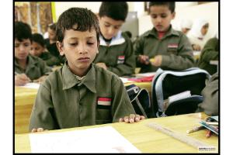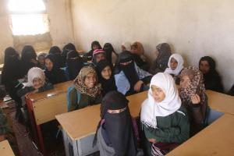

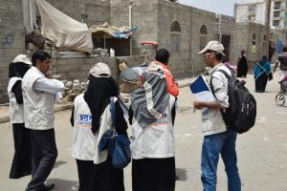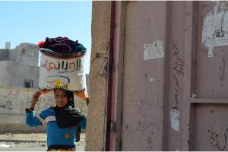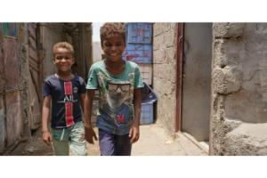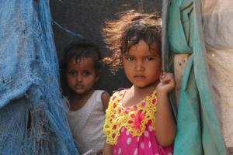

**Conclusion :**

We affirm that education remains a lifeline and hope for the future of thousands of children who have been deprived of their most basic rights due to the ongoing conflict. The results achieved during this period have demonstrated our unwavering commitment to ensuring that these children have safe and stimulating educational opportunities .

to the donors, GlobalGiving's key partners support other nonprofits by connecting them with donors and businesses . Which helped us help Sanid Relief and Development Organization , a wide range of services and support To help it increase its impact and achieve its goals by reaching out to donors. And managing crowdfunding campaigns for its projects , providing the necessary tools and resources to increase the chances of success . And double Financing opportunities It facilitates the process of obtaining grants from companies. and Emergency grants and donations API Capacity building and training Technical support and follow- up .

Thanks to the unlimited dedication of our team, Sanid Relief and Development Organization has been able to reintegrate a large number of children into the educational process, providing a supportive and stable learning environment. Our efforts have helped mitigate the psychological impact of the conflict, give children a sense of stability, and prepare them for a better future .

Despite the enormous challenges that remain in the Yemeni context, we firmly believe that investing in the education of displaced children is the smartest and most sustainable investment for rebuilding Yemen. We are committed to continuing our work, building on lessons learned, and scaling up our interventions to ensure that no displaced child is left behind .

We call on all partners, donors, and the international community to redouble their efforts and support, as the future of these children is our shared responsibility .