**Monthly Performance Report - Local Partner (SORD) Report   
on the Project to Provide Educational Services to Displaced Children in Yemen.  
 October 2024/AD   
Report prepared by: Muhammad Abu Haider**

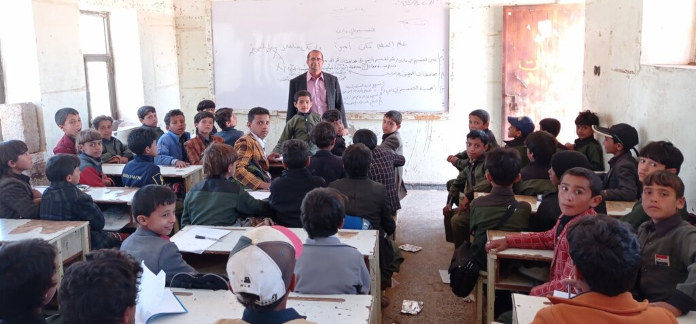

**Project's Data**

|  |  |  |  |
| --- | --- | --- | --- |
| **Project name** | **Project to provide educational services to displaced children in Yemen** | | |
| **Project location:** | **Yemen** | | |
| **Name of the organization applying for the grant** | **Sanid Organization for Relief and Development (SORD)** | | |
| **The duration of the report** | **Quarterly** | | |
| **Start date** | **20-07-2024** | **End date** | **20-10-2024** |
| **organization’s address** | **the Capital Secretariat - People’s District - Al-Habbari** | | |
| **Phone number** | **0096701205757** | | |
| **The report was prepared by** | **Muhammad Abu Haider** | | |
| **Current position** | **Project Manager** | | |
| **Email** | **Programs.officer@sanid.org** | | |
| **Mobile number** | **00967 775907606** | | |
| **The organization's website** | **www.sanid.org** | | |

**An Overview of the Tragic Situation of Children in Yemen :**

**This project will contribute to the targeted male and female students obtaining their most important rights and opening up hopes and a future for them in light of the dark conditions facing Yemeni children and displaced persons that affect their education and nutrition, which is the largest humanitarian crisis in the world. On the other hand, it will provide work for mothers and sisters of displaced children without a breadwinner, which will contribute to bridging the large and dangerous gap in the field of education.**

**The project aims to increase the opportunities for displaced male and female school-age students who are not enrolled in safe and healthy basic education services and to enhance the capacities of teachers and parent councils in sites hosting displaced persons during one academic year. The areas and schools were selected in cooperation and coordination with the executive unit, partners, and the education group affiliated with the Office for the Coordination of Humanitarian Affairs, the region, and local authorities.**

**The project outputs will include: 500 male and female students receiving the most important study and nutrition supplies during class hours, in addition to 100 male and female volunteer teachers receiving the necessary cash incentives to support the educational process in temporary schools in sites hosting displaced persons in the governorate.**

**The project will be implemented in integration and coordination with other activities targeted by the organization to protect children, which aim to help 1,500 to 3,000 children, and in coordination and cooperation with the Education Cluster partners in the governorates. The overall objective of the project is to contribute to achieving the most important rights of displaced male and female students in Yemen, especially with regard to education and nutrition. By providing access to safe and healthy basic education services, the project aims to open up opportunities and hope for the future for these vulnerable children. In addition, the project seeks to address the humanitarian crisis in Yemen by bridging the gap in education and providing job opportunities for mothers and sisters of displaced children. Through these efforts, the project aims to empower communities, enhance educational capacities, and improve the general well-being of displaced individuals in the region.  
  
  
  
  
  
  
  
  
  
  
  
  
Implemented activities:**

1. **Identification and counting of the targeted students according to the criteria for a number of 300 students.**
2. **They were returned to education.**
3. **300 male and female students were targeted with morning meals in their schools daily.**
4. **Contracting a social worker to provide consultations and follow up on the targeted students according to their psychological and social needs.**
5. **33 male and female students received medical care immediately after contracting severe diarrhea (cholera).**
6. **Referring them to isolation centers designated by the competent authorities.**
7. **Referring 33 male and female students to medical service providers to conduct the necessary medical examinations.**
8. **Referring 33 male and female students to service providers to receive the medication specified by the doctor.**
9. **Holding 3 sessions during the period with the Education Office and the relevant authorities to discuss the situation of the targeted children and develop a special plan for them educationally, socially, psychologically and living.**
10. **Holding 3 meetings with the Parents Council in the targeted areas to discuss the needs of the targeted children and develop solutions to their problems.**
11. **Continuing awareness campaigns inside the displaced persons camps to highlight the importance of education and the benefits of the project. (Target Audience: Parents, Caregivers, Community Leaders) by SORD Team.**