**Monthly Performance Report - Local Partner (SORD) Report   
on the Project to Provide Educational Services to Displaced Children in Yemen.  
 June 2024/AD   
Report prepared by: Muhammad Abu Haider**

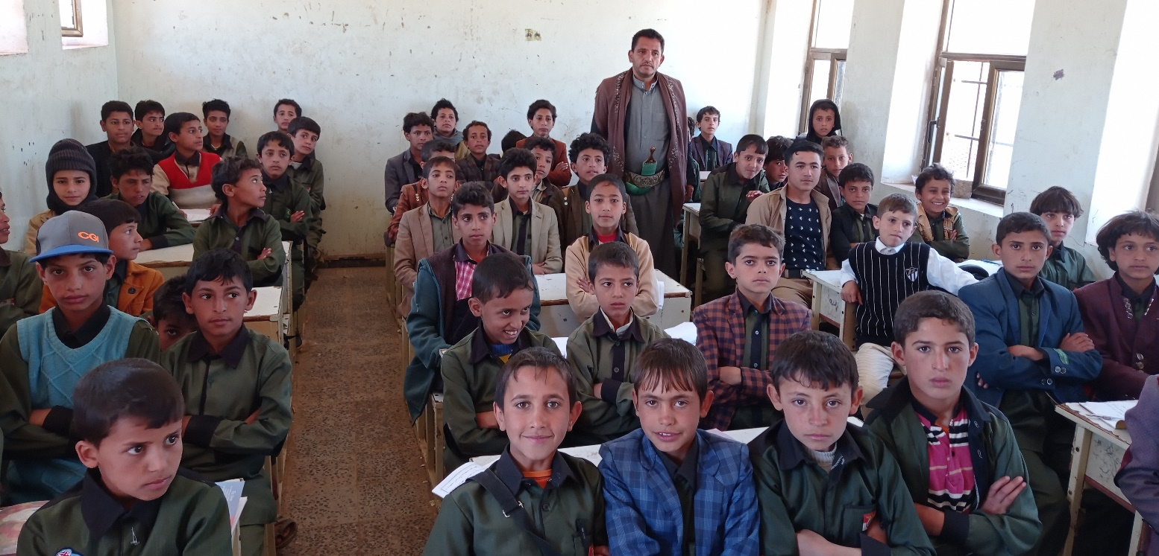

**Project's Data**

|  |  |  |  |
| --- | --- | --- | --- |
| **Project name** | **Project to provide educational services to displaced children in Yemen** | | |
| **Project location:** | **Yemen** | | |
| **Name of the organization applying for the grant** | **Sanid Organization for Relief and Development (SORD)** | | |
| **The duration of the report** | **Quarterly** | | |
| **Start date** | **3/1/2024** | **End date** | **6/26/2024** |
| **organization’s address** | **the Capital Secretariat - People’s District - Al-Habbari** | | |
| **Phone number** | **0096701205757** | | |
| **The report was prepared by** | **Muhammad Abu Haider** | | |
| **Current position** | **Project Manager** | | |
| **Email** | **Programs.officer@sanid.org** | | |
| **Mobile number** | **00967 775907606** | | |
| **The organization's website** | **www.sanid.org** | | |

**An Overview of the Tragic Situation of Children in Yemen :**

The project aims to contribute to the targeted male and female students obtaining their most important rights and opening hopes and a future before them in light of the dark conditions facing Yemeni children and the displaced that affect their education and nutrition, which is the largest humanitarian crisis in the world. On the other hand, it will also provide work for the mothers and sisters of displaced children without families, which will contribute to bridging the large and dangerous gap in the field of education.  
  
 The project aims to increase the access of displaced school-age male and female students who are not enrolled to safe and healthy basic education services and to enhance the capabilities of teachers and parents’ councils in sites to host the displaced during one academic year. The regions and schools were selected in cooperation and coordination with the executive unit, partners and the affiliated education group.   
  
To the Office for the Coordination of Humanitarian Affairs in the region and local authorities. The project's outcomes will be: 500 male and female students will receive the most important study and nutrition supplies during school hours, in addition to 100 male and female volunteer teachers receiving the necessary cash incentives to support the educational process in temporary schools in sites hosting displaced people in the governorate.   
  
The project will be implemented in integration and coordination with other activities targeted by the Foundation for Child Protection, which aims to help 1,500 to 3,000 children, and in coordination and cooperation with the Education Cluster partners in the governorates.   
  
The project's overall goal is to contribute to achieving the most important rights of displaced male and female students in Yemen, especially regarding education and nutrition.  
  
 By providing access to safe and healthy basic education services, the project aims to open opportunities and hope for the future for these vulnerable children. In addition, the project seeks to address the humanitarian crisis in Yemen by bridging the gap in education and providing job opportunities for mothers and sisters of displaced children. Through these efforts, the project aims to empower communities, enhance educational capabilities, and improve the general well-being of displaced individuals in the region.

**Activities that were Implemented:**

♣ Conducting 2 awareness campaigns inside IDP camps to highlight the importance of education and the benefits of the project. (Target audience: parents, caregivers, community leaders) through the SORD team.   
♣ Identifying and registering out-of-school children within targeted displacement camps. (Responsible party: Project outreach team) for children disfigured by conflict and gender-based violence services.   
♣ Initialize and prepare to conduct and implement 3 registration campaigns and information sessions for parents and caregivers about the program. (Responsible party: project awareness team and teachers).  
 ♣ Conducting 2 training workshops on effective teaching methodologies, child-centered learning, and psychosocial support for teachers. (Responsible party: Project Education Specialist)