**January 2022 project update**

By Nicola Lawson, UK Manager and Trustee

**Happy New Year**

The boys and girls at our schools in Honduras want me to start this January report by wishing you, our Global Giving supporters, a peaceful start to 2022 and expressing their sincere gratitude for all your care and kindness in 2021.

**The effects of the Covid-19 Pandemic on poverty levels**

Throughout this last year the poor children of Honduras continued to be disproportionately hit by the effects of the Covid-19 pandemic. Lockdowns and informal job losses deprived poor families of their only means to earn a living and state school closures robbed youngsters of early education and life-saving interventions like school feeding.

The country suffers high levels of violence and the pandemic curfews increased safety threats in the home and local communities, particularly for women and girls.

Poor families relying on rural occupations were also blighted by adverse weather events and the effects of climate change on lives and livelihoods.

The result of all this was increased levels of deprivation across the region and unprecedented demand for places at both our Sisters of Mary schools in 2021.

**Welcoming new Children – Thanks to you!**

With your help we were able to welcome more of these children in desperate need and ensure that all the boys and girls in our care were safe, well fed and thrived at school. There were 1584 boys and girls at our schools in 2021. The majority of these children joined us suffering the severe effects of neglect, malnutrition and a poor start in life.

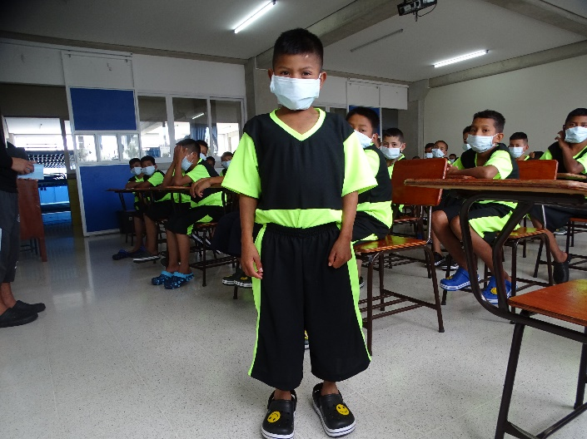

Reinery is one of these children. He is 12 years old but because of severe malnutrition his growth has been stunted and he looks much younger. He is the ninth child in a family of twelve. His parents are uneducated and make a simple living as farmers.

All the members of the family, right down to the youngest, work hard in the fields to help their parents make a living. Despite their efforts, there is never enough food to eat and then last year the family home was hit by Hurricane Eta. It destroyed their home and their entire livelihood.

With your kindness in 2021 we were able to fund places for two of the boys from this family at our school in Amarateca. One of these boys is Reinery shown above.

Your donations helped us give the boys the remedial care they needed, a balanced diet, a good education and a chance of a better future. Now safe with us they can grow and thrive and enjoy a proper childhood. Reinery says “**With the help of good-hearted people I am here in Grade 7 in Amarateca. I have in mind to have a good future. I want to be an electrician and here with my new learnings in my new home and school I can make that dream come true and help my family**”.

**A brighter future for children**

Thanks to your generosity despite the challenges of the pandemic, we were able to keep teaching on track in 2021 and purchase the equipment needed to move studies online when face to face classes were not possible. This included new computers and vital computing and internet hardware like routers and connectors.

The children were able to maintain their academic subjects like maths, English and physics and learn vocational skills relevant to local job vacancies including mechanics, computing and business studies. They were able to sit their national exams on schedule in October and the older students had work experience and passed ready for work when they graduated in November.

Thanks to you, a total of 222 boys and girls graduated in 2021 and last year saw the first graduates from our boys’ school in Amarateca. We are thrilled that 134 of the most deprived young boys in this region have now graduated from our school with the skills they need to find work.

In 2021, these children became independent and productive adults able to look forward to a brighter future thanks to you.

Boys and girls celebrating graduation November 2021