Global Giving Report

November to January

The Christmas and New year period have been busy as we see in a new year of 2024.
To this end we have been working closely with Emmanuel University and diversifying our literacy specialist inputs in the primary sector in Malawi. We have managed to increase the welcomed inputs into this government primary Demonstration School such that we now have volunteer teachers in each of Standards 1, 2 and 3. The critical input is from the Waterloo Foundation where we were able to place Thandiwe (Thandi) in Standard 1 to commence literacy teaching last year, and she has moved up to Standard 2 this academic year. We would like to maintain this support to the learners as they progress up to Standards 3 and 4.

As we are an integral part of the Strengthening Teacher Education and Practice (STEP) consortium, technical support to the Ministry of Education, developing literacy teaching knowledge, skills, attitudes and practices with all 22 public and private teacher training colleges in Malawi which train primary school teachers. We are now working with all the language teacher educators in Malawi and we have helped to train them.

This means that we can also utilise the Demonstration School to develop materials to demonstrate to teacher educators and student teachers all over Malawi, now and future, what can be done. Part of our work is to ensure that there are physical and online materials available in every Teacher Training College, and we want to develop video content that shows how the teaching methods, new in Malawi, can be undertaken, and the learner interactions that are so different, and the children’s resulting skills. This is a huge and exciting opportunity that supersedes the development of Emmanuel University’s role in teacher training and a new diploma.

With fun and engaging lessons, we have so far increased learning outcomes in foundational literacy and improved educational potential for 250 current learners, supported by classroom-based low-cost technical training and mentoring.

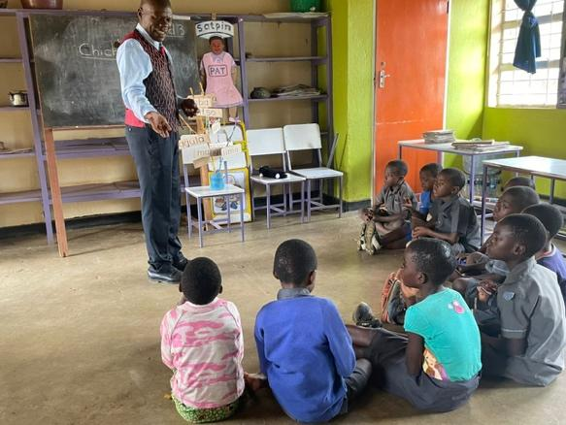

Our Senior Field Officer, Andrew Mchisa, has grown in capacity and responsibility, focussing on running the programme and taking the lead on management.

Andrew has continued to develop several literacy activities and fun Teaching and Learning Using Locally Available Resources (TALULAR) resources, such as the ‘CharChar Baby’ (a dancing puppet made from scrap cardboard), which he uses to teach phonemes and phonics (letter sounds) to the whole school during the daily whole school assembly. Learners from Std1 - Std8 do their best to be at school on time not to miss these exciting, interactive sessions where learners (and teachers) sing and march as they learn new concepts such as English short and long vowel sounds. Government employed teachers have also benefited from these ‘phonics assemblies’ as they have also now learned that English vowels have two sounds, short and long. As a direct result of the visible successes in Standards1, 2 & 3 primary classes the government employed teachers of the remaining classes (Standards 4, 5, 6, 7 & 8) have requested to receive additional training to improve their own knowledge of English letter sounds and phonics. We will need to fund-raise for this to be able to increase the current project reach.

The government employed teachers report anecdotally that children have become more engaged with school life and that the absentee levels have reduced in the CharChar intervention classes.

At the time of this report’s submission, we are pleased to be able to provide learners’ progress (summative assessment) at the end of the first full academic year (July 2023). Even though this is technically outside of the first year’s reporting frame we would like to share the exciting results.

Planned outcomes | Progress to date
Two newly qualified teachers will become accomplished practitioners in primary literacy and numeracy education. Their progress as Specialist Teachers will be measured through regular lesson observations and termly assessments of learners’ progress. | Three newly qualified teachers have been trained as foundational literacy specialists to successfully deliver a foundational literacy intervention in Standards 1, 2 and 3 to 250 children.
Approximately 260 learners initially (plus similar numbers of learners in future years) will gain foundational literacy and numeracy skills, transforming their prospects in work and education and providing a route out of poverty. We will assess their progress through termly assessments of letter name and sound recognition, and single digit number knowledge. 15 girls and 15 boys will be selected at random and their results compared to our baseline and national data. | All 250 learners from the three classes were formally assessed at the end of the school year (July 2023). Average scores by class were:  Std 1:  letter names - 23.5/26  Letter sounds - 90%  CVC words - 83%  High Frequency words 8/10  Decodable words 15/22  Std 2:  letter names - 25/26  Letter sounds - 31/32 (includes digraphs)  CVC words - 96%  High Frequency words 9/10  Decodable words 20/22  Std 3:  Note these Std 3 learners here had the same exposure to evidence-based teaching practices as those in Std 2.  letter names - 26/26  Letter sounds - 31/32 (includes digraphs)  CVC words - 80%  High Frequency words 8/10  Decodable words 70%  It is worth noting that assessment results from Standard 2 learners supported by this programme are higher than the older children’s literacy levels in Standard 4 who have not received the intervention.  Std 4:  20/26 letter names  10/32 letter sounds.  The intervention exceeds the national results which assessed letter names and sounds in 2021 in Standards 2 and 4: National Reading Program – YESA Report (p. 23)  Std 2 Letter names: 5.5/26  Std 2 Letter sounds: 3.5/26  Std 4 Letter names: 21.6/26  Std 4 Letter sounds: 6.3/26
Government employed teachers in the same school will be introduced to and experience current best practice in phonics and numeracy teaching and will receive on-the-job support in the second academic year. Their response will be assessed through informal interviews during school visits and training days. | School management and class teachers requested Andrew to extend the training and support all classes including upper primary. In the absence of funding, he has found some creative ways to support teachers and learners in Stds 4- 8, without compromising the intervention in Std1, 2 & 3. We are pleased to report government teachers in Stds1,2 & 3 have adopted some of the teaching and learning strategies such as grouping learners with mixed abilities, teaching new literacy concepts through games, songs and other play-based activities.
Six lecturers and 150 student teachers at Emmanuel University will benefit from seeing and experiencing current best practice applied in a classroom setting, indirectly benefiting around 5,850 learners per year in the future. The impact on lecturers and students will be assessed through surveys, focus groups, student coursework, and meetings between CharChar Literacy and the University. | Post Covid, the university has had to reduce the number of lecturers in each department due to low student teacher enrolment. However, CharChar was able to implement an intensive course on evidence-based foundational literacy instruction through a series of lectures for student-teachers and their lecturers. Topics include early childhood development, oral language development, phonological awareness and phonics. These lectures were further supplemented by a Whatsapp group to encourage student teachers to exchange their ideas and questions around foundational literacy instruction methods and practices.
We will, jointly with our partner, Emmanuel University, monitor our active and established working relationship with the key directors in the Ministry of Education and their interest in developments in the Teacher Training sector, based on the number of relevant visits and meetings. Wider sector involvement in the demonstrations will be measured by how the sector engages with our work for example by developing video materials of best-practice teaching for use in other teacher training settings nationally. | We have successfully developed a video bank showcasing foundational literacy best-practice teaching approaches and play-based activities, which has already been used in the Florida State University led, USAID funded, STEP Activity (Jan 2023 - August 2023). This content is the only classroom-based instruction content from Malawi, which was used in a Florida State University accredited foundational literacy course to demonstrate contextually relevant best practice examples of foundational literacy instruction with Malawian teachers and learners. This material has so far been used to train 121 language lecturers from public and private teacher training colleges and Education stakeholders in foundational literacy instruction.

Operations Director
Andrew White

