Report: Monthly Performance Report - Local Partner (SORD) June 2025

Project Name: Emergency Intervention to Rescue Animals in Zoos
(Providing medical care, emergency protection, food, and clean water to meet the urgent needs of animals in Zoos in Yemen. Taiz - Ibb - Sana'a )
The site: Yemen (Sana'a) - Taiz - Ibb
Applicable organization: Sanid Organization For Relief and Development
Report duration : Quarterly​
Start date: 01-03-2025
Expiration Date: 01-06-2025

Contact information :
- Report author's name : SHAIF Ezz El-Din
- Current position: Project Manager
- The organization's website www.sanid.org
- e-mail Programs.officer@sanid.org
- Mobile phone number: 00967 778515109
- Organization's Location :
Republic of Yemen - Sana'a - Al-Hasaba - Al-Jumhuriyah Street - Al-Habari Roundabout - Behind Al-Jadary Petroleum Derivatives Station

Project Summary :
The project aims to provide emergency medical care, protection, food, and clean water to meet the immediate needs of animals in zoos in Yemen. This project aims to provide emergency medical care, food, and clean water to animals in zoos in Yemen. Animals in zoos in Yemen are suffering from difficult conditions due to the ongoing conflict in the country. Many of these animals are in dire need of emergency medical care, food, and clean water to survive. This project aims to provide these essential services to animals in zoos across Yemen. This will be achieved by identifying zoos in need of emergency assistance and providing emergency medical care to sick and injured animals in these zoos. Food and clean water will be provided to all animals in these zoos on a regular basis. A long-term plan will be developed for the ongoing care and maintenance of these animals, including the establishment of a network of animal welfare organizations and volunteers to provide ongoing support.
The project aims to uphold the principles of justice by ensuring that all animals ,regardless of species or origin, have equitable access to life-saving interventions. This entails meeting the urgent needs of every animal in distress, fostering a sense of responsibility for their welfare, and promoting the equitable distribution of resources to enhance their chances of survival.
Project data :
- Context and Need: * Witnessing one of the world's worst humanitarian crisesintervention to save animals in zoos is an urgent need. The need is not limited to saving human lives, but extends to protecting all life forms affected by conflict, including animals in zoos. These animals, often endangered species or those in need of special environments and care, are at risk of mass death if immediate intervention is not taken. Therefore, the need lies in providing :
- Emergency care : Includes food, water, veterinary care, and shelter .
- Capacity building : Training the remaining zoo staff to handle emergencies .
- Sustainable support : Find long-term solutions to ensure the continued care of these animals even after the crisis ends .
Saving these animals not only reflects a commitment to animal welfare, but also a concern for biodiversity and the preservation of endangered species, which are considered part of
the world's heritage.
- Project objectives :
* General objective :
- Preserving the threatened biodiversity of the Malhan Nature Reserve and ensuring its sustainability for future generations.
- Develop a comprehensive management plan for the reserve that focuses on partnership and cooperation with the local community.
* SMART Objectives * :
Protection of threatened species :
- Contribute to the conservation of endangered animal and plant species, including rare species such as the Arabian leopard (if present or reintroduction efforts are part of the plan) and rare birds.
- Monitor, prevent and report violations of poaching and illegal trade in rare birds (migratory and resident).
- Ensuring the safety of birds in target areas and ensuring that they are not killed or hunted.
- Providing medical and nutritional care to animals and birds to ensure their survival.
- Promoting sustainable management of natural resources:
- Identify and regulate grazing seasons to reduce pressure on plant resources.
- Implementing comprehensive cleaning campaigns within the reserve.
- Identify alternatives to reduce deforestation.
Building community awareness and partnership :
- Raising local community awareness of the importance of biodiversity and the sustainability of natural resources.
- Educating students in educational institutions (schools, universities, institutes) about the importance of preserving reserves, especially the Malhan Reserve.
- Building a relationship based on partnership and cooperation between the reserve and the local community.
Strengthening the legal framework and accountability:
- Follow up on the activation and implementation of current Yemeni laws related to the protection of rare and protected birds in general.
- Continue meetings with relevant government agencies to activate the role of protection and legal prosecution of perpetrators of crimes related to the destruction of protected areas.

Activities carried out during the reporting period (mention detailed activities with quantities and locations):
Sanid Organization's Nature Conservation Unit implemented the following activities :
- Conduct a quarterly assessment of parks' emergency aid needs, including animal health and nutrition.
- Conduct 2 interviews and workshops with key stakeholders (staff, leadership, and partners) to discuss the assessment of urgent needs and priorities.
- Two meetings were held with the relevant official authorities in the targeted parks to assess the condition of the animals and identify the potential obstacles and risks resulting from the lack of support .
- Develop a plan to protect animals in parks and improve their health, nutrition, and appearance.
- Implementing a health campaign consisting of three veterinarians for two weeks to treat several animals. Veterinarians also provided nutritional supplements, vaccines and vitamins.
- A workshop was held on the importance of the project.
- Training 15 individuals on community awareness methods to conserve wildlife and endangered species in the project's target areas.
- Training community volunteers on community awareness methods to conserve wildlife and endangered species .
- Implementing a field awareness campaign with the participation of community committees in the targeted areas, targeting 60 local residents.

Achievements and results during the reporting period :
Amidst the armed conflict and societal collapse in Yemen, countless lives hang in the balanceincluding the lives of innocent animals trapped in zoos across the country Facing famine drought, disease, and inadequate conditions, these creatures are teetering on the brink of extinction .
Our project serves as a vital lifeline, providing urgent humanitarian services and ensuring their welfare and survival. Through immediate care, rehabilitation, and long-term sustainable measures we will foster a future where Yemen's zoo animals receive the respect and protection they deserve .
As the humanitarian situation in Yemen collapses, animals, especially those in zoos, have been particularly hard hit. A lack of food, clean water, and veterinary services has led to deteriorating health conditions, leading to illness and death, and even the extinction of some endangered species, such as lions, tigers, and the rare Arabian leopard, unless urgent action is taken and life-saving emergency assistance is provided .
The prolonged armed conflict since March 2015 has left significant destruction in all aspects of life, particularly wildlife, which has become unable to conserve rare and endangered animalsincluding the Arabian leopard .
The tragic situation has extended to artificial parks dedicated to wildlife, which are no longer able to continue operating and meet the needs of their animals
This has led to the death of a large number of wildlife, including rare and endangered speciesSince the organization has issued project updates to accommodate its expansion of activities during 2025 to include most of Yemen's zoos, implementation of the new update began in early February 2025
Given the expansion of its plan, it has begun conducting a comprehensive survey of the parks assessing previous phases, and commencing implementation of the plan.
Challenges and lessons learned :
- Challenges :
- Scarcity of resources and limited support for these activities.
- Decrease in treatment and food due to scarcity of financial resources .
- Interruption in the provision of detergents, disinfectants, and treatments for injured animals due to scarcity of financial support .
- Lack of food and meat for some animals in the parks due to scarcity of financial support
- Lessons learned :
- Increased community awareness of the importance of protecting animals and caring for the environment, particularly parks as a visitor and animal protection park.
- The interaction of the competent authorities with the activities implemented by Sanid (Nature Conservation)
- Community Feelings of Love, Appreciation and Gratitude GlobalGiving And its supporters and donors On cooperation and providing assistance to Yemen and hopes to increase support to achieve the project’s goals and protect animals in parks. The role is represented by platform GlobalGiving In her dedication to connecting donors with grassroots initiatives, she has had a profound impact on organizations. Like the Sanid organization in Providing the resources, exposure, and training opportunities you provide and always striving to highlight these organizations to appear, succeed, and achieve profits that enable them to succeed in the goals of the projects they adopt.
- Future plans (for the coming period)
1-: Immediate Animal Care
Our top priority is to meet the animals' most urgent needs
We will provide emergency medical care, nutritious food, and clean water to alleviate their suffering and prevent further deterioration.
2-: Infrastructure Rehabilitatio
Dilapidated fenced areas and broken sewage systems pose significant threats
We will repair and upgrade these facilities, creating safe, comfortable, and healthy environments for animals.
3- Capacity Building
Equipping local zookeepers and veterinary staff with best animal welfare practices is critical to long-term success. We will provide comprehensive training programs and establish a system for ongoing monitoring and preventative care
4- Public Awareness and Education:
Promoting empathy and understanding is essential to ensuring sustainable support. We will launch public awareness campaigns and engage local communities in protecting the welfare of zoo animals.
5-Collaboration with international organizations
By partnering with NGOs, wildlife conservation groups, and government agencies, we can leverage resources and expertise and maximize our impact.
Photographs (optional but recommended) :
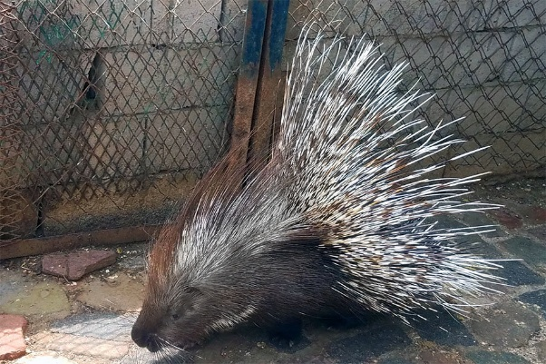 | 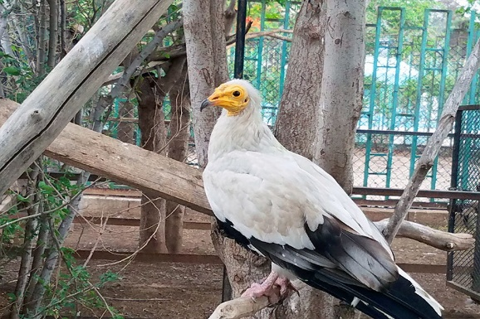
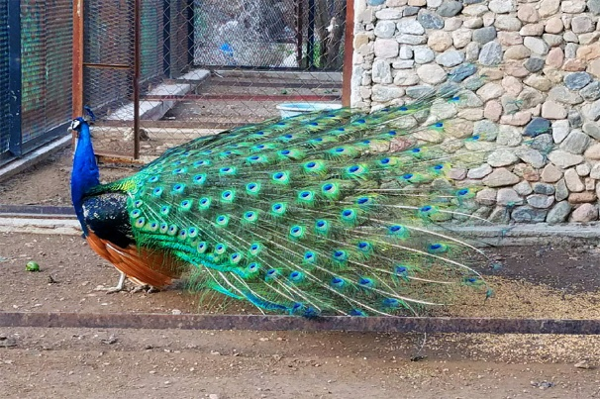 | 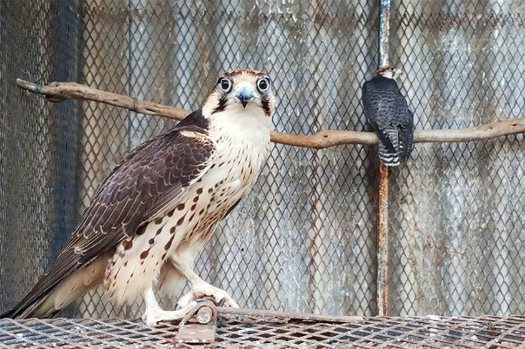
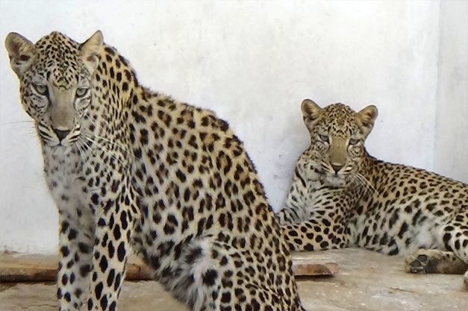 | 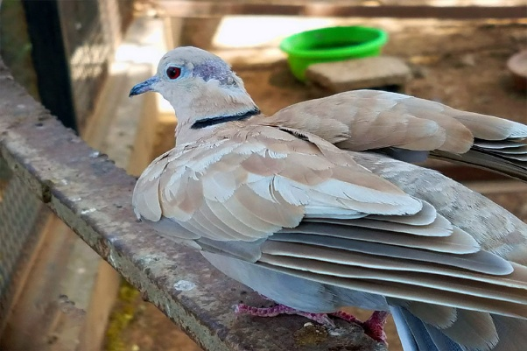
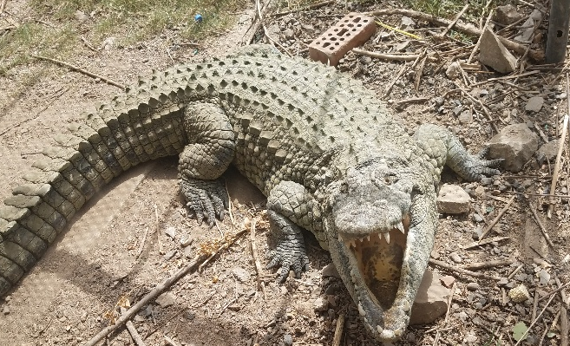 | 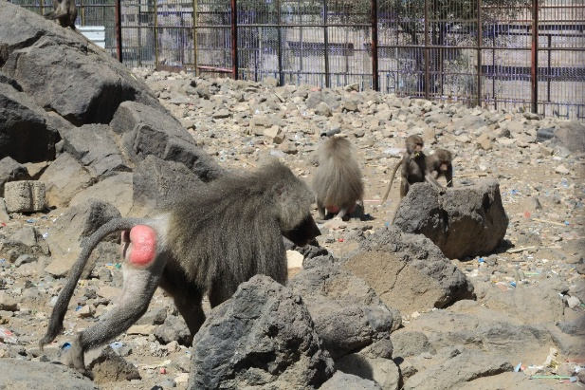

Conclusion:
In concluding this vital project, we emphasize the importance of the efforts made to provide medical care, emergency protection, food, and clean water to animals in zoos in the governorates of Taiz, Ibb , and Sana'a. These animals have faced extremely difficult conditions as a result of the ongoing crisis, threatening their survival and well-being.
Thanks to the generous support of GlobalGiving And its supporters and donors , and the great dedication of the SanidOrganization's team .
Through (SanidOrganization Relief and Development and volunteers , we were able to provide urgent assistance that made a tangible difference in the lives of these animals Our activities have helped alleviate suffering, improve health conditions, and provide the basic requirements that ensure the survival of these species in the face of current challenges.
This project not only represents a humanitarian response to vulnerable species, but also reflects a commitment to preserving biodiversity, which is an integral part of Yemen's and the world's natural heritage.
Despite the achievements, continued support is still needed to ensure the long-term sustainability of these animals' care. We hope these partnerships remain strong enough to face any future challenges, and together we will continue to protect the lives that depend on us.

