**A Report Taiz Zoo is a way to Protect Against Extinction  
September 2023 AD**

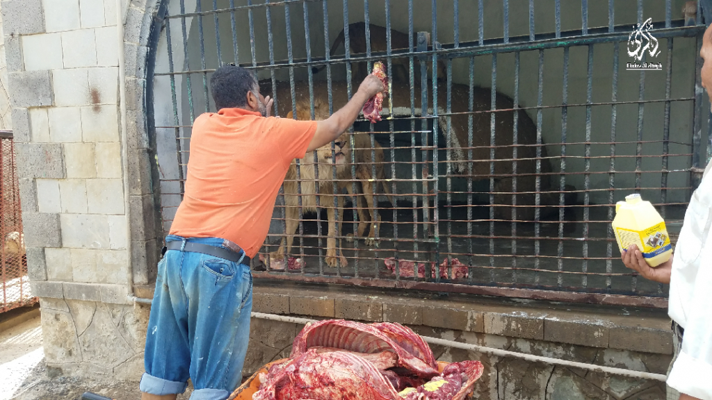

**About the Project:**

**An overview of the status of Taiz Zoo** Due to the scarcity of resources that the Zoo in Taiz Governorate is going through, which has resulted in a lack of interest from the official authorities in the park, this has led to a deterioration in the conditions of the park, the most important of which is the spread of diseases among the animals in the park as a result of the acute shortage and inability of the health aspect in providing healthy vehicles and food (veterinary medicine) and also as a result of the food shortage, which was These two elements are the biggest challenge facing the Sand Organization for Nature Conservation in this period. It has intensified its efforts despite the meager funding and scarcity of capabilities. However, the organization was primarily concerned at this stage with taking care of the animals inside the park healthily and nutritionally in order to preserve the animals from death as a result of disease and hunger, as it saw that this is the The most important thing that can be implemented.

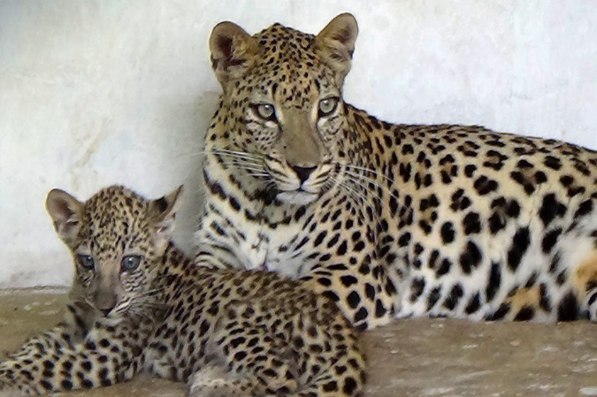

***Diseases*** among the animals in the park as a result of the acute shortage and inability of the health aspect in providing healthy vehicles and food (veterinary medicine) and also as a result of the food shortage, which was These two elements are the biggest challenge facing the Sand Organization for Nature Conservation in this period. It has intensified its efforts despite the meager funding and scarcity of capabilities. However, the organization was primarily concerned at this stage with taking care of the animals inside the park healthily and nutritionally in order to preserve the animals from death as a result of disease and hunger, as it saw that this is the The most important thing that can be implemented

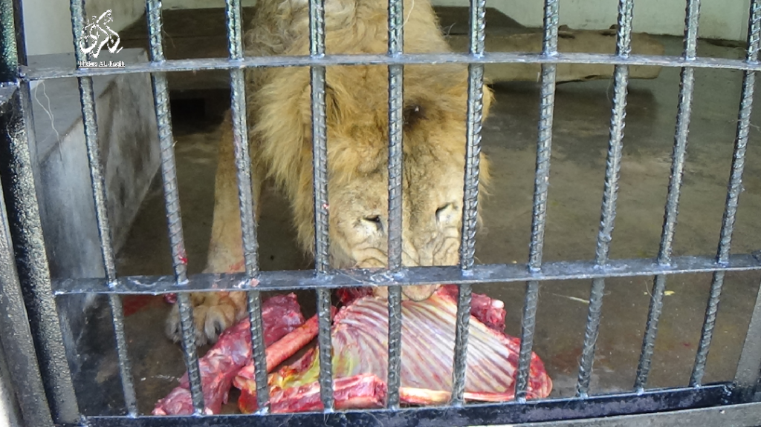

**Activities that were implemented in the third quarter ,SanId has implemented the following activities:**

• 4 meetings were held with the concerned official and popular authorities in Taiz Governorate in order to study the deteriorating situation of the park and search for sufficient funding to preserve the lives of the animals in the park that suffer from disease and hunger.

• Two veterinarians were appointed to review the health conditions of the animals and contribute to their treatment.

• A joint committee was formed from the organization, the Environmental Protection Authority, the Tourism Office, and the Agriculture Office to discuss a plan to protect the animals in the park and improve their health and nutritional status, as well as the appearance of the park.

• Implementing a health campaign to treat some animals by contracting with 2 veterinarians for a week, during which they treated many animals. And (providing nutritional supplements, vaccines and vitamins through veterinarians.

• Providing a number of detergents, sterilizers, and treatments to treat animals exposed to pups. Continuing to monitor the conditions in Taiz Park and other zoos and constantly monitoring events in what the animals go through in these parks. The most important of which are the zoos in Sana’a and Taiz, and learning about the health conditions that the many animals are experiencing and taking care of them. In gardens, inventorying the damage they inflict, and submitting reports to the competent authorities.

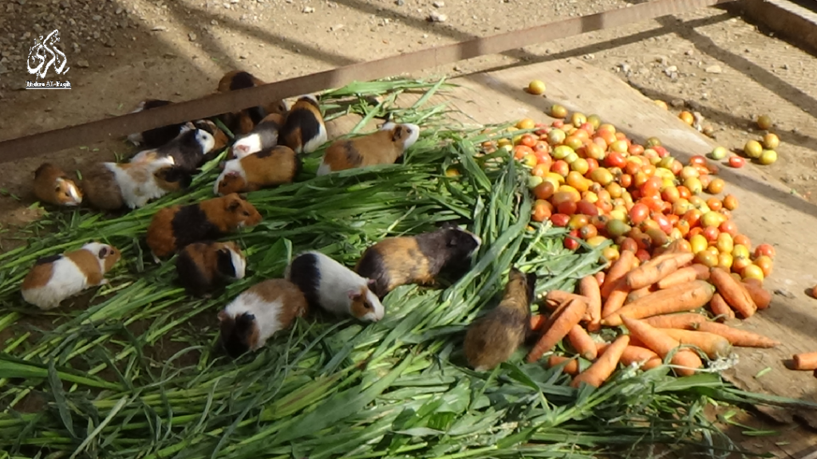

**Conducting** awareness sessions mong the community surrounding the park, as well as concerned official and community bodies, on the necessity of preservationOn biodiversity in the Republic of Yemen, as the organization considers environmental protection to be the protection of natural resources and their sustainability for future generations

**The most important challenges and difficulties:**

* Scarcity of capabilities and lack of support provided for these activities.
* Decrease in treatment and food due to scarcity of financial capabilities.

**Lessons learned:**

* High level of community awareness of the importance of protecting animals and taking care of the environment, especially gardens as a park for visitors and to protect animals.
* The interaction of the competent authorities with the activities carried out by SANED.
* The community feels love, appreciation and gratitude GlobalGiving for cooperation and providing aid to Yemen and hopes to increase support to achieve the project goals and protect animals in the parks.

**Recommendations:**

* Increasing financial support to provide adequate food and medicine for zoo animals.
* Improving the appearance of the garden and reclaiming the seating areas.
* Providing salaries for the garden staff to carry out their duty towards the garden.