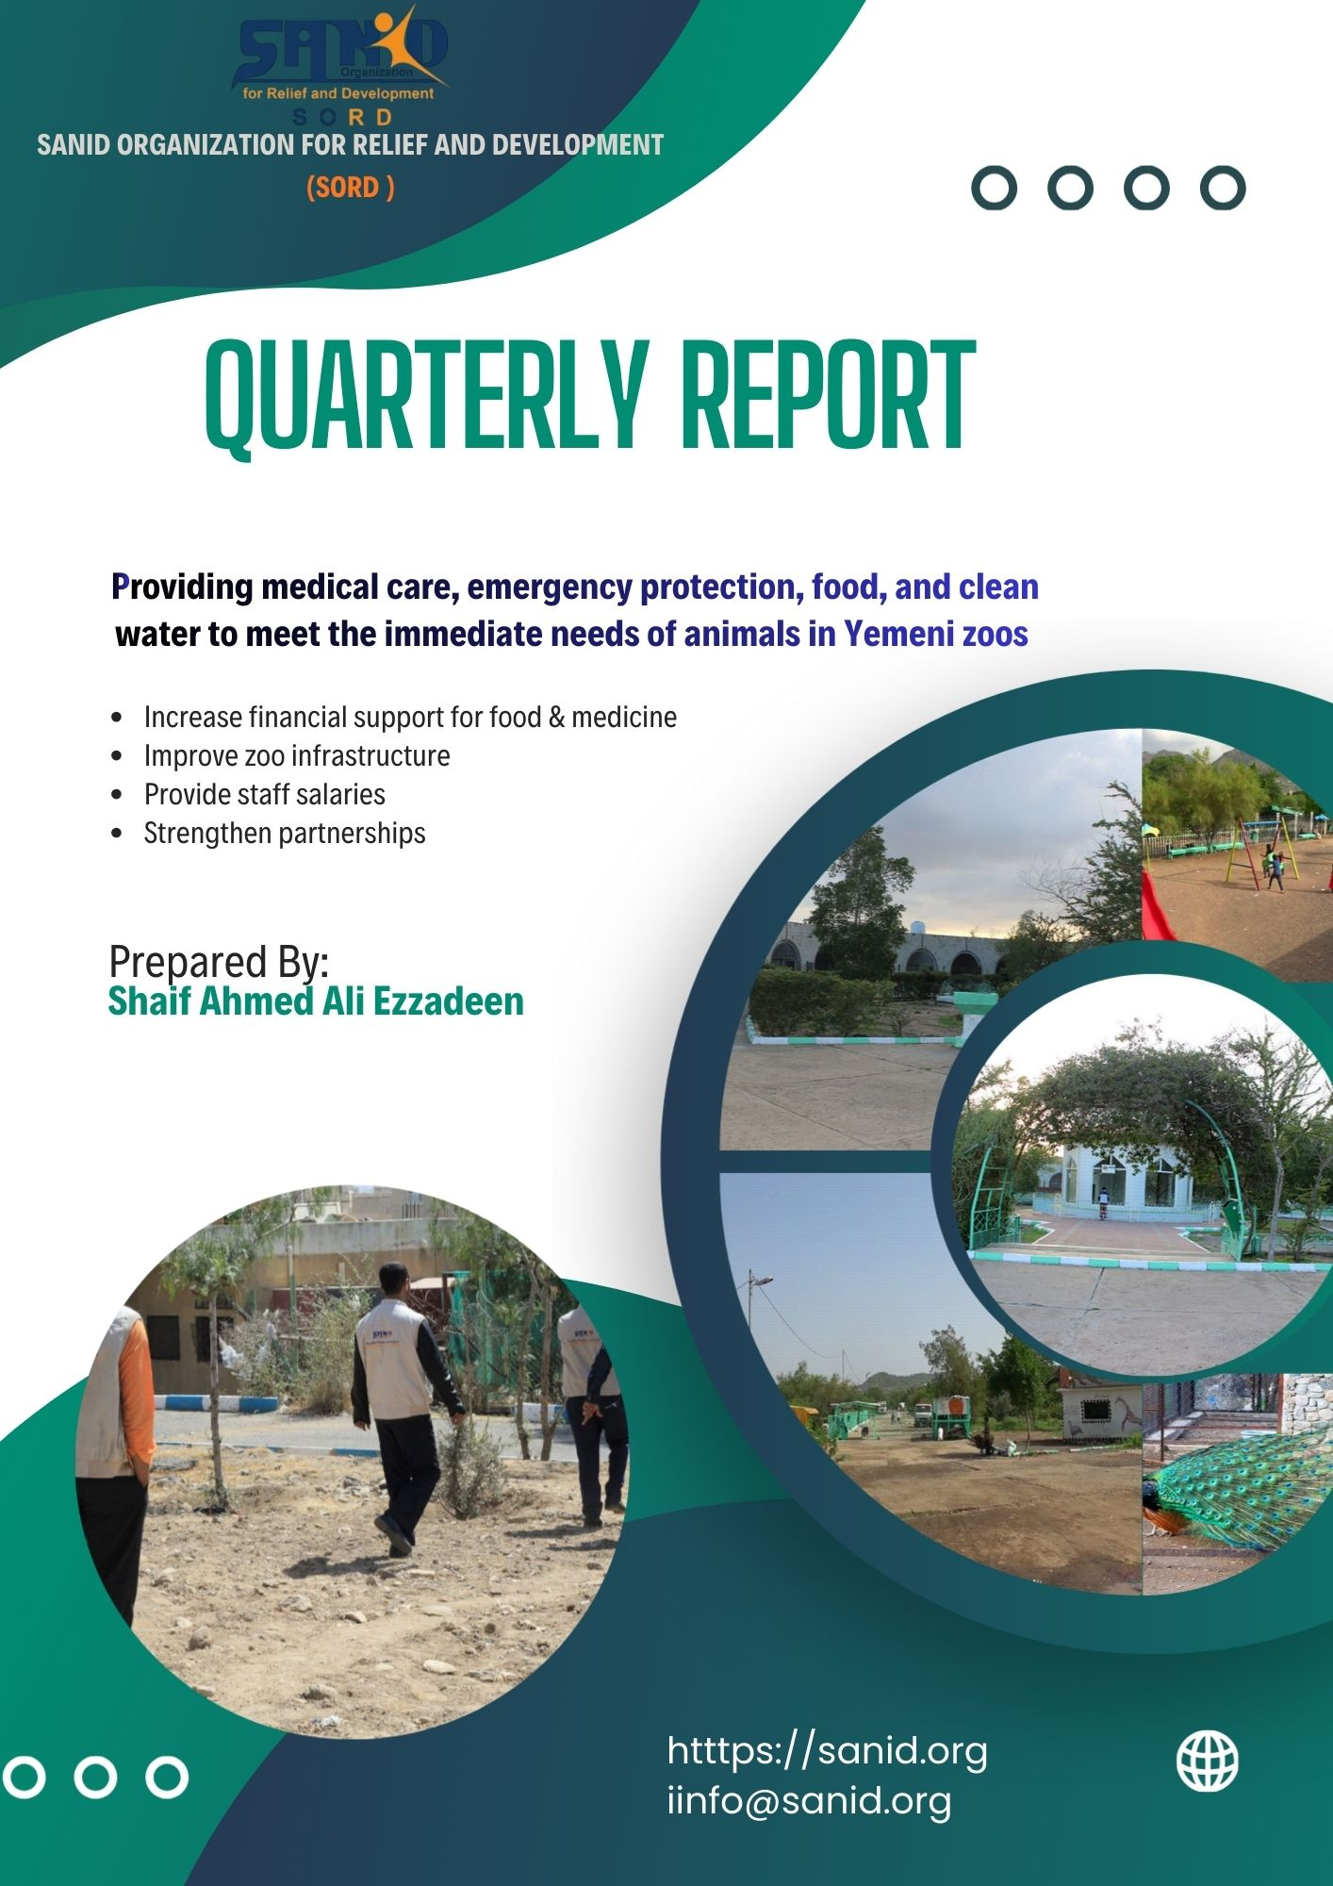

SANID Organization: Nature Conservation Unit
Project Status Update: Emergency Zoo Intervention (Feb 2026)
I. Ethical Framework: "The Principle of Justice"
Our intervention is guided by the belief that justice extends to all living beings. In the context of the Yemeni conflict, we ensure that:
- Equitable Access: All animals, regardless of species or origin, receive life-saving medical care.
- Shared Responsibility: We foster a sense of duty within the local community to protect those who cannot protect themselves.
- Strategic Distribution: Resources are allocated based on urgent distress levels to maximize survival rates.
II. Accomplishments to Date
Despite restricted funding, the team has maintained a "stability-first" approach:
- Medical & Sanitation: Deployed two specialized veterinarians to administer vaccines and vitamins. We have maintained strict hygiene protocols using consistent disinfectant supplies to prevent disease outbreaks.
- Strategic Monitoring: Implemented a cycle of continuous assessment, involving three major stakeholder workshops to identify "high-risk" zones within the parks.
- Social Advocacy: Conducted three community sessions focused on biodiversity, successfully linking animal welfare to the broader preservation of Yemen's natural heritage.
III. Urgent Resource Gaps
The following table summarizes the "Support vs. Need" reality as of February 2026:
Category | Current Status | Critical Need
Nutrition | Intermittent (meat/food) | Consistent daily supply
Medical | Basic supplements/emergency aid | Specialized trauma care & chronic meds
Human Capital | Volunteer/Modest support | Dedicated salaries for 24/7 staff
Infrastructure | Degraded/Unsafe | Restoration of seating and enclosures

IV. Future Roadmap
Our next phase focuses on transitioning from "Emergency Response" to "Sustainable Maintenance." This involves:
- Establishing a formalized Animal Welfare Volunteer Network.
- Creating a long-term maintenance plan to bridge the gap between conflict cessation and tourism recovery.
- Securing direct stipends for zoo staff to prevent the total abandonment of animal care duties.

Quarterly Project Report
Project Title: Emergency Animal Rescue Intervention in Yemeni Zoos Organization:
SAND Relief and Development Organization Reporting Period:
November 2025 – February 2026
Prepared by: Shaif Ezz El-Din, Project Manager
Location: Yemen

1. Executive Summary
This project provided emergency medical care, food, clean water, and protection to animals in Yemeni zoos affected by conflict. Despite limited resources, Sanid implemented veterinary services, food distribution, awareness sessions, and stakeholder coordination. Sustained financial support is urgently needed to ensure continuity and long-term animal welfare.

2. Project Background
Animals in Yemeni zoos face severe shortages of food, water, and medical care due to the ongoing crisis. The project aimed to:
- Deliver emergency veterinary services.
- Provide food and clean water.
- Strengthen zoo infrastructure and staff capacity.
- Build partnerships for long-term animal welfare.
The intervention was guided by principles of justice and equity, ensuring all animals—regardless of species—had access to life-saving support.

3. Activities Implemented
- Continuous assessment of zoo needs (animal health, nutrition, infrastructure, staffing).
- Interviews and workshops with staff, leadership, and partners to identify priorities.
- Three coordination meetings with official and community bodies.
- Follow-up on zoo protection and nutrition plans, with progress evaluation.
- Veterinary care by two veterinarians (nutritional supplements, vaccines, vitamins).
- Provision of detergents, disinfectants, and treatments for injured animals.
- Three awareness sessions with communities and officials on biodiversity preservation.
- Intermittent provision of food and meat to animals based on available resources.

4. Achievements
- Improved animal health through veterinary interventions.
- Strengthened collaboration with local authorities and communities.
- Raised awareness on biodiversity and animal welfare.
- Maintained basic food and medical supplies despite resource constraints.

5. Challenges
- Limited financial resources restricting food and medicine supply.
- Insufficient support for zoo staff salaries and infrastructure.
- Reduced access to treatment due to funding gaps.

