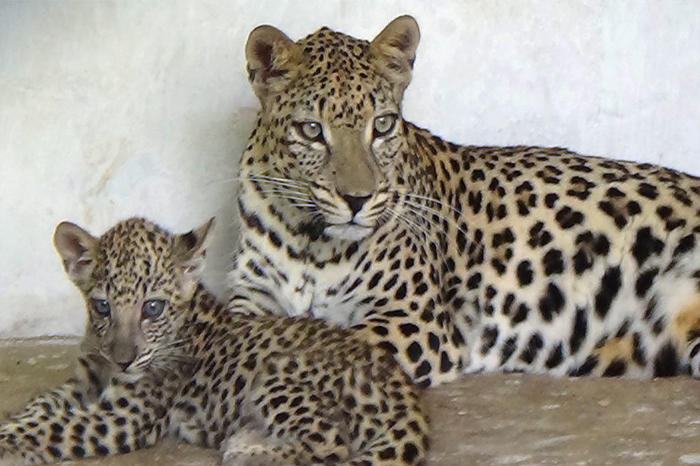

Monthly Performance Report - Local Partner

SAND Organization (Nature Conservation Sector)

Project: Protecting the Arabian leopard in Yemen from extinction
📅 Report period | November 2025/M
✍️ Report prepared by | Shaif Ezz El-Din

📋 Project data
Item | The Details
Project name | Protecting the Arabian leopard in Yemen from extinction
Project site | Yemen
Name of the organization applying for the grant | SAND Relief and Development Organization (SORD)
Report duration | November 2025
Start date (of the project) | July 2025
Project completion date | November 2025
Organization address | Capital Governorate - Shu'ub District - Al-Habari
Telephone number | 0096701205757
Report prepared by | Shaif Ezz El-Din
Current job | project manager
e-mail | Programs.officer@sanid.org
mobile number | 00967 775907606
Organization website | www.sanid.org

🐆 An overview of the Arabian leopard's status in Yemen
The Arabian leopard is one of the most prominent animals native to the mountainous regions of Yemen, and the Yemeni government has declared it the national animal . Leopards are found in several areas, including Al Mahrah, Ad Dali', the Yafa' Mountains, Abyan, Shabwah, Al Bayda', Rada'a, Ibb , and the Bani Qais Reserve in Hajjah. Some leopards are also kept in zoos in Sana'a, Ibb , and Taiz as part of conservation efforts .
The most significant challenge facing the Arabian leopard is the danger of hunting , as it is killed by sheep owners in retaliation for preying on their livestock .
Protecting this rare animal requires intensive efforts from the SAND (Nature Conservation Sector) organization, in coordination with the relevant authorities, to activate awareness and guidance for the residents of the areas where it is found, and to focus on the importance of preserving this endangered species as one of the original inhabitants .
⚠️ Threats to Survival
- Habitat destruction from agriculture, urban expansion, and deforestation
- Poaching for skins and traditional medicine
- Human-wildlife conflict, especially in rural areas
- Genetic isolation due to fragmented populations

🚀 Activities implemented during the reporting period (November 2025)
The SAND organization, in cooperation with official and relevant authorities, sought to activate laws to protect the Arabian leopard and propose the enactment of strict laws to limit its hunting. The activities implemented included the following :
- Community awareness :
  - Conducting an awareness campaign among the people of the areas where the Arabian leopard is found and lives .
  - Implementing awareness campaigns in areas where Arabian leopards are found, criminalizing smuggling and killing, and emphasizing the need to report any dangers to which the leopard is exposed .
- Capacity building and monitoring :
  - Implementing training for volunteers from local activists in the targeted areas on the process of monitoring and reporting violations against the Arabian leopard in the three most affected areas .
  - Field visits to areas where the Arabian leopard is found to meet with local officials and discuss the need to establish monitoring and tracking centers for wild animals .
- Coordination and partnership :
  - One meeting was held with the Environmental Protection Authority to discuss the general situation of the Arabian leopard and ways and means of protecting it .
  - Three meetings were held with the relevant government authorities to activate the protection and legal prosecution of perpetrators of crimes against this animal .
  - Conducting 3 visits to educational institutions (schools, universities and institutes) to emphasize to students the importance of preserving and protecting the Arabian leopard in coordination with these institutions .
- Supporting the environment of tigers in captivity :
  - Field visits to zoos where Arabian tigers are present, to review their conditions and study their needs for the coming year 2026 .
  - Feeding under the supervision of a veterinary specialist for Arabian tigers and their cubs in Taiz Park .

🚧 Challenges and obstacles
- The deteriorating economic situation in Yemen and its negative impact on the overall decline in the environmental situation .
- Lack of support and donations allocated to nature conservation efforts and the protection of rare species .

🎯 Suggested next steps
- Continuing efforts to lobby and coordinate with official bodies to enact and activate laws protecting the environment and endangered animals .
- Searching for new sources of funding to establish field monitoring and tracking centers .
- Long-term funding for habitat restoration and monitoring
- Education programs to foster coexistence between humans and leopards
- Stronger legal frameworks to prosecute poaching and illegal trade
- Scientific research to track population health and movement
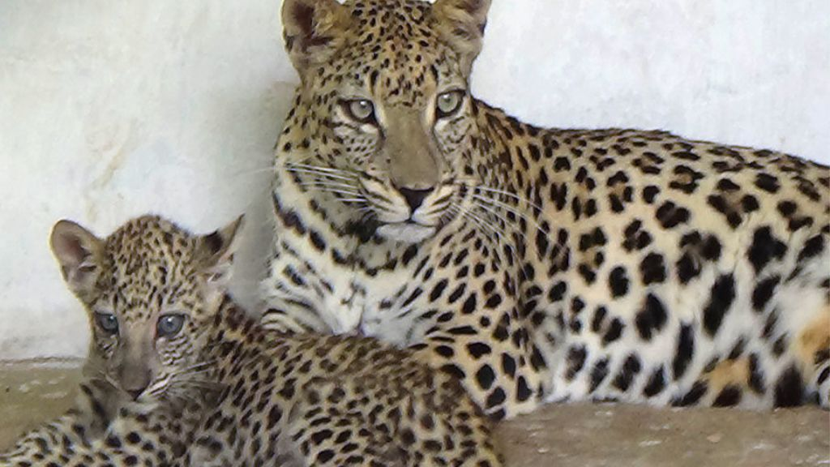 | 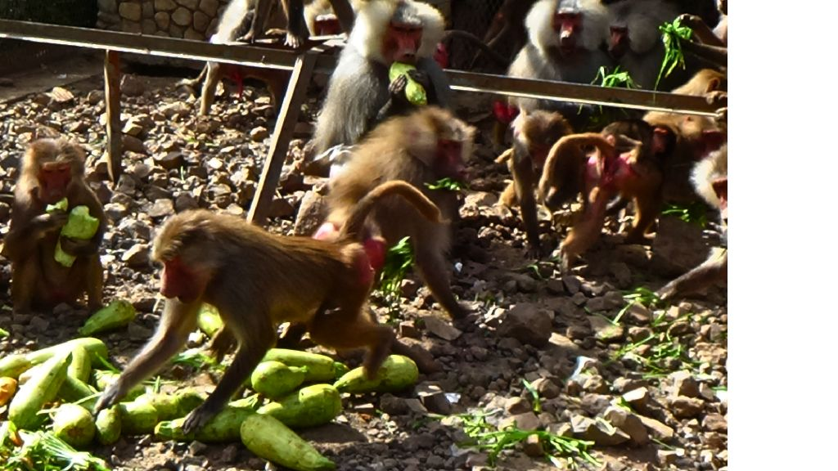
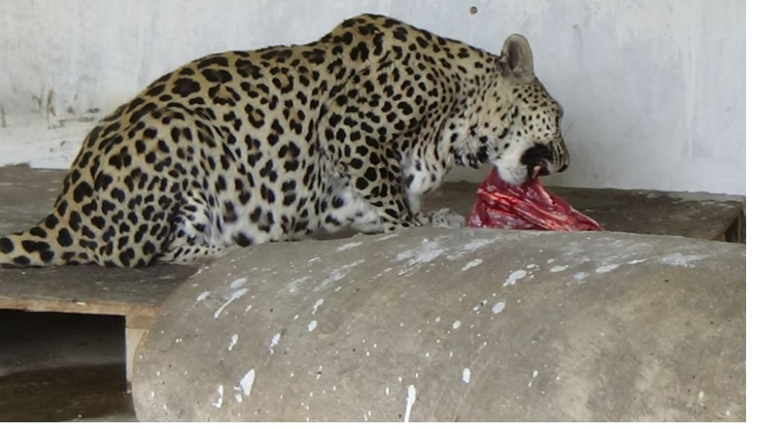 | 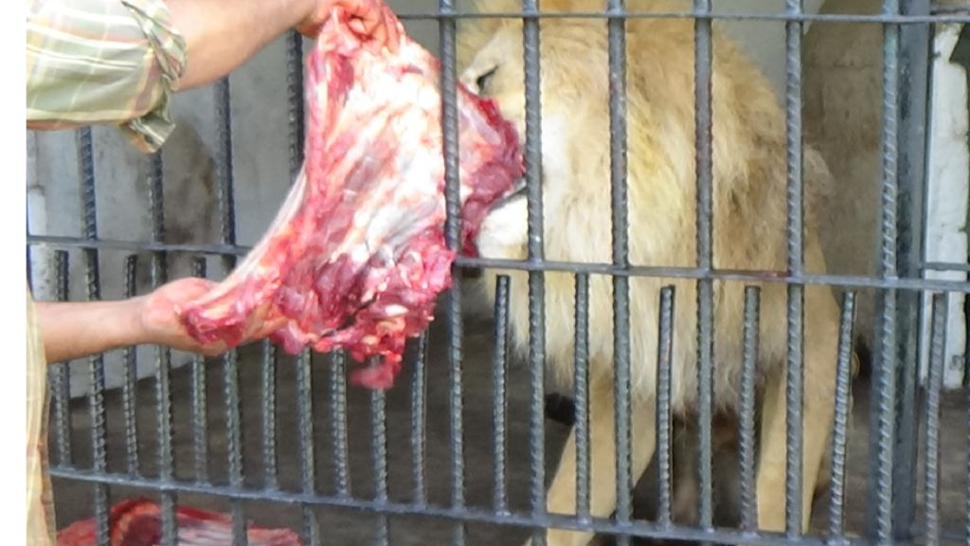
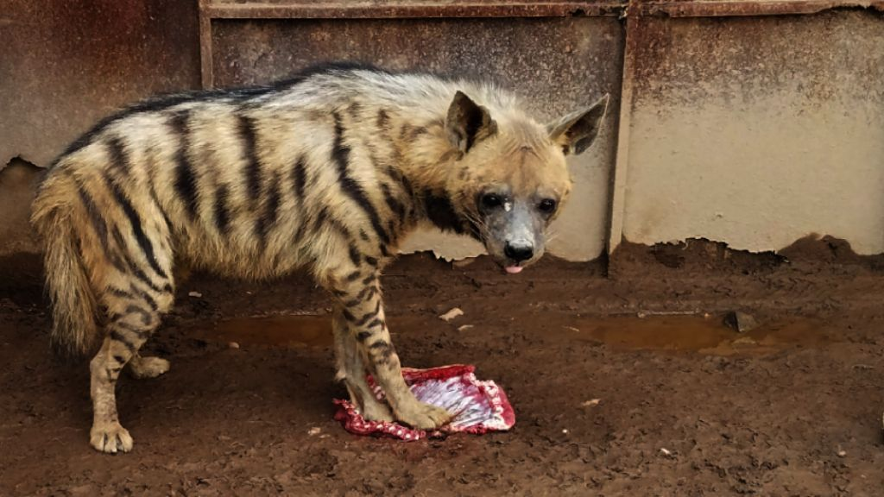 | 