**Monthly performance report - local partner SANID organization (nature conservation sector)**

**For the project: Protecting the Arabian leopard in Yemen from extinction.**

**November 2023/AD**

**Report prepared by: Muhammad Abu Haider**

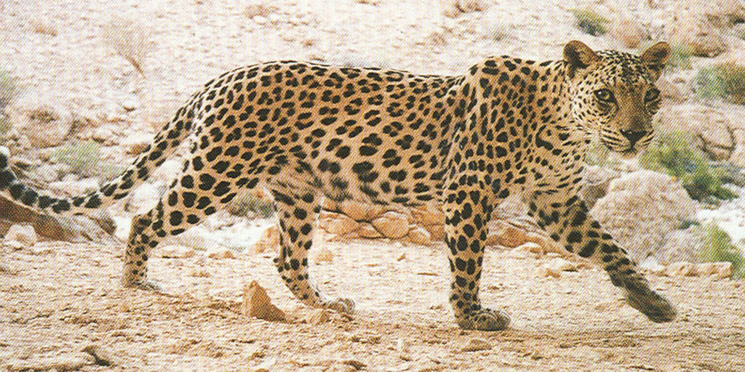

|  |  |  |  |
| --- | --- | --- | --- |
| project name | **Protecting the Arabian leopard in Yemen from extinction** | | |
| The project Location | **Yemen** | | |
| Name of the organization applying for the scholarship | Sanid Organization for Relief and Development ) SORD( | | |
| Report duration | My quarter | | |
| starting date | **August** | **Expiry date** | **October** |
| Organization address | Municipality of the Capital - People's District - Al-Habbari | | |
| phone number | *0096701205757* | | |
| Report preparer | Muhammad Abu Haider | | |
| Current Position | project manager | | |
| E-mail | programmes.officer@sanid.org | | |
| mobile number | *00967 775907606* | | |
| The organization's website | www.sanid.org | | |

**project's data**

**An overview of the status of the Arabian leopard in**

The Arabian leopard is found in mountainous areas, as Yemen is one of the most prominent environments in which it has been endemic since ancient times, which led the Yemeni government to declare it the national animal.

It is found in several areas in the country, including: Al-Mahra, Al-Dhalea, and in the Yafaa Mountains, Abyan, Shabwa, Al-Bayda, Radaa, Ibb, and the Bani Qais Reserve in Hajjah.

Dozens of tigers are also present as part of their preservation in a number of zoos in Yemen, such as: the Zoo in the capital, Sana’a, the Ibb Zoo, and the Zoo in Taiz, southwest of the country.

It also exists The Arabian leopard in the “Kur Al-Awaliq” mountains in the Yemeni governorate of Shabwa, after disappearing for 20 years from the areas of Shabwa.

The Arabian leopard faces the threat of being hunted with justification It preys on sheep owned by citizens Which made him vulnerable to being killed by sheep owners in Shabwa who threatened to kill the tiger in retaliation for the killing of his sheep .

It seems daunting and very difficult to protect a wild animal, which requires the SAND organization (Nature Conservation Sector) By working hard and calling on the concerned authorities to take action and coordinate in order to raise awareness among the people of the areas where the Arabian leopard is found and inhabited.

This requires activating awareness and guiding the population about the importance of preserving the rare animals that characterize their regions, such as the Arabian leopard.

The presence of rare animals and endangered species means that these animals are older than humans and are among the original settlers on Earth, and we should respect that.

Activities carried out :

Nature Conservation Sector) seeks, through the official and competent authorities, to activate the laws in force in Yemen that protect this type of animal. It also seeks to enact strict laws and not tolerate anyone who hunts any rare animal and places it in prison for a period of no less than five years, to be an example to everyone . He assaults these animals By implementing the following:

* Community awareness sessions were carried out by an expert and interested team to educate the people of the areas where the Arabian leopard is found and inhabited.
* Conducting the process of monitoring , monitoring and reporting violations against the Arabian leopard in the three most affected areas .
* A meeting was held with the Environmental Protection Authority and proposals were approved about work and coordination between the organization and the authority, contracting with a legal and consulting office, and working to review the laws in force in Yemen related to the protection of wild animals that are vulnerable to extinction, the most important of which is the Arabian leopard.
* Continuous implementation of awareness in areas where the Arabian leopard is present, criminalizing smuggling and killing, and reporting any dangers to which the Arabian leopard is exposed.
* Agreement with some educational institutions (schools, universities, and institutes) to hold introductory activities for students about the importance of preserving and protecting the Arabian leopard.
* Discussing the plan for the reserves, approving it, and beginning its implementation, including activating the role of protection and legal prosecution of those who commit crimes against this animal.
* Field trips to zoos and learning about the needs of the Arabian leopard.
* Providing food under the supervision of a veterinary specialist to Arabian tigers and their cubs in zoos.
* Rehabilitating some of the cages inhabited by tigers in the parks, in coordination with the parks administration.
* Continue to follow up with the government in finding legal and logistical government support
* Continuous evaluation and exploration of the extent to which society accepts the necessity of protecting Arabian tigers in the face of wars and conflicts.
* Continuing to search for financial funding for the purpose of establishing model monitoring centers for Arabian leopards, their movements, and the risks to which they are exposed.

Indicators :

1. Increased awareness of the importance of Arabian tigers as an authentic animal wealth and the need to protect them from killing and smuggling among citizens in areas where Arabian tigers are found.
2. The relative response from official authorities regarding activating laws to protect wild animals (the Arabian leopard) and limit smuggling and killing of them.
3. The recovery of some Arabian tigers that the veterinary team was able to reach.

**Challenges and obstacles :**

* The deterioration of the economic situation in Yemen and its reflection on the deterioration of the environmental situation.
* The government's inability to provide the necessary needs for Arabian tigers in parks and their various areas.
* Weak strict implementation of the laws in force by the government against those who neglect the importance of purebred livestock, especially the Arabian leopard.
* Lack of typical reserves.
* Lack of support and donations.