Monthly Performance Report - Local Partner Sanid Organization (Nature Conservation Sector)
Project: Protecting the Arabian Leopard in Yemen from extinction.

March 2023 / AD
The author of the report: Muhammad Abu Haidar

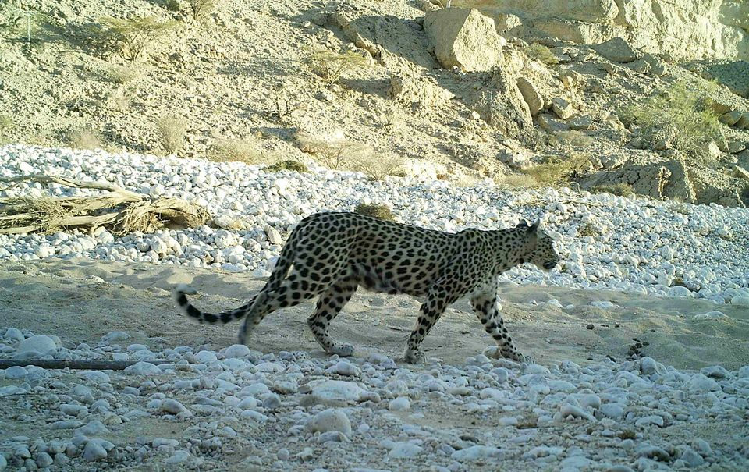

project name | Protecting the Arabian leopard in Yemen from extinction
The project Location | Yemen
The name of the organization applying for the scholarship | Sand Organization for Relief and Development ( SORD )
Report duration | 3 Months
starting date | 1/1/2023 | Expiry date | 3/10/2023
Organization address | Capital Municipality - Directorate of Shoub - Al Habari
phone number | 0096701205757
Prepared the report | Muhammad Abu Haider
Current Position | project manager
E-mail | Programs.officer@sanid.org
mobile number | 00967 775907606
Organization's website | www.sanid.org

project's data

An overview of the situation of the Arabian leopard in Yemen

The Arabian leopard is found in mountainous areas, with Yemen being one of the most prominent environments in which it has been endemic since ancient times, which made the Yemeni government declare it the national animal.
It is found in several regions in the country, including: Al-Mahra, Al-Dhalea, and in the mountains of Yafea, Abyan, Shabwa, Al-Bayda, Rada’a, Ibb, and the Bani Qais Reserve in Hajjah.
There are also dozens of tigers in the framework of their preservation in a number of zoos in Yemen, such as: the zoo in the capital, Sana'a, the Ibb zoo, and the zoo in Taiz, southwest of Al-Balah.
As that exists The Arabian leopard in the “Kur al-Awaleq” mountains in the Yemeni governorate of Shabwa, after its disappearance for 20 years from the areas of Shabwa.
The Arabian leopard faces the danger of being hunted, with justification It preys on the sheep owned by the citizens Which made him vulnerable to being killed by sheep owners in Shabwa who vow to kill the tiger in revenge for the killing of his sheep .
It seems daunting and very difficult to protect a wild animal, which requires the Sanid Organization (Nature Conservation Sector) By working hard and inviting the concerned authorities to move and coordinate in order to educate the people of the areas where the Arabian leopard lives and resides.
This requires activating awareness and guiding the population about the importance of preserving the rare animals that characterize their areas, such as the Arabian leopard.
The presence of rare animals and endangered species means that these animals are older than humans and are the original endemic to Earth and we should respect that.
.

activities :
Sand (Nature Conservation Sector) seeks through the official and competent authorities to activate the laws in force in Yemen that provide for the protection of this type of animal . He abuses these animals By implementing the following:
- Coordination done And a procedure Raising awareness among the people of the areas where the Arabian leopard resides.
- Training of volunteers from local activists in the targeted areas on the process of monitoring and reporting violations against the Arabian leopard in the three most affected areas .
- Two meetings were held with the Environmental Protection Authority and proposals were submitted on work and coordination between the organization and the authority in contracting with legal offices and consultants to review the laws in force in Yemen concerned with protecting wild animals that are endangered, the most important of which is the Arabian leopard.
- Government directives were extracted to prevent the issuance of permits to remove the Arabian tigers from Yemen except for the purpose of breeding and then returning them to their original habitat.
- SANED is following up on the implementation of the Yemeni government's previous announcement of reserves that protect the Arabian tigers.
- Implementing awareness in the areas of the presence of the Arabian tigers to criminalize smuggling and killing, and to report any dangers to which the Arabian tiger is exposed.
- 4 visits were made to educational institutions (schools, universities and institutes) to familiarize students with the importance of preserving and protecting the Arabian leopard, in coordination with educational institutions.
- 3 meetings were held with the competent authorities in the government to activate the role of protection and legal prosecution of the perpetrators of crimes against this animal.
- visit was made to the Bani Qais area, where the Arabian leopard resides, and the meeting with local officials and the ability to convince them of the need to find a protected area was carried out, to study the need to find centers for monitoring and tracking wild animals, and to obtain sufficient data to develop protection plans.
- Field trip to the animal parks in Sana'a and Taiz, and to see the needs of the Arabian leopard, where the female of the Arabian leopard resides (and follow up on the health status of the Arabian leopard.
- Providing medical care to the female Arabian leopard by giving her vaccinations and special food supplies to keep her alive . Sana'a Zoo.
- Providing food under the supervision of a veterinary specialist for the Arabian tigers in Taiz Park and their cubs.
- Expansion of cages and places inhabited by tigers in the gardens, in coordination with the Department of Gardens.

Indicators :
- Increased awareness of the importance of the Arabian tigers as an authentic animal wealth and the need to protect them from killing and smuggling among citizens in the areas where the Arab tigers exist.
- Relative response from the official authorities about activating the laws for the protection of wild animals (the Arabian leopard) and limiting smuggling and killing of them.
- The recovery of some Arab tigers that the veterinary team was able to reach .
- The response from the official authorities to pay attention to the Arabian tiger.
Challenges and obstacles :
- The deterioration of the economic situation in Yemen and its reflection on the deterioration of the environmental situation.
- Lack of support and donations.
Lessons learned:
coordination with the competent authorities (the Supreme Council for the Coordination of Humanitarian Affairs - the Ministry of Agriculture - the local community - the Environmental Protection Authority).
Learn about the many Yemeni regions where endangered wild animals reside.
Continuous communication with donors through globalgiving and clarifying the status of endangered wild animals (the Arabian leopard) in Yemen, which is considered one of the most important indigenous national livestock. in Yemen and the extent of its exposure to danger.
face difficulty in grazing their livestock for fear of being predated by the Arab tiger, which leads to weakening their livelihoods. This leads to the outbreak of hostility between humans and the Arab tiger, which may expose the latter to killing and chasing. . .
I finish

.

