**Monthly performance report - local partner SAND Organization (Nature Conservation Sector)**

**For the project: Protecting the Arabian leopard in Yemen from extinction**

**March 2024 / AD**

**Report prepared by : SHAIF EZ-ADDEN**

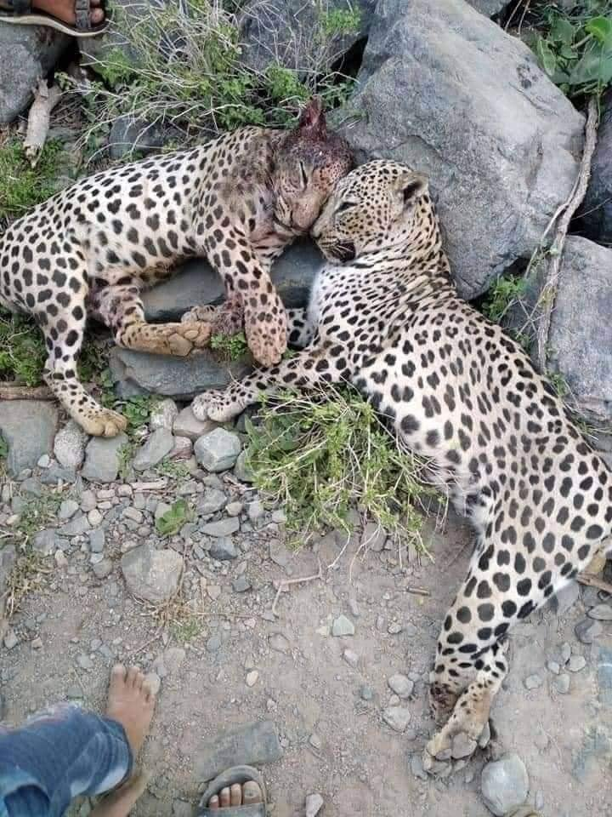

|  |  |  |  |
| --- | --- | --- | --- |
| **Project Name** | **Protecting the Arabian leopard in Yemen from extinction** | | |
| **The project Location** | **Yemen** | | |
| **Name of the organization applying for the scholarship** | **Sanid Organization for Relief and Development (SORD)** | | |
| **Report duration** |  | | |
| **Starting date** | **01-12-2023** | **Expiry date** | **04-03-2024** |
| **Organization address** | **Municipality of the Capital - People's District - Al-Habbari** | | |
| **phone number** | ***0096701231744*** | | |
| **Report preparer** | **Shaif EZ-ADDEEN** | | |
| **Current Position** | **project manager** | | |
| **E-mail** | **programmes officer@sanid org** | | |
| **mobile number** | ***0096778515109*** | | |
| **The organization's website** | **www sanid org** | | |

**project's data**

**An overview of the status of the Arabian leopard in**

The Arabian leopard is found in mountainous areas, as Yemen is one of the most prominent environments in which it has been endemic since ancient times, which led the Yemeni government to declare it the national animal

It is found in several areas in the country, including: Al-Mahra, Al-Dhalea, and in the Yafaa Mountains, Abyan, Shabwa, Al-Bayda, Radaa, Ibb, and the Bani Qais Reserve in Hajjah

Dozens of tigers are also present as part of their preservation in a number of zoos in Yemen, such as: the Zoo in the capital, Sana’a, the Ibb Zoo, and the Zoo in Taiz, southwest of the country

It also exists The Arabian leopard in the “Kur Al-Awaliq” mountains in the Yemeni governorate of Shabwa, after disappearing for 20 years from the areas of Shabwa

The Arabian leopard faces the threat of being hunted with justification It preys on sheep owned by citizens Which made him vulnerable to being killed by sheep owners in Shabwa who threatened to kill the tiger in retaliation for the killing of his sheep

It seems daunting and very difficult to protect a wild animal, which requires the SAND organization (Nature Conservation Sector) By working hard and calling on the concerned authorities to take action and coordination in order to raise awareness among the people of the areas where the Arabian leopard is found and inhabited

This requires activating awareness and guiding the population about the importance of preserving the rare animals that characterize their areas, such as the Arabian leopard

The presence of rare animals and endangered species means that these animals are older than humans and are among the original settlers on Earth, and we should respect that

Activities carried out:

Nature Conservation Sector) seeks , through the official and competent authorities, to activate the laws in force in Yemen that protect this type of animal It also seeks to enact strict laws and not tolerate anyone who hunts any rare animal and places it in prison for a period of no less than five years, to be an example to everyone He assaults these animals By implementing the following:

* Continuing the awareness-raising process among the people of the areas where the Arabian leopard is found and inhabited
* Training for volunteers from local activists in the targeted areas on the process of monitoring and reporting violations against the Arabian leopard in the three most affected areas
* Two meetings were held with the Environmental Protection Authority and proposals were presented about work and coordination between the organization and the authority in contracting with legal offices and consultants to review the laws in force in Yemen related to the protection of wild animals that are vulnerable to extinction, the most important of which is the Arabian leopard
* Reaching the stability of the Arabian leopard in Yemen and preventing it from leaving Yemen through the efforts of Saned ’s awareness and follow-up efforts with the competent authorities of the Yemeni government
* Continue to follow up on the Yemeni government’s implementation of its previous announcement of reserves that protect Arabian tigers
* Implementing awareness in areas where the Arabian leopard is present, criminalizing smuggling and killing, and reporting any dangers to which the Arabian leopard is exposed
* Four visits were made to educational institutions (schools, universities, and institutes) to introduce students to the importance of preserving and protecting the Arabian leopard, in coordination with educational institutions
* 3 meetings were held with the competent government authorities to activate the role of protection and legal prosecution of those who commit crimes against this animal
* trip took place to the Beni Qais area, where the Arabian leopard is found, and a meeting was held with local officials and we were able to convince them of the necessity of creating a reserve to provide, study the necessity of creating centers for monitoring and tracking wild animals, and obtain sufficient data to develop protection plans
* Field trip to the zoos in Sana’a and Taiz and the Malhan Reserve and learn about the needs of the Arabian leopard, where the female Arabian leopard is present (and follow up on the health status of the Arabian leopard
* Providing medical care for the female Arabian leopard by providing her with vaccines and special food supplies to maintain her survival At the Zoo in Sanaa
* Providing food under the supervision of a veterinary specialist to the Arabian tigers in Taiz Park and their cubs
* Expanding the cages and places inhabited by tigers in the parks, in coordination with the parks administration

**Indicators :**

1. Increased awareness of the importance of Arabian tigers as authentic livestock and the necessity of protecting them from killing and smuggling among citizens in areas where Arabian tigers are present
2. Response from official authorities regarding the activation of laws to protect wild animals (the Arabian leopard) and limit smuggling and killing of them
3. The recovery of some Arabian tigers that the veterinary team was able to reach
4. Response from official authorities to pay attention to the Arabian leopard

**Challenges and obstacles**

* **The deterioration of the economic situation in Yemen and its impact on the deterioration of the environmental situation**
* **Lack of support and donations**

**Lessons learned**

coordination with the competent authorities (Supreme Council for Coordination of Humanitarian Affairs - Ministry of Agriculture - Local Community - Environmental Protection Authority)

Identify many areas of Yemen that contain wild animals that are vulnerable to extinction

Continuous communication with donors through **global giving and clarifying the status of endangered wild animals (the Arabian leopard) in Yemen, which is considered one of the most important authentic national animal resources existing in Yemen and the extent of its exposure to danger**

**are facing difficulty in grazing their livestock for fear of being preyed upon by the Arabian leopard, which will weaken their livelihoods This leads to the outbreak of hostility between humans and the Arabian leopard, which may expose the latter to killing and persecution**

**I finish**