Arabian Leopard Protection Report Yemen
OCTOBER 2024
Report prepared by: Mohammed Abu Haidar

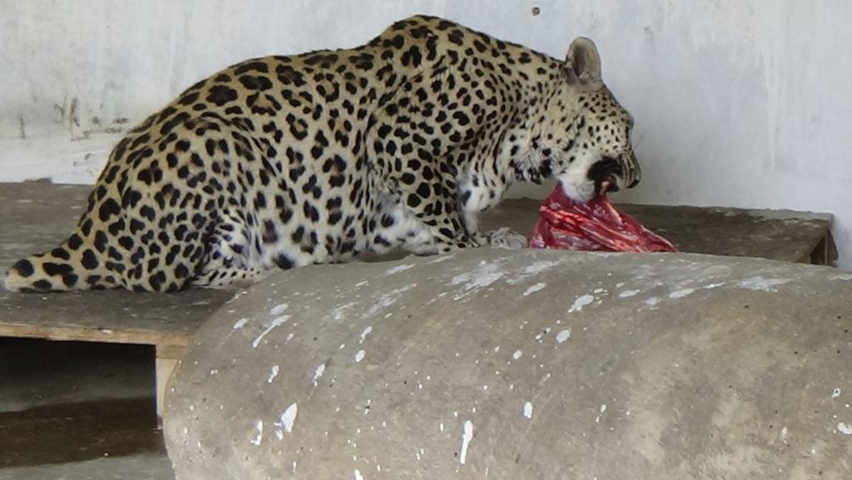

Project Data :
-------------------
Project Name : Arabian Leopard Protection Report Yemen October 2024
The project Location: Yemen
Name of the organization applying for the scholarship:
Sanid Organization for Relief and Development
Report duration: My quarter
Starting date 01/08/2024 Expiry date 29/10/2024
Organization address: Municipality of the Capital - People's District - Al-Habbari
Phone Number: 0096701231744
Report preparer : Mohammed Abu Hider
Current Position: Project Manager
E-mail: programmes.officer@sanid.org
Mobile Number: 00967775907606
The organization's website: https://sanid.org
------------------------------------------------------------------------------------------------

An overview of the status of the Arabian leopard in Yemen

The Arabian leopard is found in mountainous areas, as Yemen is one of the most prominent environments in which it has been endemic since ancient times, which led the Yemeni government to declare it the national animal.

It is found in several areas in the country, including: Al Mahrah, Al Dhale'e, and in the mountains of Yafa, Abyan, Shabwa, Al Bayda, Rada'a, Ibb, and the Bani Qais Reserve in Hajjah.
There are also dozens of leopards in the context of preserving them in a number of zoos in Yemen, such as: the zoo in the capital Sana'a, the Ibb Zoo, and the Zoo in Taiz in the southwest of the country.
The Arabian leopard is also found in the "Kor Al Awaliq" mountains in the Yemeni governorate of Shabwa, after disappearing for 20 years from the Shabwa regions.
The Arabian leopard faces the risk of hunting on the pretext that it preys on sheep owned by citizens, which has made it vulnerable to killing by sheep owners in Shabwa who threaten to kill the leopard in revenge for the killing of their sheep.
It seems very difficult and hard to protect a wild animal, which requires Sand (Nature Conservation Sector) to work hard and call on the concerned authorities to move and coordinate in order to educate the people of the areas where the Arabian leopard is present and inhabited.

This requires activating awareness and guiding the population on the importance of preserving the rare animals that characterize their areas, such as the Arabian leopard.

The presence of rare animals and endangered species means that these animals are older than humans and that they are indigenous to the Earth, and we must respect that.

Implemented activities:
Sand (Nature Conservation Sector) sought to pay great attention to preserving the Arabian leopard, as it gave it great importance in its goals, activities, and popular, official, and specialized events during the third quarter of 2024 AD by implementing the following:
• Continuing to raise awareness among the people of the areas where the Arabian leopard is present and inhabited, where 15 awareness sessions were held at a rate of 5 sessions per month, targeting 150 people from the official and popular sides and specialists in this field.
• Training volunteers from local activists in the targeted areas on the process of monitoring and reporting violations against the Arabian leopard in the three most affected areas. 21 volunteers were trained on monitoring, tracking and surveillance skills.
• 6 meetings were held with the Environment Protection Authority and legal advisors, and the laws in force in Yemen and the authority responsible for protecting endangered wild animals, most notably the Arabian leopard, were reviewed, and proposals were made on work and coordination between the organization.
• Implementing awareness in areas where Arabian leopards are present by criminalizing smuggling and killing and reporting any risks to which the Arabian leopard is exposed.
• 12 visits were made to educational institutions (schools, universities and institutes) to emphasize to students the importance of preserving and protecting the Arabian leopard in coordination with educational institutions.
• 4 meetings were held with the relevant government authorities to activate the role of protection and legal prosecution of perpetrators of crimes against this animal.
• Field visits were made to areas where the Arabian leopard is present, and meetings were held with local officials and a study was presented on the necessity of establishing centers for monitoring and tracking wild animals and obtaining sufficient data to develop protection plans.
• Field visits to the zoos in Sana'a and Taiz and the Malhan Reserve and reviewing the needs of the Arabian leopard (and following up on the health status of the Arabian leopards.
• Providing food under the supervision of a veterinary specialist to the Arabian leopards in Taiz Park and their cubs.
• Starting to contract with academic researchers on the biology and behavior of the Arabian leopard.
• Tracking and updating data on the abundance of the Arabian leopard and studying the needs of the new areas of its presence. Indicators
Challenges and obstacles:
• The deterioration of the economic situation in Yemen and its reflection on the deterioration of the environmental situation.
• Lack of support and donations.
• Security and political challenges.
• Lack of financial and human resources.
• Poaching and illegal trade.
• Habitat degradation.
• Lack of community awareness of the importance of protecting the Arabian leopard.

Future plans:
• Strengthening monitoring and surveillance efforts.
• Expanding the scope of habitat protection.
• Increasing investments in scientific research.
• Strengthening cooperation with partners.
• Developing more effective awareness programs.

End….

