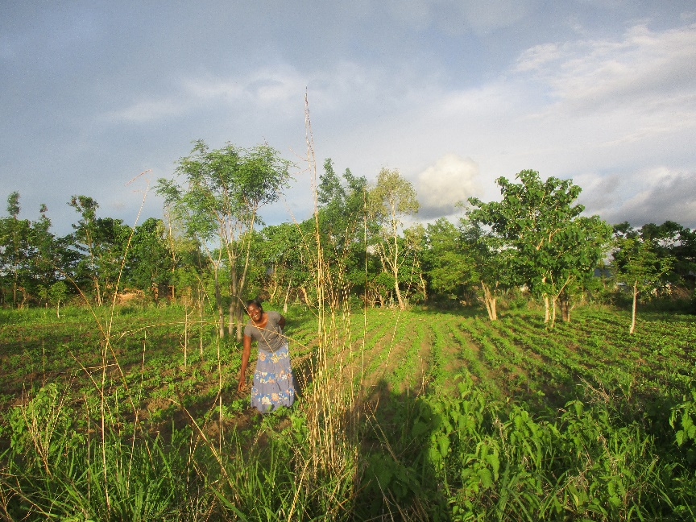
For once the rains are good! Hilda in the flourishing soy bean field
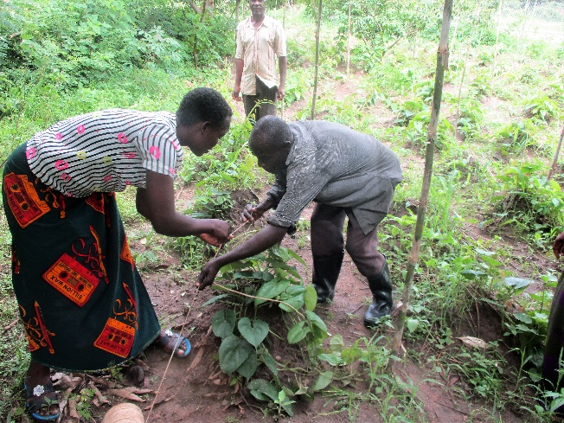
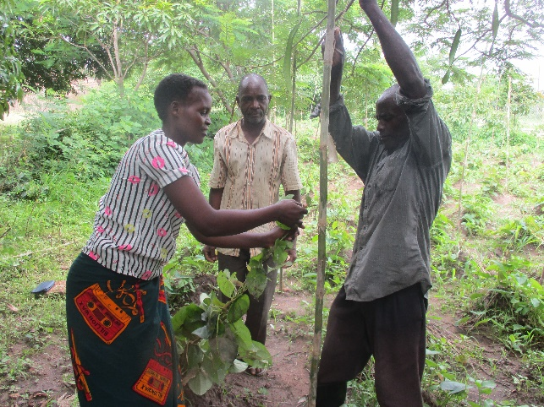
The yam plants are growing well. they must be supported by bamboo stakes

Photos fpr GlobalGiving report
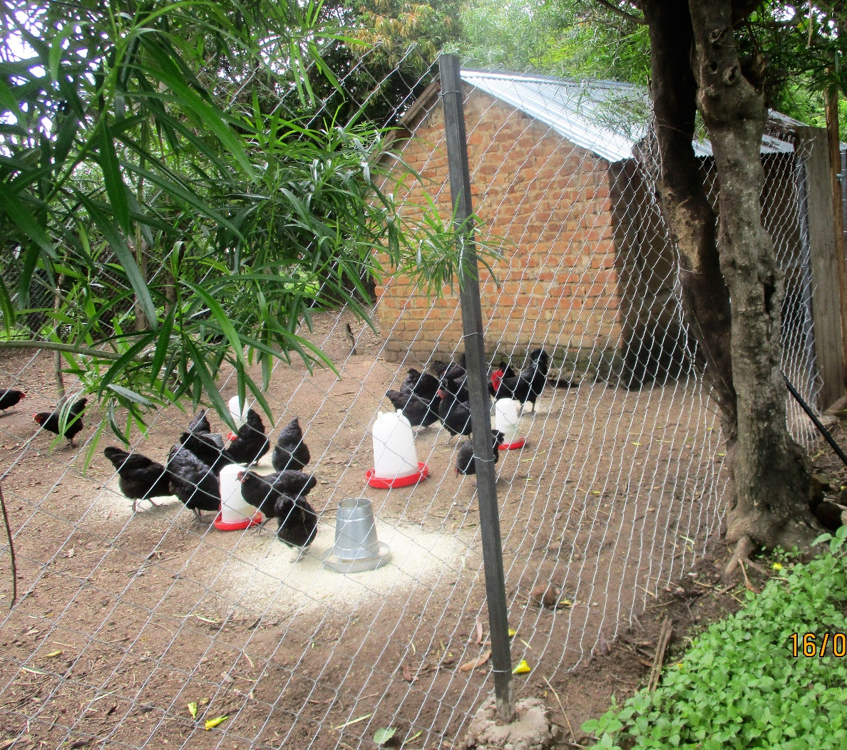
Tiko’s Black Australobe chickens with a new fence

