Al-Adha
Qurbani Project
Lebanon 2020
Relief Sector
Annex

Background: 2
Project Description 4
Intervention Logic 5
Target Group 6
Location (s) 6
Duration 6
Human Resources 7
Implementation Plan 7
Budget 8

Background:
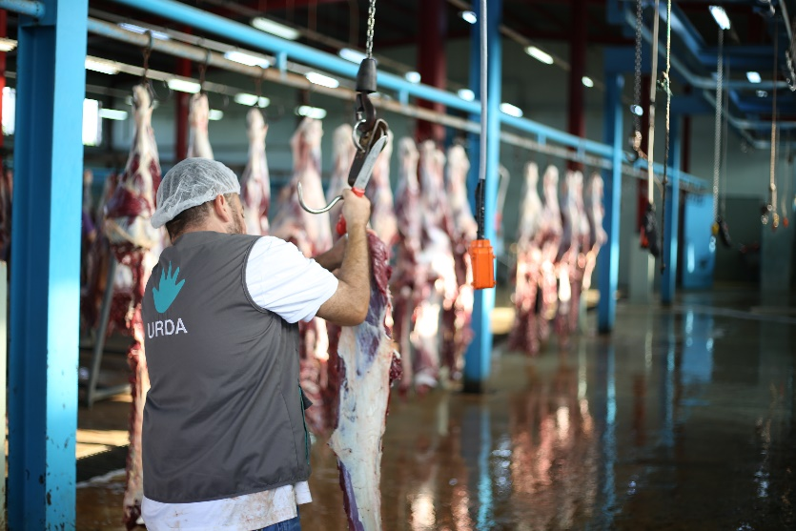
What is Eid-Al-Adha?
There are two key Eid’s (Celebration Festivals) in Islam: Eid Al-Fitr, which signifies the completion of the Holy Month of Ramadan; and Eid Al-Fitr, the Greater Eid, which follows the completion of the annual Hajj pilgrimage, at the time of Qurbani (sacrifice).

The day of Eid Al-Adha falls on the tenth day in the final (twelfth) month of the Islamic Lunar Calendar; Dhu-al-Hijjah.
The day that celebrations fall on is dependent on a legitimate sighting of the moon, following the completion of the annual Holy Pilgrimage of Hajj.

The celebration of Eid Al-Adha is to commemorate Prophet Ibrahim’s devotion to Allah SWT and his readiness to sacrifice his son, Ismail. At the very point of sacrifice, Allah SWT replaced Ismail with a ram, which was to be slaughtered in place of his son. This command from Allah SWT was a test of Prophet Ibrahim’s willingness and commitment to obey his Lord’s command, without question. Therefore, Eid Al-Adha means the festival of sacrifice.

The act of Qurbani (sacrifice) is carried out following the Eid Salaah (Eid Prayers), which are performed in the congregation at the nearest Mosque on the morning of Eid.

The act of Qurbani consists of slaughtering an animal as a sacrifice to mark this occasion in remembrance of Prophet Ibrahim’s sacrifice for Allah SWT. This is also known as Udhiya. The days of animal sacrifice total four days, from the 10th to the 13th of Dhu-al-Hijjah.

The sacrificial animal must be a sheep, lamb, goat, cow, bull, or a camel; the sheep, lamb or goat consist of one Qurbani share, whereas a bull, cow, or camel consists of seven shares per animal. The animal must be in good health and over a certain age to be slaughtered, humanely, and gently.

The Qurbani meat can then divided into three equal portions per share; one-third is for you and your family, one-third is for friends, and the final third is to be donated to those in need.

Traditionally, the day is spent celebrating with family, friends, and loved ones, often wearing new or best attire and the giving of gifts.

What is Al-Adha Project?

Starting from this, Union of Relief and Development Associations (URDA) implements Qurbani Project each year as part of its Al-Adha Eid projects.

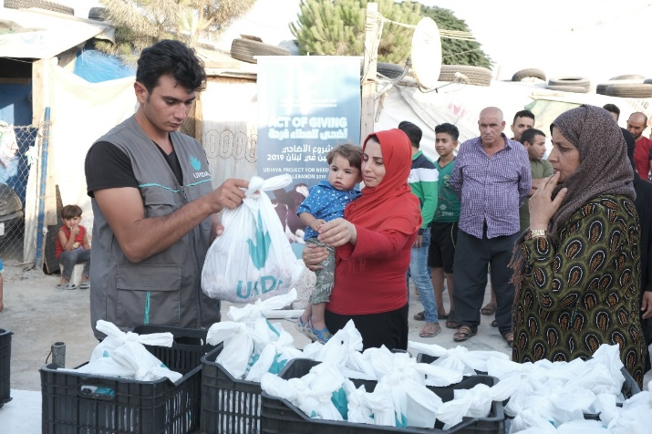
This project targets the most vulnerable families living in Lebanon and is implemented yearly all over the country. It is considered a crucial project due to its role in strengthening the bonds between the members of the communities (the privileged with the under-privileged) as well as providing the people who perform the ritual of sacrifice during the Adha Eid with the opportunity to donate the fresh meat to the most vulnerable families, which is the main objective of performing this type of ritual in the first place.

In line with UNDP’s SDG # 2 “Zero Hunger” which calls for “ending hunger and ensuring access by all people, in particular the poor and people in vulnerable situations, including infants, to safe, nutritious and sufficient food all year round by 2030” and “ending all forms of malnutrition”, URDA launches its annual “Qurbani Project” which aims at providing meat portions to the most vulnerable families in Lebanon, inclusive of Lebanese families as well as Palestinian and Syrian refugees living in controlled and arbitrary camps.

What is the current situation in Lebanon?

Lebanon is facing a multi-layered crisis.
The spread of the pandemic, happening within the context of a fragile and weakened economy, is critically affecting the livelihood and socio-economic conditions of the Lebanese population and -by default- the refugees’ as well.

The imposed lockdowns exacerbated the implications of the deepened fiscal and economic crisis, both horizontally and vertically. Horizontally, vulnerability is fast expanding to reach wider segments of the population; vertically, the depth and extent of vulnerability are intensified crossing 50% poverty and unemployment rates.

A study by Information International estimates the number of layoffs per Economic sector in 2020 in certain sectors (detailed below) if no prompt joint action is taken by the different Lebanese stakeholders:

- Around 10,000 to 15,000 Layoffs among private schools and the education sector;
- Around 50,000 employees will be jeopardized as per the report, as a result of the closure of touristic and entertainment sites;
- 20,000 to 25,000 employees may lose their jobs as numerous small enterprises are closed, amid rising inflation, a weaker lira and slashed demand on non-essential goods.
- 50,000 to 60,000 fresh graduates may become unemployed as international and regional doors are shut in the face of Lebanon amid the deteriorating circumstances.
- Returning expatriates who lost their jobs may constitute a total of 200,000 unemployed persons.
Thus, there’s a necessity more than ever to support the vulnerable Lebanese and refugees in the current stage to help them earn their living.

Project Description

Building on last year’s success and beneficiaries’ satisfaction, URDA is implementing the “Qurbani Project” for this year too. As mentioned previously, the project targets disadvantaged families living under the poverty lines, from Syrian and Palestinian refugees as well as Lebanese families within the hosting communities. The project will be implemented in all Lebanese governorates and will include controlled and uncontrolled refugee camps.

- Meat portions and pricing:
URDA will be supervising the slaughtering of donated Qurbans (sheep or cow) as well as the butchering, packaging, and distribution of meat portions to the poor families living in designated underprivileged areas during the first day of Adha Eid.

Each meat portion weighs 2 kg approximately. Prices differ depending on the slaughtered animal as shown in the below diagram:

- Implementation details:
When it is time for implementation, a sub-committee composed of URDA staff members from different departments and sectors shall be formed and tasked with planning, monitoring and evaluation, and supervising all aspects of the process including:

- Selection of cattle and ensuring its compliance with imposed standards such as weight and age.
- Supervision of slaughter to ensure that it is being done according to the Islamic standards.
- Quality control in terms of sanitation and hygiene in the slaughterhouses, proper refrigeration when storing and transporting the meat, and ensuring that the proper families are receiving the portions.
- On-site intervention and implementation of corrective actions in case any non-conformities are detected.

- COVID19 Prevention Guidelines:
During implementation, URDA staff members, volunteers, and key stakeholders will adhere to the prevention guidelines and practices recommended by the ministry of public health and will abide by URDA’s relief sector protocol that includes mainly equipment with PPE gears, gloves, and masks, as well as maintaining social distancing. These preventive measures are to avoid potential exposure, employ general hygiene measures, and safe food practices during the Qurbani project.

Intervention Logic
- Impact:
- Providing food services to poor families during Al-Adha Eid 1441 - 2020.
- Outcomes:
- Providing 24,000 families in different areas of Lebanon with fresh meat during Al-Adha Eid 1441 - 2020.
- Promoting the value of social solidarity.
- Improving the psychological wellbeing of targeted families during the days of Al-Adha Eid.
- Outputs:
- 3,000 heads of cows and sheep will be slaughtered.
- An average of 24,000 portions of fresh meat will be distributed to 24,000 families all over Lebanon.
Important note:
URDA’s Qurbani Project target for the year 2020 is to reach out for 24,000 beneficiaries. The output is based on the latest official figures issued by the World Bank that the poverty rate in Lebanon exceeds 52%.
Every donation counts, and every donation helps us reach the desired output.

Target Group

An estimated 24,000 families living under the poverty line and of various nationalities are expected to benefit from this project as shown in the below diagram:

Location (s)

“Qurban Project” will be implemented simultaneously in different locations covering all the Lebanese territories and will be targeting specifically underprivileged areas with a condensed population.
The following shows the various areas where the project will be implemented:
- Beirut and Mount Lebanon
- Iqleem, Saida & Tyre
- North Lebanon and Akkar
- Beqaa & Baalbeck-Hermel
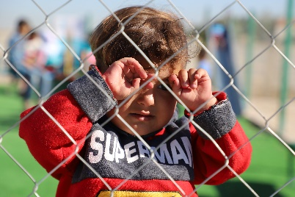
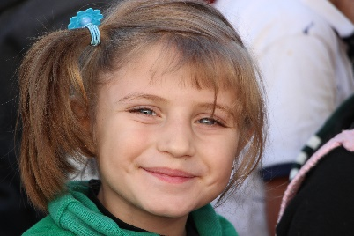
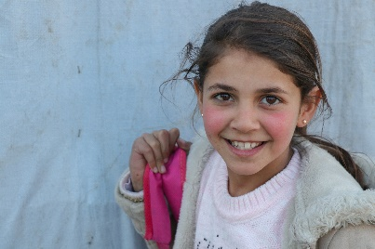
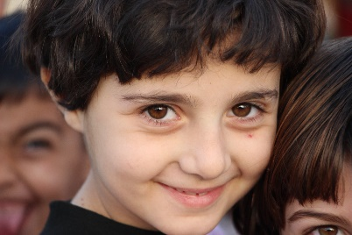
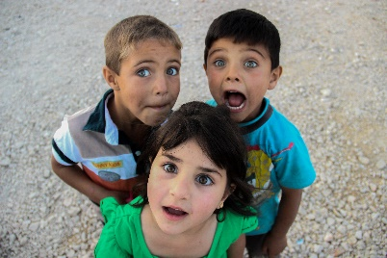

Duration

Implementation of the “Qurbani Project” shall take place during Al-Adha Eid of 2020 / 1441. It is worth mentioning that the procurement process and logistical preparation shall begin at least 20 days before the first day of the Adha Eid. Slaughtering, butchering, portioning, and distribution of meat portions shall take place during the 4 days of Al-Adha Eid if needed.
The total duration of the project is 45 days in the months of June and July 2020.
Below is an indicative timetable of the main activities of the project:

Task | Duration
Project planning and official agreement | 7 days
Logistical preparation | 14 days
Implementation of the project | 4 days
Reporting | 15 days

Human Resources

The project will be implemented under URDA’s Relief sector and will be managed by a sub-committee composed of selected staff members from different departments and sectors.

Implementation Plan

- Preparatory Phase
- Development of an action plan
- Logistical preparation
- Assignment of Sub-Committee members
- Role distribution and task assignment.
- Procurement Process: Request for quotations, selection of suppliers, and signing the agreements.
- Outreach and selection of beneficiaries
- Visibility plan (stickers, roll-ups, banners...).
- Coordination with slaughterhouses
- Identification of distribution areas and development of distribution plan
- Executive Phase
- Slaughter of Qurbans, butchering, portioning, and packaging of meat during Eid.
- Distribution of meat portions.
- Monitoring and evaluating the implementation of the project in all areas.
- Media coverage of the project.
- Evaluation Phase
- Evaluation of the project.
- Preparing a narrative report of the project.
- Preparing a financial report for the project.

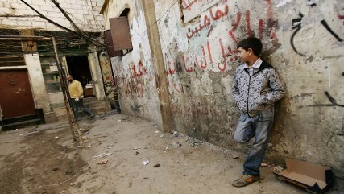
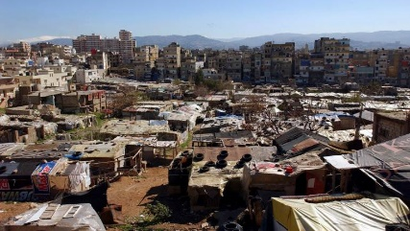
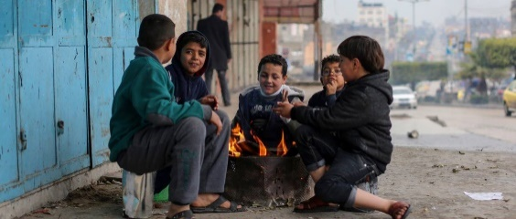
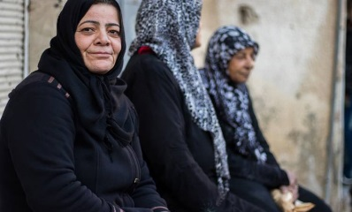
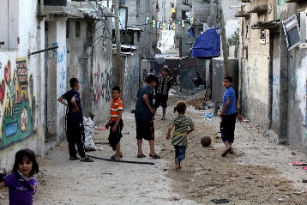

Budget

Qurbani Prices for the years 2020 / 1441 are as follow:
Item | Unit Price (USD)
Cow Portion | $ 193
Imported Sheep | $ 210
Local Sheep | $ 238

