**GlobalGiving Quarterly Progress Report for Swazi SHEROES (Q1 FY 2025-26)**

**Reporting Period: April 2025 – June 2025**

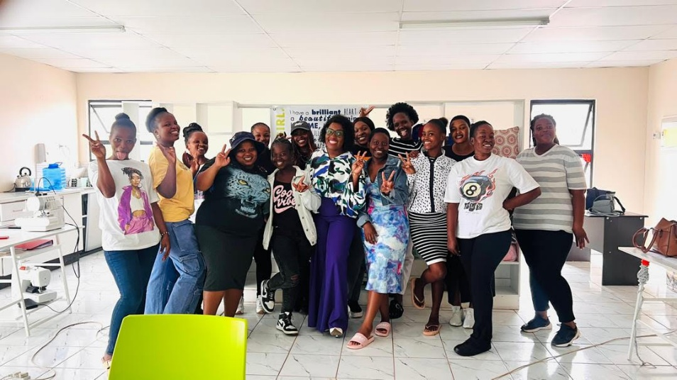

2025 Cohort

Jewelry made by beneficiaries of Swazi SHEROES

Beneficiaries of Swazi SHEROES