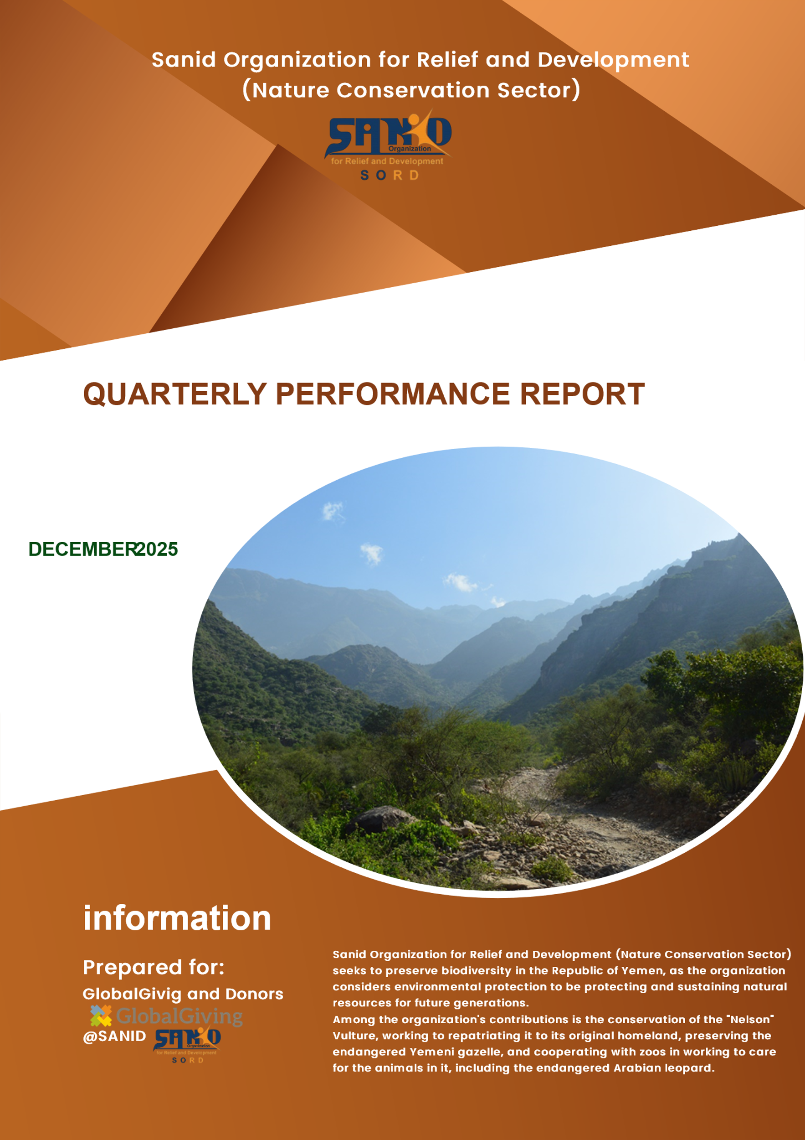
📝 Monthly Performance Report – Local Partner Sanid Organization (Nature Conservation Sector)
Project: Conservation of Biodiversity in the Milhan Protected Area
Month: December 2025
Report Preparer: Shaif Ezz Aldain

Project Data
Field | Detail
Project Name | Conservation of Biodiversity in the Milhan Protected Area
Project Location | Yemen – Al Mahwit Governorate – Milhan District
Grantee Organization | Sanid Organization for Relief and Development (SORD)
Reporting Period | November
Start Date | September 2025
End Date | December 2025
Organization Address | Amanat Al Asimah – Shu’oub District – Al Habari
Telephone No. | 0096701231744
Report Preparer | Shaif Azz Aldain
Current Position | Project Manager
Email | Programs.officer@sanid.org
Mobile No. | 00967 778515109
Organization Website | https://sanid.org

Project Overview
Status of the Arabian Leopard in Yemen
Milhan Protected Area, located in Al-Mahwit Governorate, is one of Yemen’s unique natural reserves. It reflects the richness and beauty of Yemen’s environment, encompassing diverse plant species and wildlife.
The area was officially declared a natural reserve by government decree in 2010 and is widely known as the “Arabian Leopard Reserve,” as it hosts the Arabian leopard, lynx, and other wildlife species. It also contains countless bird species, ancient trees, dense forests, and natural springs that captivate visitors.
Prior to the outbreak of war, Yemen had prepared a comprehensive file to submit to UNESCO, aiming to include Milhan in the list of globally recognized natural reserves. Unfortunately, this process was halted due to the conflict.
The role of government authorities, local communities, and residents of the reserve remains critical in safeguarding its natural and environmental assets. Developing service and eco-tourism projects in the area would transform Milhan into a distinguished tourist destination.
Implemented Activities
- Continued coordination with the Environmental Protection Authority for field visits by Sanid’s team to monitor the reserve’s needs and progress.
- Ongoing documentation of bird species in the area, including photographs and identification of species such as partridge, falcon, hawk, cattle egret, hoopoe, pigeons, sparrows, and vultures.
- Monitoring violations affecting rare birds (migratory and resident) through a volunteer team.
- Engagement of local activists and volunteers in surveillance and reporting processes.
- Regular meetings with the Environmental Protection Authority, legal office, and advisors to address delays in enforcing laws protecting rare birds and the reserve’s heritage.
- Awareness sessions in areas where rare birds are found, emphasizing the prohibition of smuggling, hunting, and reporting risks.
- Continued visits to educational institutions (schools, universities, institutes) to raise awareness among students about the importance of protecting reserves, especially Milhan.
- Development of reserve management plans.
- Ongoing meetings with government authorities to strengthen legal enforcement against violations such as deforestation.
- Community awareness sessions conducted by volunteers and conservation advocates.
- Mid-term evaluation surveys to assess community acceptance of reserve protection during conflict.
- Efforts to secure funding for establishing bird migration monitoring centers.
- Field visits with veterinary teams to assess the health of animals and birds, and ensure prevention of tree cutting for firewood.
- Provision of medical care to certain bird species, including vaccinations and specialized food supplies.
- Veterinary-supervised feeding of Arabian leopards in Milhan Reserve.
Challenges and Constraints
- Deteriorating economic conditions in Yemen and their negative impact on the environment.
- Government inability to provide necessary resources for reserves, including trees, birds, and wildlife.
- Weak enforcement of existing environmental protection laws.
- Absence of model reserves.
- Limited capacity for monitoring and tracking migratory birds.
- Insufficient funding and donations.

SANID ORGANIZATION FOR RELIEF AND DEVELOPMENT (SORD)
Sana'a - Al-Hasba - Shu'ub District - Al-Hasba Al-Jamahiriya Street -Alhabari Round-behind Aljedri Station
 https://sanid.org  www.facebook.com/sanid.org  https://twitter.com/sanid_org
 https://www.instagram.com/sanidorganization
Tel : +9671231744 Mob:+967775433335 /+967771055500 Email : info@sanid.org

