**Monthly Performance Report - Local Partner SANID Organization ( Nature Conservation Sector)**

**For project: Preserving Wildlife and Biodiversity in the Melhan Conservation Area**

**July 2024 / AD**

**prepared by: Mohammed Abu Haider**

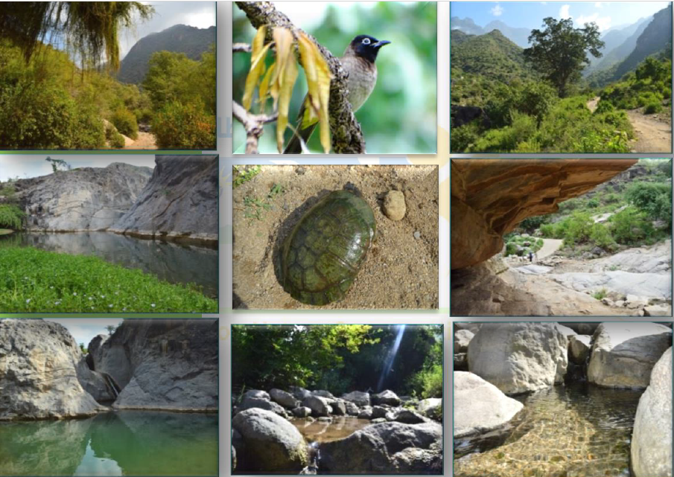

|  |  |  |  |
| --- | --- | --- | --- |
| project name | **Preserving biodiversity in the Melhan Protected Area** | | |
| The project Location | **Yemen - Al Mahwit Governorate - Melhan District** | | |
| Name of the organization applying for the scholarship | Sand Relief and Development Organization | | |
| Report duration | Three and a half months​ | | |
| starting date | **01-04-2024** | **Expiry date** | **15-07-2024** |
| Organization address | Municipality of the Capital - People's District - Al-Habbari | | |
| phone number | *0096701205757* | | |
| Report preparer | Mohammed Abu Haider | | |
| Current Position | project manager | | |
| E-mail | programmes.officer@sanid.org | | |
| mobile number | *00967 775907606* | | |
| The organization's website | www.sanid.org | | |

**project's data**

**Overview of Wildlife and Biodiversity in the Melhan Conservation Area In Yemen**

The project aims to preserve the endangered biodiversity in the Malhan Natural Reserve, which is considered a unique site that still maintains its ecological system represented by the Arabian leopard, which became extinct from the Arabian Peninsula as a result of the threats and dangers surrounding its environment, the Malhan area, as well as the distinguished plants with cash crops such as medicinal and aromatic plants. Perennial trees that reach more than 300 years and varying heights of up to more than 100 meters. All the plants and trees are part of the process of stabilizing the soil and humans as a result of climatic variables, erosion factors, and natural disasters such as collapses due to their location near the towering Malhan Mountains. Therefore, the spotlight was shed on this reserve, and many studies of a traditional nature and self-financing were carried out, prompting all those interested in nature to pay attention to this distinguished patch of land, as the state had previously taken care to issue a decision to declare it a natural reserve by decision issued by the Presidency of the Government No. 349 of 2010 AD. All this biodiversity is reflected in the lives of individuals and society, which relies entirely on these natural resources and practices its main activity in agriculture, some handicrafts, and traditional professions. Rural women have an important and prominent role in visible and unseen activities such as farming the land, raising livestock, and raising wild bees. Increasing the breeding of wild predatory birds, such as Arabian partridges, rabbits, and voles. All the residents of the reserve depend on these natural resources as the sole source of their livelihood and feed their children using ancient traditional methods. It also depends on wildlife and animals (mammals, reptiles, and insects). The reserve includes various plant and animal species, including some rare and endangered species. The project aims to develop a management plan that takes into account all aspects and establishes a relationship between the reserve and the local community based on partnership and cooperation in preserving the animal and plant components of the reserve. This is limited to hunting and commercial purposes, determining and organizing grazing seasons, and raising community awareness of the importance of biodiversity and the sustainability of natural resources. The project will also implement cleaning campaigns throughout the reserve and find alternatives, especially to reduce excessive tree cutting. The main target group for this project is the local community located in the Malhan Conservation Area, with parts of five areas representing seven sub-areas. The expected direct result of this project is the conservation of animal and plant species, especially threatened species, and the sustainability of natural resources for future generations. The importance of this project for international conservation is that the Malhan Reserve represents a unique combination of physical factors that support many different ecosystems of great biological value, including endemic and threatened species, as well as a unique land use in its own right. Preserving these vital values is part of universal values because the environment has no boundaries and is considered an extension of other environments.

**Activities carried out:**

* A field trip by the organization’s team to the reserve to conduct a field survey. And inspect the reserve and its emergency needs.
* Ensure the safety of the birds in those areas and that they do not die or be exposed to hunting.
* Continue to monitor violations against rare birds, whether migratory or settled, through a volunteer team.
* Training volunteer local activists in the targeted areas to monitor and report these violations.
* Holding meetings with the competent authorities and contracting with a legal office to follow up on the activation and implementation of the laws in force in Yemen concerned with protecting rare birds, as well as protected areas in general, and preserving their beauty as an authentic Yemeni civilizational cultural heritage.
* Implementing three awareness sessions in areas where rare birds of all kinds are found, criminalizing smuggling and killing, and reporting any dangers to which these birds are exposed.
* Field visit to educational institutions (schools, universities, and institutes) to implement previous agreements to introduce students to the importance of preserving and protecting reserves, the most important of which is the Malhan Reserve, in coordination with educational institutions.
* Continuing ongoing meetings with the competent government authorities to activate the role of protection and legal prosecution of perpetrators of crimes against the leveling of protected areas.
* Coordination and continuous communication with We have reliable and specialized partners on the ground to work to protect the reserve.
* Field visits were made to the reserve, accompanied by a veterinary team, to monitor the health of animals and birds. Ensure that citizens do not cut trees again and use them for firewood.
* Providing medical care for some birds and animals by giving them vaccines and special food supplies to maintain their survival.