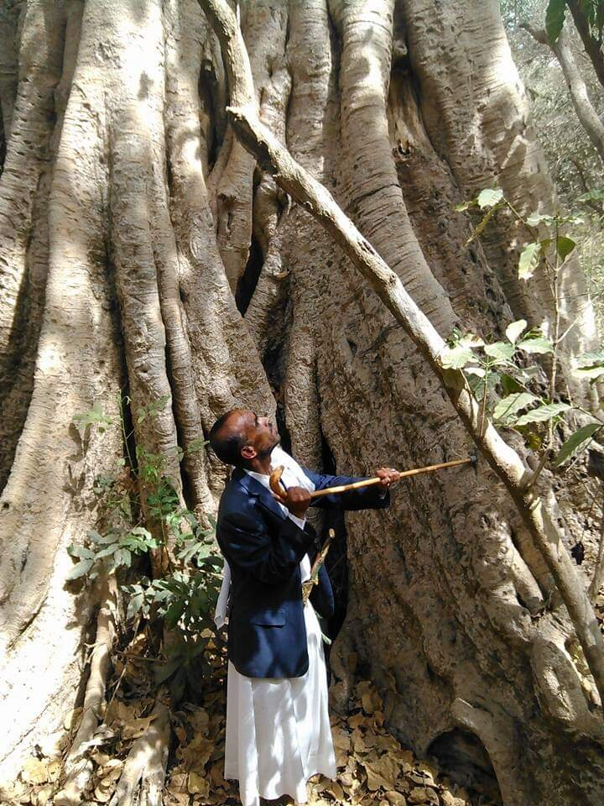

Conservation of wildlife and biodiversity in the Malhan Protected Area

|  |
| --- |
|  |
|  |
| **31 MAR 2025**  Sanid Organization for Relief and Development  Author: Shaif Ahmed Ali Izzadeen |



|  |  |  |  |  |
| --- | --- | --- | --- | --- |
| Project Name | Preserving biodiversity in the Melham Protected Area | | | |
| The Protect Location | Yemen - Al Mahwit Governorate Melman District | | | |
| Organization | Sanid Relief and Development Organization | | | |
| Report Duration | Three and a half months​ | | | |
| Starting Date | January 1, 2025 | Expiry date | March 30, 2025 |
| Organization address | Municipality of the Capital - People's District - Al-Habbari | | | |
| Phone Number | *0096701205757* | | | |
| Report Preparer | Shaif Ahmed Ali Ezadeen | | | |
| Current Position | Project Manager | | | |
| E-Mail | programmes.officer@sanid.org | | | |
| Mobile Number | *00967 778515109* | | | |
| WEB SITE | www.sanid.org | | | |

Project Data

Overview

The project aims to preserve the threatened biodiversity of the Malhan Nature Reserve, a unique site that still maintains its ecological system.   
This includes the Arabian leopard, which became extinct in the Arabian Peninsula due to the threats and hazards surrounding its environment in the Malhan area.   
The project also includes distinctive cash crops, such as medicinal and aromatic plants, and perennial trees that can reach over 300 years old and vary in height, reaching over 100 meters.   
All plants and trees contribute to the stabilization process for soil and humans as a result of climate change, erosion, and natural disasters such as landslides, due to its location near the towering Malhan Mountains.   
Therefore, the focus has been placed on this reserve, and numerous traditional and self-funded studies have been conducted, encouraging all those interested in nature to pay attention to this unique area of ​​land.  
 The state has previously taken an interest in this area, declaring it a nature reserve by Prime Ministerial Decree No. (349) of 2010.   
All this biodiversity impacts the lives of individuals and communities, which are entirely dependent on these natural resources and pursue their primary activities of agriculture, some handicrafts, and traditional professions.  
 Rural women play an important and prominent role in visible and invisible activities and businesses, such as farming, livestock breeding, wild beekeeping, and the increased breeding of wild carnivorous birds such as Arabian partridges, rabbits, and ibex.   
All the local residents of the reserve depend on these natural resources as their sole source of livelihood and for feeding their children, using ancient traditional methods. They also depend on wildlife and animals (mammals, reptiles, and insects).  
 The reserve includes diverse plant and animal species, including some rare and endangered species.   
The project aims to develop a management plan that takes into account all aspects and establishes a relationship between the reserve and the local community based on partnership and cooperation in preserving the reserve's animal and plant components. This is limited to hunting and commercial purposes, defining and regulating grazing seasons, and raising community awareness of the importance of biodiversity and the sustainability of natural resources.   
The project will also implement clean-up campaigns throughout the reserve and identify alternatives, particularly to reduce excessive logging.   
The primary target group for this project is the local community located within the Malhan Reserve, comprising parts of five zones representing seven sub-zones. The expected direct outcome of this project is the conservation of animal and plant species, especially threatened species, and the sustainability of natural resources for future generations.   
The importance of this project for international conservation lies in the fact that the Malhan Reserve represents a unique combination of physical factors that support many different ecosystems of great biological value, including endemic and endangered species, as well as the unique land use itself.   
Preserving these vital values ​​is part of universal values, as the environment has no borders and is considered an extension of other environments

Implemented Activities :

▪ Distributing volunteers from local activists in the targeted areas to monitor and report these violations.

▪ Conducting three awareness sessions in areas where rare birds of all kinds are found, criminalizing smuggling and killing, and reporting any risks to these birds.

▪ Four meetings were held with relevant authorities through the Legal Office to follow up on the activation and implementation of existing laws in Yemen related to the protection of rare birds, as well as the reserve in general, and to preserve its beauty as an authentic Yemeni cultural heritage.

▪ Field visits were conducted by the organization's team to the reserve to monitor and inspect the reserve and its emergency needs.

▪ Ensuring the safety of birds in these areas, and ensuring that they are not dying or being hunted.

▪ Continuing to monitor violations against rare birds, both migratory and resident, through a volunteer team.

▪ Field visits were conducted to educational institutions (five schools, three universities, and six institutes) to raise awareness and educate students on the importance of preserving and protecting the reserves, most notably the Malhan Reserve, in coordination with the educational institutions.

▪ Continuing to hold meetings with relevant government agencies to activate the role of protection and legally prosecute perpetrators of crimes related to the destruction of reserves.

▪ Two meetings were held with trusted partners and experts on the ground to work on protecting the reserve.

▪ Three field visits were conducted to the reserve, accompanied by a veterinary team, to monitor the health of the animals and birds and ensure that citizens do not re-cut trees for firewood.

▪ Medical care was provided to some birds and animals by administering vaccines and special food supplies to ensure their survival.

